Leadership in Performance of an Organization

Wahab Lukman Olamilekun
Introduction

The main objective of this research is to investigate if a specific type of CEO’s leadership is related to the performance of the employees, using a case study related to CEO’s Dangote group Organization, as is the case of Aliko Dangote. The

study also described both leadership qualities and performance in service sector of good leadership qualities.

Keywords: Organizational Performance relationship, Rewards for performances, Culture and Leadership Qualities.
Leadership Concept of Dangote group Organization

The leadership Concept of Dangote group Organization is the process of influencing the behavior of other to work willingly and enthusiastically for achieving predetermined goals.
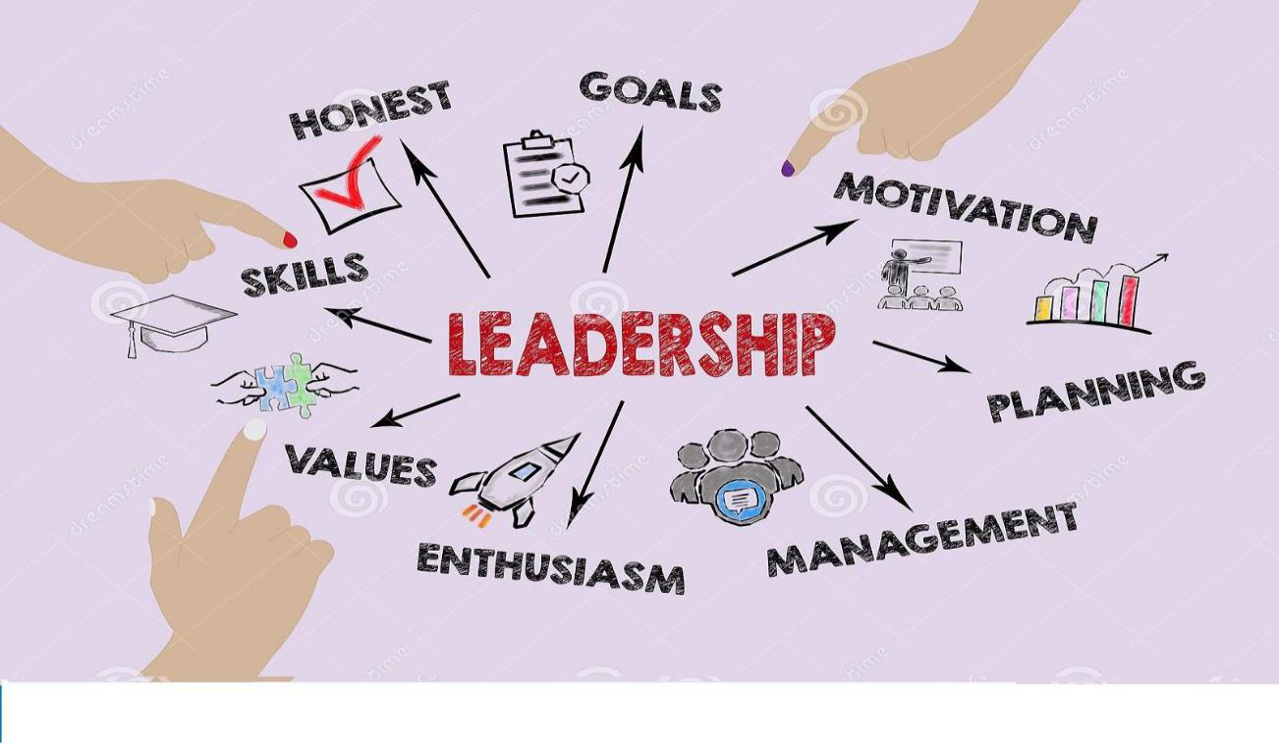


Structure of Dangote group Organization

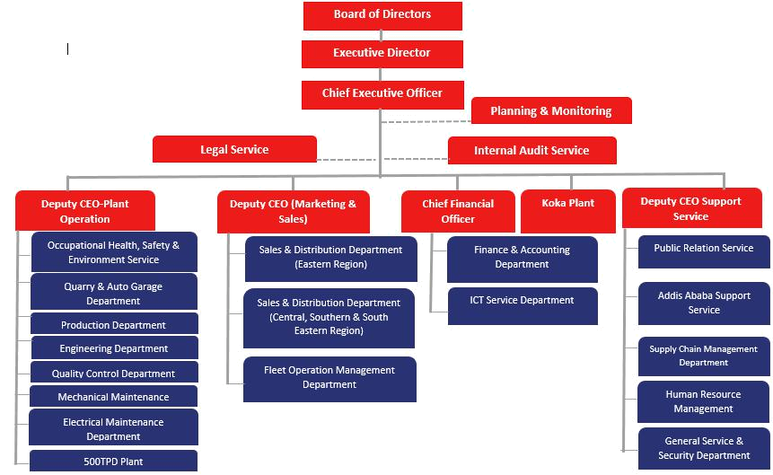
leadership behaviors

Be open and honest. The best leaders are open and honest with their team members.

Lead by example. Effective delegating is a necessary skill for managers to have and leading by example is also key.

Have confidence.

Encourage feedback.

Provide evidence.

Be self-analytical.

Promote successes.

Embrace change.
Types of leadership behaviors

I)Task-focused: Task behavior is when your actions are centered on the task - the job that needs to be done.

ii)Relationship-focused behaviors: Relationship behavior is when your actions are more centered towards relationships with your people.

leadership styles

Delegative Leadership: a delegative leadership style focuses on delegating initiative to team members. This can be a successful strategy if team members are competent, take responsibility and prefer engaging in individual work and it also no as laissez-faire leadership.
Organizational Performance

Organizational performance involves comparing a company's actual output with what it intended its output to be, i.e., its goals and objectives.
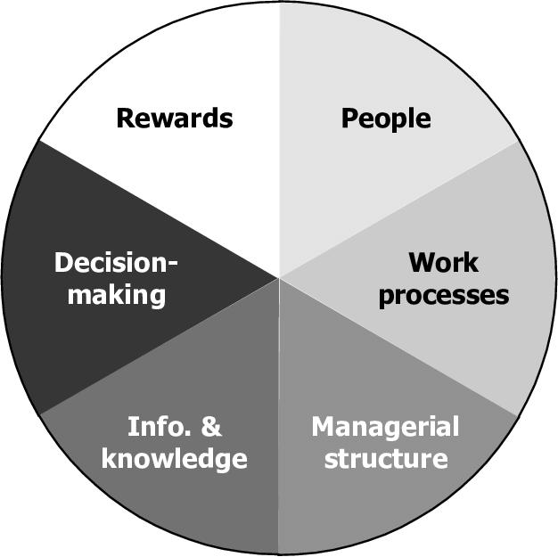
RESEARCH METHODOLOGY

This chapter examines the various sources of data used in the research, the designed population study, sample size, techniques used, instruments and method of data analysis.

Objectives and Research Hypothesis

The main goal of this research is to investigate if a specific type of CEO’s leadership is related to the performance of the employees, using a case study related to CEO’s Dangote group Organization.

Therefore, this research intends to answer the following research questions:

- How does leadership style positively and significantly affect job performance?

- How does leadership practice positively and significantly related to job performance?

Considering the previous literature review, the present work was conducted to investigate how leadership practices affect organization job performance using qualitative data (questionnaires) and in-depth interviews.
Sample, Sources and Data Collection Methods

It was not possible to administer questionnaires to all staff rather a combination of stratified random sampling with multi -stage cluster sampled was used. Stratified random sampling was used to ensure that the selection cut across all categories of staff. Multi-stage sampling was also used to ensure that the research cut across the zones and some of the institute branches within the state.

The data collection method used in this study involved two sources: the primary and secondary sources. The primary sources include the information obtained from the administration and a survey by questionnaire. The secondary source was based on information from relevant literature, textbooks, journals and academy of management reviews on leadership style on employee performance.

Data Analysis Method

The data collected through the questionnaire presented in tabular form. The data gathered from the questionnaire were analyzed and presented in frequency and percentage tables. The data were also interpreted, and the chi square statistical test was used to test the stated hypotheses.
CONCLUSION AND RECOMMENDATIONS

The important purpose of the studies is to seek out the effect of management conduct on a firm’s enterprise growth. The case employer in the studies became Dangote Group. An interview with the CEO of Dangote Group became carried out. There are over 30,000 employs performing at Dangote Group in Nigeria, 29 professionals the survey questionnaire way to covid 19. The studies became accomplished to test how the firm grows toward achievement and achieves objectives with the help of management behaviors and differing sorts of management behaviors have been discussed.

THANKS FOR LISTEN AND ANY QUESTION?

