**TRADITIONAL VS ONLINE: A Learner's Preference**

Jamie Yvonne S. Andaya1, Ruzel Keer Josh G. Catriz1,

Maureen Isobelle M. Dechavez1, Christianna Denise L. Lubiano1,

Jose Francis B. Mainggang1, Tiffany Faith B. Marzo1,

Rendel O. Opena1, Dianna Rose B. Flora2

1Researchers, 2Research Adviser

**ABSTRACT**

Online learning is education through the use of advanced technologies while Traditional learning is conventional education. Students have their own preferences in what learning mode should be implemented. This problem became the bottom line to conduct this study entitled: TRADITIONAL VS ONLINE: A Learner’s Preference. With this study, the researchers aimed to know the preference of the students, the advantages and disadvantages of the two learning modes, and the factors that affect their preference. The researchers made use of interviews to gather data from students from Junior High School in Lorma Special Science High School. Therefore, this research is Qualitative in nature and used a Descriptive research design. Majority of The researchers conclude that more students prefer Traditional Learning more than Online learning. This is due to the Advantages and Disadvantages of the two learning modes. There were also many factors affecting their preference. Majority of the reason why students prefer Traditional Learning is because of the presence of Interaction both student to student and student to teacher which leads to better Understanding of Lessons. While for Online Learning, the students prefer it due to its Convenience. The researchers recommend having this study conducted on a larger locale so that the preferences are not just limited to the students of Lorma Special Science High School. The researchers would also like to recommend to the future researchers to have more deep understanding or study on this topic in order for other students to also benefit and put into the environment which they can learn more. Finally, the researchers would like to recommend to future researchers to study ways for the two learning modes to be more effective.

**Keywords:**

Traditional Learning; Online Learning; Students; Preference; Learning Mode

**Chapter 1**

**INTRODUCTION**

**1.1 Background of the Study**

Online learning is a term to describe an emerging approach to learn at students’ own premise through advanced information-communication technologies (such as Blackboard, Moodle, YouTube, Virtual Reality) either asynchronously or synchronously (Yang, 2020). On the other hand, Traditional learning, also known as back-to-basics, conventional education or customary education, refers to long-established customs that society traditionally used in schools (Gaimaro, 2019).

The advent of online education has made it possible for students with busy lives and limited flexibility to obtain a quality education. As opposed to traditional classroom teaching. Online learning has made it possible to offer classes worldwide through a single Internet connection. Although it boasts several advantages over traditional education, online instruction still has its drawbacks. Still, online education seems to be the path many students are taking (Paul and Jefferson, 2016).

Online learning offers numerous advantages to students such as convenience, flexibility and access to education. Due to students’ busy lifestyle the flexibility and convenience of online learning format appeals to students. Studies have also documented that the quality of online education is similar to face-to-face learning. In fact, in their report based on a meta-analysis and review of thousands of studies related to online learning, the Department of Education in the U.S. concluded that, in general, online learning is more effective than face-to-face learning (Muhajira, 2020).

Online Learning has benefited students and teachers as India's Edtech Market recently rose by giving education through technology. During such tough times, when SARS-CoV-2 (Covid-19) has forced schools and colleges to remain completely in lock down for a few weeks due to the seriousness of the situation, EdTech companies can prove to be of great help to students (Brianna et al., 2019).

Online education in Chinese universities has also increased exponentially after the Covid-19 outbreak. However, through the sudden shift due to the virus, it has given education institutes a shift of concern where they would prioritize their ability to adopt online learning in a massive manner while providing quality education (Carey, 2020).

In the article "Analysis of Student Performance in an Online vs. Face-to-Face learning " it was stated that a growing number of students are now opting for online classes due to the fact that students find the traditional classroom modality restrictive, inflexible, and impractical. In this age of technological advancement, schools can now provide effective classroom teaching via the Web. The study said that learners now want quality programs they can access from anywhere and at any time. In addition to flexibility and access, multiple other face value benefits, including program choice and time efficiency, have increased the attractiveness of online learning.

The findings of the study from Adnan, M. and Anwar, K., (2020) highlighted that online learning cannot produce desired results in underdeveloped countries like Pakistan, where a vast majority of students are unable to access the internet due to technical as well as monetary issues. The lack of face-to-face interaction with the teacher, response time and absence of traditional classroom socialization were among some other issues highlighted by students.

According to the eLearning Industry, (2018) Traditional classes are more suitable for young children, teenagers, and young adolescents who are yet to join the workforce. Regular attendance in classes helps them interact with other individuals of their own age, be better disciplined, follow a regular schedule, and improve their physical fitness and mental alertness. In online classes, the learner is not directly interacting with the faculty. So in case of having any questions, they may find it difficult to ask their online instructor. However, these courses often offer alternatives to live query resolution like online forums, emails, and chat rooms.

Mothers from different public schools in the Philippines noted that their main concern is the students access to technology, especially the internet, since there are those who live in remote areas who do not even have access to electricity. They shared the same sentiment which is that in order for students to attend online, each student must have his own gadget which would lead to additional expenses for the parents. Internet connectivity and resources to purchase gadgets as the main challenge for students (CNN, 2020).

Distance learners are the best according to Knowly, (2020) Exam results have shown that distance learners can get similar, or better scores in exams compared to traditional students, because they study more. In fact, many of the top universities in the world are offering distance courses now. The other modality, classroom teaching, is a well-established instructional medium in which teaching style and structure have been refined over several centuries. Face-to-face instruction has numerous benefits not found in its online counterpart (Xu and Jaggars, 2016).

According to Finney, (2015) When the participants were asked if they would like to take more online classes the female students were divided between whether they would (31%) or would not (36%) take online classes with (36%) having no preference. Among males, the distribution of the responses was not as even. Of the male participants, only (26%) desired to take online classes with (31%) not wanting to take online classes and (49%) had no preference.

The majority of the students preferred a combination of online and face-to-face classes with the minority of students preferring online classes only. The participants found that when using online classes they liked that they were able to go at their own pace and repeat a lesson if needed. There were not many differences when it came to gender but the female participants had a higher percentage that liked online classes because they were able to repeat a lesson (Finney, 2015).

Online and traditional education share many qualities. Students are still required to attend class, learn the material, submit assignments, and complete group projects. While teachers still have to design curriculums, maximize instructional quality, answer class questions, motivate students to learn, and grade assignments. Despite these basic similarities, there are many differences between the two modalities.

Traditionally, classroom instruction is known to be teacher-centered and requires passive learning by the student, while online instruction is often student-centered and requires active learning (Paul and Jefferson, 2016).

The aim of this research is to know the students’ preference in terms of learning mode, whether the students prefer learning online or the traditional way for the students to learn more and for them to be in the environment which they are more comfortable to study.

**1.2 Theoretical Framework and Research Paradigm**

For the theoretical framework, the researchers incorporated two related theories to our research to make it reliable and consistent.

**Connectivism**. The theory Connectivism from Siemens explains how Internet technologies have created new opportunities for people to learn and share information across the World Wide Web and among themselves. It gives information on what online learning is or how it works. Connectivism shows the diversity of ways to learn online. This emphasizes how technology can access the internet for people to be able to learn anywhere in the world. Even if they are outside of school, they can still learn through the process of using technology and accessing wikis, YouTube videos, discussion forms, etc.

**Behaviorism**. According to Leahey, (2020) Behaviorism views that learning is changing the behavior of students, from being able to produce oral or written product, and the task of the teacher is to control the stimulus and the learning environment in order to change the desired destination approaching, gift givers and teachers of students who have been able to show significant changes while punishment given to students who are notable to show the change of meaning. This shows that the behavior of a person can somewhat trigger responses.

**RESEARCH PARADIGM**

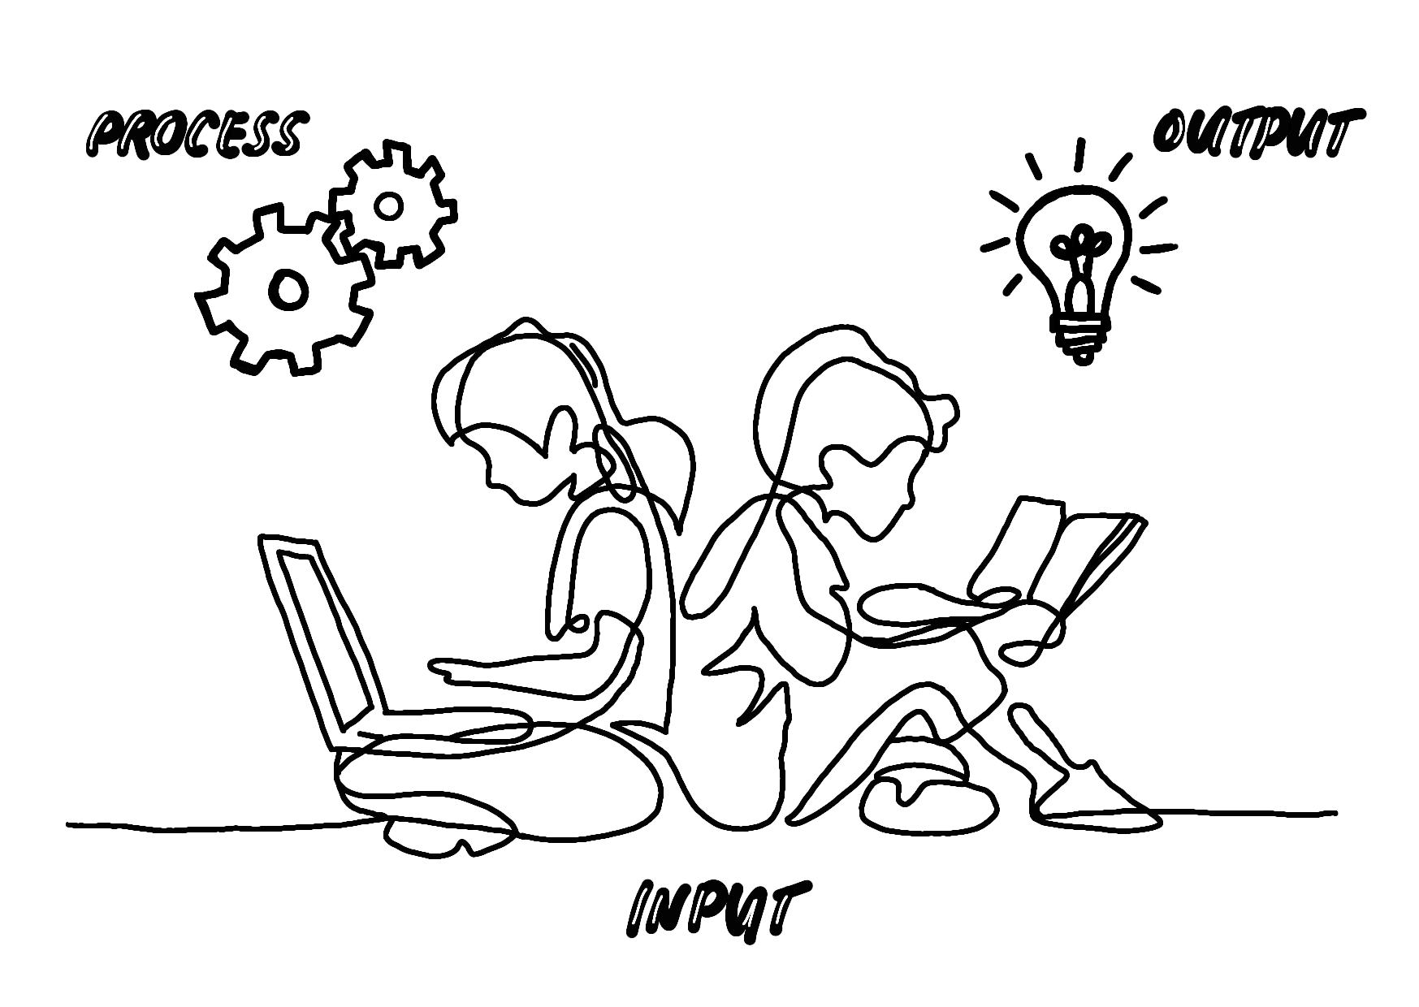

**Figure 1. Research Paradigm**

For the Research Paradigm, the researchers chose to represent their study with the figure of children who are studying. The children reading the book and laptop are the input. The book symbolizes traditional learning and the laptop symbolizes online learning. The things to measure are the advantages and disadvantages of the two learning modes, the students preference, and the factors that affect their preferred learning mode. The gears serve as the process because it represents the analysis and understanding of knowledge being gained. In this step, this is where the researchers interview and Thematize the data gathered from the students. Finally, the lightbulb symbolizes new ideas developed from the learning process. The lightbulb is when the researchers already have the results to propose a proposal on what learning mode should be implemented in Lorma Colleges Special Science High School.

**STATEMENT OF THE PROBLEM:**

This study aims to identify the preference of the students whether it is online learning or traditional learning. Specifically, it sought to answer the following questions:

1. What are the advantages and disadvantages of the two learning modes?;

2. What is the preferred learning mode of students?; and

3. What are the factors that affect their preferred learning mode?

**Chapter 2**

**METHODOLOGY**

This study is Qualitative in nature. Qualitative research focuses on words rather than numbers. According to Bhandar (2020), Qualitative research involves collecting and analyzing non-numerical data to understand concepts, opinions, or experiences. Qualitative method is used to gain an understanding of underlying reasons, opinions, and motivations. This method seeks to discover the thoughts and feelings of respondents. People and groups are studied in their natural setting. Since this study focuses on the preference of the students on Online and Traditional Learning thus Qualitative Method is used. It is most commonly used to help inform new concepts, theories, and products (Tiley, 2017).

**2.1 Research Design**

Descriptive research design was utilized for this study. According to McCombes (2019), Descriptive research aims to accurately and systematically describe a population, situation or phenomenon. It can answer what, where, when and how questions, but not why questions. A descriptive research design can use a wide variety of research methods to investigate one or more variables. It also states that this research design is mainly used in human behaviours, among other things, and the researcher observes characteristics, behaviours, and reactions, which fits nicely into this research as it talks about the learner's preferred learning mode.

**2.2 Population and Locale of the Study**

The researchers relied on their own judgment when choosing members of the population to participate in the study. The participants of this research were 10 junior high school students of Lorma Colleges Special Science High School. Since this study focuses on students’ preference about online and traditional learning, the respondent must have experienced both learning modes. In choosing the participants, purposive sampling was used. According to Crossman (2019), a purposive sample is a non-probability sample that is selected based on the characteristics of a population and the objective of the study. The researchers chose to use purposive sampling in order to target certain characteristics of a population that will best respond to the questions.

**2.3 Data Gathering Tool**

In the process of gathering data, a structured interview was done. It will allow the researchers to acquire information and the thoughts and opinion of the respondents. This was the option the researchers used as there is a pandemic in which human contact is no longer needed as the interview can be done through the use of Zoom and Messenger. The researchers based the questions to be asked to the participants on the SOPs (Statement of the Problem) which can be found in Chapter 1.

**2.4 Data Gathering Procedures and Ethical Consideration**

The researchers found answers to the questions presented by following a systematic procedure. First, the researchers made a letter for Mrs. Elizabeth Camara, the director of Lorma Colleges Basic Education Schools stating that the researchers can go ahead and start interviewing. Afterwards, the researchers identified 10 individuals who are qualified to be a participant in this study.

Furthermore, the researchers asked both the parent/guardian and the participants for their permission before going on. The researchers informed the participants about how the questions and their answers are to be used for the research. The researchers also asked the participants to obtain their full cooperation and honesty in answering. The researchers assured the respondents that their answers will be handled with utmost confidentiality.

**2.5 Analysis/Treatment of Data**

Thematization was used in the analysis of the data gathered from the interviews. According to Statistics Solutions, thematizing refers to the analysis of responses for the presence of themes. Responses can be examined multiple times on an overall basis or on responses per question to identify the themes. The researchers examined the data to identify common themes – topics, ideas and patterns of meaning that come up repeatedly on the response of the participants (Caulfield, 2019). The researchers chose this method because the researchers can organize the data that was gathered by examining and analyzing the data for common themes, like whether the participants chose online learning or traditional learning, or if the participants have a common theme or answer on why the participants chose that specific mode of learning.

**Chapter 3**

**RESULTS AND DISCUSSION**

This chapter discusses the results of the data collected.

**3.1 Advantages and Disadvantages of the Two Learning Modes**

**3.1.1a Online Learning Advantages**

**Convenience.** The most common theme found by the researchers is Convenience. The respondents identified it as an advantage for Online Learning because they are at the comfort of their own homes which means Lesson Delivery can be accessed anytime. Furthermore, Convenience also means that they are safe, can focus, and access their gadgets for learning.

**3.1.1b Online Learning Disadvantages**

**Poor Internet Connectivity.** The most common theme found by the researchers is Poor Internet Connectivity. This was the theme that was found out as a disadvantage for Online Learning because the Philippines ranks 2nd with the slowest internet in ASEAN countries (Porcalla, 2020).

**Lack of Interaction.** Since Online Learning is done in their homes, Lack of Interaction with both co-students and teachers are iminent which leads to Distractions that limits their ability to learn.

**Workload.** Since Online Learning makes use of gadgets as its medium, there is definitely a Prolonged Screen Timebecause the learning resources are online-supported.

**3.1.2a Traditional Learning Advantages**

**Interaction.** The most common theme found by the researchers is Interaction because the connection between student to student and teacher to teacher is much more evident. Therefore, the teachers can deliver the lessons more and the students can understand better because feedback is delivered faster or in real time. They also have interactions with their fellow students and as they interact with studies and even extracurricular activities and school events as they enjoy learning and being together.

**3.1.2b Traditional Learning Disadvantages**

**Distraction.** The most common theme found by the researchers is Distraction. They identified Distraction as a disadvantage for Traditional Learning because the student-to-student interaction is greatly present. That is why students can have chit chat with their classmates and lose focus on the class, and affect their discipline.

**3.2 The Preferred Learning Mode of Students**

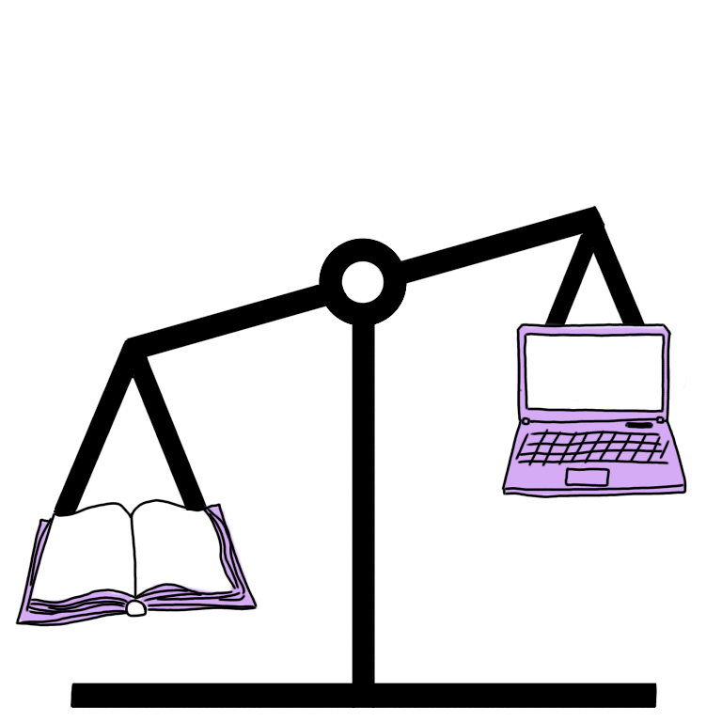

Figure 2. Preferred Learning Mode of Students

**Preferred Learning Mode.** After conducting the interview, the researchers found out that the preferred learning mode of most students is Traditional Learning. Having sixty percent (60%) of the responses choosing Traditional Learning and the remaining forty percent (40%) of course choose Online Learning. Most of the students prefer Traditional Learning because of the advantage it gives.

It is heavier than the advantage that Online Learning gives. Also, the disadvantage of Traditional Learning is less damaging than the disadvantage of Online Learning because in Online Learning the disadvantage is Poor Internet Connectivity which leads to the whole educational process to stop unlike in Traditional Learning, Distraction is the disadvantage. If distractions are fixed, the students can still learn.

**3.3 Factors that Affect the Students’ Preference**

For those students who chose **Traditional Learning**, the factor that affected their preference is having more **interaction.** This is supported by our Connectivism Theory which states that learning happens when connections are made. Since traditional learning involves face to face classes, interaction is done easier which leads to effective learning. The students can ask questions easier and receive faster feedback, the teachers can present their lessons clearly and faster.

While for those students who chose **Online Learning,** the factor that affected their preference is **convenience.** This is supported by our Behaviorism Theory which states that the environment of the learner has an impact on their behavior. Since they are at the comfort of their own homes, they are much likely to be comfortable with their environment. Thus, it makes learning effective.

**Chapter 4**

**CONCLUSIONS AND RECOMMENDATIONS**

**4.1 Conclusion**

The researchers conclude that more students prefer Traditional Learning more than Online learning. This is due to the Advantages and Disadvantages of the two learning modes. Most of the students prefer Traditional Learning because of the advantage it gives. It is heavier than the advantage that Online Learning gives. Also, the disadvantage of Traditional Learning is less damaging than the disadvantage of Online Learning because in Online Learning the disadvantage is Poor Internet Connectivity which leads to the whole educational process to stop unlike in Traditional Learning, distraction is the disadvantage. If distractions are fixed, the students can still learn.

There were also many factors affecting their preference. According to the summary, Percent of the students prefer Traditional Learning which result in percent who prefer Online Learning. Majority of the reason why students prefer Traditional Learning more is because the presence of Interaction both student to student and student to teacher is greatly present. Which also leads to better Understanding of lessons that results in effective learning. While for Online Learning, the students prefer it due to its Convenience which makes them comfortable and at ease. Lastly, the researchers can conclude that there are different factors that affect the students’ preference when it comes to learning.

**4.2 Recommendations**

The researchers recommend having this study conducted on a larger locale so that the preferences are not just limited to the students of Lorma Colleges Special Science High School. The researchers would like to recommend to the future researchers to have deeper understanding or study on this topic in order for other students to also benefit and put into the environment which they can learn more. Finally, the researchers would like to recommend to future researchers to study ways for the two learning modes to be more effective.

**REFERENCES**

Bhandar, Pritha (2020). What is Qualitative Research? referred June 19, 2020 from [https://www.scribbr.com/methodology/qualitative-research](https://www.scribbr.com/methodology/qualitative-research/)/

Brianna, Carey, et al. (2020). Shivangi Dhawan referred June 20, 2020 from https://journals.sagepub.com/doi/full/10.1177/0047239520934018

Caufield, J. (2019). How to do thematic analysis retrieved from https://www.scribbr.com/methodology/thematic-analysis/on December 8, 2019.

CNN Philippine Staff (2020). With the transition to online learning, students may not be given equal opportunity, educ stakeholders say retrieved from https://cnnphilippines.com/news/2020/6/6/internet-access-hinder-transition-to-online-learning.html

Daukilas, S., Kasperiuniene, J. (2015). PRINCIPLES OF CONNECTIVISM LEARNING THEORY IN INTERNATIONAL STUDIES retrieved from https://www.researchgate.net/publication/313887087_PRINCIPLES_OF_CONNECTIVISM_LEARNING_THEORY_IN_INTERNATIONAL_STUDIES

De, Barindra (2018). Traditional Learning Vs. Online Learning retrieved from <https://elearningindustry.com/traditional-learning-vs-online-learning>

Finney, D. referred May 2015 from https://scholarworks.csustan.edu/bitstream/handle/011235813/888/FinneyD%20Sp2015.pdf?sequence=1

Gaimaro, A. (2019). Self-Directed Learning Strategies in Educational Context retrieved from https://www.igi-global.com/chapter/designing-innovative-faculty-development-initiatives-through-the-lens-of-the-adult-learner/224472

McCombes, Shona (2019). Descriptive Research Design referred May 15, 2019 from https://www.scribbr.com/methodology/descriptive-research/#:~:text=Descriptive%20research%20aims%20to%20accurately,investigate%20one%20or%20more%20variables.

Muhajirah, M. (2020). International Journal of Asian Education retrieved from https://ijae.journal-asia.education/index.php/data/article/view/23

Muhammad A., Kainat A. (2020). Online learning amid the COVID-19 pandemic: Students' perspectives retrieved from https://files.eric.ed.gov/fulltext/ED606496.pdf

Paul, J., Jefferson, F. (2019). A Comparative Analysis of Student Performance in an Online vs. Face-to-Face Learning retrieved from https://www.frontiersin.org/articles/10.3389/fcomp.2019.00007/full

Porcalla, Delon (2020). Philippines internet ‘second slowest’ in Asean, ranks 110th worldwide referred December 28, 2020 from https://www.philstar.com/headlines/2020/12/28/2066612/philippines-internet-second-slowest-asean-ranks-110th-worldwide#:~:text=Philippines%20internet%20'second%20slowest'%20in,ranks%20110th%20worldwide%20%7C%20Philstar.com&text=A%20member%20of%20the%20House,and%20110th%20among%20139%20countries.

Tiley,C. (2017). Qualitative Research: What Is It And Why Should You Use It? referred December 08, 2019 from https://www.onepoll.com/qualitative-research-what-is-it-and-why-should-you-use-it/

Yang, K. (2020). Practical Approaches to Innovation in Higher Education retrieved from https://www.igi-global.com/chapter/what-can-college-teachers-learn-from-students-experiential-narratives-in-hybrid-courses/243330

|  |  |  |
| --- | --- | --- |
|  |  |  |
|  |  |  |
|  |  |  |
|  |  |  |
|  | | |