**teraevents.org**

Invitation Letter/ Invoice/ Memebrship (Tera in CAPS, Use Full Form)

Conference Reorder not working

Letter generator (yellow and green colour?)

Text Editor for posts and pages

Remove Membership Letter button from customer login

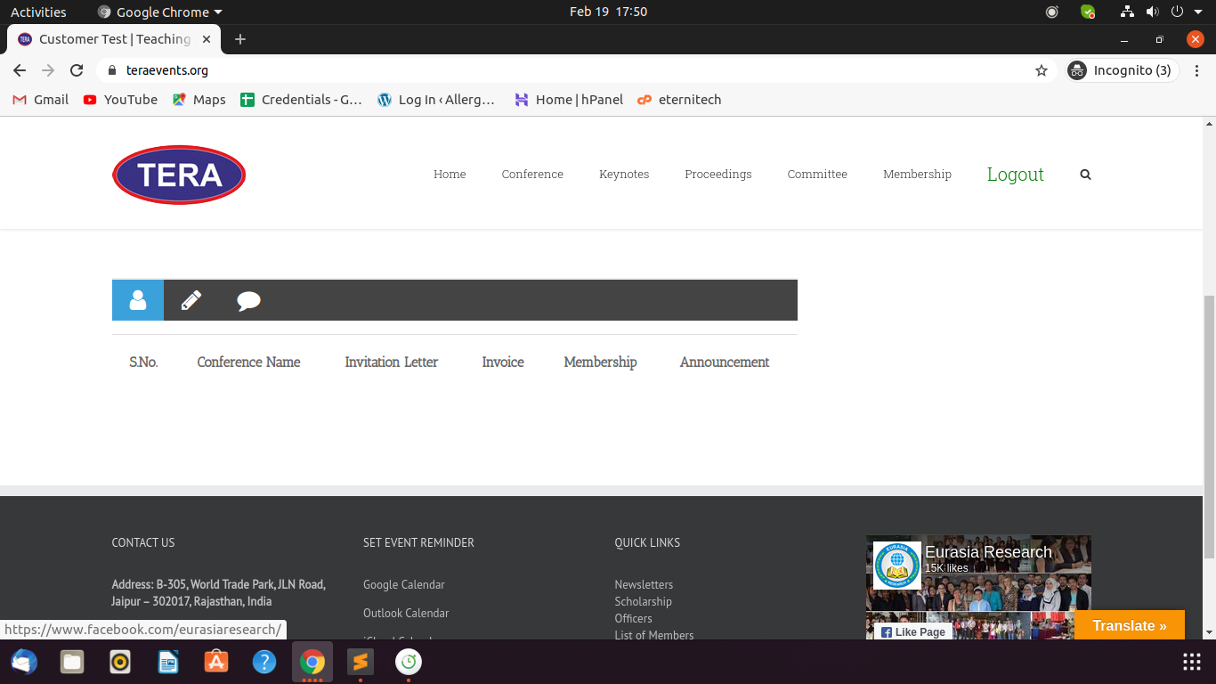

**sshraevents.org**

Conference front end: Name on top of banner

Letter generator (yellow and green colour?)

Text Editor for posts and pages

Remove Membership Letter button from customer login

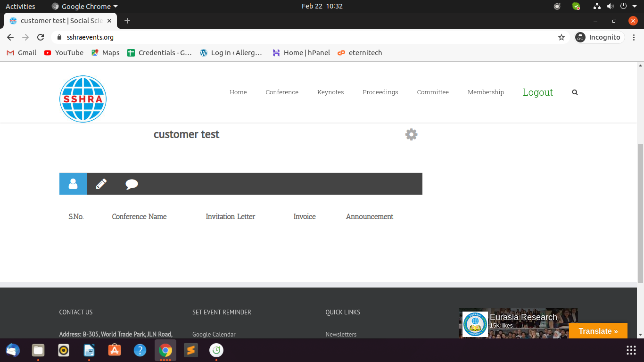

**icbellp.org**

Name not coming properly in banners

Reorder not working

Text Editor for posts and pages

Remove Membership Letter button from customer login

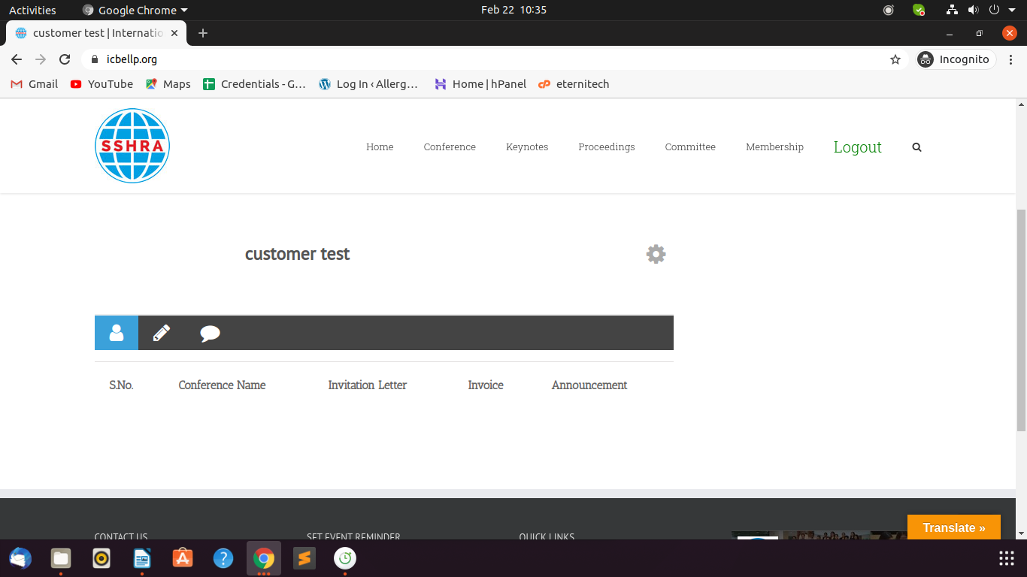

**straevents.org**

Text Editor for posts and pages

Remove Membership Letter button from customer login

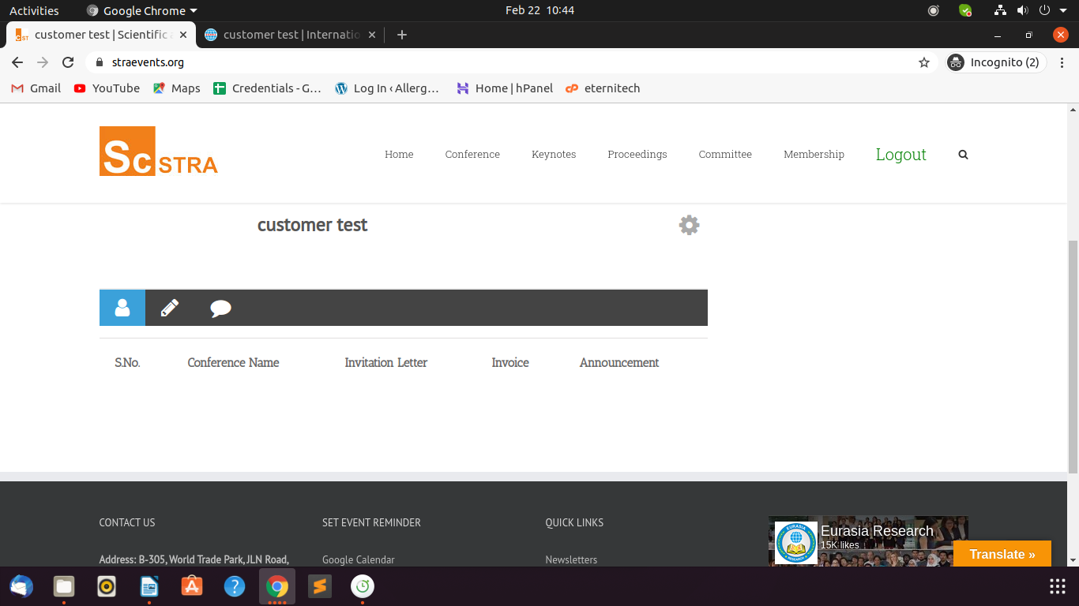

**hbsraevents.org**

Name not coming properly in banners

Letters Title wrong

Text Editor for posts and pages

Remove Membership Letter button from customer login

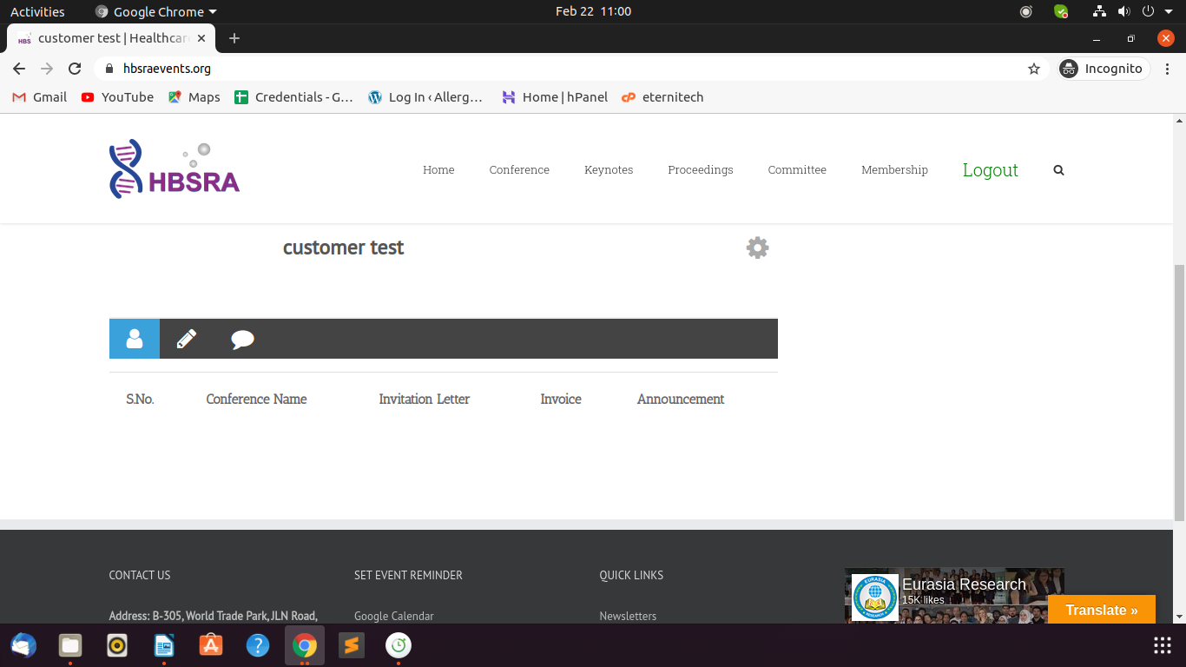

**teraweb.org**

Clone posts and pages

**sshraweb.org**

Text Editor for posts and pages

**straweb.org**

Website appearance (upcoming conference, newsletter, membership, list of keynotes, technical committee, officers) and Responsiveness

Text Editor for posts and pages

**hbsra.org**

Text Editor for posts and pages