**teraevents.org**

Invitation Letter/ Invoice/ Memebrship (Tera in CAPS, Use Full Form)

Conference Reorder not working: Now it is working.. please do not update the plugin

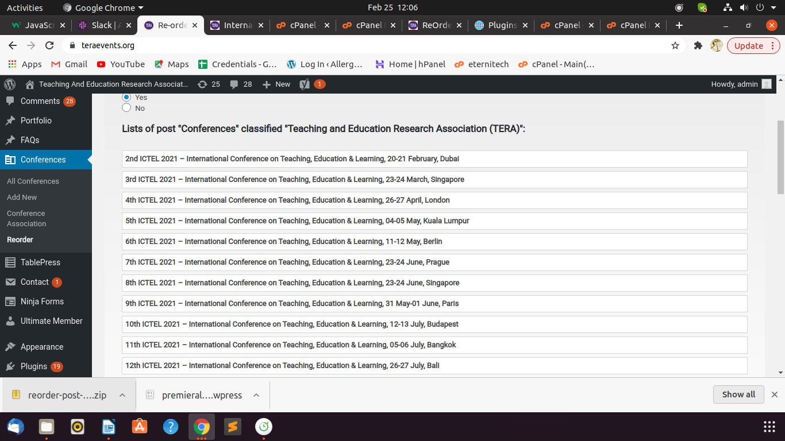

Letter generator (yellow and green colour?)

Text Editor for posts and pages

Remove Membership Letter button from customer login

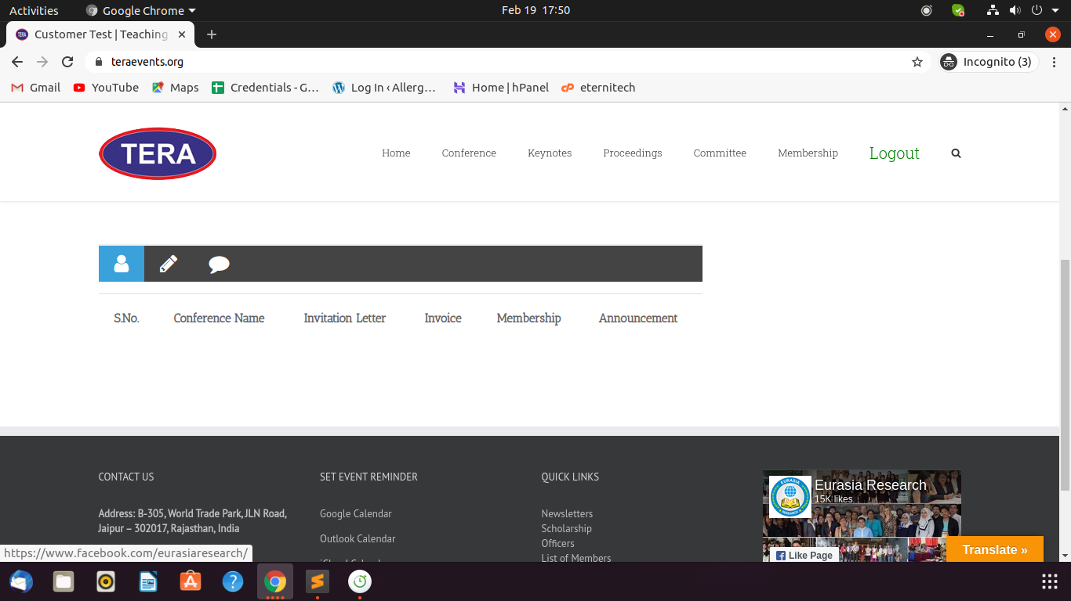

**sshraevents.org**

Conference front end: Name on top of banner

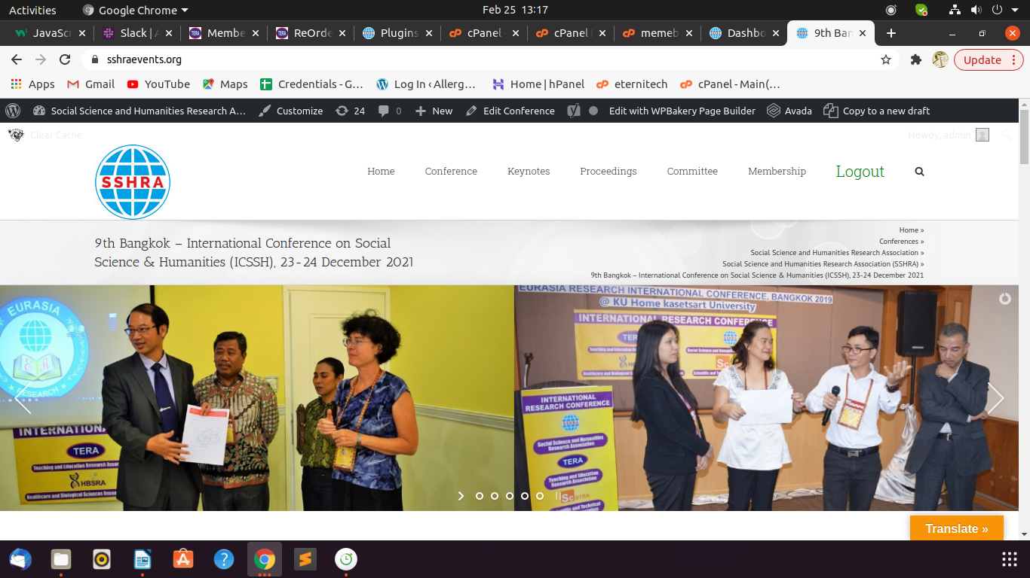

Letter generator (yellow and green colour?)

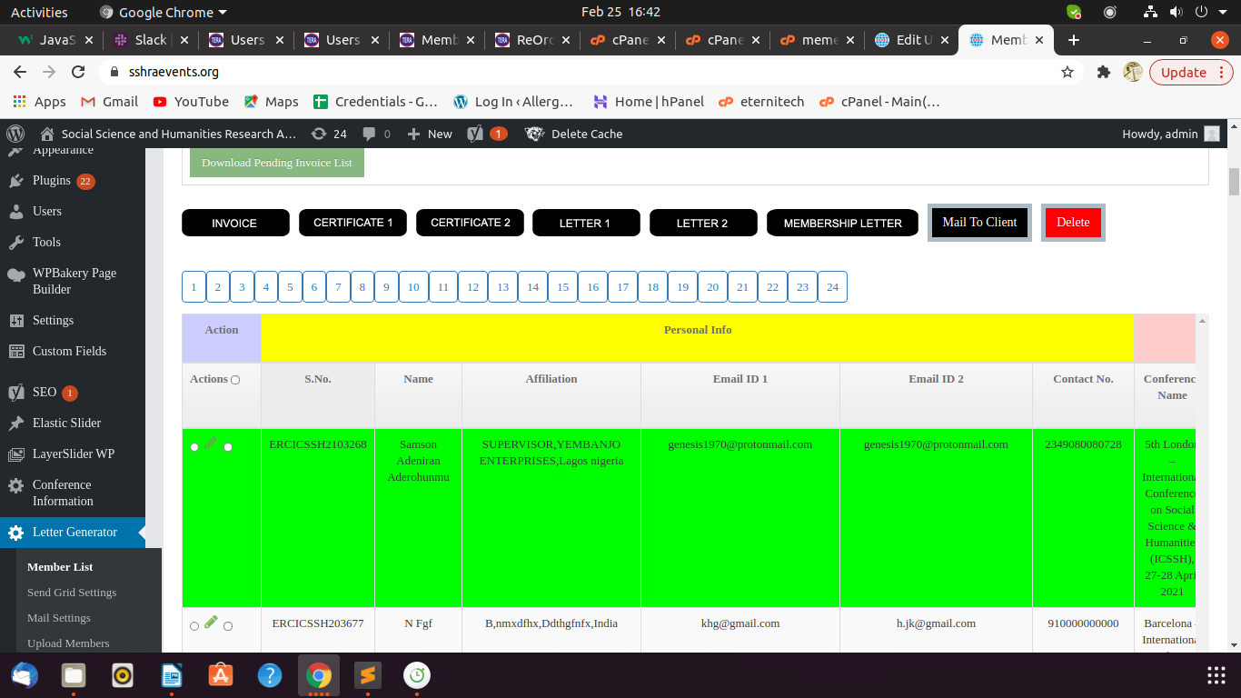

it is working now.

(when you send a mail to a user it becomes Orange and when user logs in and download the attachments entry changes from Orange color to Green color)

Text Editor for posts and pages

Remove Membership Letter button from customer login

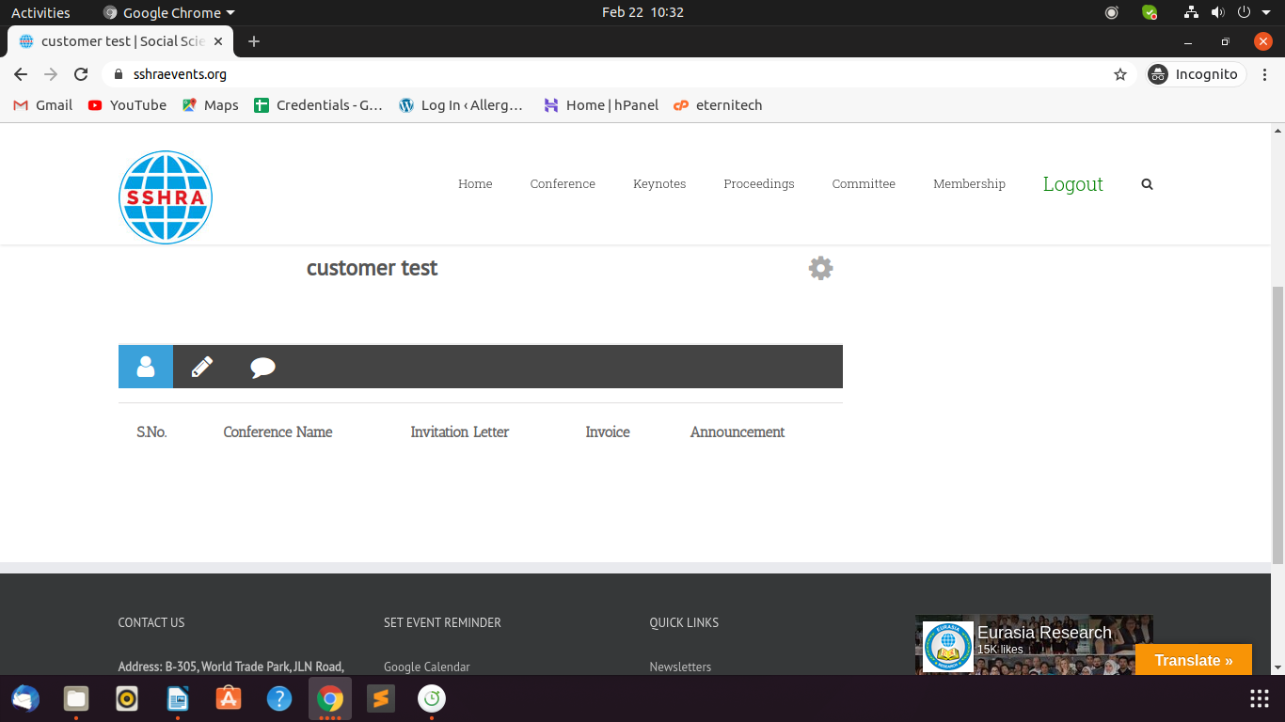

**icbellp.org**

Name not coming properly in banners

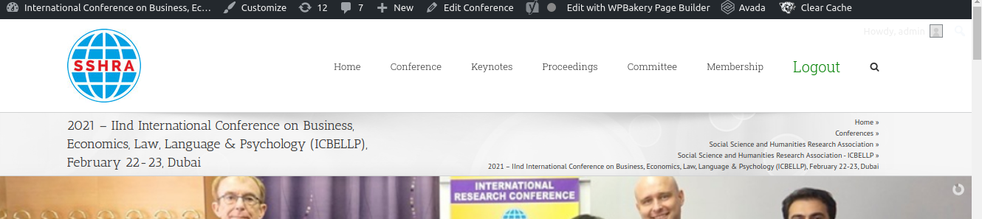

Reorder not working

Text Editor for posts and pages

Remove Membership Letter button from customer login

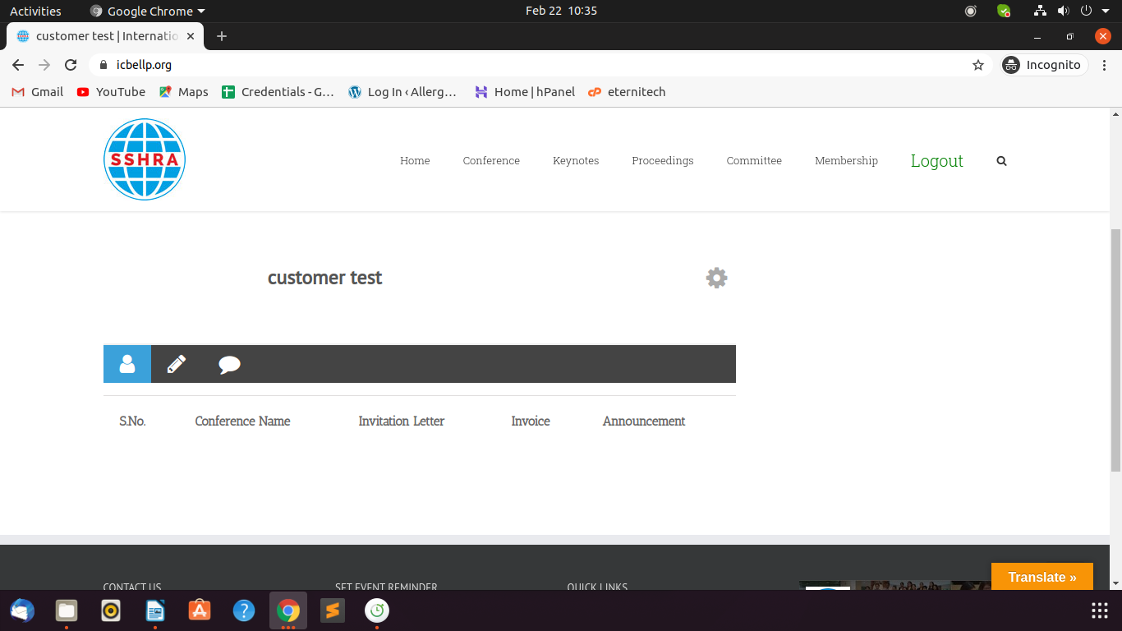

**straevents.org**

Text Editor for posts and pages

Remove Membership Letter button from customer login

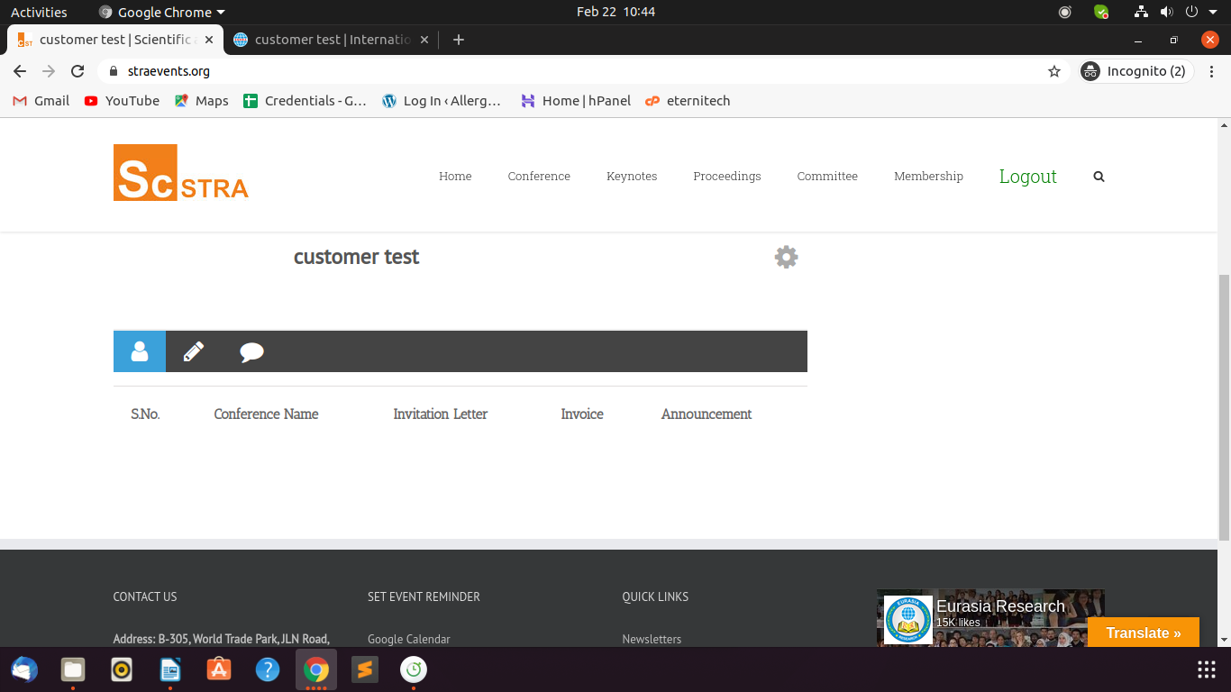

**hbsraevents.org**

Name not coming properly in banners

Letters Title wrong

Text Editor for posts and pages

Remove Membership Letter button from customer login

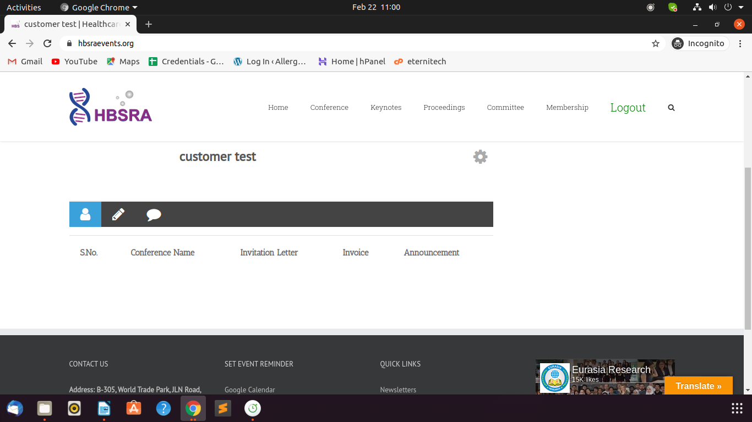

**teraweb.org**

Clone posts and pages

**sshraweb.org**

Text Editor for posts and pages

**straweb.org**

Website appearance (upcoming conference, newsletter, membership, list of keynotes, technical committee, officers) and Responsiveness

Text Editor for posts and pages

**hbsra.org**

Text Editor for posts and pages