teraevents.org
Invitation Letter/ Invoice/ Memebrship (Tera in CAPS, Use Full Form)
Conference Reorder not working: Now it is working.. please do not update the plugin
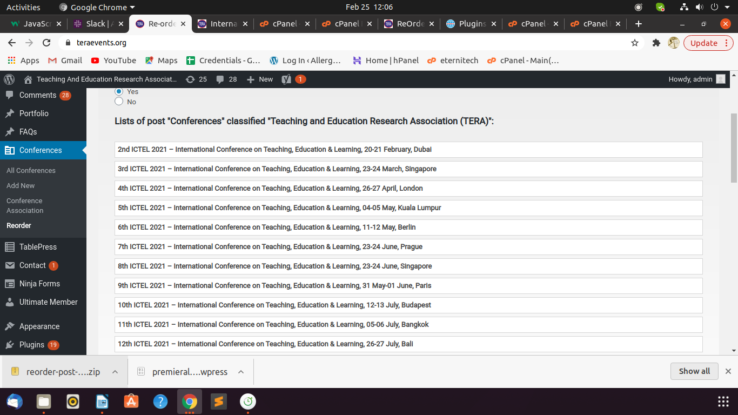

Letter generator (yellow and green colour?)
Text Editor for posts and pages
Remove Membership Letter button from customer login

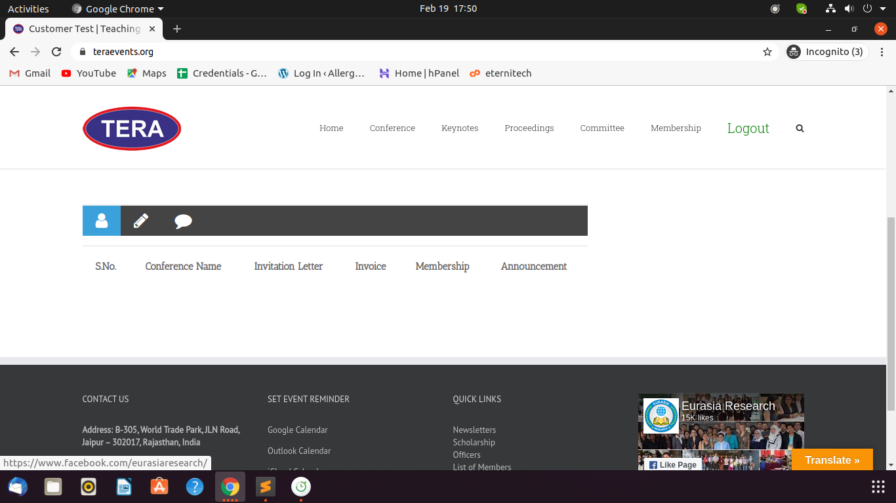

sshraevents.org

Conference front end: Name on top of banner

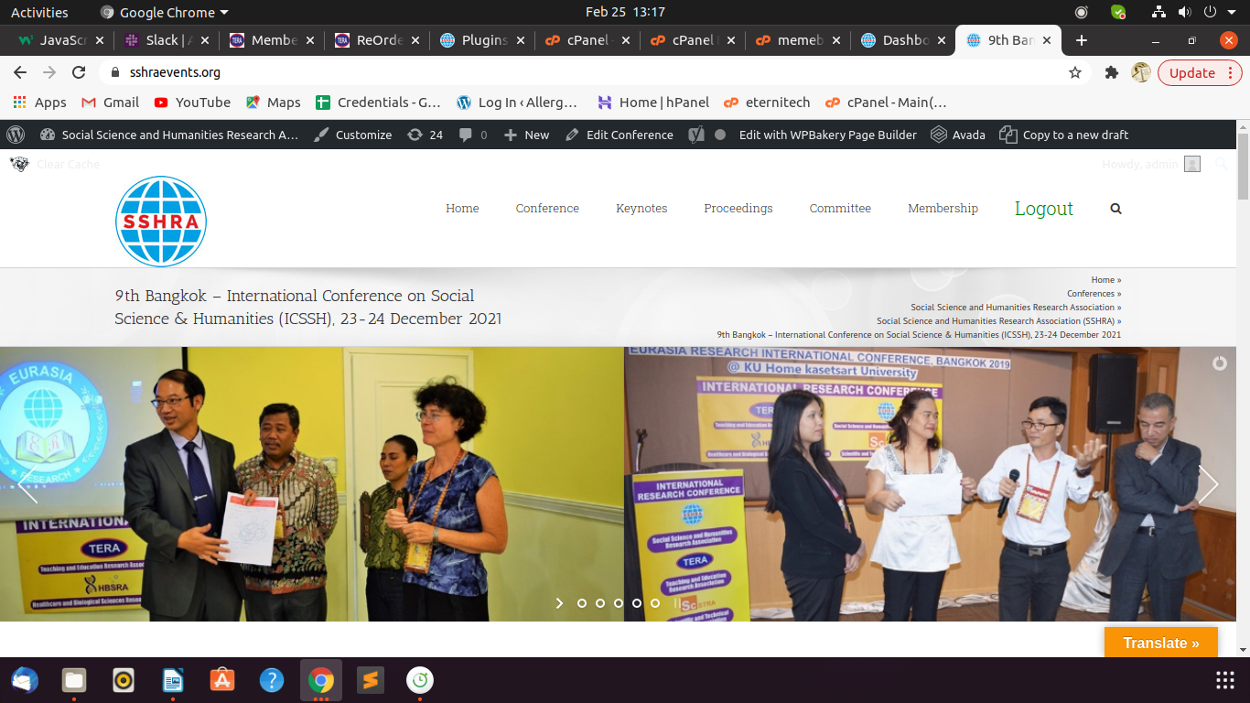

Letter generator (yellow and green colour?)

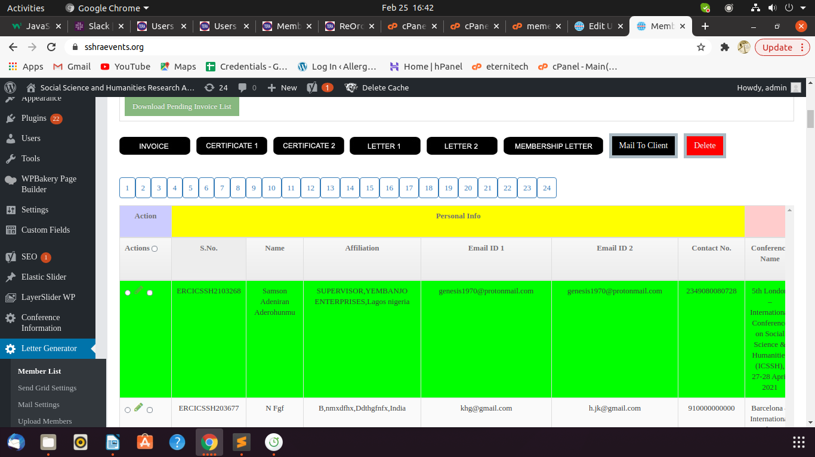

it is working now.
(when you send a mail to a user it becomes Orange and when user logs in and download the attachments entry changes from Orange color to Green color)

Text Editor for posts and pages
Remove Membership Letter button from customer login

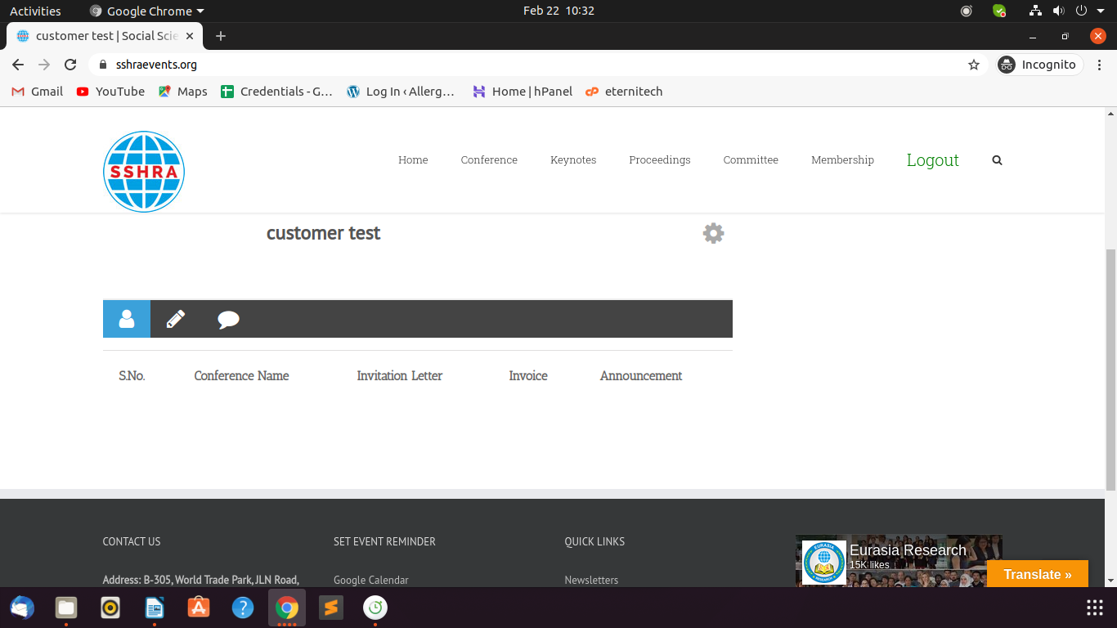

icbellp.org

Name not coming properly in banners
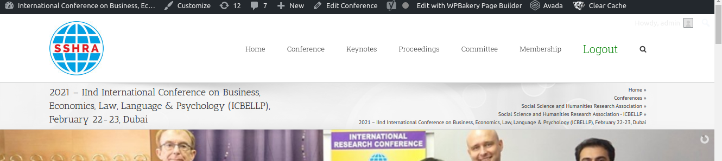

Reorder not working
Text Editor for posts and pages
Remove Membership Letter button from customer login
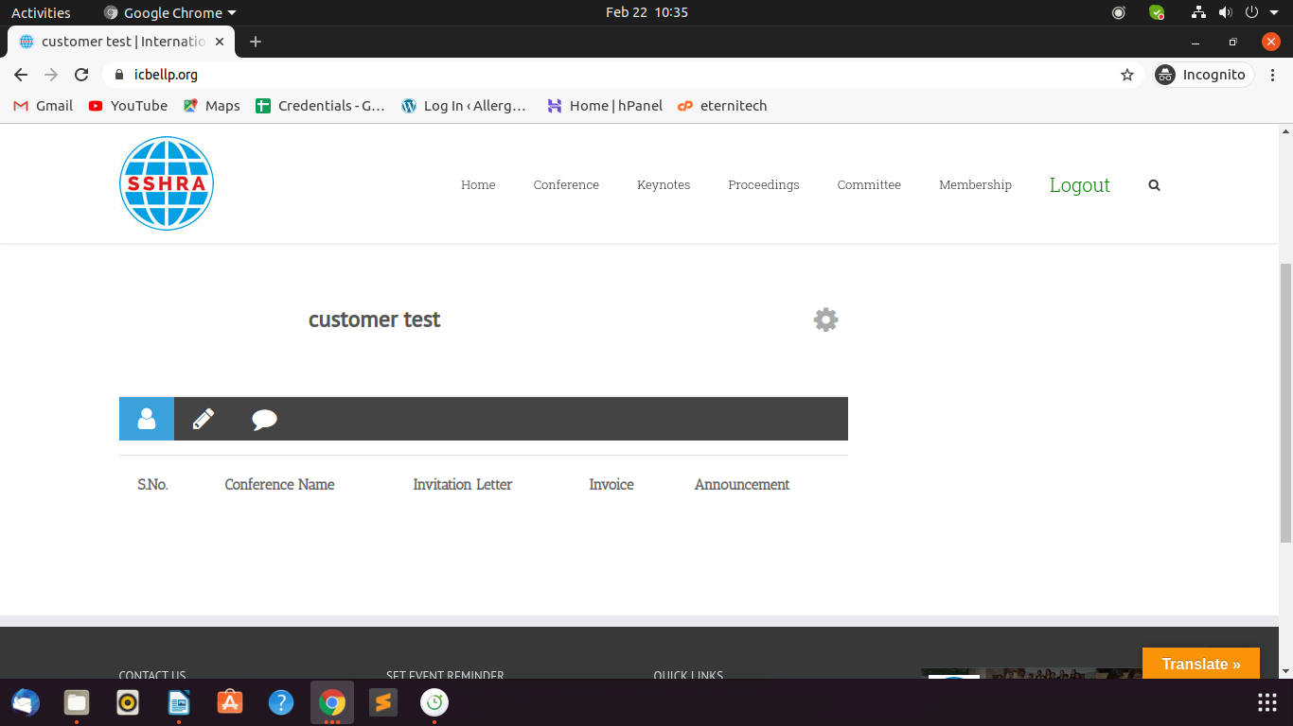

straevents.org

Text Editor for posts and pages
Remove Membership Letter button from customer login

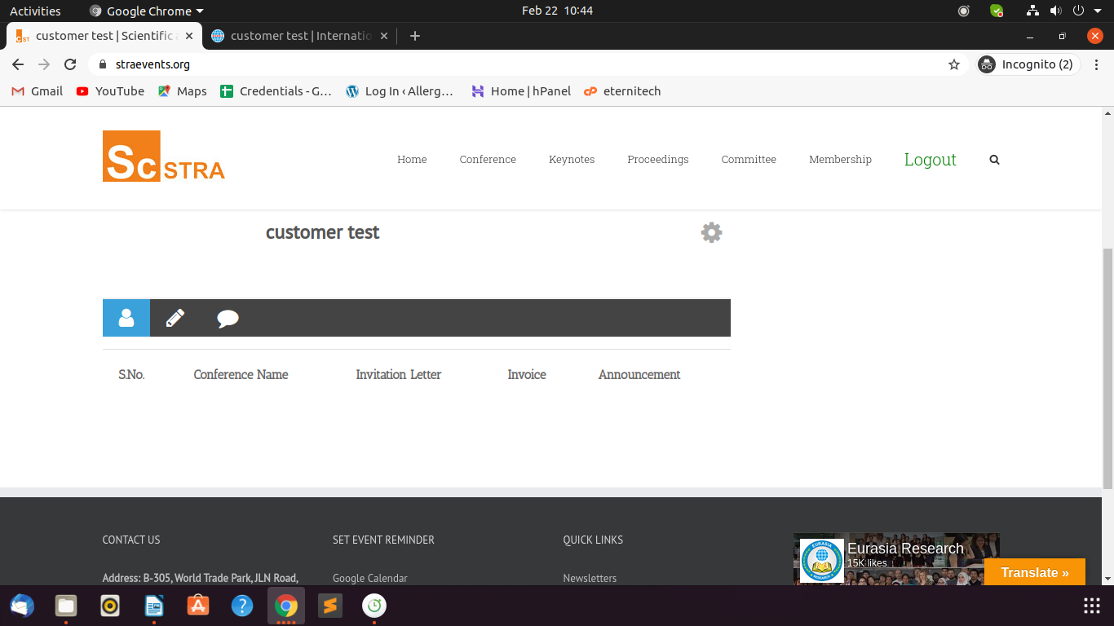

hbsraevents.org

Name not coming properly in banners
Letters Title wrong
Text Editor for posts and pages
Remove Membership Letter button from customer login

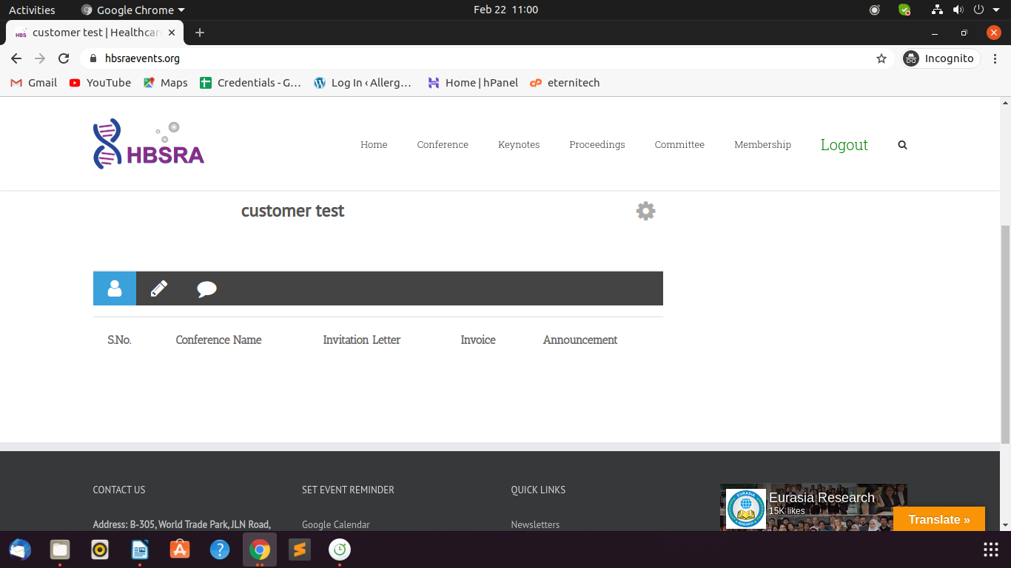

teraweb.org

Clone posts and pages

sshraweb.org

Text Editor for posts and pages

straweb.org

Website appearance (upcoming conference, newsletter, membership, list of keynotes, technical committee, officers) and Responsiveness

Text Editor for posts and pages

hbsra.org

Text Editor for posts and pages

