**AJCP** / Editorial

**Status of Histopathology Services in Ethiopia**

*Giorgis Okubazgi, PhD (c), ASCP, HTL,1 Bereket Berhane, MD,1 Mesfin Nigussie, MD,2 Aster Tsegaye, PhD,3 and Fatuma Hassen, PhD3*

From the 1St Paul Hospital Millennium Medical College, Addis Ababa, Ethiopia; 2International Clinical Laboratories, Addis Ababa, Ethiopia; and

3Addis Ababa University, Addis Ababa, Ethiopia.

**Key Words:** Histopathology; Cancer; Turnaround time

*Am J Clin Pathol* January 2020;153:3-4 DOI: 10.1093/AJCP/AQZ144

Downloaded from https://academic.oup.com/ajcp/article/153/1/3/5581862 by guest on 21 August 2021

Sub-Saharan Africa countries are the poorest nations in the world, while experiencing increasing numbers of cancer cases due to human immunodeficiency virus ep- idemic, growth and aging of the population, and adop- tion of westernized lifestyles. For patients throughout the region with cancer, the scarcity of histopathology serv- ices has often been an obstacle to receiving appropriate diagnosis and treatment. The lack of infrastructure along with lack of training for pathologists is further problems for delivery of the service in these countries. The availa- bility of pathologists in the region is typically less than one per million populations versus more than 60 per million populations in the United States.1-3

Ethiopia is one of the sub-Saharan African countries lo- cated in East Africa, with a population of about 102,403,196 (2016 estimate) and a geographical area of 1,127,127 km2. It is divided into nine federal regions and two city admin- istrations, and the capital is Addis Ababa. In Ethiopia, the incidence of cancer is increasing without an increase in his- topathology services. Here, the practice of cytopathology and fine-needle aspiration cytology started after the estab- lishment of the Department of Anatomic Pathology in Tikur Anbesa Hospital, Addis Ababa, in 1965.4

A cross-sectional study has been conducted to assess histopathology laboratory facilities in Ethiopia. A check- list was prepared to assess the location of the histopa- thology service, availability of equipment, number of professionals, and turnaround time in all regions and city administrations of Ethiopia.

There are 13 histopathology laboratories in the whole country, nine governmental and four private institutions

❚**Figure 1**❚. Of the 13 histopathology laboratories, seven are located in the capital, Addis Ababa. This indicates

* 1. % of all histopathology laboratories were concentrated in Addis Ababa, which contain an estimated population of 4 million. Six (46.2%) are spread in Tigray (1), Amhara (2), Oromia (2), SNNPR (1). However; there is no histopathology services in Afar, Somali, Benishangul-Gumuz, Harari, Gambella, and Dire Dawa city administration have no histopathology services where a population of 40,239,100 resides.

All histopathology laboratories possessed at least one functioning rotary microtome. Eleven labs (84.6%) had an automatic tissue processor, six (46%) had au- tomatic staining equipment but only two (15.2%) had automated mounting equipment; seven (53.8%) owned a cryostat. Five laboratories (38.5%) had no archival mechanism for slides and tissue blocks. When it comes to safe tissue grossing, the large majority of histopa- thology laboratories were found lacking; 11 (84.6%) of the laboratories lacked fume hoods for toxic chemicals in grossing.

As turnaround time (TAT) is one of quality indicators of the laboratory, it was assessed at all visited institutions. As a result, the shortest turnaround time for biopsy reporting was 7 days while the longest was 30 days. ❚**Figure 2**❚. There were 44 Pathologists responsible for the diagnosis of cancer and registered at the institutions assessed. There were also 38 Laboratory professionals active in the Anatomic pathology laboratory among them there were few (10) Histotechnicians/Histotechnologists with formal training of the profession.

Of the 13 assessed histopathology services, seven (53.8%) are located in the capital, Addis Ababa, whereas 80% of the population resides in the rural areas. This finding is in agreement with the study by Yeshi et al,4 which found that most of the service was delivered in urban areas while most of the population resides in rural areas. The same is true in the Sudan where 78.4% of pathologists were found to reside in Khartoum.1

The scarce and outmoded equipment, in addition to the lack of expertise for operation and maintenance,

© American Society for Clinical Pathology, 2019. All rights reserved. For permissions, please e-mail: [journals.permissions@oup.com](mailto:journals.permissions@oup.com)

**Okbazgi et al** / HistopatHology services in etHiopia



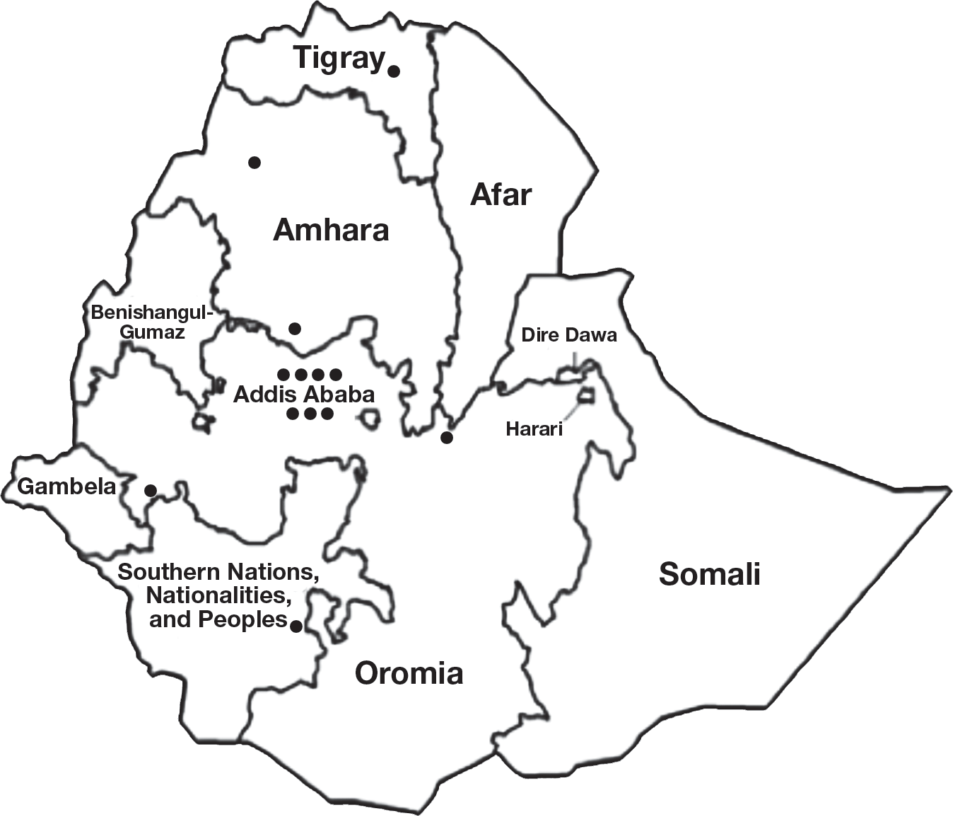❚**Figure 1**❚ A map of Ethiopia; black circles indicate the loca- tion of currently available histopathology services.

has resulted in an inadequate histopathology service in Ethiopia. For instance, in Gambi General Hospital there is only one outmoded microtome and other tasks are done manually. The majority of the institutions do not utilize a cryostat due to either installation prob- lems or lack of training, or both. Most of the cryo- stats are donations and training was not included with

❚**Figure 2**❚ The turnaround time at assessed institutions. Turnaround time was not assessed at the Ethiopian Public Health Institute because it is a research center. AFGH, Ethiopian Armed Forces General Hospital; AGHMC, Adama General Hospital and Medical College; AHRI, Armauer Hansen Research Institute, Armed Forces General Hospital; ASUH, Ayder Specialized University Hospital; GGH, Gambi General Hospital; GUH, Gondar University Hospital; HUH, Hawassa University Hospital; ICL, International Clinical Laboratories; JUSH, Jimma University Specialized Hospital; KGH, Kadisco General Hospital; P, Public; Pt, Private; SPHMMC, St Paul Hospital Millennium Medical College; TASUH, Tikur Anbessa Specialized University Hospital.

inpatient ward. This may result in lengthy delays in the therapeutic management of the disease as well as unnec- essary expense for the patient.

Downloaded from https://academic.oup.com/ajcp/article/153/1/3/5581862 by guest on 21 August 2021

the gift. Contributions from donors are gratefully

received, but the cryostats may be left idle for many years. Our findings are in agreement with the study by Benediktsson et al5 in Uganda, which described the donation of a tissue processor whose manual was written in a language not understood by the histology technicians. As a result, the machine was left idle for 3 years. Another study from Afghanistan, by Deck,6 reported that a set of histopathology equipment was left for more than 1 year without installation because no instructions or assistance to set it up had been pro- vided with the equipment.2

The average turnaround time for surgical pathology samples was 15.9 days in our survey, whereas the UK Royal College of Pathologists recommended that histo- pathology diagnostic biopsy turnaround time is within 7 days. This is found to be a great problem for patients travelling long distances from rural areas. Patients are forced to wait for the report from the histopathology lab- oratory, even after they have been discharged from the

*Corresponding author: Giorgis Okubazgi, MSc, HTL(ASCP);* [*georgeokb@gmail.com.*](mailto:georgeokb@gmail.com)

**References**

* + 1. Awadelkarim K, Mohamedani AA, Barberis M. Role of pa- thology in Sub-Saharan Africa: an example from Sudan. *Pathol Lab Med Int.* 2010;2:49-57.
    2. Okesina AB. Pathology in West Africa: problems of training and practice. *Bull Royal Coll Pathol.* 2009;148:306-308.
    3. Gopal S, Krysiak R, Liomba NG, et al. Early experience after developing a pathology laboratory in Malawi, with emphasis on cancer diagnoses. *PloS One.* 2013;8:e70361.
    4. Yeshi MM, Tambouret RH, Brachtel EF. Fine-needle aspiration cytology in Ethiopia. *Arch Pathol Lab Med.* 2013;137:791-797.
    5. Benediktsson H, Whitelaw J, Roy I. Pathology services in developing countries: a challenge. *Arch Path Lab Med*. 2007;131:1636-1639.
    6. Deck JH. The face of pathology in Afghanistan in 2006-2007.

*Arch Pathol Lab Med.* 2011;135:179-182.

**4** *Am J Clin Pathol* 2020;153:3-4

DOI: 10.1093/ajcp/aqz144

© American Society for Clinical Pathology