*Author Name et al.*

*Vol. m, No.n, pp. a-b (to be filled by editorial desk)*

*Date of Publication: (to be filled by editorial desk)*

*DOI: (to be filled by editorial desk)*

*This paper can be cited as: (to be filled by editorial desk)*

*This work is licensed under the Creative Commons Attribution-NonCommercial 4.0 International License. To view a copy of this license, visit http://creativecommons.org/licenses/by-nc/4.0/ or send a letter to Creative Commons, PO Box 1866, Mountain View, CA 94042, USA.*

**Risk factors of flatfoot in children：A systematic review and meta analysis**

**MA. Liya Xu**

*Faculty* *of Sports and Human Sciences, Beijing Sports University, Beijing, China, 100084*

**MA. Hongyi Gu**

*Faculty* *of Sports and Human Sciences, Beijing Sports University, Beijing, China, 100084*

**Prof. Yimin Zhang**

*China Institute of sports and health, Beijing Sports University, Beijing, China, 100084*

**MA. Tingting Sun**

*China Institute of sports and health, Beijing Sports University, Beijing, China, 100084*

**Abstract**

***Purpose:*** *To explore the risk factors of flat feet in children and adolescents, so as to provide reference basis for the study of foot growth and development in children and adolescents.* ***Method:*** *The cross-sectional research literature on children with flatfoot published at home and abroad from 2001 to 2021 in five electronic databases: PubMed, Web of Science, EBSCO sportfocus, CNKI China HowNet and Wanfang Data knowledge service platform were searched. Two researchers independently searched the literature according to the inclusion and exclusion criteria to evaluate the literature quality of the selected research, Finally, 20 literatures were included. After extracting relevant data, use review Manager5 4.1 software, and analyze the detection rate and risk factors of children's flat feet.* ***Result:*** *A total of 20 studies were included for meta-analysis. The total number of respondents was 23289, and the survey sites involved 13 countries around the world; A total of 8165 children with flatfoot symptoms were detected, and the total detection rate of flatfoot was 35.1%. The results of meta-analysis showed that male gender (or = 1.46) and young age (or = 2.87) were the risk factors for the occurrence of children's flatfoot; age growth [e.g. 9 years old (or = 0.62) and 12 years old (or = 0.44)] were the protective factors for the occurrence of children's flatfoot.* ***Conclusion:*** *The detection rate of flat feet in children and adolescents is high. Boys and young age are the risk factors of flat feet in children and adolescents, and age growth is the protective factor of flat feet in children and adolescents.*

**Keywords (Font-12 Bold)**

Flatfoot， Children，Risk factors，Meta analysis

**1. Introduction**

Flatfeet are characterized by the collapse or over flattening of the medial longitudinal arch of the foot. Children's flat feet are very common in clinic. Generally, they are physiological, manifested as flexible flat feet, which is not a disease. Most of the symptoms will gradually improve with the increase of age(Živković, et al. 2018). Most studies believe that the formation of flatfoot is related to the collapse of medial longitudinal arch caused by abnormal foot bone structure or muscle ligament relaxation. However, in addition to the reasons of physiological structure, there are many external factors affecting the occurrence of flatfoot in children(喻祝仙, et al. 2002). Parents are very concerned about the causes of children's flat feet. They worry that some flat feet will be prone to fatigue or pain, and then whether they will develop into pathological flat feet. Although some cross-sectional surveys have been conducted to study the relevant influencing factors of flatfoot in children, the sample size is small, the research results are uneven, and the accuracy of most studies due to the influence of various confounding factors remains to be discussed. This study is to search the literature published at home and abroad on the related factors of children's flatfoot from 2001 to 2021, evaluate the relevant literature by meta-analysis, and explore the risk factors of children's flatfoot, so as to form an overall understanding and analyze it in combination with foreign studies, so as to provide reference basis for the study of children's foot growth and development, Looking for the direction of further research will provide useful help for the formation of clinical guidelines in the future. To study the nutritional health of consumers.

**2. Method**

**2.1 Literature Search**

The research on risk factors of children's flatfoot published in PubMed, web of science, EBSCO sportfocus, CNKI China HowNet and Wanfang Data knowledge service platform at home and abroad was retrieved. The retrieval time limit was from January 1, 2001 to March 1, 2021 (Table 1).

**Table 1:** *Literature retrieval formula*

|  |  |
| --- | --- |
| **Database** | **Literature retrieval formula** |
| CNKI（n=175） | 主题=“儿童”＋“青少年”AND主题=“足型”+“足弓”+“扁平足”AND主题=“影响因素”+“相关因素” |
| Wanfang（n=382） | (主题:(“儿童”OR“青少年”) and 主题:(“足弓”OR“足型”OR“扁平足”) and 主题:(“影响因素”OR“相关因素”)) and Date:2001-2021 |
| Web of Science（n=507） | #1:TS=children* OR TS=teenagers* OR TS=（“preschool child”)* OR TS=adolescent*  #2:TS=（“arch of foot”）OR TS=（“flatfoot”）OR TS=（“foot style”） OR TS=（“Pes Planus”）  #3:TS=（“influence factors”）OR TS=（“related factors”）#1 AND #2 AND #3 |
| Pubmed（n=230） | ("children"[Title/Abstract] OR "teenager"[Title/Abstract] OR "adolescent"[Title/Abstract]) AND ("arch of foot"[Title/Abstract] OR "flatfoot"[Title/Abstract] OR "foot style"[Title/Abstract] OR " Pes Planus "[Title/Abstract] OR " influence factors "[Title/Abstract] OR " related factors "[Title/Abstract]) |
| EBSCO-SPORTDiscus  （n=23） | #S1：SU"arch of foot" OR SU "flatfoot" OR SU "foot style" OR SU "strephexopodia" OR SU "strephenopodia" OR SU "High arched foot" OR SU "talipes cavus"  #S2：SU"children" OR SU "teenager" OR SU "adolescent"  #S3：SU"related factors" OR SU "influence factors"  #S1 AND #S2 AND #S3 |

**2.2 Inclusion and Exclusion Criteria**

The literature on risk factors of children's flat feet published at home and abroad from January 1, 2001 to March 1, 2021 were selected. The inclusion and exclusion criteria are formulated with reference to the Pecos principles of Cochrane Library (Table 2).

**Table 2:** *Inclusion and exclusion criteria*

|  |  |
| --- | --- |
| **Inclusion** | **exclusion** |
| children（age ≤ 18 years） | adult（sge > 18） |
| a clear definition standard of flatfoot | pathological flatfoot population (spastic flatfoot, rigid flatfoot) |
| the original data are complete, and the detection rate of flatfoot can be extracted | people with severe pain or inflammatory reaction (such as arthritis) |
| cross sectional study | in addition to cross-sectional case-control studies and cohort studies |

**2.3 Literature Screening and Data Extraction**

Follow Cochrane system evaluator manual 4.2 As for the method of research selection in version 2, the retrieval results of different databases are imported into the document management software endnote x9. The retrieval process is carried out independently by two researchers. The results are cross checked. If differences cannot be resolved, the third researcher will rule. Firstly, by reading the title and abstract of the literature, the literature that obviously does not meet the inclusion criteria is excluded; The remaining literatures were read and screened again to determine the literatures that finally met the inclusion and exclusion criteria. Extract the following information or data included in the study: first author, publication time, region, sample size, detection rate, risk factors, etc. In addition, data extraction includes reporting research results and their related statistical significance.

**2.4 Document Quality Evaluation**

The quality evaluation of each selected literature was completed independently by two researchers, The quality evaluation method uses the cross-sectional research quality evaluation scale of the agency for health care research and quality (AHRQ)(曾宪涛, et al. 2012), which has 11 items in total. If the answer to the scale is "no" or "unclear", 0 point is calculated as "yes" 1 point. Documents with 0-3 points are of low quality, documents with 4-7 points are of medium quality, and documents with 8-11 points are of high quality. Only studies with a score of 4 or more were included in the meta-analysis.

**2.5 Statistical Method**

Using Review Manager 5.4 software for statistical analysis, and the effect quantity was described by the or value of risk factors of children's flatfoot and its *95%CI*. The heterogeneity of the included literature was tested. When *P ≥ 0.1* and *I2 < 50%*, there was no significant statistical heterogeneity. The fixed effect model was used; *P < 0.1*, *I2 ≥ 50%* suggested statistical heterogeneity. Random effect model was used for combined analysis; Sensitivity analysis was carried out by comparing the differences between fixed effect model and random effect model; Publication bias was assessed by funnel plot.

**3. Result**

**3.1 Basic Characteristics of Included Literature**

1251 literatures were obtained through preliminary search. After preliminary screening of title, abstract and full text, Finally, 20 literatures were included (the screening process is shown in Figure 1). All literatures were cross-sectional studies, including 4 Chinese literatures and 16 English literatures. The cumulative number of respondents was 23289, and the survey sites involved 13 countries around the world. A total of 8165 children with flat foot symptoms were detected, and the total detection rate of flat foot was 35.1%. Among the 20 literatures, 17 were of medium quality and 3 were of high quality. (Table 4)

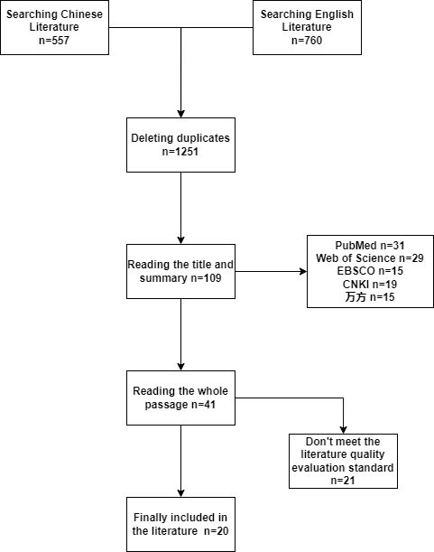

**Figure 1:** *Document screening flow chart*

**Table 3:** *Basic information of included literature*

|  |  |  |  |  |  |  |  |
| --- | --- | --- | --- | --- | --- | --- | --- |
| **Number** | **Author** | **Year** | **Country** | **Sample size** | **Detection rate** | **Research factors** | **Research factors** |
| 1(Stavlas, et al. 2005) | Panagiotis Stavlas | 2005 | Greece | 5866 | 4.4% | Gender, age, joint relaxation | 6 |
| 2(Pfeiffer, et al. 2006) | Martin Pfeiffer | 2006 | Greece | 835 | 44% | Gender, age, BMI | 6 |
| 3(张丽华 2007) | 张丽华 | 2007 | china | 1629 | 41.9% | Gender, age | 4 |
| 4(Adoracion Villarroya, et al. 2008) | M.ADORACIO´N VILLARROYA | 2008 | Spain | 245 | 30.6% | Gender, BMI, exercise level | 4 |
| 5(Twomey, et al. 2010) | D. Twomey | 2010 | Australia | 52 | 51.9% | Gender | 4 |
| 6(Abolarin, et al. 2011) | Temilola Abolarin | 2011 | Nigeria | 560 | 24.7% | Gender, age, shoe type, region | 6 |
| 7(Chen, et al. 2011) | Kun-Chung Chen | 2011 | china | 2638 | 44% | age | 7 |
| 8(Chang, et al. 2014) | Chia-Hsieh Chang | 2014 | china | 1228 | 45.3% | Gender, age, BMI | 8 |
| 9(Chen, et al. 2014) | Kun-Chung Chen | 2014 | china | 484 | 48.5% | Gender, age, BMI, Joint relaxation and movement time | 8 |
| 10(Galli, et al. 2014) | M. Galli | 2014 | Italy | 140 | 88% | Joint relaxation | 4 |
| 11(Jolanta Pauk 2014) | Jolanta Pauk | 2014 | poland | 75 | 56% | Gender, exercise time, school type | 4 |
| 12(Evans and Karimi 2015) | Angela Margaret Evans | 2015 | Australia | 728 | 40% | Age, BMI, region | 4 |
| 13(Yuto tashiro 2015) | Yuto tashiro | 2015 | Japan | 619 | 17.8% | Gender , age | 7 |
| 14(乐 2016) | 韩珵琨 | 2016 | china | 23 | 69.6% | nothing | 4 |
| 15(Drefus, et al. 2017) | Lisa C. Drefus | 2017 | America | 60 | 55% | nothing | 4 |
| 16(韩炳善，袁媛 2019) | 韩炳善 | 2019 | china | 3074 | 59.98% | Gender , age | 7 |
| 17(Abich, et al. 2020) | Yohannes Abich | 2020 | Ethiopia | 823 | 17.6% | Gender, age, school type, BMI, shoe type, exercise time | 8 |
| 18(Fuentes-Venado, et al. 2020) | Fuentes-Venado, Claudia E. | 2020 | Mexico | 367 | 57.7% | Age, BMI | 4 |
| 19(钟雨婷，吕婧仪，陈天午，姜方宜，陈俊，陈世益 2020) | 钟雨婷 | 2020 | china | 3226 | 56.1% | Gender, age, BMI | 7 |
| 20(Anna Boryczka-Trefler;Małgorzata Kalinowska 2021) | Anna Boryczka-Trefler | 2021 | poland | 50 | 56% | age | 6 |

**3.2 Meta analysis results**

According to the heterogeneity test results in Table 4, gender, age of 12, age of 17, BMI, joint relaxation, shoe type, school type There was significant heterogeneity among the literatures on the related factors of exercise level (P < 0.1), so the random effect model was used to merge the effect quantities; there was no significant heterogeneity among the literatures on the related factors of age 3, age 9 and region (P > 0.1), so the fixed effect model was used to combine the effect quantities. The meta-analysis results showed that male students, age of 3 years, joint relaxation, wearing sports shoes and urban children were the risk factors for detecting flatfoot; age of 9 years, 12 years, 17 years and exercise time greater than 180 minutes a week were the protective factors for detecting flatfoot. Except for gender, age and BMI In addition to the standard, there are few literatures included in other indicators, so generally speaking, boys and age of 3 years old are the risk factors for detecting flat feet in children; The age of 9 and 12 is the protective factor for children to detect flatfoot. See Fig. 2-6 for the heterogeneity analysis of each index.

**Table 4:** *Meta analysis of risk factors of flatfoot in children*

|  |  |  |  |  |  |  |  |
| --- | --- | --- | --- | --- | --- | --- | --- |
| **Related factors** |  | **Control factor** | **Included number** | **Heterogeneity test** | | **Effect model** | **OR（95%CI）** |
| **I2** | **P** |
| Gender | boy | girl | 12 | 70% | <0.001 | random | 1.46[1.26,1.70] |
| Age | 3 | 6 | 7 | 0% | 0.77 | fixed | 2.87[2.54,3.25] |
| 9 | 5 | 43% | 0.14 | fixed | 0.62[0.50,0.77] |
| 12 | 6 | 76% | <0.001 | random | 0.44[0.28,0.69] |
| 17 | 2 | 87% | 0.006 | random | 0.27[0.09,0.80] |
| BMI | 18.5-23.9 | <18.5 or >23.9 | 7 | 93% | <0.001 | random | 0.85[0.56,1.28] |
| Joint relaxation | positive | negative | 2 | 89% | 0.002 | random | 4.82[1.19,19.41] |
| Shoe shape | sneakers | other | 2 | 85% | 0.01 | random | 2.97 [1.46, 6.03] |
| Region | city | countryside | 2 | 0% | 0.61 | fixed | 2.10 [1.66, 2.64] |
| School type | public | private | 2 | 87% | 0.005 | random | 0.27 [0.06, 1.37] |
| Exercise time | long-time (>180min/week) | Short-time  (<180min/week) | 3 | 81% | 0.006 | random | 0.25 [0.08, 0.80] |

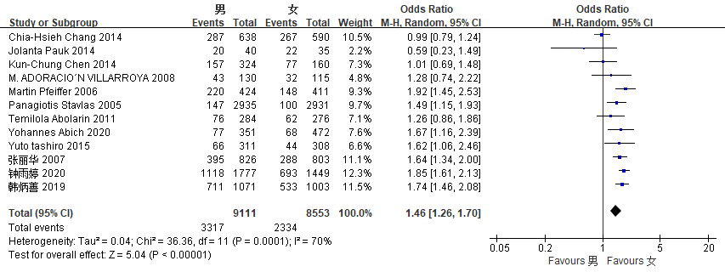

**Figure 2:** *Heterogeneity analysis of gender indicators*

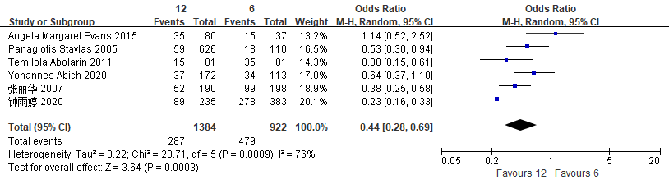

**Figure 3:** *Heterogeneity analysis of indicators aged 12 years*

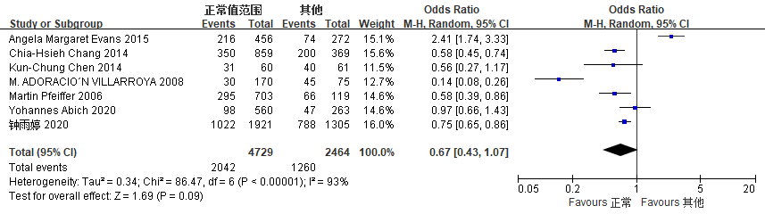

**Figure 4:** *Heterogeneity analysis of BMI indicators*

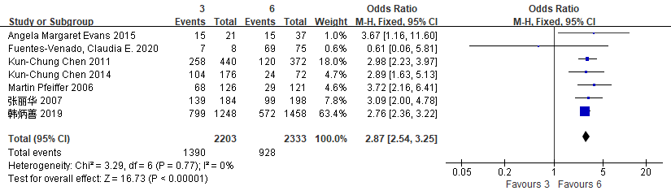

**Figure 5:** *Heterogeneity analysis of indicators aged 3 years*

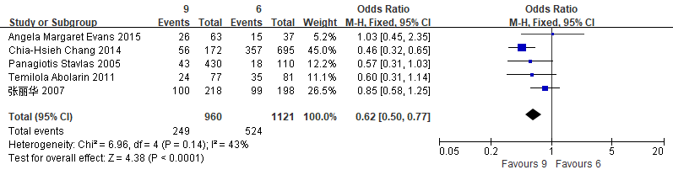

**Figure 6:** *Heterogeneity analysis of indicators aged 9 years*

**3.3 Sensitivity Analysis**

For the nine factors included, fixed effect model and random effect model are used for sensitivity analysis. It can be seen from Table 5 that the or value *(95% CI)* results of the two effect models are relatively close, and *I2* is the same. It seems that the meta-analysis of this study is stable.

**Table 5:** *Sensitivity analysis of related factors of flatfoot in children*

|  |  |  |  |  |
| --- | --- | --- | --- | --- |
| **Related factors** | **Fixed effect model** | | **Random effect model** | |
| **I2** | **OR（95%CI）** | **I2** | **OR（95%CI）** |
| Boy | 70% | 1.57 [1.46, 1.68] | 70% | 1.46[1.26,1.70] |
| 3 years | 0% | 2.87[2.54,3.25] | 0% | 2.87 [2.53, 3.24] |
| 9 years | 43% | 0.62[0.50,0.77] | 43% | 0.64 [0.47, 0.87] |
| 12 years | 76% | 0.38 [0.31, 0.46] | 76% | 0.44[0.28,0.69] |
| 17 years | 87% | 0.37 [0.26, 0.52] | 87% | 0.27[0.09,0.80] |
| Joint relaxation | 89% | 7.84 [6.05, 10.16] | 89% | 4.82[1.19,19.41] |
| Shoe shape | 85% | 2.98 [2.27, 3.91] | 85% | 2.97 [1.46, 6.03] |
| Region | 0% | 2.10 [1.66, 2.64] | 0% | 2.10 [1.67, 2.64] |
| Exercise time | 81% | 0.34 [0.21, 0.55] | 81% | 0.25 [0.08, 0.80] |

**3.4 Publication bias assessment**

It can be seen from table 2 that there are ≥ 7 literatures included in the three related factors of gender, age 3 years and BMI, which can be used to evaluate the publication bias. Figure 7 shows that the points of the funnel diagram of three factors are almost evenly distributed on both sides of the axis, indicating that the literature included in this study is less likely to have publication bias, and the results are more reliable.

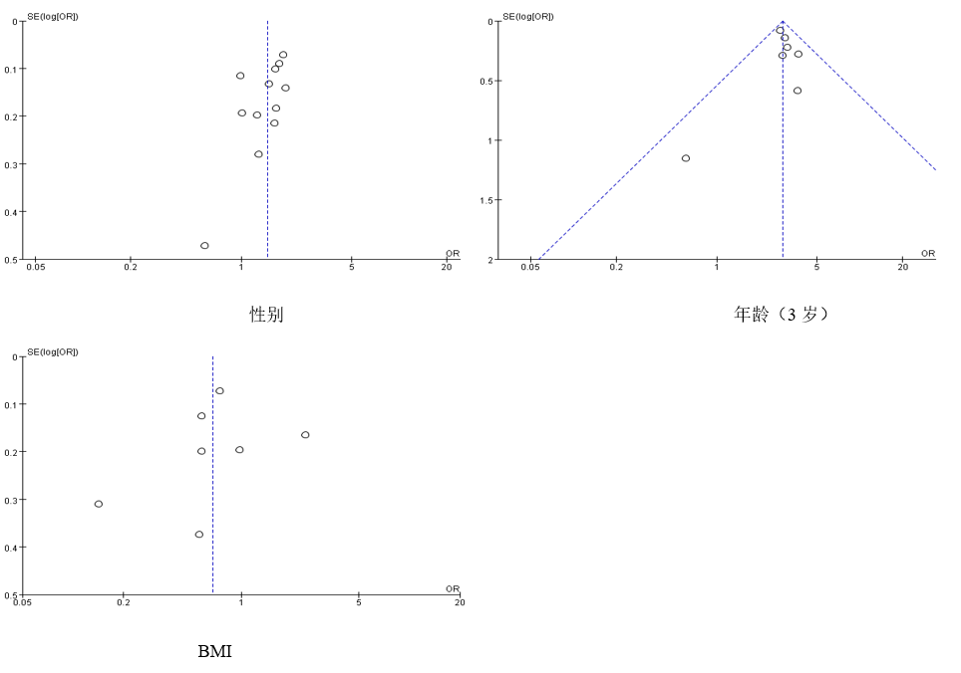

**Figure 7:** *Funnel diagram*

**4. Discuss**

Children are born with mild dorsiflexion and valgus, and almost all infants are flat feet due to immature physiological development. With the gradual growth and development, the plantar fat gradually disappeared, the valgus decreased, and the longitudinal and transverse arches of the foot began to be significant(聪 2018). Children and adolescents are in a critical period of growth and development, and preschool is the main stage of foot arch development. If the abnormal arch persists, or there are complications such as pain and bone deformity, it will seriously affect their health-related quality of life(曾岚 2020). The epidemiological incidence rate of flat foot is different from that of the domestic and foreign, but it is considered that the flat foot of children will be improved with age(Chen, et al. 2014). Flatfoot in children and adolescents will lead to obvious symptoms, damage health-related quality of life, affect lower limb biomechanics and increase the risk of lower limb injury. Flatfoot will reduce the dorsal flexion of the back of the foot relative to the tibia, increase the abduction of the front of the foot, and lead to the dynamic changes of knee and hip joints in children and adolescents. Therefore, children with flatfoot often have lower limb pain(Zukauskas, et al. 2021). This study collates the relevant literature at home and abroad in recent years, in order to explore the relevant factors of flat feet in children and adolescents, and provide reference basis for the study of foot growth and development in children and adolescents. The results of meta-analysis showed that gender, male, age of 3 years, joint relaxation, wearing sports shoes and city were the risk factors of flat feet in children and adolescents; The protective factors of flatfoot in children and adolescents were 9 years old, 12 years old, 17 years old and exercise time more than 180 minutes a week. In addition to the three indicators of gender, age and BMI, the other indicators are less included in the literature, so generally speaking, boys and age of 3 years are the risk factors for flat feet in children and adolescents; The age of 9 and 12 is the protective factor for children and adolescents to detect flat feet.

Although this study strictly followed the inclusion and exclusion criteria to screen the relevant literature for meta-analysis, there are still some limitations. The sample size of the original research literature of this study is quite different, and the research assumptions and analysis methods included in the study are also different, which has a certain impact on the research results; All the literatures included in this study are cross-sectional studies, which mainly compare and analyze the detection rate and related factors of flat feet in children and adolescents, but do not include some prospective cohort studies and case-control studies, and the investigation and analysis of related factors are not comprehensive enough; The occurrence of flatfoot is affected by internal factors (age, gender, nutritional status, genetics, race, development differences) and other external factors (shoe type, environmental conditions and physical activities). This study does not separate the external and internal factors affecting flatfoot, which will also have a certain impact on the results.

The healthy development of foot arch is very important in the critical period of growth and development of children and adolescents. Moderate physical activity is an important part of the four health cornerstones proposed by the World Health Organization. In 2018, China's first physical activity guide for children and adolescents was officially released. The main target population of this guide is healthy children and adolescents aged 6-17. It is the first time to put forward the recommended amount of daily physical activities for Chinese children and adolescents: children and adolescents should carry out medium and high-intensity physical activities for at least 60 minutes a day, including high-intensity physical activities for at least 3 days a week and resistance activities to enhance muscle strength and bone health. Proper physical activity is helpful to the development of foot arch and reduce the incidence of flat foot. Parents should choose suitable shoes for their children and help their children control their weight within the normal range during the critical period of foot arch development of children and adolescents. According to the results of this study, aiming at the foot arch development of children and adolescents, we should start from both internal and external factors, encourage children and adolescents to carry out appropriate jumping training to promote foot development, increase the opportunity of barefoot walking, and avoid excessive weight-bearing and sitting for a long time; However, in physical exercise, pay attention to avoid items that have a strong impact on the arch of the foot to prevent foot injury. Some children with symptomatic flat feet can also choose appropriate arch pads to adjust the plantar pressure distribution. The prevention of flatfoot is better than treatment. Only by clarifying the causes of flatfoot and distinguishing its risk factors and protective factors, can we more effectively carry out the research on the foot arch health of children and adolescents, reduce the occurrence of flatfoot, and provide a reference basis for the research outline of foot growth and development of children and adolescents.

**5. Discuss**

Through meta-analysis, the detection rate of flat feet in children at home and abroad in recent 20 years is high, which is 35.1%. Boys and young age are the risk factors of flat feet in children, and age growth is the protective factor of flat feet in children and adolescents.

**REFERENCES**

Abich, Yohannes, et al.

2020 Flatfoot and associated factors among Ethiopian school children aged 11 to 15 years: A school-based study. Plos One 15(8).

Abolarin, T., et al.

2011 Predictive factors for flatfoot: The role of age and footwear in children in urban and rural communities in South West Nigeria. Foot (Edinb) 21(4):188-92.

Adoracion Villarroya, M., et al.

2008 Foot structure in overweight and obese children. Int J Pediatr Obes 3(1):39-45.

Anna Boryczka-Trefler;Małgorzata Kalinowska

2021 How to Define Pediatric Flatfoot Comparison of 2 Methods: Foot Posture in Static and Dynamic Conditions in Children 5 to 9 Years Old. Foot Ankle Spec.

Chang, C. H., et al.

2014 Flatfoot diagnosis by a unique bimodal distribution of footprint index in children. PLoS One 9(12):e115808.

Chen, Kun-Chung, et al.

2014 An investigation of the factors affecting flatfoot in children with delayed motor development. Research in Developmental Disabilities 35(3):639-645.

Chen, Kun-Chung, et al.

2011 Footprint analysis of flatfoot in preschool-aged children. European Journal of Pediatrics 170(5):611-617.

Drefus, Lisa C., et al.

2017 Reliability of the Arch Height Index as a Measure of Foot Structure in Children. Pediatric Physical Therapy 29(1):83-88.

Evans, A. M., and L. Karimi

2015 The relationship between paediatric foot posture and body mass index: do heavier children really have flatter feet? J Foot Ankle Res 8:46.

Fuentes-Venado, Claudia E., et al.

2020 Evaluación comparativa del pie plano en preescolares. Boletín médico del Hospital Infantil de México 77(6):312-319.

Galli, M., et al.

2014 The effects of low arched feet on foot rotation during gait in children with Down syndrome. Journal of Intellectual Disability Research 58(8):758-764.

Jolanta Pauk, PhD

2014 Assessing Plantar Pressure Distribution in Children with Flatfoot Arch. ORIGINAL ARTICLES.

Pfeiffer, M., et al.

2006 Prevalence of flat foot in preschool-aged children. Pediatrics 118(2):634-9.

Stavlas, P., et al.

2005 The evolution of foot morphology in children between 6 and 17 years of age: a cross-sectional study based on footprints in a Mediterranean population. J Foot Ankle Surg 44(6):424-8.

Twomey, D., et al.

2010 Kinematic differences between normal and low arched feet in children using the Heidelberg foot measurement method. Gait Posture 32(1):1-5.

Yuto tashiro, RPT

2015 Children with flat feet have weaker toe grip strength than those having a normal arch. ORIGINAL ARTICLES.

Živković, Dobrica, Slađan Karaleić, and Ivana Anđelković

2018 FLAT FEET AND OBESITY AMONG CHILDREN. / RAVNO STOPALO I GOJAZNOST KOD DECE. Facta Universitatis: Series Physical Education & Sport 16(2):347-358.

Zukauskas, Saidas, Vidmantas Barauskas, and Emilis Cekanauskas

2021 Comparison of multiple flatfoot indicators in 5-8-year-old children. Open Medicine 16(1):246-256.

曾岚

2020 长沙市3～6岁学龄前儿童足姿指数的横断面研究 硕士, 南华大学.

曾宪涛, et al.

2012 Meta分析系列之四:观察性研究的质量评价工具. 中国循证心血管医学杂志 4(04):297-299.

聪, 郭 朋，罗

2018 儿童扁平足病因、检测方法和治疗现状. 医学信息.

韩炳善，袁媛

2019 西安市 2 074 名学龄前儿童扁平足发生情况. 中国学校卫生.

乐, 韩珵琨， 弓太生， 李 方， 白

2016 6～10岁儿童扁平足基本参数的测量与分析. 技术.

喻祝仙, et al.

2002 扁平足的检测与康复训练. 中国临床康复 6(3):407-407.

张丽华, 回俊岭, 陈树君,夏凤岐,隋月林,赵文涛

2007 沧州市1 629名儿童青少年足弓发育状况. 中国学校卫生.

钟雨婷，吕婧仪，陈天午，姜方宜，陈俊，陈世益

2020 上海市学龄儿童足弓指数及扁平足的流行病学研究. 中国学校卫生