Abstract— This article describes how foreign direct investment in Mongolia has changed in last ten years also how it’s effects GDP. Even though FDI into Mongolia has been grown along with the country's economic development with trade openness to the world, a few studies have used regression analysis to analyze determinant factors of FDI. This paper studies the effect of foreign direct investment on economic growth in Mongolia also to suggest the effects that develop Mongolian economy through the foreign direct investment.
Exploring the Effects of Foreign Direct Investment Growth in Mongolia
Narantuya Purevjav
Institute of Education and Economic Research
Ioeer.mng@gmail.com

INTRODUCTION
Foreign Direct investment (FDI) is one of the most crucial part of global economy also it is an investment which made by a firm or individual in one country into business interests located in another country. (Chen, 2021) In other words, FDI takes place when an investor establishes foreign business operations or acquires foreign business assets in a foreign company. An increasing share of flows directed towards developing countries (al, 1996) largely took the form of foreign direct investment (FDI) rather than portfolio or equity flows. When 10% or more investment is received from an overseas investor intending to manage the firm, it is known as FDI. (World Bank, 1992)
The financial system enhances the efficient allocation of resources and in this sense, it improves the absorptive capacity of a country with respect to FDI inflows. A more developed system may contribute to the process of technological diffusion associated with FDI.
Foreign direct investment has been the engine of Mongolian economic growth and is highly dependent on commodity prices., FDI flows to Mongolia amounted to USD 2,4 billion in 2019, up from USD 2,2 billion in 2018 (+12,4%), mostly due to continued large mining projects, especially the Oyu Tolgoi copper-gold mine. The total FDI reached USD 22,6 billion in 2019. Mongolia's main investment partners are China, Canada, Russia, Great Britain, and the United States. The sectors attracting the most foreign investment are mining, oil, and construction.

Mongolia is ranked 81st on the World Bank’s list, losing 7 spots compared to the previous year. The country made some progress with regards to resolving insolvency, but other countries have shown a better improvement in the business environment. (UNCTAD, 2021)
Mongolia is a small country with a vulnerable economy that is directly dependent on the external environment. Between the two great powers, far from the sea, in unfavorable geographical, natural and climatic conditions, with a small economy based on the export of a small number of products and a small population, external factors, foreign investment, aid and current economic development responsible for deciding. This is one of the important factors for further reforming the economic structure of our country and its participation in the international labor schedule. (Mehmet Demirbag, 2005)
The three main factors for Mongolia's development are:
a) natural resources.
b) population.
c) foreign direct investment. The comparative advantages of the Mongolian economy are natural resources, agriculture, and primarily livestock products.
This paper argues that the development of the financial system of the recipient country is an important precondition for FDI to have a positive impact on economic growth. The main contribution of this paper is to investigate empirically the role the development of the financial system plays in enhancing the positive relationship between FDI and economic growth of Mongolia.

LITERATURE REVIEW

There is a massive literature emphasizing the nice effect FDI may also have on monetary increase. Next to the direct boom of capital formation of the recipient economy, FDI may additionally assist growing increase via way of means of introducing new technology, together with new manufacturing procedures and techniques, managerial abilities, ideas, and new types of capital items.
The subsequent query is what situations within side the host u. s. is crucial to maximize the generation spillovers mentioned above? In the literature it's been emphasized via way of means of a few that the spillover impact can best achieve success given sure traits of the surroundings within side the host. Some authors argue that the adoption of latest technology and control abilities calls for inputs from the exertions force. High-degree capital items want to be blended with exertions which could apprehend and paintings with the brand-new generation.
According to Nekipelov (2011), monetary increase is dynamics of the extent of very last items and services (“mixture product”) produced all through a particular time unit. There are one-of-a-kind standards of monetary increase and methods of measuring it, however the center definition is in phrases of increase in the end efficient ability of the economy, normally measured via way of means of actual increase in Gross Domestic Product. (Susilo, 2018)
According to Kuznets (1934), GDP may be decided in 3 methods, all of which should, in principle, supply the equal result. They are the product (or output) technique, the earnings technique, and the expenditure technique. Expenditure technique is taken on this study via way of means of attention that FDI because the item of this research is measured as gross investment from foreign places this is calculated in bask of expenditure approached GDP. [Susilo, 2018]
Borensztein (1998) helps those ideas, thinking about FDI as methods of attaining generation spillovers, with more contribution to the financial boom than could have country wide investments. The significance of generation switch is highlighted additionally with the aid of using Findlay who believes that FDI results in a spillover of superior technology to nearby markets. [Alfar, Chanda, Kalemli-Ozcan, & Sayek, 2006]

DATA AND METHODOLOGY OF EMPIRICAL ANALYSIS

Foreign direct investment (FDI) plays a critical role in bridging wealthy and poor economies
and in transferring capital, knowledge, ideas, and value systems across borders and
nations. Data on FDI are provided by several sources, such as Balance of Payments Statistics Yearbook and International Finance Statistics by the International Monetary Fund (IMF), European Union Direct Investment Yearbook by EUROSTAT, World Investment Report by UNCTAD, World Development Indicators by the World Bank, and International Direct Investment Statistics Yearbook by OECD.
UNCTAD data on FDI inflows and outflows contains capital provided —directly or via other related enterprises— by a far-off direct investor to a FDI enterprise (inflows), or capital received by a foreign direct investor from a FDI enterprise (outflows). FDI includes three components: equity capital, reinvested earnings and intra-company loans with explanation as follows (UNCTAD, 2012):
1. Equity capital is the foreign direct investor's purchase of shares in an enterprise in a country other than that of its residence.
2. Reinvested earnings are the direct investor's share (in proportion to direct equity participation) of earnings not distributed as dividends by affiliates or earnings not remitted to the direct investor. Those profits retained by affiliates are reinvested.
3. Intra-company loans or intra-company debt transactions are short- or long-term borrowing and lending of funds between direct investors (parent enterprises) and affiliate enterprises.
Mongolia presents an interesting example as one of the poorest transition economies, largely isolated from external sources of financial and human capital,2 and with virtually no historical experience of capitalism. (Anderson, 2000) It does, however, have an advantageous location between the two large emerging markets of China and the Russian Federation, and possesses extensive and largely untapped mineral resources.

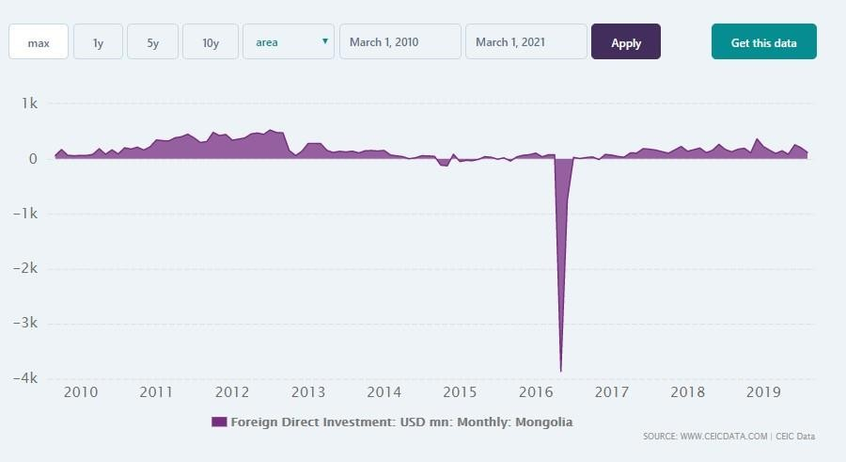

Mongolia Foreign Direct Investment (FDI) increased by 317.1 USD in Mar 2021, compared with a rise of 100.2 USD within the previous month. Mongolia Foreign Direct Investment:
USD net flows data is updated monthly, available from Jan 2009 to Mar 2021. the
info reached an all-time high of 524.0 USD in Jul 2012 and a record low of -3.9 USD in May 2016. The Bank of Mongolia provides monthly Foreign Direct Investment in USD. In the latest reports of Mongolia, accounting recorded a deficit of 82.2 USD in Mar 2021. Mongolia Direct Investment Abroad expanded by 2.4 USD in Mar 2021. Its Foreign Portfolio Investment increased by 26.8 USD in Mar 2021. The country's Nominal GDP was reported at 3.7 USD bn in Dec 2020. [CEIC, 2021]
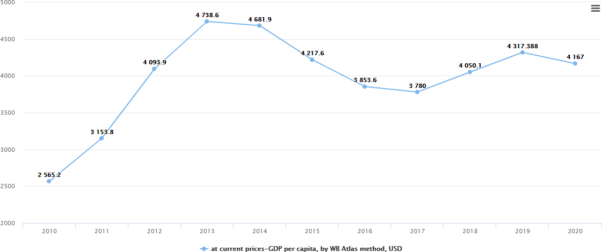
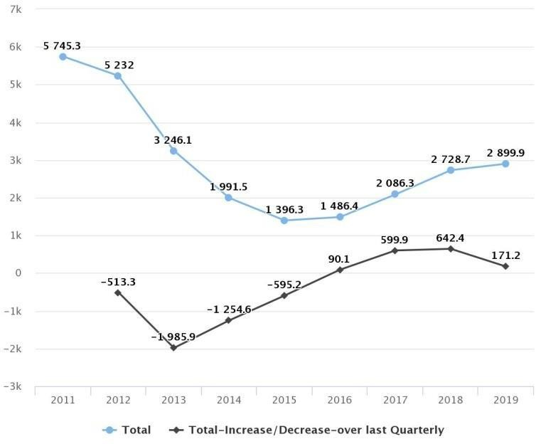
figure 2
figure 2

RESULTS OF THE EMPIRICAL ANALYSIS

The figure 2 shows that GDP of Mongolia through 2010-2020. In 2010, the GDP of Mongolia was 2562.2$ and the next three years its increased to 4738.6$. However, GDP decreased to 3780$ in next 4 years. After that GDP increased to 4317.6$ until 2019. In 2020, GDP was decreased by little 4167$.
Also, the figure 3 shows FDI inflows with increase/decrease rate in Mongolia during the last decade. The FDI inflow in 2011 was $5745,3 and decreased to $5232 in 2012.The next three years it went on decreasing rapidly and it increased to $1486.4 in the year 2016. In the next three years 2017-2019 FDI equity inflow increased quite little. The FDI equity inflow increased to $2086.3 2017. In 2018 FDI equity inflow increased to $2728.7. In 2019 the FDI inflow increased a little to $2899.9. [UNCTAD, 2021]

Country Comparison for the Protection of Investors

Table (UNCTAD, 2021) 1 | Mongolia | East Asia & Pacific | United States | Germany
Index of Transaction Transparency* | 6.0 | 5.0 | 7.4 | 5.0
Index of Manager’s Responsibility** | 8.0 | 5.0 | 8.6 | 5.0
Index of Shareholders’ Power*** | 8.0 | 6.0 | 9.0 | 5.0

Country Comparison for Corporate Taxation

 | Mongolia | East Asia & Pacific | United States | Germany
Number of Payments of Taxes per Year | 19.0 | 22.9 | 10.6 | 9.0
Time Taken for Administrative Formalities (Hours) | 134.0 | 198.0 | 175.0 | 218.0
Total Share of Taxes (% of Profit) | 24.7 | 33.9 | 43.8 | 49.0
Table 2 (UNCTAD, 2021)

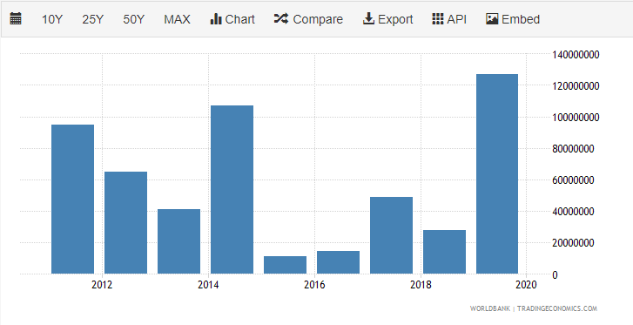
figure 4

Foreign direct investment refers to direct investment equity flows in an economy. it’s the sum of equity capital, reinvestment of earnings, and other capital. Direct investment may be a category of cross-border investment related to a resident in one economy having control or a big degree of influence on the management of an enterprise that's resident in another economy. Ownership of 10 percent or more of the standard shares of stock is that the criterion for determining the existence of an immediate investment relationship. This series shows net outflows of investment from the reporting economy to the remainder of the planet. Data are in current U.S. dollars. [Trending Economics, 2021]

CONCLUSION AND SUGGESTION
Empirical investigations presented on paper strongly suggest that this is often the case. Mongolia's foreign direct investment inflows have risen sharply, bringing total foreign direct investment reserves to $ 16.69 billion.
Regarding the goal of foreign direct investment, most foreign direct investment was directed to the mining sector, especially copper and coal mining. Foreign direct investment within the economic services sector has been small.
Agriculture and manufacturing accounted for less than a little share of foreign direct investment inflows. Although this study summarizes foreign direct investment, analyzing it by different criteria helps to know the uneven effects of an equivalent size and even an equivalent environment.
In conclusion, the aim of this study was to look at the impact of FDI growth on specific conditions in transition countries. There are mixed assumptions and evidence within the literature that such an impact is feasible, but variety of things have shown the positive role of foreign direct investment within the economic development of those countries, but the conditions of this role have also been taken under consideration.
Relevant growth determinants are established, and a model of international regression has been developed. the most point of my conclusion is that foreign direct investment has always had a positive and significant economic impact on the economy, so it's right that Mongolia is endorsing the initiative to draw in direct investment to its economy.
If the past may be a reasonable forecast for the longer term, foreign direct investment is predicted to enhance Mongolia's economic process within the coming years. Additionally, the foreign direct investment ratio remains above the expenditure ratio altogether regressions, indicating that foreign direct investment may be a better policy option than governments' own spending.

REFERENCES

- Alfar, L., Chanda,:. A., Kalemli-Ozcan, S., & Sayek, S. “How Does Foreign Direct Investment Promote Economic Growth?” pp. 5-6, 2006.
- CEIC, “Mongolia Foreign Direct Investment.” Retrieved from www.ceicdata.com: https://www.ceicdata.com/en/indicator/mongolia/foreign-direct-investment
- Chen, J, “Foreign Direct Investment,” Retrieved from https://www.investopedia.com/terms/f/fdi.asp 2021, 2 21
- Mehmet Demirbag, E. T. “Patterns of foreign direct investment in Mongolia” Eurasian Geography and Economics.CEIC, 2005
- “Mongolia Foreign Direct Investment.” Retrieved from www.ceicdata.com: https://www.ceicdata.com/en/indicator/mongolia/foreign-direct-investment
- Mongolian Statistical Information System “Mongolian Statistical Information System” Retrieved from 1212.mn, 2020
https://www.1212.mn/tables.aspx?tbl_id=DT_NSO_1500_005V4&ECONOMIC_select_all=0&EC ONOMICSingleSelect=_1&YearQ_select_all=0&YearQSingleSelect=&YearY_select_all=0&YearYSi ngleSelect=_2011_2012_2013_2014_2015_2016_2017_2018_2019&viewtype=linechart
- Mongolian Statistical Information System “GROSS DOMESTIC PRODUCT PER CAPITA” Retrieved from 1212.mn, 2020
https://www.1212.mn/tables.aspx?tbl_id=DT_NSO_0500_010V1&13999001_select_all=0&1399 9001SingleSelect=_T1&GDP_03_select_all=0&GDP_03SingleSelect=_2&YearY_select_all=0&Year YSingleSelect=_2020_2019_2018_2017_2016_2015_2014_2013_2012_2011_2010&viewtype=li necha
- Susilo, D. “The Impact of Foreign Direct Investment on Economic Growth” Faculty of Economic, 51. Trending Economics. (2021, March)
- UNCTAD. (2012). World Investment Report. Retrieved from www. unctadstat.unctad.org.
- UNCTAD. (2021, May). sandantertrade.com. Retrieved from https://santandertrade.com/en/portal/establish-overseas/mongolia/investing-3
- World Bank. (1992). worldbank.org.

 

