**Obaid Masood Website:**

* All the Headings Font Color- Black
* Menu- “Contact” to “Contact Us”
* Main Logo on the top left corner- make it bigger
* Banner- Reduce the bottom as it gets cut, Pegler banner make sure its not cut
* Our brands- dummy text can be removed
* Top 8 brands-
  + Pegler Yorkshire
  + Cosmoplast
  + McAlpine
  + VADO
  + PEX
  + Terrain
  + Globe
  + COMAP
* 5 projects for the main webpage-

Expo 2020 Dubai-Globe design not Sustainability Pavilion

The Royal Atlantis Resort and Residences

Dubai Mall

Emirates Palace, Abu Dhabi

Jumeirah Beach Hotel

* Our Products- possible add the white line below
* Our Products- dummy text can be removed
* Call email whatsapp icons- bit larger
* Above “Why Obaid Masood” in the red area- Company Logo
* Check the heading and content for below - Refer <https://docs.google.com/document/d/10xDfeXoABVgLXH88tG3kXNX9X1lLc6X6/edit>
* 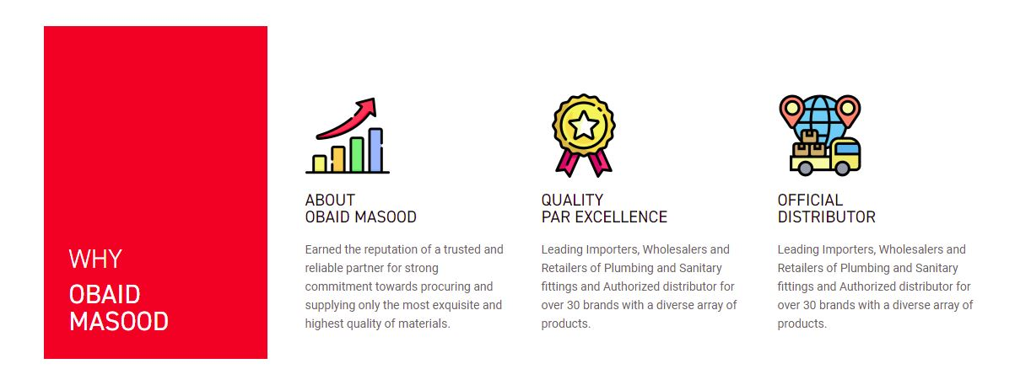
* “Our Clients” Logos- constant moving
* Few transition animations

**About us**

* A Banner Image
* Different way of representing the below

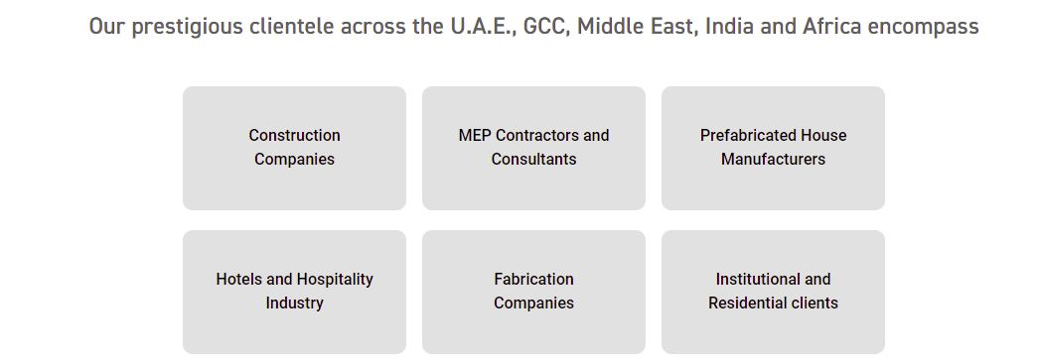

**Products Drop Down Menu**

* Increase the font size
* Vector icons for Compression fittings bit large
* Pegler, Vado, Pex- Products page- paragraph and the products will follow
* (Cosmoplast, G-style, COMAP, Mackelpine)- paragraph & catalogue- same page-one by one

**Internal Product Page**

* Remove review and additional information section
* Remove amount and colors
* Add specification sheet download option
* Add WRAS approved logo <https://drive.google.com/drive/u/0/folders/1aQGCt2YqvmocStRXfXEYJbK9Z7eh7_vo> for the pegler products. Find sample below

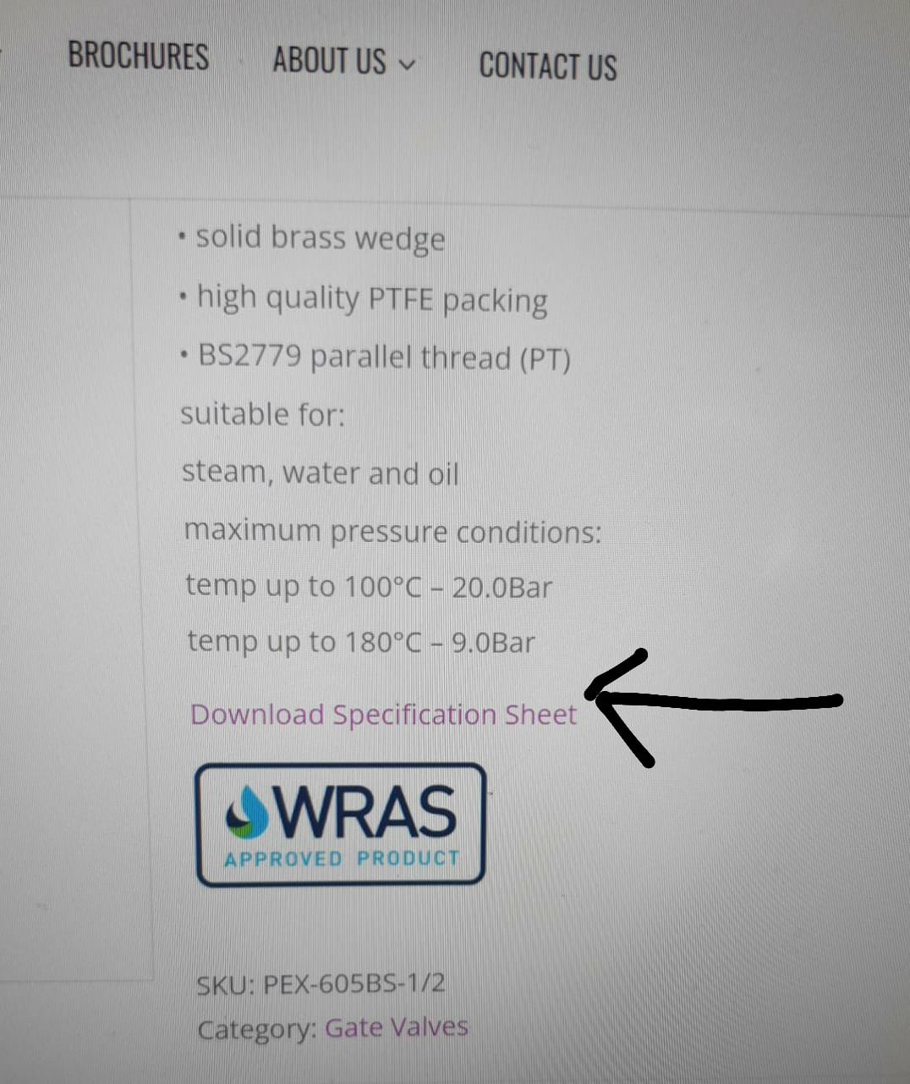

**Brands Page**

From Brands Menu navigate to the corresponding pages

**Project Page**

1st 12 images based on the order- yet to give

**Catalogue Page**

Renaming

**Contact us Page**

* Remove exclamation
* And align the icons with the map
* Attach document option for enquiry form
* Careers section with attach document