*Author Name et al.*

*Vol. Issue , pp. To be filled by editorial desk*

*Date of Publication To be filled by editorial desk*

*DOI: To be filled by editorial desk*

*This Paper can be cited as: To be filled by editorial desk*

**Kinetics: role of catalysis**

**Yoshifumi Asahara**

*Osaka Prefecture University, Sakai, Osaka, JAPAN*

*Email: 233.c.ces@gmail.com*

**Abstract**

*It seems to be desirable to work on learning items through one of the primary industrial reactions. We take catalytic action in Haber Bosch method to deepen students’ understanding of kinetics (, focusing on transition state of rate-determining step) as well as chemical equilibrium. The adsorption interaction of a catalyst to the reactant (d-orbital occupancy of catalyst as an index) is primary indicator of catalytic activity (Sabatier principle). The reaction due to molecular collision and the one with catalyst consist of multi-elementary steps are compared with the energy profile. Consideration of the relationship between activation energy and reaction rate those above will lead to not only an experimental understanding but also a theoretical understanding. Finally, we will take water gas shift reaction and water decomposition by photocatalyst as hydrogen gas production reaction with consideration of reaction kinetics and chemical equilibrium theory through catalysis.*

**Keywords**

reaction rate, chemical equilibrium, ammonia synthesis, activation energy, speed-determining step, catalysis, reaction mechanism

**1. Introduction**

The yield of ammonia produced was examined by considering Le Chatelier's Principle of the Haber process. Appropriate catalyst is needed to proceed the reaction on low temperature, which is advantageous in chemical equilibrium. Through considering the function of the catalyst from the elementary reaction process, students will have a better understanding of reaction kinetics.

**2. Implementation**

**2.1. Arrehenius Equation**

The Arrhenius equation is expressed as follows: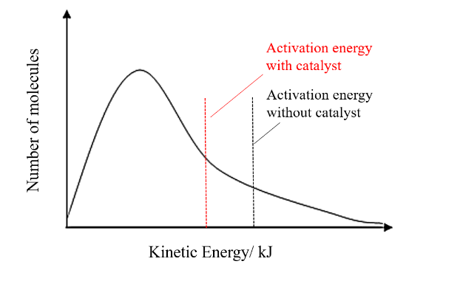

***k = Ae*−*E/RT = A exp(*−*E / RT )***

*A: Frequency factor*

*E: Activation energy*

*R: gas constant*

*T: absolute temperature*

Boltzmann factor *exp(*−*E / RT)* is the ratio of the number of molecules with effective collision energy (≧ E; Integrated area above the activation energy, Fig.1) to the total number of collision molecules *A*, per unit time, concentration, volume.

**2.2. Rate Determining Step**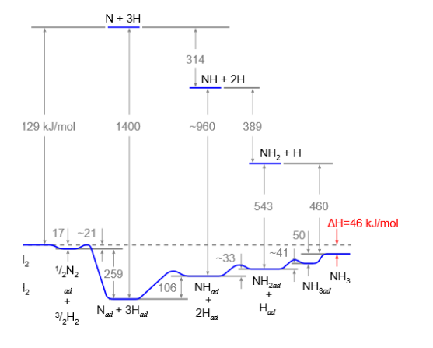

The reaction proceeds through several elementary reactions.

The rate-determining-step proceeds the slowest, while the others are in equilibrium. In the Haber-Bosch method, dissociation of nitrogen molecule bond is considered to be the rate-determining. The adsorption/ desorption process on catalyst surface causes a decrease in activation energy and an increase in reaction rate. 1., 2. ]

The adsorption interaction of a catalyst to the reactant (d-orbital occupancy of catalyst as an index) is primary indicator of catalytic activity (Fig. 3 Sabatier principle). 3, 4. ]

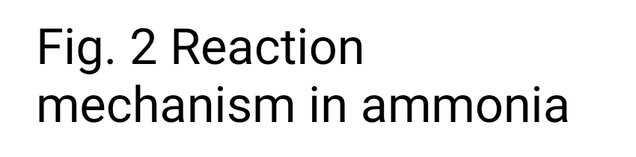

**2.3. Sustainable Use**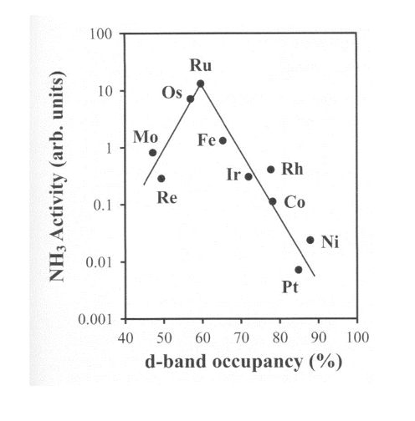

Water-gas shift reaction and photolysis of water are taken up as hydrogen gas production reactions, and reaction kinetics and chemical equilibrium theory are considered from the viewpoint of catalysis.

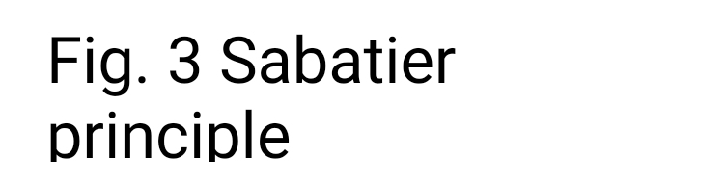

**REFERENCES**

1. G. Ertl, Reactions at Surfaces: From Atoms to Complexity

(Novel Lecture), *Angew Chemie. Int. Ed.,* 47 pp. 3524–3535, *2008*.

2. G. Ertl, Dynamics of Reactions at Surfaces, *ADVANCES IN CATALYSIS.*, vol. 45, pp. 1–129, 2000.

3. B. HAMME, and J.K NORSKOV, Theoretical Surface Science and Catalysis-Calculations and Concepts, *ADVANCES IN CATALYSIS.*, vol. 45, pp.71–69, 2000.

4. H. Ooka, and R. Nakamura*, J. Phys. Chem Lett.,*10, pp. 6706-

6713, 2019

**Appendix: Curriculum for High School Chemistry**

1. **Substance composition, States of matter**
2. Constituent particles, Ions, and periodic table of substances
3. Chemical bond, Molecular structure, Crystal structure
4. Three states of matter, Gas law, Solution
5. **Stoichiometry, Reaction mechanism**
6. Amount of substance, Chemical reaction formula
7. Thermochemistry
8. Reaction rate
9. Chemical equilibrium
10. **Role of catalyst - Arrhenius Equation**

**- Rate-determining-step**

**- Function of catalyst**

1. Acid-base, Ionization degree
2. Redox
3. Battery, Electrolysis

Hydrolysis (production of hydrogen)

1. **Organic compounds**
2. aliphatic compounds, aromatic compounds
3. Structure and properties of organic compounds
4. Natural polymer compound
5. Synthetic polymer compound
6. **Inorganic chemistry**
7. Metal elements, transition metal elements
8. Non-metal elements
9. Cation phylogenetic separation
10. Solubility product, common-ion effect, fractional precipitation
11. Various spectroscopic analysis

* The following theme settings would be effective to arouse interest and promote understanding of concepts and laws, and cultivate scientific thinking ability

1. The smallest particle unit handled in the chemical field, and states of matter
2. Industrial Chemistry: Haber-Bosch method, Ostwald method
3. Petrochemical, Functional Polymer (Materials Informatics etc.)
4. Characteristics and utilization of inorganic substances, Analytical chemistry