*Author Name et al.*

*Vol. Issue , pp. To be filled by editorial desk*

*Date of Publication To be filled by editorial desk*

*DOI: To be filled by editorial desk*

*This Paper can be cited as: To be filled by editorial desk*

**Kinetics: Reaction Mechanism**

**Yoshifumi Asahara**

*Osaka Prefecture University, Sakai, Osaka , JAPAN, Email: zeneco.drive@gmail.com*

**Abstract**

*Some reaction mechanism is a series of elementary reaction processes from original to generating system, and corresponding rate equations can be combined using one or more approximation equations, which includes concept of rate-limiting step. A Catalyst provide other reaction pathway with low activation energy and increases the rate of product formation. Starting from confirming the reaction rate equation experimentally obtained from the change in concentration to time, and consider up to reaction kinetics from the viewpoint of catalytic reaction mechanism for ammonia production reaction and CO2 reduction reaction.*

**Keywords**

*reaction rate, chemical equilibrium, activation energy, speed-limiting step, catalysis*

1. **INTRODUCTION**

Catalytic reaction of ammonia synthesis is taken to deepen students’ understanding of kinetics. The adsorption interaction of a catalyst to the reactant (d-orbital occupancy of catalyst as an index) is primary indicator of catalytic activity (Sabatier principle). The reaction due to molecular collision and the one with catalyst consist of multi-elementary steps are compared with the energy profile. Consideration of the relationship between activation energy and reaction rate those above will lead to not only an experimental understanding but also a theoretical understanding. Also, we take water gas shift reaction and photodecomposition of water for artificial photosynthesis.

1. **IMPLEMENTATION**

**2.1 ARREHENIUS EQUATION**

Fig.1 Boltzmann distribution

The Arrhenius equation is expressed as follows:

***k = Ae*−*E/RT = A exp(*−*E / RT )***

*A: Frequency factor*

*E: Activation energy*

*R: gas constant*

*T: absolute temperature*

Boltzmann factor *exp (*−*E / RT)* is the ratio of the number of molecules with effective collision energy (≧ E; Integrated area above the activation energy, Fig.1) to the total number of collision molecules *A*, per unit time, concentration, volume.

**2.2 RATE LIMITING STEP**

The reaction proceeds through several elementary reactions. The rate-limiting-step proceeds the slowest, while the others are in equilibrium. In the Haber-Bosch method, dissociation of nitrogen molecule bond is considered to be the rate-determining. The adsorption/ desorption process on catalyst surface causes a decrease in activation energy and an increase in reaction rate. 1., 2. ]The adsorption interaction of a catalyst to the reactant (d-orbital occupancy of catalyst as an index) is primary. indicator of catalytic activity (Fig. 3 Sabatier principle).

Fig. 3 Sabatier principle

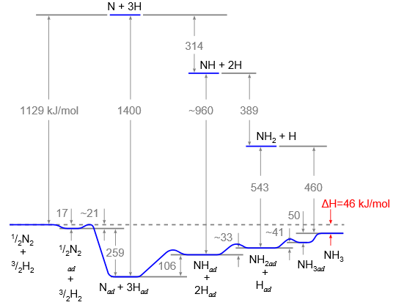

Fig. 2 Reaction mechanism in ammonia synthesis

* 1. **APPLICATION IN SUSTAINABLE SOCIETY**

Water-gas shift reaction and photolysis of water are taken up as hydrogen gas production reactions, and reaction kinetics and chemical equilibrium theory are considered from the viewpoint of catalysis.

**REFERENCES**

1. G. Ertl, Reactions at Surfaces: From Atoms to Complexity

(Novel Lecture), *Angew Chemie. Int. Ed.,* 47 pp. 3524–3535, *2008*.

2. G. Ertl, Dynamics of Reactions at Surfaces, *ADVANCES IN CATALYSIS.*, vol. 45, pp. 1–129, 2000.

3. B. HAMME, and J.K NORSKOV, Theoretical Surface Science and Catalysis-Calculations and Concepts, *ADVANCES IN CATALYSIS.*, vol. 45, pp.71–69, 2000.

4. H. Ooka, and R. Nakamura*, J. Phys. Chem Lett.,*10, pp. 6706-

6713, 2019

**Appendix: Curriculum for High School Chemistry**

1. **Substance composition, States of matter**
2. Constituent particles, Ions, and periodic table of substances
3. Chemical bond, Molecular structure, Crystal structure
4. Three states of matter, Gas law, Solution
5. **Stoichiometry, Reaction mechanism**
6. Amount of substance, Chemical reaction formula
7. Thermochemistry
8. Reaction rate
9. Chemical equilibrium
10. **Kinetics: Catalysis**
11. Acid-base, Ionization degree
12. Redox
13. Battery, Electrolysis, Hydrolysis (production of hydrogen)
14. **Organic compounds**
15. aliphatic compounds, aromatic compounds
16. Structure and properties of organic compounds
17. Natural polymer compound
18. Synthetic polymer compound
19. **Inorganic chemistry**
20. Metal elements, transition metal elements
21. Non-metal elements
22. Cation phylogenetic separation
23. Solubility product, common-ion effect, fractional precipitation
24. Various spectroscopic analysis