Author Name et al.

Vol. Issue , pp. To be filled by editorial desk

Date of Publication To be filled by editorial desk

DOI: To be filled by editorial desk

This Paper can be cited as: To be filled by editorial desk
A MODEL FOR DISTANCE LEARNING ENHANCING WITH ESPORTS AND PSYCHOEDUCATION
Khirin Srisupap
Information Technology Management, Faculty of Engineering, Mahidol University,
Nakhon Pathom, Thailand, khirin.sri@student.mahidol.ac.th

Supaporn Kiattisin
Information Technology Management, Faculty of Engineering, Mahidol University,
Nakhon Pathom, Thailand, supaporn.kit@mahidol.edu

Theeraya Mayakul
Information Technology Management, Faculty of Engineering, Mahidol University,
Nakhon Pathom, Thailand, theeraya.may@mahidol.edu

Abstract
The COVID-19 pandemic has disrupted several industries, even education. Leading to "the study from home" is a viable option. It creates complications due to poor involvement and learners' interest. Thus, esports are considered to apply for boosting fanaticism, as well improving leadership and collaboration skill. The psychological hypothesis is appropriate to mitigate the influence of esports on schooling. This study aims to integrate and create a new paradigm for esports for distant learning to increase accessibility and provide equity between teachers and students. A survey was used to compare our new model to the traditional one. The results show that 81.6 percent of respondents concur and satisfy the combination of esports and learning. The new model offers significant participation, critical thinking, and self-development benefits. In addition, the most critical elements to require are the IT competencies and gaming abilities for both teacher and student.
Keywords (Font-12 Bold)
Esports, Gamification, distance-learning, Gagne’s theory
1. Introduction
Online education, often known as tele-education or distant learning, has been utilized in the education business for many years to enable students in remote regions to study via television transmission or satellite. Additionally, given the COVID-19 scenario, online education is an important alternative. Traditional education takes place a premium on instructors above students. It is primarily one-way communication which is not ideal for online learning may have a more substantial influence on pupils and exacerbate the inequality in learner quality. The study discovered that online learning is less beneficial for students. For example, if the atmosphere is not conducive to learning, such as social media, the focus and attention will be impaired. Communication between teachers and students is necessary to be effective in the learning process. The researcher is particularly interested in improving the quality of conventional teaching and learning. Combining esports ideas with Gagne's learning theory,(Robert M. Gagne, Walter W. Wager, Katharine Golas, 2005) a model ideal for teaching should be created to improve education's efficiency and quality.
2. Objective and scope of work
The study focuses on design relevant to psychological theory and the principle of esports. This research focuses on designing a study model based on the critical factors of esports and learning theory. The researcher selected the Gagne 9 levels, the appropriate learning theory for esports and education. The study does not involve esports application or gaming development, and the researcher proves the acceptability and correctness of the proposed model, which is the preliminary result.
3. Literature Review
According to the objective, the benefits of esports on education are extracted. The related technologies have to identify. Our proposed assumption is to integrate the psychology approach to eliminate the esports side effect—applying esports concepts to learning methodology to optimize the model's suitability. We set the learning style and goal as student-centric. Figure 1 shows the process of literature review and model development.
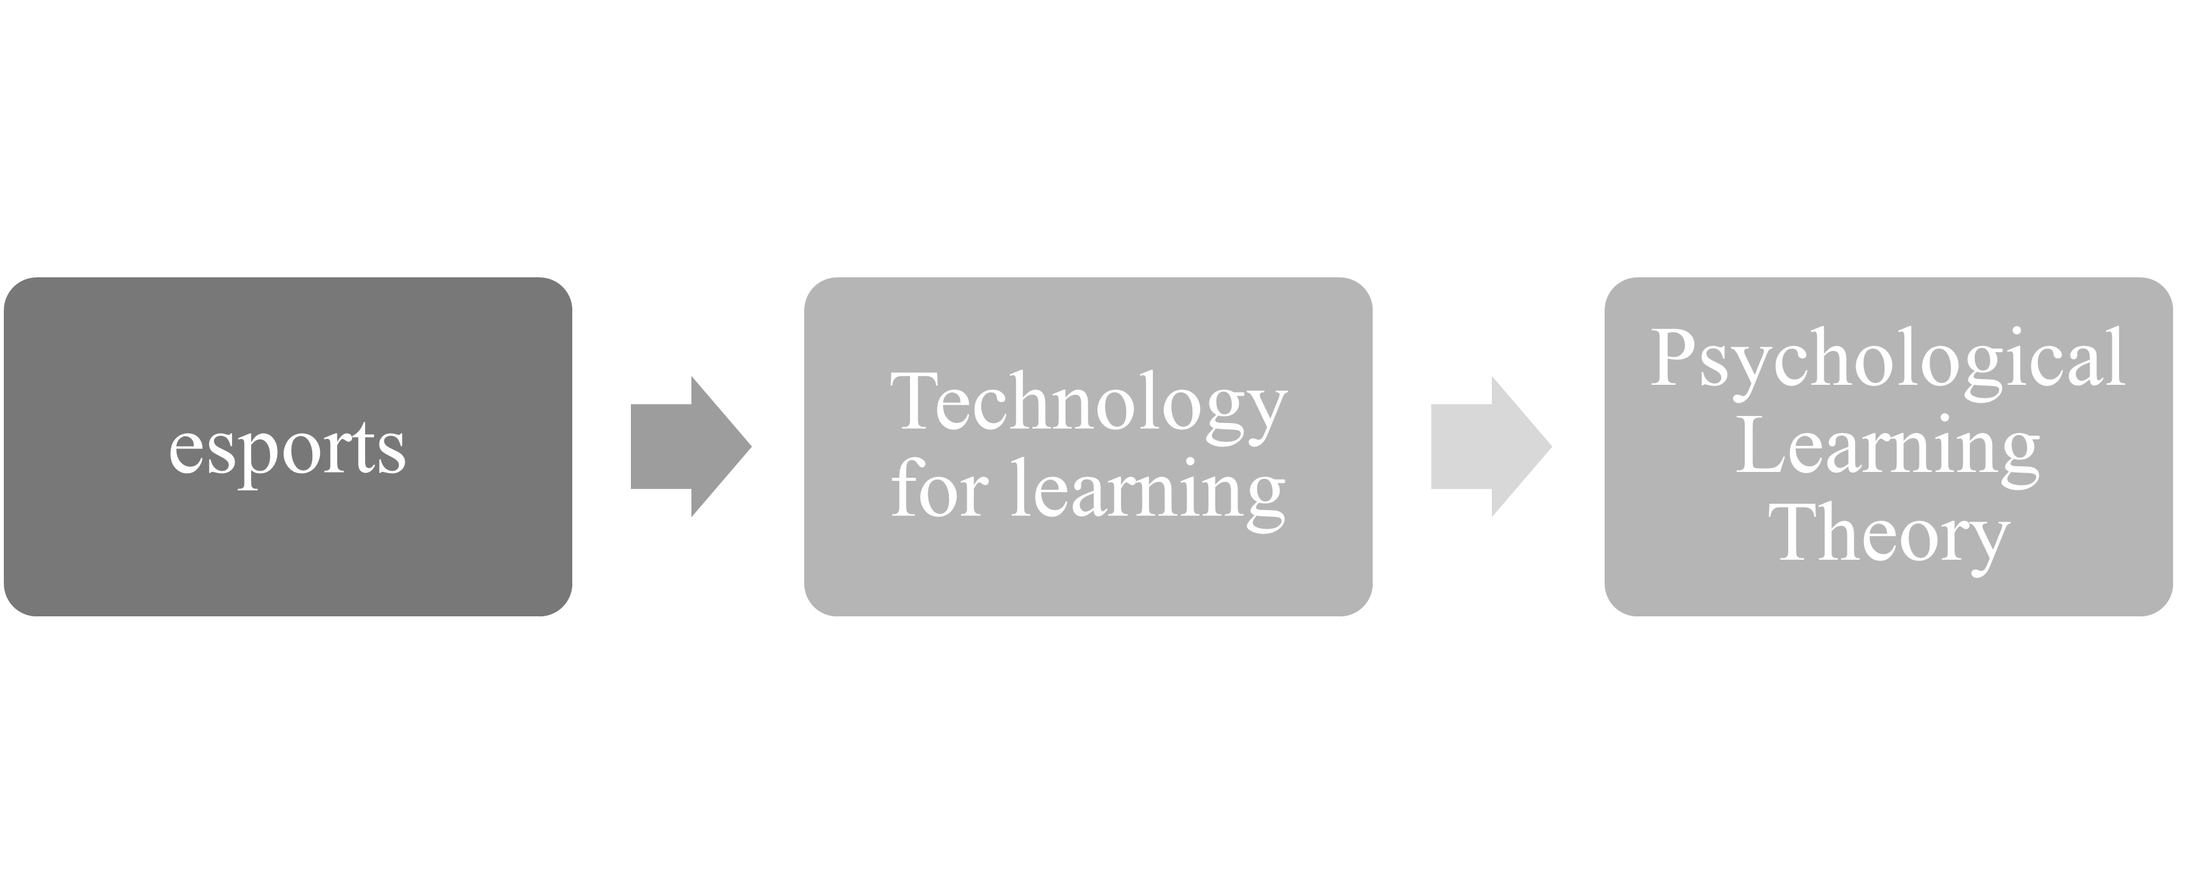
Figure 1: The methodology for proposed model development

3.1 The esports
Nowadays, Esports is a new and unusual sport. It is a subset of competitive video gaming. It has grown in popularity in several nations. Then, it has accepted and elevated esports to the level of a legitimate sport. We can categorize esports into various types. For instance, Popular esports genres include Player vs. Player (PvP; e.g., Street Fighter, FIFA), first-person shooters (FPS; e.g., Counter-Strike: Global Offensive or CS:GO), real-time strategy games (RTS; e.g., StarCraft), multiplayer online battle arenas (MOBA; e.g., League of Legends or LoL).
Esports can involve a single-player vs other players, up to eight players versus eight players, or a combination of the two, depending on the game's style. The vast majority of tournaments are held online in what is referred to as a 'multiplayer' setting.(Funk et al., 2018)
Esports has exploded in popularity. Numerous researchers and influencers have questioned whether esports compare with other sports. It is not merely a matter of esports terminology. In the public's perception, it also encompasses the sphere of conventional sports. Many people (particularly fans of 'conventional' sports) believe that esports cannot be considered a sport because the participants' competency is not based on physical ability. It appears as though the contenders in esports are just individuals who sit in a chair, even though football, basketball, simulations, and esports games (such as FIFA, NHL) are not sports.(Hamari & Sjöblom, 2017; Jenny et al., 2017)
The consequences of sport are factual and genuine. While the outcomes of esports are obtained in the virtual world or through electronic media, which are governed by real-world competitors. It is able to indicate that esports is equally sport. However, the researcher synthesizes and contrasts esports and traditional sports, shown in Table 1.(Michael G Wagner, 2006)

TABLE 1. Comparison of esports and sport
 | Esports | Sport
What (Equipment) | Human computer interface | Human physical object interface
Where (Location) | electronic systems | real world
Why (Purpose) | Entertainment  / psychological improvement | Entertainment/  physical improvement
How to play | Through the system/network | Real situation
When | No limitation | Time / season limitation

Although esports is a subcategory of electronic games, all are not considered sports. Sports-themed video games must be structured (or uniform), organized, and competitive (or transparent), among other things. Additionally, video games must be supported and endorsed by an organization. There is a set standard of play, and competitors must adhere to it. For instance, Super Smash Brothers Melee, a Nintendo-published fighting game, has an exact configuration for playing and competing. However, it currently lacks an institutional framework for organizing tournaments. The game does not require a rating system, leagues, or management. One type of game is a popular smartphone game such as Candy crush, which has a straightforward game structure and rules but is not competitive. As a result, it is not recognized as a sport, referring to a sport-based video game such as FIFA. It incorporates a simulation of conventional sports into the game. However, no institution has entered this competition. In comparison, esports such as League of Legends, Counter-Strike: Global Offensive, or CS: GO have tournament management systems, and competition determines the ultimate winners and losers.(Funk et al., 2018)
3.2 Technology for learning
Technology facilitates access to education without the burden of time and location. Everybody can acquire information, knowledge, and skills through the online platform. Additionally, technology provides new chances for people to learn. Anyone, regardless of location, may be educated at any moment with only a computer, a smartphone, and the internet. The researcher has collected the following list of instructional technologies that has been widely adopted nowadays. (Figure 2)
Figure 2: Technology for learning

3.2.1 E-learning
The term “e-learning” has been used since the 1990s and has defined various aspects. E-learning (or electronic learning) is the system delivering education through websites, networks, and the Internet. The knowledge, skill, and content are shared among the ecosystems. It also includes lessons through satellite TV, audio cassettes, or log files that can be a learning material.(Tavangarian et al., 2004). (Figure 2)
Finally, e-learning has already been incorporated into educational technology and is the same as other online learning methods.(Moore et al., 2011).

3.2.2 Online learning
Online learning is the most popular method of distance learning. It improves the accessibility of learners who have constraints on distance, travel and boundary factors that impede their ineligibility to study. Online learning also influences on behaviors that are flexibility and interactive communication with the instructors. Most of the professional staffs considered to change the traditional form by integrating social media and learning technologies given as Facebook live, YouTube, and video steaming. (Moore et al., 2011). (Figure 2)

3.2.3 Distance learning
The term "distance education" is the most often used. Distance learning aims to educate and provide access to education for individuals who live a long distance from a school. A recent study has revealed that definitions are incompatible with online learning and distance education due to technology such as computers and smartphones in education. The definitions also included references to printed goods and electronic media. By the way, distance education is described as the use of new media and experiences to aid in the dissemination of educational possibilities.(King et al., n.d.; Sherry, 1995). (Figure 2)

3.3 Learning Theory
Educational psychology concepts serve as a guide for the education business and process. Several researchers have established and developed numerous ideas on education. There are several schools of thought which are humanism, behaviorism, cognitivism, and constructivism (including connectivism). It is generally categorized into four groups and separated into instructional styles.(Lockey et al., 2021)
Table 2. shows that the format of learning is divided into three main principles:

Pedagogy: It focuses on teachers as the center of learning.

Andragogy: It is the student-centered. The concept is based on the following assumptions; self-concept, adult learner experience, readiness to learn, orientation to learning, and motivation to learn.

Heutagogy: Main idea is the Learning in which the learner research self-learning. The teacher encourages students to achieve planned learning. This kind of learning requires a high level of responsibility.
TABLE 2. Group of learning theory
Format of Learning | Pedagogy | Andragogy | Heutagogy
Position | Teacher Center | Learner Center | Leaner Led
Group of Learning | Behaviorism | Cognitivism | Connectivism
Constructivism
Humanism

The examples of critical theories are demonstrated in each group. Learning theory is a type of psychology that is related to behavioral change. The theory said that humans could learn by hearing, touching, reading, and using technology. The learning of children and adults is different. Children learn in the room, and questioning adults often learn by having experience. The learning in the classroom will be based on the experience the teacher has to offer through interaction between teachers and learners. The teacher will be the one who creates a psychological atmosphere that is conducive to learning. Referring to the theory, the teacher creates suitable conditions and learning situations for the students. Therefore, the teacher must consider teaching a style, including building interaction with learners. (Lockey et al., 2021)The four theories of learning are as follows:

3.3.1 Humanism learning theory
Humanism's concept of learning is an individual act to be accomplished the objectives of each human being. For example, Maslow's theory, the most well-known and widely accepted, mentions this premise. All human beings have fundamental, inherent, hierarchical wants and a desire to know and develop themselves. The teaching and learning approaches based on this idea emphasize identifying and meeting students' fundamental needs. It provides learners with flexibility and the ability to study. It requires a learning environment that promotes learners to develop a genuine self-awareness.(Lockey et al., 2021)

3.3.2 Behaviorism learning theory
The underlying principle of this category of behaviors is the practice of rewarding behavior to reinforce it, such as rewarding (Positive reinforcement and Negative Reinforcement). Teachers play a critical part in this learning pattern since they are responsible for policing education by identifying what is proper and incorrect. A strength of this technique is its emphasis on mastering prerequisite skills before proceeding to more complicated topics, which is also congruent with Bloom's idea of 'mastery learning.' This collection of theories is appropriate for learning about fundamental concepts and structures that will be expanded further in the future. Learners are similar to whites who have never had any encounters. While the teacher provides information and advice to students, the theory also discovered that extended usage limits students' thinking patterns, making them less susceptible to class participation and affecting their inspiration and capacity to think creatively.(Lockey et al., 2021)

3.3.3 Cognitive learning theory
Cognitive learning is a type of education that focuses on cognitive processes or ideas. This group has broadened the scope of behavioral learning to include the thinking process, which is a mental process. These thinkers claim that human learning is not just a function of behavior in response to stimuli. Human learning is intricate. Learning is a cognitive process that occurs as a result of the acquisition of knowledge, its definition, and correlation, as well as the process of using that information to act and solve issues. Learning is the cognitive process by which humans develop self-awareness. This category includes theories such as Gestalt, Field, and Gagne.(Lockey et al., 2021; The International HETL Review, 2010)

3.3.4 Constructivism learning theory
Piaget's is the well-known of the Constructivism learning theory. Acquiring or accumulating knowledge is a natural process within the learner. The learner is the one who creates knowledge, brings experiences, objects observed in the environment, or new information gained in conjunction with previously learned knowledge to develop their understanding, or "Cognitive structure" or "Schema." It contributes the knowledge which is not about memorizing information. The learning should consist of experience or the previous knowledge that they had before to create the meaningful knowledge of that thing. Each person may create a different meaning because they have different prior experiences or knowledge. (Kiili, 2005; Lockey et al., 2021)
According to the literature, the researcher concludes and analyzes the main concepts for the proposed model design. The distance learning concept is suitable because of its flexible learning style. It requires an ability to apply new mechanisms to learning. The theory that serves as the foundation for design is the Cognitive learning theory because of self-awareness and thinking process improvement. Hence, Gagne's is the functional theory for esports and learning, which are analyzed the key factors in the next section.
4. Development of esports with learning
4.1 Esports’ key factor
The researcher has conducted a literature review on esports to design a new teaching approach. However, esports has several definitions that both agree and disagree with elevating the game to the level of the sport. The subjective interpretations are based on a variety of users' ideas. In this aspect, the researcher has focused exclusively on esports. Regardless, esports is a technology-based sport. These games can play on any device, both a computer or a mobile device. It determines whether there is a sound playing approach, discipline in play, and distinct patterns and aims. It enables players to gain additional soft skills and may incorporate these principles into teaching and learning. Esports will undoubtedly assist pupils in developing further in education area as well. (Bruckman et al., 2013)
Figure 3: esports key factor

In addition to improving soft skills, learners also have enjoyment and class engagement. It can solve distance learning problems: procrastination, inability to stay focused, and low social interaction. The researcher summarized esports' benefits into nine factors: Goal setting, Teamwork, Leadership, Planning, Communication, Adaptive, Critical thinking, Technology, Challenge. (Figure 3.)

Learning theory
The researchers prefer Gagne's theory which incorporates mindfulness. Gagne proposes that cognitive learning activities may be hierarchically classify as follows: recognition, stimuli, response production, next steps, use of language, discriminations, conceptualization, rule the researchers prefer Gagne's theory which incorporates mindfulness. Gagne proposes that cognitive learning activities may be hierarchical: recognition, stimuli, response production, next steps, use of language, discriminations, conceptualization, rule application, and problem-solving.
The hierarchy's purpose is to denote the criteria that must be met in order to allow learning at each level. The prerequisites are determined by reviewing the learning task, training skills, and characterization. The learning hierarchy serves as the foundation for both teaching and learning.(Robert M. Gagne, Walter W. Wager, Katharine Golas, 2005)
Moreover, the provision outlines nine instructional events and corresponding cognitive processes:
Figure 4: Gagne’s theory

- Gaining attention (reception)
- Informing learners of the objective (expectancy)
- Stimulating recall of prior learning (retrieval)
- Presenting the stimulus (selective perception)
- Providing learning guidance (semantic encoding)
- Eliciting performance (responding)
- Providing feedback (reinforcement)
- Assessing performance (retrieval)
- Enhancing retention and transfer (generalization).

These events should satisfy or provide the necessary conditions for learning and serve as the basis for designing instruction and selecting appropriate media. (Figure 4)
Gagne's learner-centered methodology matches our goal to provide quality distance education. The theory is also a synthesis of several approaches to defining cognition of learning. When we consider the esports perspective, Gagne's is the exact manner of motivation to the problem-solving skills. Its process includes preparing, practicing, assessing, and transferring knowledge with esports alignment.

Mapping key factor for the proposed model
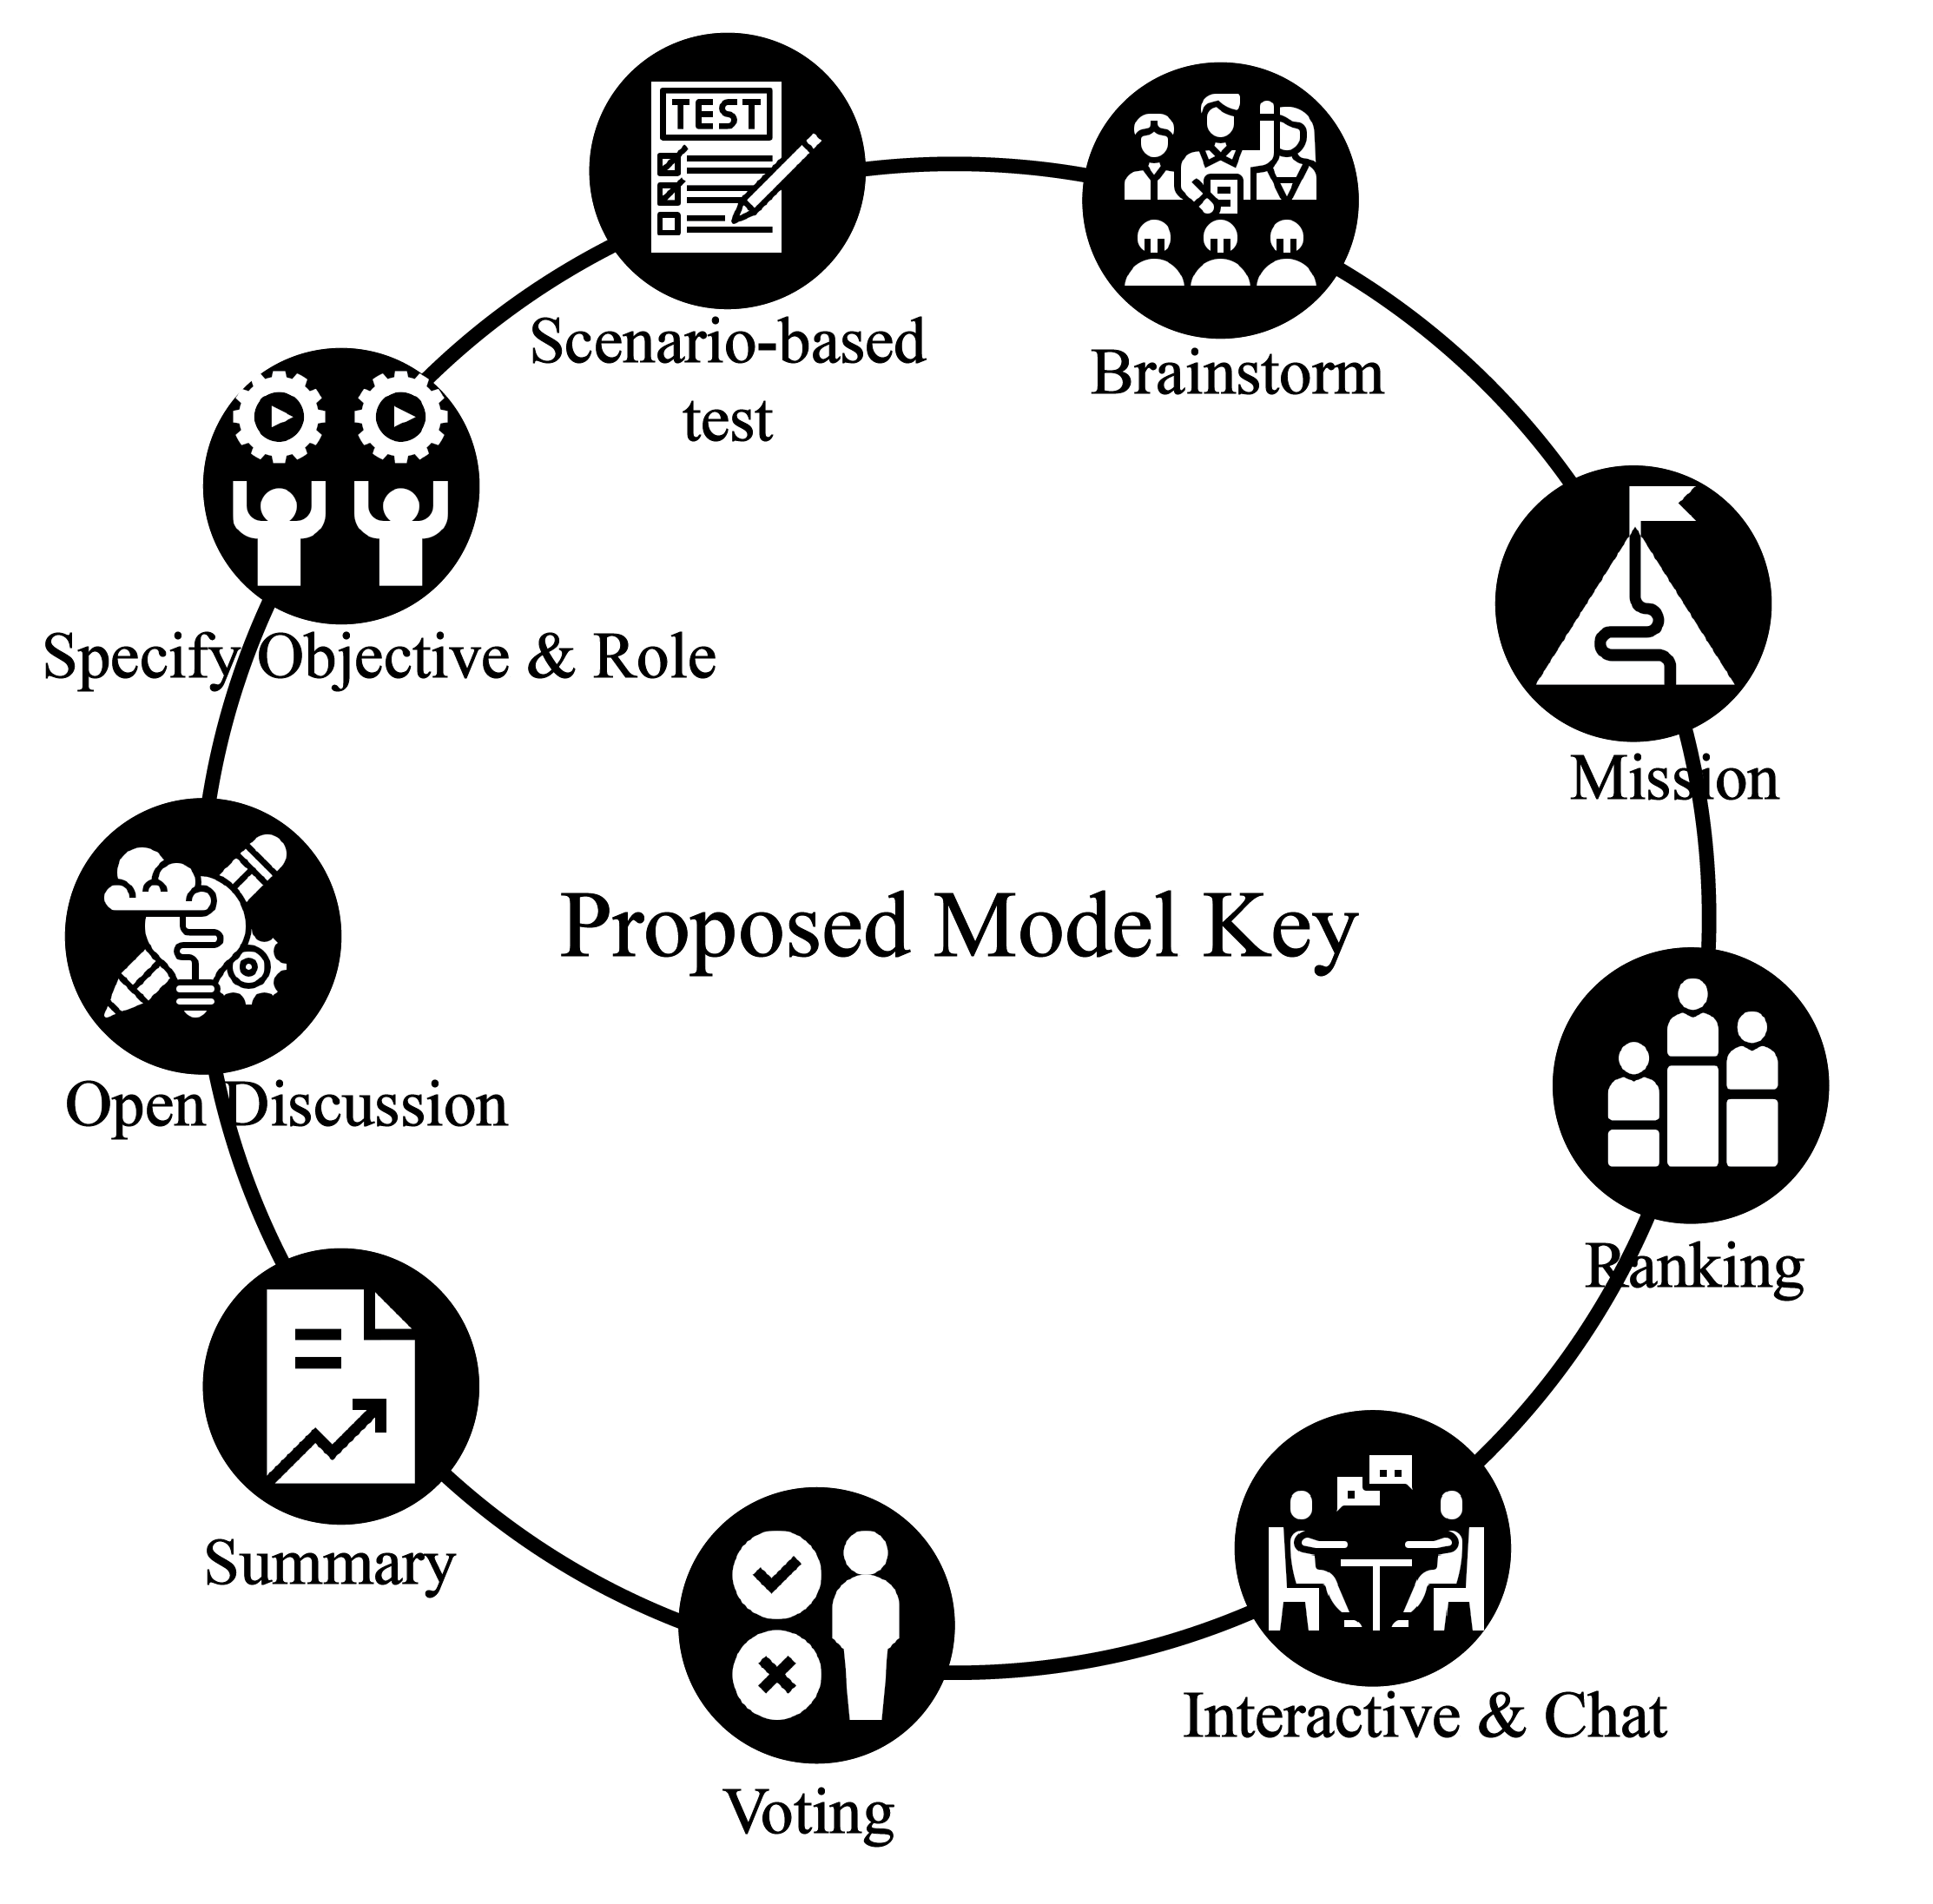
Figure 5: Proposed model key

According to the esports key factor and the Gagne’s theory, the researcher applies the principle and integrates the learning model, as shown in Figure 5.

Summary
The researchers prepared to summarize the principles that the researchers have reviewed. The details in the table 3.

Table 3. Compare Gagne’s theory with esports
 | Specify Objective & roles | Open discussion | Scenario-based test | Brainstorm | Mission | Communication | Voting | Ranking | Summary
Activity | Identify and goal setting | Course designing | Personality and knowledge assessment | Team building | Team competition | Opinion sharing and exchange among team | Participating and giving the score or grade for other | Showing the score and rank | Lesson learns and knowledge
Tool | Interactive classroom | Interactive classroom | Kahoot / Slido | Interactive classroom | MOBA style game | Interactive chat | e-vote / poll | Dashboard | Interactive classroom
Output/ Outcome | Goal setting/Intention | Leaning by learner/ | Baseline/  Learner- background | Role & Responsibility/ collaboration | Milestone /impulsion | Point of view  Knowledge /Communication skill | Engagement/  Impartiality | Transparency/  Competition | Knowledge /Soft skill
Role
Teacher | Team leader | listener | Assessor | Observer | Team leader | Observer | Observer | Team member | Team leader
Learner | Team member | Team member | Examiner | Team member | Team member | Team member | Team member | Team member | Team member
The study presents details and examples of the Proposed Process model. The researchers have taken the Gagne as a model for managing learning system and consolidated the esports key factors to game pattern. The activity and process were fabricated as the model, shown in Figure 6
Figure 6: Proposed Process Model
Figure 6. describes the activities and workflow of distance learning, according to Gagne. It begins with student participation to set the learning goal together. The teacher plays the role of the instructor and coach. The communication is open session to discuss among class members. The technology given as interactive chat, messaging and social media tool are required in these preparation step. The lesson pattern should be competitive game and score dashboard is useful for stimulation and self-awareness. To achieve the mission requires the problem-solving and team building which are the esports dominants. The final process is to summarize the new knowledge, skill, and experience by sharing opinion.

Proof of concept
After the proposed model has been completed, the researcher creates a survey questionnaire for feasibility evaluation. The questions gauge their agreement or disagreement (5-point Likert scale) with our esports-distance-learning model. The questionnaires shown in Table 4.
The sample group is people who have an experience in esports (or gaming) and distance learning (online classroom, e-learning, and tele-education). Moreover, the sample group should consist of relevant individuals, such as learners and instructors. We estimated the sample size using the central limit theorem for this pilot study.(Kwak & Kim, 2017) The minimum sample size of 30-100 is enough to obtain statistics and values.

Table 4. Questionnaires
 | Questionnaires
1 | Would you think applying the principles of esports to learning will increase the learning efficiency of the learners?
2 | Would you agree that teachers and students work together to design objectives knowledge assessment and the role of learners?
3 | Would you agree that learner center learning design will make teaching more effective?
4 | Would you think that using game principles to design lessons and tests will improve learners' learning efficiency?
5 | Would you agree that teamwork in the classroom can help keep learners on teams, understand the different roles in the team and make learning fun?
6 | Would you think that having various tasks in the lesson will make the learners have fun, understand the lesson and help develop the soft skills of the learners?
7 | Would you think that real-time chat will help learners understand the lesson well and not get bored?
8 | Would you think that allowing students to rate and assess the abilities of others in the class will make learning more challenging and fun?
9 | You think that showing the scores through the dashboard will help students see their progress and encourage them to learn better?
10 | Would you agree that make the report and summarize what has been learned in the lesson such as knowledge, soft skills will allow learners to understand the lesson and see their own development more?
11 | Would you agree with this model?
12 | Would you believe that this model can be applied and effective results in learning?

Result
This study aims to determine the proposed model's applicability to learning platforms. The questions will inquire each process acceptability and any additional ideas for enhancing the model's efficacy given as technology and tool.
Figure 7: Result of survey
The survey questionnaire is randomly assigned to students and instructors. The study got 100 respondents, corresponding to 100% of the sample population, consistent with 95% confident interval.
Results of the survey summarized Physical characteristics of respondents: 46 percent are instructors, 54 percent are learners, and 10 percent of all respondents have esports experience. All respondents have experience of online education. According to the questionnaire, both teachers and students ultimately agreed that incorporating esports concepts into their learning would boost their learning efficiency by 86.32 percent. The researchers summarized the mean values from each questionnaire shown in Figure.7.
There is an interesting point from the instructor's score was an average of 3.98. It was considered to be moderately agreed upon because of misleading of esports. They are concerned when the game is used in the classroom without proper control. It leads to a negative outcome in teaching, including distraction and physical problems, which should outweigh the benefits. According to Gagne's theory, instructors should ensure skills are mentor, coaching, management, and digital competency. Moreover, the course material and tools must convert into the digital version and need proper preparation.
The infrastructure is another concern that the education provider must plan and manage to achieve a quality and accessible learning platform. For example, the internet (network), devices, and applications are standard set for all students. The regulation should be raised to control and reduce the risk given as time consumption, age restriction, role, and responsibility for teachers, learners, parents, and providers.

Conclusion
The proposed model successfully integrates the distance learning platform's esports and cognitive learning approach. It is accepted by the teacher and learner to create a better learning system in term of participation, self-awareness, teamwork, critical thinking, and problem-solving. Moreover, this model should be implemented to eliminate the burden of schooling during COVID-19. The processes are mission, voting, and ranking can allow the study enjoyment. The scenario-based is the best solution for touching experience and improving fundamental skills. However, a coin has two sides. The governance mechanism is required to create usefulness among all parties and sustainability.

REFERENCES
Bruckman, Amy., ACM Digital Library., & ACM Special Interest Group on Computer-Human Interaction. (2013). Media Technologies and Learning in the StarCraft eSport Community. ACM.
Funk, D. C., Pizzo, A. D., & Baker, B. J. (2018). eSport management: Embracing eSport education and research opportunities. In Sport Management Review (Vol. 21, Issue 1, pp. 7–13). Elsevier Ltd. https://doi.org/10.1016/j.smr.2017.07.008
Hamari, J., & Sjöblom, M. (2017). What is eSports and why do people watch it?
Jenny, S. E., Manning, R. D., Keiper, M. C., & Olrich, T. W. (2017). Virtual(ly) Athletes: Where eSports Fit Within the Definition of “Sport.” Quest, 69(1), 1–18. https://doi.org/10.1080/00336297.2016.1144517
Kiili, K. (2005). Digital game-based learning: Towards an experiential gaming model. Internet and Higher Education, 8(1), 13–24. https://doi.org/10.1016/j.iheduc.2004.12.001
King, F. B., Young, M. F., Drivere-Richmond, K., & Schrader, P. G. (n.d.). Defining Distance Learning and Distance Education.
Kwak, S. G., & Kim, J. H. (2017). Central limit theorem: The cornerstone of modern statistics. Korean Journal of Anesthesiology, 70(2), 144–156. https://doi.org/10.4097/kjae.2017.70.2.144
Lockey, A., Conaghan, P., Bland, A., & Astin, F. (2021). Educational theory and its application to advanced life support courses: a narrative review. Resuscitation Plus, 5(October), 100053. https://doi.org/10.1016/j.resplu.2020.100053
Michael G Wagner. (2006). On the Scientific Relevance of eSports. Ethics, 69–73. https://doi.org/10.1086/290752
Moore, J. L., Dickson-Deane, C., & Galyen, K. (2011). E-Learning, online learning, and distance learning environments: Are they the same? Internet and Higher Education, 14(2), 129–135. https://doi.org/10.1016/j.iheduc.2010.10.001
Robert M. Gagne, Walter W. Wager, Katharine Golas, J. M. K. (2005). Principles ofinstructional design (5th ed.) (Thomson Wa).
Sherry, L. (1995). Issues in Distance Learning. In International Jl. of Educational Telecommunications (Vol. 1, Issue 4).
Tavangarian, D., Leypold, M. E., Nölting, K., Röser, M., & Voigt, D. (2004). Is e-Learning the solution for individual learning? Electronic Journal of e-Learnin. Electronic Journal of E-Learning, 2(2), 273–280. http://wwwra.informatik.uni-rostock.de
The International HETL Review. (2010). https://www.hetl.org

