**Investigating the Effects of Social Media**

**on the Well-Being of Teenagers**

By Sara Saraiji

# Abstract

There has been a positive association between screen time and depressive symptoms among adolescents. Research has found that using social media will increase self- comparisons especially if engaged with passively. Therefore, this would increase the chances of depression and lower well-being. However, the main reason why I decided to investigate social media further is due to its rather counter-intuitive and controversial results on individual’s well-being, especially the youth. hypothesized that if you actively use social media, your overall well-being, social bonding and sense of connectivity will be increased. Research investigating Facebook users found positive results on their well-being after 3 months.

I conducted an experiment to investigate the effect of social media on happiness, then conducted a t-Test which showed a statistically significant difference in the mean of happiness scores before and after the experiment.

I asked many students to refrain from social media for 33 hours and then tested their happiness score before and after.

# **1 Introduction**

Social media is a platform where various videos, pictures, locations, and music are shared with people worldwide. It is a way of expressing personalities, hobbies, interests, culture, and intimacy. We could praise social media for being a significant contributor in comprehensively embracing diversity and raising awareness on countless social, cultural and political issues due to its convenience and practicality.

However, something is exciting on social media; the use of positive intermittent reinforcement (PIR); which is also used in slot machines to see what you won. This is a design technique that is also used on social media- every time you pull down your social media page, you get new posts from different accounts, but you do not know what the latest posts are going to be or who shared it and this operates exactly like slot machines in casinos. This unconscious habit is consciously implanted to program social media users (Orlowski, 2020).

Previous research (Verduyn et al., 2017) hypothesized that actively using social media increases connectivity, social bonding, and well-being, while using social media passively can have the opposite effect on an individual by decreasing well-being, increasing social comparisons, and envy (Burke et al., 2010). A study of 10,557 Facebook users had their Facebook accounts examined for three months, and after that, they were asked to fill out a questionnaire. They found that active Facebook users' well-being was not affected; however, users who used Facebook for communication with friends and family were found to have positive results (Burke and Kraut, 2016). This suggests that social media if used correctly, increases well-being. Therefore, this is supported by another experiment which discovered that those who use social media frequently as a source of communication are more satisfied with their lives (Dienlin et al., 2017) and have more positive attitudes (Hunt et al., 2018).

In contrast, undergraduate students from the University of Pennsylvania were asked to limit their social media to 10 minutes a day or continue using it as usual. The control and experimental groups showed decreased FOMO (fear of missing out) and anxiety, but the experimental group showed more decrease in depression and loneliness (Hunt et al., 2018). However, other studies have found very minimal correlations between social media and life satisfaction/depression (Utz and Breuer 2016, Orben and Przybylski 2019).

A more extensive study of 2897 participants were told to deactivate Facebook for four weeks and found that the experimental group showed slight increase in well-being measures (Allcott et al., 2019). Another study on emotional responses across time (Bayer et al., 2016) investigated our emotional outcomes from updating your status on social media and found an increased positive effect after 10 minutes, but the positive effects did not last long. Additionally, there is a positive correlation between screen time and depressive symptoms among adolescents (Hoare et al., 2016). The on-screen evidence time affecting self-esteem is weak (Hoare et al., 2016) as there are mixed results, but more studies have found negative results (Carson et al., 2016).

There is a wealth of experiments about social media use affecting self-esteem. An experiment was conducted on children aged 10-14 who were interviewed about their social media use regarding appearance relating to self-esteem (Steinsbekk et al., 2021). They found that increased other-oriented social media use (users who view and respond to others' posts) caused a decrease in appearance self-esteem but only in girls (Steinsbekk et al., 2021). Furthermore, Frison and Eggermont, (2017) Rousseau et al., (2017) concluded that when users engage with social media passively (users who respond and view other posts), they are likely to have an increase in depression and lower well-being (Verduyn et al., 2017). They are exposing themselves to representations of idolized individuals, which inevitability leads to self-comparisons (Krause et al., 2019). However, active social media users (users that post self-oriented content and interact with other users) correlate to a healthier well-being and lower levels of depression. This is because the online self-presentations are the best versions of themselves, and they mainly receive positive feedback. But active social media use can entail many things, including commenting, liking, and sharing other content (Escobar- Viera et al., 2018). Hence, Steinsbekk and Wichstrøm, (2021) proposed that ‘self-oriented’ social media use would consist of personal pictures and updates, ‘other-oriented’ use consists of behavior such as liking or commenting on other users' posts. These terms have important implications for self-esteem (Festinger, 1954). There is supporting research: browsing on your profile does not impact self-esteem, whereas browsing others' profiles do (Gonzales and Hancock, 2011).

Social media has an intriguing yet suspicious way of fixating and obsessing people over Instagram feeds, lifestyle posts, and artificial lives built through the power of social media. Consequently, this consumes people's lives and sucks them into a platform that may be more focused on economic factors and capitalization over social factors by allowing users to create their own 'social media identity' based on Gauntlet's Identity theory (Guantlett, 2008) which states that our identities are reinforced through social media. Previous research (Robinson et al., 2021) has stated that social media promotes self-absorption (Lawrence et al., 2021), but it could be argued that posting Instagram stories or pictures of yourself would improve self-esteem and confidence levels (Bayer et al., 2016). All in all, I will cover both the positive and negative effects of social media use on the well-being of individuals. Furthermore, I plan on making inferences of social media’s effects after conducting an experiment as a source of primary research and correlating the results I have found by conducting a t-Test to measure the extent to which my results are statistically different.

# **2 Methodology**

Firstly, I selected 32 participants using target sampling. I went up to students in my year group during our free lessons, asking them whether they could complete this questionnaire. I turned the link to this questionnaire into a Q.R. code and asked participants whether they could complete it to ensure participants did not feel any peer pressure and felt comfortable. I also did not want to force anyone or make them believe that this was compulsory by giving them the right to withdraw at any time. So that way, this research would be ethical - considering some people find questions about their social media use (like the number of hours they spend on social media every day) to be private or sensitive information due to personal struggles (mental health, procrastination, cyberbullying). Once participants could access the questionnaire, I left the premises to limit researcher bias as much as possible as I did not want to look intimidating or make them feel rushed to receive the most accurate results possible, increasing the internal validity of this primary research. All participants knew I was available nearby to inquire about a question if they did not understand it. Therefore, this increases the internal validity of the results. However, all participants who completed this questionnaire go to Gems FirstPoint school in Dubai and are in year 12. Therefore, the results may not accurately represent all teenagers within the 16-18 age range as there may be culture bias.

During my free lesson, I asked students in year 12 whether they would be willing to stay off social media for 33 hours and complete the happiness quiz (<https://www.pursuit-of-happiness.org/science-of-happiness/happiness-quiz/>) before and after the experiment begins. I selected my participants using opportunity sampling by going into the study room and asking for their consent (detailing the nature of the study's aims to potential participants). I did not want to deceive participants of the true meaning of the experiment as this would be unethical, which would mean that I would have to give participants retrospective consent. Participants may have also felt annoyed and so choose to withdraw their data. While selecting participants, I asked around 80 students, and only 42 individuals agreed; four withdrew during the experiment. Students who disagreed felt that it was too complicated and doubted they could complete the entire experiment. Some students asked for time to decide and then informed me whether they would be taking part or not. Additionally, participants' social media platforms were not allowed to use were Instagram, Snapchat, TikTok, Facebook, Twitter, Pinterest, and Messenger. Email, YouTube, and WhatsApp were permitted for educational and family purposes.

Participants were told to stay off social media starting from 12am to 9pm the next day (33 hours). I communicated with the participants on the day where they collectively deprived themselves of social media to check whether any participants withdrew from the experiment and did not open any social media apps so far. Moreover, I ensured all participants understood the aims and objectives of this study, and I made them aware that they could ask me any questions about the experiment. I conducted this experiment twice to control and monitor participants carefully in each experiment.

# **3 Results**

I included both open and closed questions within this questionnaire. I used closed questions by asking my participants to rate themselves based on a question using a scale of 1-5, and I used open questions by including some answer choices that do not consist of numbers. Using open questions would mean that the results would be more complicated and time-consuming to analyze than closed questions. However, I would gain a lot more detail through open questions.

Most respondents (80%) reported that they enjoy spending their time on social media with a tie between the option 4 and a 5 on the numerical rating scale. Indicating that social media is still entertaining and users are happily accessing it, but does this come from users' being social and interacting with others or playing their part in modern consumerism? Moreover, 0 participants selected the option 1 or 2 which suggests that social media users are truly satisfied when they spend their time on social media. The rest of my participants (18.8%) selected 3 which means I can infer that my participants find social media quite enjoyable.

Most of my participants (34.4%) stated that social media impacts their procrastination levels daily, scoring 4 out of 5 as can be seen in Figure 7. Meaning that social media may be damaging this generation’s degree of education and knowledge as teenagers feel less motivated to study, read, and get an internship to gain real-life experience. Yes, social media can provide entertainment (Figure 8), but this source of entertainment can lead to overindulgence in perhaps not very useful things, reducing the time that could be spent on beneficial activities. However, since the modern world has become more technologically based, spending time on social media platforms and looking at media products could be an extremely positive move as this may be the more up-to-date method for 'gaining experience,' primarily because social media platforms are incredibly business-driven- as I concluded from my research. Around 25% (8 participants) selected a 3 out of 5, which is moderately acceptable. Similarly, 21.9% (7 participants) selected the maximum option – a 5 out of 5. This score could be viewed negatively or, depending on how users use social media; this could be highly advantageous because using social media to deepen knowledge on religion, history, current political issues would be worthy of your time. This makes social media a source of information, supported by the Uses and Gratification theory by Blumler and Katz (Fisher, 2020) which states that social media can be used for educational purposes.

1. **On a scale from 1-5, to what extent does social media impact your procrastination level daily?**

Figure 1- Results from question 1

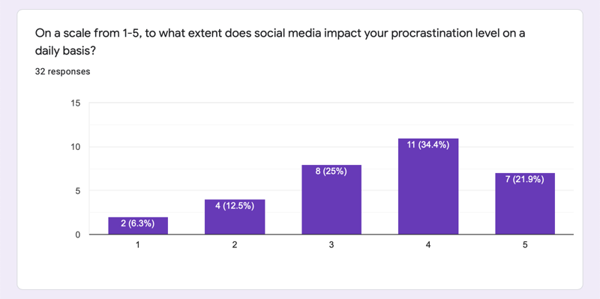

According to my results, 59.4% of participants state that social media provides entertainment as shown in Figure 2. The other most popular option was 'All of the above,' which was 28.1% of participants' answers. This shows that social media gives them comfort, connection, and entertainment. Theoretically speaking, it could give them comfort due to its drug effect (an increase of dopamine – a happy hormone in your brain) (Robinson et al., 2021). Alternatively, it could be because they are connected with others, ('connection,' 9.4% of my participants selected this option). In addition, using Blumler and Katz’s Uses and Gratification theory (Fisher, 2020), social media users either use media products (social media being inclusive) for 1) Entertainment/Escapism 2) Education/Information purposes 3) Social interaction/Personal relationships 4) Relatability/Identification. If a media product provides more than one part of this theory, it could be more popular with audiences (Fisher, 2020). This supports my findings within my questionnaire as social media users use social media for connection, entertainment, and identification (respondents may have selected the 'comfort' option as it provides them with a sense of relatability and identification with other people).

1. **What does social media mostly give you?**

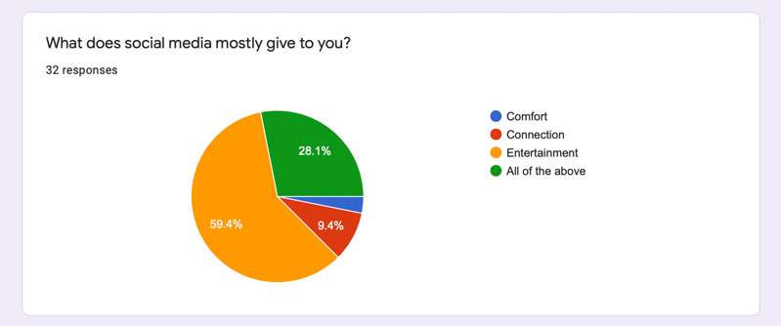

Figure 2- Results from question 2

In relation to my results, the majority of the participants stated that social media is 'sometimes' more business-based than social-based. 28.1% of my participants said it 'yes' is more business-based. However, a close percentage of 21.9% of my participants stated that it is NOT more business-based. These results could be counterintuitive as social media is social and the core of a large and growing market. I evaluated this concept throughout my research, suggesting points for and against the theory of social media being more economically driven; it can only be implied that social media is becoming more commercially focused.

When I asked my subjects when do they use social media, a staggering 68.8% said they use social media the most before bed according to Figure 10. I have yet to find out why people crave to use social media before bed. Could it be because they are done with all their daily tasks and commitments and finally have the time to use social media? The next most selected answer choice was 'In school' with 21.9% - this could be due to my sample of participants as they are all in the sixth form and have free lessons so they may be more able to use their mobile phones in school compared to younger students.

1. **When do you use social media the most?**

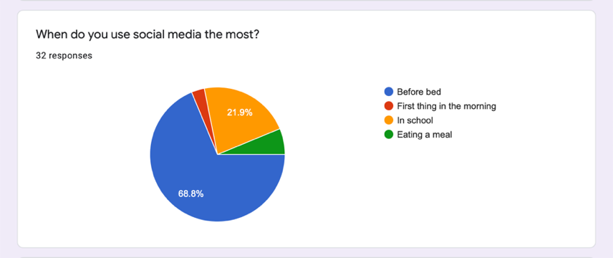

Figure 3- Results from question 3

When I asked my subjects whether social media ever made them feel worse about themselves, 46.9% said no, not at all and 40.6% said sometimes, as you can see from Figure 11.

1. **Has social media ever made you feel worse about yourself? (lower your self-steam)**

Figure 4- Results from question 4

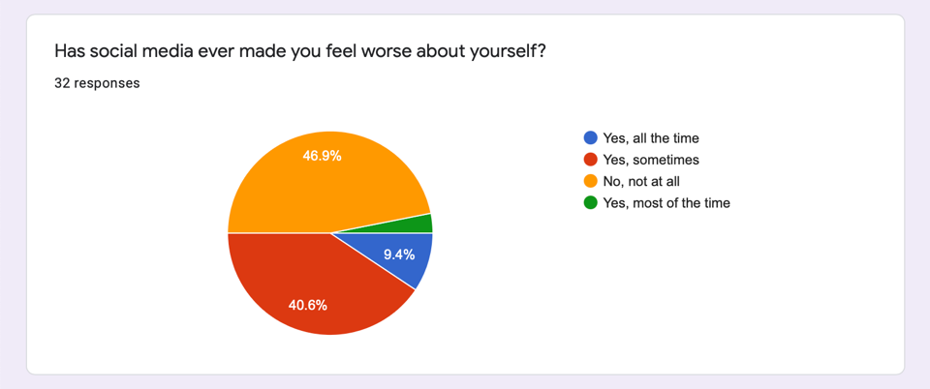

Almost all my respondents stated that social media does give them motivation and hopes for the future. This response is in contrast with the information by Akram (2018) as his article says that “The student’s motivation level lessens because utilization of these long-range interpersonal communication locales; “They depend on the virtual condition as opposed to increasing reasonable learning from this present reality." Perhaps the results are subjective to each individual's Instagram account, depending on the Instagram pages they follow.

1. 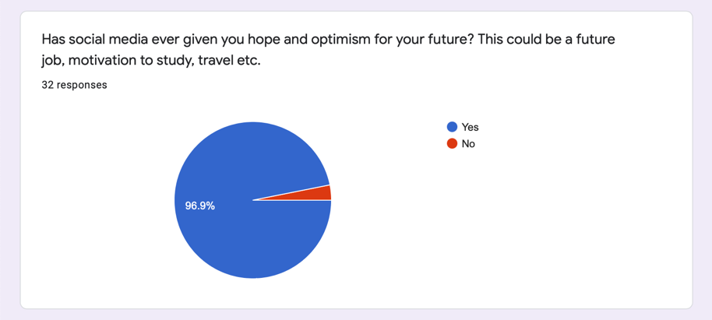**Has social media ever given you hope and optimism for your future? This could be a future job, motivation to study, travel, etc.**

Figure 5- Results from question 5

The results in Figure 13 show that out of 32 of my participants, roughly 60% said that it does not lower nor boost their confidence levels. This is contrary to the research I have looked at (Steinsbekk et al., 2021). Additionally, approximately 20% of my participants stated that it boosts their confidence levels; this correlates with (Bayer et al. 2016); however, he found that the positive effects only last for a short period. However, perhaps the individuals who selected this option of 'increased self-confidence' may have been active social media users (Steinsbekk and Wichstrøm, 2021). Around 20% of my respondents stated that social media lower their overall confidence levels. This correlates with (Burke et al., 2010). Overall, my findings are similar to Orben and Przybylski, (2019) and Utz and Breuer, (2016) as there is only very slight correlations between social media and confidence levels/well-being according to the respondent's results.

1. **Does social media boost your self-esteem (confidence) or lower your confidence levels?**

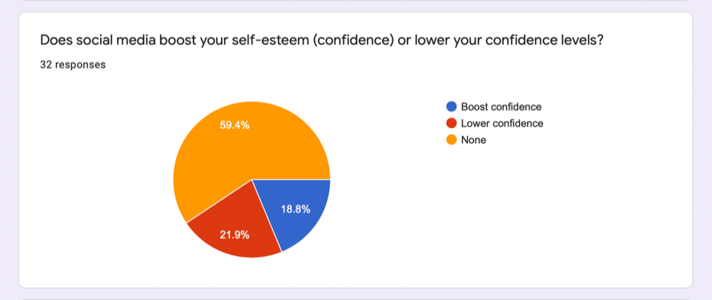

Figure 6- Results from question

Systematic reviews that examine older populations state that one in 8-12 studies find a null correlation, and the rest find a positive correlation between screen time and unfavorable psychological outcomes (Dennison et al., 2016). This shows an unclear link which is why I wanted to investigate this subject further by analyzing my experiment. Notwithstanding, the results in Figure 14 show that most students (31.3%) estimate that they spend around 3-4 hours on social media daily, but overall, the results between the answer choices are almost equal. Meaning that many of my participants are unaware of the amount of time on social media, as they could be spending a lot more time than expected or vice versa. Therefore, mirroring how they use social media; impulsively and treat it like a necessity.

Table 1- Results for question 7

1. **What was your average time spent on ‘social’ platforms last week (according to your screen time)?**

|  |  |
| --- | --- |
| **The average range of hours spent on social media per day** | **Number of students** |
| 2-3 | 8 |
| 4-5 | 7 |
| 6-7 | 5 |
| 8-9 | 3 |
| 10+ | 3 |

Screen time is the amount of time a user spends interacting with screens during a specific time frame (Orben, 2019). Table 1 shows that the majority of the participants spend 2-3 hours on social media per day. As you make your way down the table, the number of students decreases. This could be viewed positively due to less screen time or perceived negatively due to a lack of social interaction. However, if totaled (3 hours of social media per day for one week), that would add up to 21 hours per week.

### **3.1 Experiment results**

|  |  |
| --- | --- |
|  |  |

Table 2 and 3 show the results I gathered. These are the happiness scores before and after the experiment, using the online Pursuit of Happiness quiz (<https://www.pursuit-of-happiness.org/science-of-happiness/happiness-quiz/>) that gave a score out of 150 (150 being the highest). Since participants had to complete the same quiz twice, order effects could have occurred, which is the likelihood of participants getting better or bored when repeating the same task more than once, which means they would have lasting effects from the first time they completed the happiness quiz to the second, mainly because the time between completing the quiz is short (33 hours).

The participants who consent to participate tend to be less reliant on social media or perhaps more self-actualized than other individuals, which would decrease the reliability of this experiment. Moreover, since I asked participants individually to participate in the experiment, demand characteristics may have occurred. This is because I (the investigator) could have unconsciously spoken differently to participants (different tone of voice, smile more, etc.), which may have affected participants' behaviors, changing their natural behavior.

Table 2- Happiness scores before and after

|  |  |  |
| --- | --- | --- |
|  | Before | After |
| Average | 68.1 | 79.3 |
| Standard deviation | 19.9 | 21.3 |
| Minimum | 29.0 | 32.0 |
| Maximum | 114 | 116 |

The standard deviation before the experiment is around 20, and after the experiment, it is approximately 21. Similarly, the minimum and maximum scores became larger after the experiment. The average, however, is the most differentiated, with an average of 68.1 before and 79.3 after. The average happiness score with the standard deviation as an error bar is shown in Figure 16.

## 

## **3.2 Statistical Analysis and t-Test**

The average happiness score increased after 33 hours. However, after conducting a two-tail t-Test using a 95% confidence interval, the p-value was 0.00064, which is less than 0.05. This shows that there is a statistically significant difference between the two means.

Table 2- Female participants' happiness scores

|  |  |
| --- | --- |
| Before experiment | After experiment |
| 53 | 44 |
| 67 | 57 |
| 47 | 48 |
| 82 | 92 |
| 61 | 71 |
| 83 | 89 |
| 45 | 89 |
| 76 | 97 |
| 95 | 96 |
| 74 | 87 |
| 89 | 116 |
| 50 | 68 |
| 80 | 71 |
| 114 | 115 |
| 87 | 77 |
| 74 | 84 |
| 79 | 85 |
| 79 | 85 |
| 58 | 45 |
| 113 | 101 |
| 54 | 92 |
| 71 | 98 |
| 49 | 57 |
| 50 | 48 |

Overview of female participants’ happiness scores:

There were 24 female participants. The minimum happiness score within my female participants is 47 before the experiment and 44 after. Before the experiment was conducted, the highest happiness score was 114, and the highest after was 116. Female participants did score higher on the happiness quiz compared to male participants.

Table 3- Male participants' happiness scores

|  |  |
| --- | --- |
| Before experiment | After experiment |
| 62 | 71 |
| 82 | 96 |
| 95 | 92 |
| 72 | 78 |
| 43 | 65 |
| 90 | 97 |
| 46 | 64 |
| 92 | 99 |
| 89 | 93 |
| 62 | 104 |
| 29 | 32 |
| 75 | 104 |
| 89 | 88 |
| 84 | 76 |

Overview of male participants’ happiness scores:

There were 14 male participants. The lowest happiness score before the experiment is 29, and after the experiment is 32. The highest happiness score before completing the experiment is 95, and after the experiment is 104. Male scores before and after were overall lower than female participant scores. However, since my male sample size is smaller than my female sample size, I cannot conclude that males are overall less happy compared to females because this sample only ranges from ages 16-to 18. This means I cannot generalize my finding to the broader population as my sample may be unrepresentative of all males aged 16-18 years.

All in all, the average happiness scores between males and females before the experiment are equal (72.1). The happiness scores after the experiment are both similar, with females receiving an approximate mean of 81 and around 83 for males.

I conducted another two-tail t-Test to compare the averages between male and female happiness scores after the experiment. Figure 9 presents the average in a chart with error bars. I got a p value of 0.87460895 which is more than 0.05. Meaning that the average happiness score. Therefore, both male and female happiness scores increased to around the same extent.

Figure 8- Average happiness scores after experiment between males and females

## **4 Discussion**

There are many ways to test participants' happiness levels that may be more accurate than a quiz. For example, looking at biological factors – taking saliva and urine samples from participants and studying the changes in neurotransmitters and hormones. However, this was not feasible for me due to complexity issues. Moreover, happiness can be measured by studying behavior (smiling with your eyes and studying with a Duchenne smile) (Sugay et al., 2022), but this would have required observation which would be very time-consuming. Using a quiz may be unrepresentative of real-life happiness behaviors. Therefore, lowering the ecological validity of my experiment and its explanation that a 33-hour social media deprivation would increase happiness levels.

Moreover, I trusted participants not to check social media for 33 hours during the experiment. However, I could have activated participants' screen time to ensure they did not use any social media platforms during the 33-hour period. Doing so may have increased the internal validity of my experiment, but doing this would have also created an unethical invasion of privacy. I could have asked for consent for doing so but gathering participants for this experiment was already quite challenging and so informing participants to activate their screen time may have made participants less willing to participate in this experiment.

Furthermore, as I gathered participants, I noticed that males were less likely to participate. This may mirror males' dependence on social apps, including online video games. All of the four participants who withdrew were males. Perhaps females are more aware of issues caused due to excess social media use and hence are more self-actualized and determined to use it less often.

Since 27/38 (71%) of the participants had an increase in happiness scores, this would correspond to a study conducted by (Hoare, 2016). However, 29% of participants decreased their happiness scores, correlating with (Carson et al., 2016). It also relates with (Verduyn et al., 2017) as he hypothesized that an increase in screen time boosts well-being. Similarly, (Dienlin et al., 2017) as this experiment discovered that those who use social media frequently as a source of communication are more satisfied with their lives. However, there is a lack of studies that evaluate the effects of prohibiting social media on well-being over a long time (Dienlin et al., 2017), and those investigations would be practical when studying well-being because wellness includes many things other than positive and negative effects, such as life satisfaction (Diener et al., 1999). Perhaps increasing the duration of social media deprivation could have created a much more significant increase in happiness levels.

# **5 Conclusion**

In conclusion, my experiment has shown that social media can negatively impact teenagers' happiness levels and, consequently, teenagers' well-being to a certain extent. 34.4% of my questionnaire participants stated that social media had had a daily impact on their procrastination levels with a score of 4 or 5. This reflects the negative consequences of using social media extensively. Additionally, 68.8% of my participants stated that they most use social media mostly before bed. This is a drawback as social media has been positively associated with disturbed sleep (Levenson et al., 2017). In a study on 1,763 US young adults (aged 19-32) in the USA, those who checked social media 30 minutes before bed had increased sleep disturbance (adjusted odds ratio of 95% confidence interval=1.31-2.34) (Levenson et al., 2017). Moreover, if the hours of social media used per day, by my questionnaire respondents, were to be totaled (3 hours of social media per day for seven days), it would add up to 21 hours of social media per week – this is nearly an entire day of each week consumed by social media usage.

Both, male and female teenagers became happier after the experiment to around the same extent. Therefore, there was no significant difference between the happiness score of males and females after they restrained from social media for 33 hours.

Altogether, social media can bring entertainment, escapism, connection, and information. However, its consumption can inevitably cause demotivation through self-comparisons and so create a change in our overall happiness levels. It has the ability to allow you to connect with loved ones around the world and actively enhance our society in many ways. Unfortunately, it has been proven that social media can cause destructive effects on teenagers' well-being, which can impact their daily performance. For example, in school, poor sleep or distraction results.

Therefore, social media negatively impacts teenagers' happiness and well-being. Meaning that social media users should treat social media with extreme caution.

# **References**

Allcott, Hunt, Luca Braghieri, Sarah Eichmeyer, and Matthew Gentzkow. (2019) ‘The Welfare Effects of Social Media.’ *American Economic Review*, 110 (3): 629-76. <https://web.stanford.edu/~gentzkow/research/facebook.pdf>

Amy, O. (2019) 'Teenagers, screens, and social media: a narrative review of reviews and key studies,' *Social Psychiatry and Psychiatric Epidemiology,* 55:407-414

Britannica, T. Editors of Encyclopaedia (2021). Myspace. *Encyclopedia Britannica* [Online]. Available at: <https://www.britannica.com/topic/Myspace> (Accessed: 18/12/2021)

Burke, M., Kraut, E. and Kraut. (2016) 'The Relationship Between Facebook Use and Well-Being Depends on Communication Type and Tie Strength,' *Journal of Computer-Mediated Communication, 21(4)*, p265-281 <https://academic.oup.com/jcmc/article/21/4/265/4161784>

Burke, M., Marlow, C., and Lento, T. (2010) 'Social network activity and social well-being,' *SIGCHI Conference on Human Factors in Computing*, p1909-1912 <https://dl.acm.org/doi/10.1145/1753326.1753613>

Blumler, J. G. (1979) ‘The Role of Theory in Uses and Gratifications Studies’, *Communication Research*, 6(1), pp. 9–36. [10.1177/009365027900600102](https://doi.org/10.1177/009365027900600102)

Carson, V. Hunter, S., Kuzik, N., Gray, C., Poitras, V., Chaput, J., Saunders, T., Katzmarzyk, P., Okely, A., Gorber, S., Kho, M., Sampson, M., Lee, H., and Tremblay, M. (2016)‘Systematic review of sedentary behavior and health indicators in school-aged children and youth: an update,' *Applied Physiology, Nutrition, and Metabolism*. **41**(6 (Suppl. 3)): S240-S265. <https://doi.org/10.1139/apnm-2015-0630>

Clark, S. (2017) How Does Social Media Impact Bipolar Disorder? *International Bipolar Foundation* [Online]. Available at: <https://ibpf.org/how-does-social-media-impact-bipolar-disorder/> (Accessed: 04/12/21)

Dennison, M., Sisson, SB., and Morris A. (2016) ‘Obesogenic behaviors and depressive symptoms in children: a narrative literature review,' *Obesity Reviews, 1*7(8), p735-757 <https://onlinelibrary.wiley.com/doi/10.1111/obr.12419>

Diener, E., Suh, E. M., Lucas, R. E., and Smith, H. L. (1999) ‘Subjective well-being: Three decades of progress,' *Psychological Bulletin*, 125(2), 276–302.

Dienlin, T., Masur, P., and Trepte, S. (2017) 'Reinforcement or Displacement? the Reciprocity of FTF, I.M., and SNS Communication and Their Effects on Loneliness and Life Satisfaction', Journal of Computer-Mediated Communication, 22 (2), p71–87, <https://doi.org/10.1111/jcc4.12183>

Dunlin, T., Masur, PK., and Trepte, S. (2017) 'Reinforcement or displacement? The reciprocity of FTF, I.M., and SNS Communication and Their effects on Loneliness and Life Satisfaction', *Journal of Computer-Mediated Communication,* 22(2), p71-87 <https://academic.oup.com/jcmc/article/22/2/71/4161796>

Festinger, L. (1954) ‘A Theory of Social Comparison Processes’, *SAGE Social Science Collections,* 7(1), p117-140 <https://journals.sagepub.com/doi/abs/10.1177/001872675400700202?journalCode=huma>

Fisher. (2020) “Media Studies – Uses & Gratifications Theory – Simple Guide” YouTube video [Online] Available at: <https://www.youtube.com/watch?v=_1pBBnnWbDQ> ]. (Accessed: 28/01/22)

Frinson E., and Eggermont S. (2017) 'Browsing, Posting, and Liking on Instagram: The Reciprocal Relationships Between Different Types of Instagram Use and Adolescents' Depressed Mood,' *Cyberpsychology, Behaviour, and Social Networking*, 20(10), p603-609 <https://www.liebertpub.com/doi/abs/10.1089/cyber.2017.0156>

Gonzales, A., & Hancock, J. ‘Mirror, Mirror on my Facebook Wall: Effects of Exposure to Facebook on Self-Esteem’, *Cyberpsychology, Behavior, and Social Networking,* 14(1-2) <https://www.liebertpub.com/doi/abs/10.1089/cyber.2009.0411>

Gauntlett, D. (2008). *Media, Gender, and Identity.* 2nd edition. 2 Park Square, Milton Park, Abingdon, Oxon OX14 4RN Simultaneously published in the USA and Canada: Routledge 270 Madison Ave, New York, NY 10016.

Hoare, E., Milton, K., Foster, C., and Allender, S*.* (2016) ‘The associations between sedentary behavior and mental health among adolescents: a systematic review,' *Int J Behav Nutr Phys Act* **13,**108, <https://doi.org/10.1186/s12966-016-0432-4>

<https://www.statista.com/statistics/1059462/social-media-usage-uk-age/> (Accessed: 23/12/21)

Krause, H., Baum, K., Baumann, A., and Krasnova, H. (2019) 'Unifying the detrimental and beneficial effects of social network site use on self-esteem: a systematic literature review,' *Media Psychology*, 24(1), p10-47 <https://www.tandfonline.com/doi/full/10.1080/15213269.2019.1656646>

Levenson, J., Sehnsa, A., Sidani, J,. Colditz, J., and Primack, B. (2017) 'Social Media use Before Bed and Sleep Disturbance Among Young Adults in the United States: A Nationally Representative Study,' *Sleep,* 40(9) <https://academic.oup.com/sleep/article/40/9/zsx113/3926043?login=true>

Orben, A., and Przybylski A. K. (2019) 'The association between adolescent well-being and digital technology use,' *nature human behavior,* p173-182 <https://www.nature.com/articles/s41562-018-0506-1>

Phillippe, V., Oscar, Y., Maxime, R., John, J., and Ethan, K. (2017) ‘Do Social Network Sites Enhance or Undermine Subjective Well-being? A Critical Review’, *Social Issues and Policy Review,* 11 (1), p274-302

Rousseau, A., Eggermont, S., and Frison, E. (2017) 'The reciprocal and indirect relationship between passive Facebook use, comparison on Facebook, and adolescents' body dissatisfaction,' *Computers in Human Behavior, 73,* p336-344 <https://www.sciencedirect.com/science/article/abs/pii/S0747563217302157>

Steinbekk, S., Wichstrom, L., Stenseng, F., Nesi J., Hygen B., and Skalicka, V. (2021) ‘The impact of social media use on appearance self-esteem from childhood to adolescence - A 3-wave community study’, *ScienceDirect*, 114, <https://www.sciencedirect.com/science/article/pii/S0747563220302806#bib11>

Steinsbekk, S. and Wichstrøm, L. (2018) 'Cohort Profile: The Trondheim Early Secure Study (TESS) – a study of mental health, psychosocial development and health behavior from preschool to adolescence, *International Journal of Epidemiology,* 47(5), p1401-1401i <https://academic.oup.com/ije/article/47/5/1401/5094968>

Sugay, C. (2022) “How to Measure Happiness With Tests and Surveys (+Quizzes)” [Online]. Available at: <https://positivepsychology.com/measure-happiness-tests-surveys/> (Accessed: 11/02/22)

*The Social Dilemma*. 2020. [film] Directed by J. Orlowski. Colorado: Exposure Labs Argent Pictures

Tremblay, M.S., LeBlanc, A.G., Kho, M.E., *et al*. (2011) 'Systematic review of sedentary behavior and health indicators in school-aged children and youth,' *Int J Behav Nutr Phys Act* **8,**98 <https://doi.org/10.1186/1479-5868-8-98>

Tromholt, M. (2016). 'The Facebook experiment: quitting Facebook leads to higher levels of well-being,' *Cyberpsychology, Behavior, and Social Networking,* 19(11) <https://www.liebertpub.com/doi/10.1089/cyber.2016.0259>

Utz, S., and Breuer, J. (2016) 'Informational benefits from social media use for professional purposes: Results from a longitudinal study, *Journal of Psychosocial Research On Cyberspace, 16(1)* <https://cyberpsychology.eu/>

Vanman, EJ., Baker, R., and Tobin, SJ. (2018) 'The burden of online friends: the effects of giving up Facebook on stress and well-being, *The Journal of Social Psychology,* 158(4), p496-508 <https://www.tandfonline.com/doi/full/10.1080/00224545.2018.1453467>

Verduyn, P., Ybarra, O., Resibois, M., Jonides, J., and Kross, E. (2017) 'Do Social Network Sites Enhance or Undermine Subjective Well-Being: A Critical Review*,' Social Network Sites & Subjective Well-being,* <https://deepblue.lib.umich.edu/bitstream/handle/2027.42/136039/sipr12033_am.pdf>

Viera, C., Shensa, A., Bowman, N., Sidani, J., Knight, J., James, A., and Primack, B. (2018) 'Passive and Active Social Media Use and Depressive Symptoms Among United States Adults,' *Cyberpsychology, Behavior, and Social Networking,* 21(7) <https://www.liebertpub.com/doi/full/10.1089/cyber.2017.0668>

Waseem, A. (2018) 'A Study on Positive and Negative Effects of Social Media on Society,' *International journal of computer science and engineering*, 5(10) pages 347-354 <https://www.researchgate.net/profile/Waseem-Akram-19/publication/323903323_A_Study_on_Positive_and_Negative_Effects_of_Social_Media_on_Society/links/5ab1c064a6fdcc1bc0bfefef/A-Study-on-Positive-and-Negative-Effects-of-Social-Media-on-Society.pdf>