Tahani S. Alangari

Imam Abdulrahman Bin Faisal University, Dammam, Saudi Arabia

The Predictors of Student Engagement:

Instructional support vs. Emotional support

[1]

***Abstract***— Student success can be impacted by internal factors such as their emotional well-being and external factors such as organizational support and instructional support in the classroom. This study is to identify at least one factor that forecasts student engagement. It is a cross-sectional, conducted on 6206 teachers and encompassed three years of data collection and observations of math instruction in approximately 50 schools and 300 classrooms. A multiple linear regression revealed that a model predicting student engagement from emotional support, classroom organization, and instructional support was significant. Four linear regression models were tested using hierarchical regression to examine the effects of independent variables: emotional support was the highest predictor of student engagement while instructional support was the lowest.

*Keywords*— student engagement, emotional support, organizational support, instructional support.

# INTRODUCTION

S

tudent engagement is a critical aspect of student success, as engaged students are more likely to be motivated, achieve higher academic performance, and exhibit positive behaviors in the classroom [1]. Effective teaching methods and active student involvement are critical indicators of instructional support, which alongside emotional assistance, predicts student engagement. One of the key aspect of instructional support is engaging students and creating concise instruction, as well as opportunities for participation in lessons [2]. Numerous research publications have also emphasized the benefits of instructional support on engagement, revealing a positive correlation between teacher support of student autonomy and engagement. Furthermore, the students' sense of competence was found to play a mediation role in this relationship [3].

In the classroom, a positive sense of belonging and self-efficacy can be promoted through instructional support. Studies showed that the support that teachers provide in the classroom has an impact on the engagement of students. Other research also showed a positive correlation between a student's sense of belonging and their level of engagement, and the students' perceptions of the support they received from their teacher mediated this relationship [4].

In promoting student engagement, emotional support has become a topic of great interest lately. Research emphasized on the significance of emotional support in fostering engagement, indicating that students who feel supported and connected to their peers and teachers are more likely to be engaged while in the classroom [5]. A study found a positive relationship between emotional support from teachers and student engagement, with the students' classroom sense of belonging mediating this relationship [6]. In addition, student engagement can be influenced by the emotional support provided by peers. In their study, they discovered that positive peer relationships correlated with heightened engagement, whereas poor relationships negatively impacted student engagement [6]. Research also found that social support from peers is positively related to engagement among students from low-income backgrounds [4].

Classroom organization is another important indicator of student engagement. Classroom organization establish clear rules and routines that effectively manage student behavior, and create a positive and supportive classroom climate [1]. Multiple studies have shown that classroom organization is positively correlated with engagement. For instance, a found that classroom organization was positively correlated with participation, and that this relationship was determined by students' sense of autonomy and ability adjust [5].

Other research has highlighted the importance of classroom organization in indirectly promoting engagement by reducing students' anxiety and encouraging their sense of control. For instance, study) found that classroom organization was negatively associated with student anxiety and that this relationship was mediated by students' perceptions of teacher support [7].

Despite numerous studies on student engagement, there are many gaps in research. For instance, there is lack of research that focuses on how different predictors of engagement interact with each other. In this case, there is a need to deeper understand of how these predictors work together to create engagement in students. A study discovered that engagement had a positive association with instructional and emotional support [8]. However, the impact of these two factors was not independent. Another study found that emotional support's association with engagement was more robust when instructional support was high [9]. This implies that engagement is affected by a complicated interplay between instructional and emotional support. Another gap in the literature is the need for more research examining the role of cultural and contextual factors in predicting engagement. For instance, a research pointed out that teacher support is intricately linked to student engagement, however, the strength of this correlation changes across cultural settings, being more robust in collectivistic regions than it is in individualistic ones [10].

Consequently, it can be drawn that internal elements such as emotional well-being can influence student achievement, as can external factors such as organizational support and instructional assistance in the classroom [11]. Student engagement is a useful indicator of examining the effect of these factors on student success. While there is an extensive body of research examining predictors of student engagement, there is still a gap in our understanding of the specific factors that most strongly predict student engagement and it is not clear the casual relationship among these factors with student engagement and which factor is dominant. Therefore, this study will endeavor to expound on the above relationship to identify at least one factor that forecasts student engagement by answering the question: what is the relationship between emotional, organizational, and instructional support and student engagement? And testing the following Hypotheses:

Null Hypothesis

Emotional support, classroom organization, and instructional support do not predict student engagement.

Alternative Hypothesis

At least one of the factors from emotional support, classroom organization, and instructional support predicts student engagement.

# II. Method

The National Center for Teacher Effectiveness is part of CPSR, the Inter-university Consortium for Political and Social Research. Data came from a study, which involved 6206 math teachers, was cross-sectional in nature and spanned three years of data collection and observations of math instruction in about 50 schools and 300 classrooms. Data were gathered from teacher surveys, student assessments, and classroom observations. Using a seven-point Likert scale, the observational data was quantitatively coded into three categories: Low (1,2), Mid (3,4,5), and High (6,7) [12].

# III. Results

## Descriptive Statistics

For all the variables examined, the minimum rating was low range and the maximum rating was high range (See table 1). For student engagement, the minimum rating was 1.00 and the maximum rating was 7.00; for total emotional support, the minimum rating was 3.00 and the maximum rating was 14.00; for total class organization, the minimum rating was 4.00 and the maximum rating was 14.00; for total instructional support, the minimum rating was 5.00 and the maximum rating was 32.00. Also, student engagement was approximately normally distributed (Skewness = -0.05, SE = 0.03).

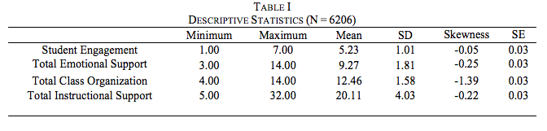

Overall student engagement seems to increase with an increase in the total instructional support rating. This is supported by the observation that the overall student engagement shifts up one unit with a shift in the total instructional support rating from 1 to 2. Also, overall student engagement shifts from 3 to 4, 4 to 5 and 5 to 6 with a shift in the total instructional support rating from 20 to 25, 25 to 30 and 30 to 35 respectfully. However, this pattern does not seem to be consistent across the dataset as for the same level of total instructional support rating, there are different levels of student engagement. For example, for the total instructional support rating of 20, student engagement rating ranges from 3 to 7. So, at the same level of instructional support, while some students engaged poorly others seem to be engaging strongly.

A substantial model predicting student involvement from emotional support, classroom organization, and instructional assistance was discovered using multiple linear regression (F (3,6107) = 864.67, p < .001). Specifically, while controlling for other variables in the model constant: per unit of increase in the total rating of emotional support, student engagement increases by 0.039 units (B = .039, t = 5.00, p < .001, 95% CI: (.024, .054)); per unit of increase in the total rating of classroom organization, student engagement increases by 0.137 units (B = .137, t = 19.15, p < .001); per unit of increase in the total rating of instructional support, student engagement increases by 0.099 units (B = .099, t = 28.60, p < .001). Also, overall, the model was found to be a good fit (R2adj. = .298). Therefore, 29.8% of the variance in Student Engagement can be accounted by emotional support, classroom organization, and instructional support.

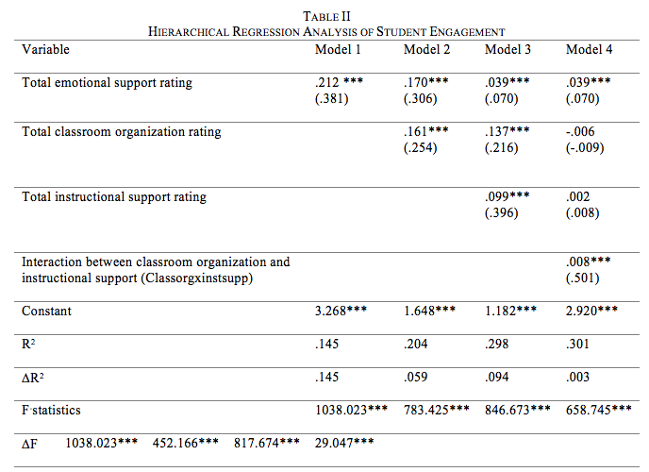

Four linear regression models were tested using hierarchical regression to examine the effects of independent variables: emotional support (first model), classroom organization (added in the second model), instructional support (added in the third model) and the interaction between classroom organization and instructional support (added in the final model) on the dependent variable: student engagement (see table 2). The first model contained total emotional support rating as the predictor: predicted value of student engagement = 3.268 + .212*(total emotional support rating). The model was found to be significant, F(1, 6109) = 1038.02, p < .001. Also, the model showed a good fit where 14.5 % of the variance in student engagement was explained by the model (R2 = .145). Total emotional support rating had a significant positive impact on student engagement where there was an increase of .212 unit in student engagement per unit of increase in total emotional support rating (B = .212, t = 32.22, p <.001).

The second model contained an additional predictor variable, total classroom organization rating: predicted value of student engagement = 1.648 + .170*(total emotional support rating) + .161*(total classroom organization rating). The model remained significant, F(2, 6108) = 783.43, p < .001. Also, the model showed a good fit where 20.4% of the variance in student engagement was explained by the model (R2 = .204). The addition of total classroom organization rating explained additional 5.9% of the valiance in student engagement compared to the first model (R2 change = .059, Fchange = 452.17, p < .001). While keeping the total emotional support rating constant, there was an increase of .161 unit in student engagement per unit of increase in total classroom organization rating (B = .161, t = 21.26, p <.001).

An additional predictor variable was included in the third model: predicted value of student engagement = 1.182 + .039*(total emotional support rating) + .137*(total classroom organization rating) + .099*(total instructional support rating). The addition of total instructional support rating explained additional 9.4% of the valiance in student engagement compared to the second model (R2 change = .094, Fchange = 817.67, p < .001). The model showed a good fit where 29.8 % of the variance in student engagement was explained by the model (R2 = .298). While keeping total emotional support and total instructional support ratings constant, student engagement increased by .137 units per unit of increase in total classroom organization rating (B = .137, t = 19.15, p <.001). Also, while keeping total emotional support and total classroom organization ratings constant, student engagement increased by .099 units per unit of increase in total instructional support rating (B = .099, t = 28.60, p <.001).

In the final model, a term representing the interaction between total classroom organization and total instructional support ratings was added to the predictor variable in the third model: predicted value of student engagement = 2.920 + .039*(total emotional support rating) - .006*(total classroom organization rating) + .002*(total instructional support rating) +.008*(total classroom organization rating*total instructional support rating). Multicollinearity was detected for total classroom organization rating (VIF = 16.37, Tolerance = .061) and total instructional support rating (VIF = 46.81, Tolerance = .021). The addition of interaction term explained additional .30% of the valiance in student engagement compared to the third model (R2 change = .003, Fchange = 29.05, p < .001).

The model was a good fit where 30.1 % of the variance in student engagement was explained by the model (R2 = .301). While keeping the total classroom organization and total instructional support ratings and the interaction term constant, a small but significant effect of total emotional support on student engagement remained (B = .039, t = 5.00, p < .001). Also, while keeping total emotional support, total classroom organization, and total instructional support ratings constant, there was a small but significant effect of the interaction between total classroom organization and total instructional support ratings on student engagement (B = .008, t = 5.39, p < .001).

Since after addition of the interaction term, the effects of classroom organization and instructional support were no longer significant, instructional support is a full moderator of classroom organization. So, the relationship between classroom organization and student engagement is moderated by the level of instructional support. Also, since there was still a significant effect of emotional support on student engagement after addition of interaction term, instructional support does not seem to be moderating the relationship between emotional support and student engagement. These results support the importance of both instructional support and classroom organization in addition to emotional support on student engagement.

Since it is not clear whether the impact of emotional support on student engagement is mediated by organizational support and Instructional support in the classroom. Also, it is not clear whether there is a casual relationship between classroom organization and student engagement mediated by instructional support separate from a causal relationship between emotional support and student engagement mediated by instructional support. Here a path analysis is conducted to test the hypotheses that an increase in emotional support causes an increase in student engagement mediated by classroom organization and instructional support (see figure 1).

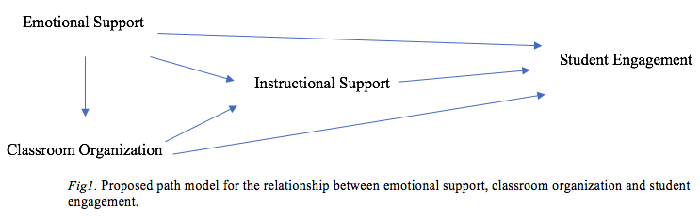

Three different regression analyses were conducted to test the hypothesis. The direct effect of each of the predictor variables (the variables with arrows pointing away from them in figure 1) on the dependent variable (the variable with arrows pointing to it) was expressed as the standardized regression coefficient (β) for each. The indirect effect of each predictor variable was calculated by taking the product of the direct effect of each of the predictor variables on the mediating variable and that of the mediating variable on the dependent variable. Additionally, the error (e) was calculated as a square root of the unexplained variance in the dependent variable (√(1-R2)) for each of the regression models (figure 2). The total associations between the emotional support and student engagement and between classroom organization and student engagement were calculated as correlation coefficients, r = .380 and r = .344.

The effect of emotional support and classroom organization on instructional support was tested by a regression analysis with emotional support and classroom organization as predictor variables and instructional support as dependent variable: Instructional Support = $4.722+ .598 × Emotional support+ .095 × Classroom orgnaization.$ There were significant (p < .001) direct effects of emotional support (β = .598) and classroom organization (β = .095) on instructional support with the error, e = .775 (see Figure 2).

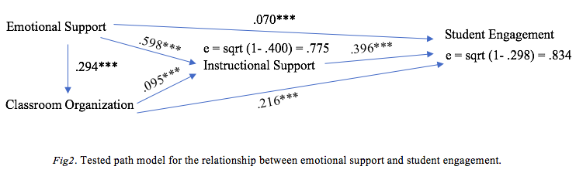

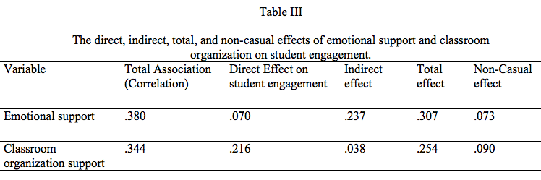The effects of emotional support, classroom organization and instructional support on student engagement was examined with regression model: Student Engagement = $1.182+ .070$ $× Emotional support+ .396 × Instructional support+.216 × Classroom organization$. The direct effects of emotional support (β = .070), classroom organization (β = .216), and instructional support (β = .396) on student engagement were found to be significant (p < .001) with error, e = .834 (see Figure 2). The indirect effect of emotional support on student engagement via instructional support was calculated as .598*.396 = .237 and of classroom organization on student engagement via instructional support was calculated as .095* .396 = .038. The total effects of emotional support and classroom organization on student engagement were calculated as the sums of direct and indirect effects to yield .307 and .253 respectively. The non-casual effects of emotional support (.073) and classroom organization (.090) on student engagement were calculated by subtracting the respective total effects from the corresponding total associations (see Table 3).

To test whether there was a substantial effect of emotional support on student engagement via classroom organization and instructional support, a regression analysis with emotional support as the predictor and classroom organization as the dependent variable was conducted: classroom organization = 10.068 + .294 X Emotional Support. There was a significant (p < .001) direct effect of emotional support (β = .294) on classroom organization with error of the regression model, e = .914 (see Figure 3).

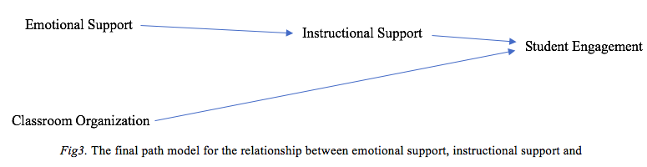

Since the error of the regression model for the relationship between emotional support and classroom organization was the largest of the three (see figure 2), the path from emotional support to classroom organization was discarded in the final path model (see figure 3). Also, since the direct effect of emotional support and the indirect effect of classroom organization on student engagement were negligible, the corresponding paths were discarded from the final path model (see figure 3). Therefore, based on the path analysis, instructional support influences student engagement; emotional support has no direct effect on student engagement, but has an indirect effect when mediated by instructional support; classroom organization only has a direct effect on student engagement. Also, emotional support via instructional support, has relatively greater causal effect on student engagement. Based on the results, emotional support, in combination with instructional support, is likely to lead to greater student engagement. Also, classroom organization, even without instructional support, has a substantial effect on student engagement.

Student engagement is the dependent variable that has been selected to be a binary variable. The range value of this variable is from 1 to 7. In this case, these numbers have been divided into two groups. The first group named 0 includes the values 1 through 4 that indicates not engagement while the second group named 1 includes the values 5 through 7 that indicates engagement. The correct percentage of not engagement is 25.8% while the correct percentage of engagement is 95.7%.

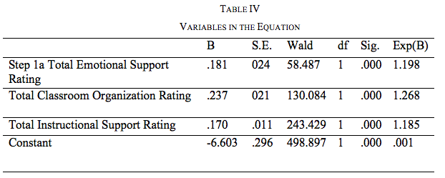

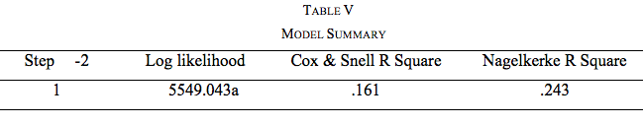

Based on Hosmer and Lemeshow Test (Chi-square 79.16, P-value= 0) indicates that the model fits the data well. Moreover, Nagelekerke R square is 0.243, and it can be seen from the classification table that around 80% of cases were classified and 25.8% of these cases were not engaged.

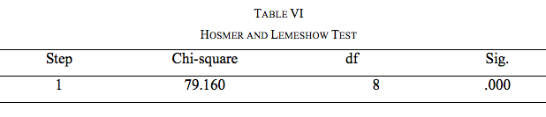

Since the significant levels of emotional, classroom organization and instructional support are below 0.05, null hypotheses are rejected and the alternative hypotheses are accepted. Therefore, it is true that emotional, classroom organization, and instructional support have a positive effect on the status of engagement. Meaning that there is a direct relationship between the independent variables- emotional, classroom organization, and instructional support- and the status of engagement- the more emotional, classroom organization, and instructional support, the greater the engagement. The odds of engagement will increase by 20% (Exp (B)-1) when the total emotional support rating increased by one unit holding the other variables fixed. The odds of engagement will increase by 27% (Exp (B)-1) when the total classroom organization rating increased by one unit holding the other fixed constant. The odds of engagement will increase by by 18.5% (Exp (B)-1) when the total instructional support increased by one unit from 1-2 holding the other fixed constant.

IV. Discussion

The study results showed that the emotional support from teachers is the strongest predictor of student engagement, while instructional support is the weakest. The study also found that classroom organization is a significant predictor of student engagement. Previous studies have also highlighted the significance of emotional support in encouraging student engagement [2]-[5]-[11]-[12].

. The results of this study affirm the importance of emotional support as the top predictor of student engagement. Significant and positive teacher-student relationships have been found to predict student engagement and achievement [7]. studies supported this, as it associates engagement with a teacher's commitment, efficacy, and a supportive school environment. Although instructional support is crucial, it seems to have a weaker correlation with student engagement [13]. This highlights the importance of teachers focusing on creating a supportive emotional environment in the classroom, in addition to providing clear and effective instruction.

The findings were also consistent with various research on the importance of emotional support for student success. For instance, a study found that students who perceive emotional support from their teachers are more likely to be engaged in school and have higher academic achievement [14]. In this case, this study highlights the importance of emotional support in promoting student engagement. Educators should, therefore, consider ways to develop positive relationships with their students and provide emotional support. This includes creating a welcoming classroom environment, getting to know students on a personal level, and providing opportunities for students to discuss their feelings and concerns. Also, a study emphasized the importance of classroom organization in promoting student engagement [15]. Therefore, educators should consider ways to organize their classrooms effectively and provide clear expectations and routines for their students. Also, educators should consider ways to provide effective instruction that meets the needs of all students and promotes active engagement in learning [16].

V. Conclusion

In this research, the findings highlight the importance of emotional support, instructional support, and classroom organization in promoting engagement. However, promoting engagement in students requires school administrators and teachers to prioritize establishing a supportive classroom climate, employing effective instructional practices, and providing emotional support. These strategies, therefore, requires extra funds to be allocated for the program. Second, the findings suggest that efforts to promote engagement should take a comprehensive and holistic approach, considering the interactions between different predictors of engagement. Teachers and school administrators should consider how emotional support, instructional support, and classroom organization may interact to impact engagement, and should strive to create a classroom environment that promotes engagement in multiple ways.

In addition, the findings highlight the need for more research examining the role of cultural and contextual factors in predicting engagement. Educational researchers should work to expand our understanding of how different cultural and contextual factors may impact engagement, and should strive to identify effective strategies for promoting engagement across diverse settings.

Student engagement is a critical aspect of student success. The current study has identified emotional support to be the highest predictor of student engagement while instructional support was the lowest. While there is still a need for more research examining the interactions between different predictors of engagement and the role of cultural and contextual factors, the current research has important implications for educational practice. By prioritizing efforts to provide emotional support, create engaging instructional practices, and establish a positive and supportive classroom climate, educators can promote engagement and enhance student success.

# References

[1] Konold, T., Cornell, D., Jia, Y., & Malone, M. (2018). School climate, student engagement, and academic achievement: A latent variable, multilevel multi-informant examination. Aera Open, 4(4), 2332858418815661.

[2] Fredricks, J. A., Blumenfeld, P. C., & Paris, A. H. (2004). School engagement: Potential of the concept, state of the evidence. Review of Educational Research, 74(1), 59-109.

[3] Reeve, J., & Tseng, C. M. (2011). Agency as a fourth aspect of students' engagement during learning activities. Contemporary Educational Psychology, 36(4), 257-267.

[4] Wigfield, A., & Fredricks, J. A. (2015). Academic motivation: Origins and contemporary perspectives. In K. R. Wentzel & D. B. Miele (Eds.), Handbook of motivation at school (pp. 3-23). New York: Routledge.

[5] Martin, A. J. (2009). Motivation and engagement across the academic lifespan: A developmental construct validity study of elementary school, high school, and university/college students. Educational and Psychological Measurement, 69(5), 794-824.

[6] Wang, M. T., & Eccles, J. S. (2013). School context, achievement motivation, and academic engagement: A longitudinal study of school engagement using a multidimensional perspective. Learning and Instruction, 28, 12-23.

[7] Henderlong, J., & Lepper, M. R. (2002). The effects of praise on children's intrinsic motivation: A review and synthesis. Psychological Bulletin, 128(5), 774-795.

[8] Roorda, D. L., Koomen, H. M. Y., Spilt, J. L., & Oort, F. J. (2011). The influence of affective teacher-student relationships on students' school engagement and achievement: A meta-analytic approach. Review of Educational Research, 81(4), 493-529.

[9] Henriksen, R. E., & Murdock, J. L. (2016). A systematic review of the relationship between teacher support and student engagement. Educational Research Review, 18, 1-16.

[10] Ok, A., & Tura, G. (2018). Teacher support and student engagement: A cross-national analysis of student-level data from 55 countries. Educational Research and Evaluation, 24(1-2), 54-70.

[11] Reschly, A. L., Huebner, E. S., Appleton, J. J., & Antaramian, S. (2008). Engaging school environments, teacher commitment, and teacher efficacy during the middle school years. Applied Developmental Science, 12(1), 1-14.

[11] Wentzel, K. R. (2009). Peers and academic functioning at school. In K. H. Rubin, W. M. Bukowski, & B. Laursen (Eds.), Handbook of peer interactions, relationships, and groups (pp. 531-547). New York: Guilford Press.

[12] Kane, T., Hill, H., & Staiger, D. (2016). National Center for Teacher Effectiveness Main Study. Ann Arbor, MI: Inter-university Consortium for Political and Social Research [distributor]. <https://doi.org/10.3886/ICPSR36095.v3>.

[13] Skinner, E. A., Kindermann, T. A., & Furrer, C. J. (2009). A motivational perspective on engagement and disaffection conceptualization and assessment of children's behavioral and emotional participation in academic activities in the classroom. Educational and Psychological Measurement, 69(3), 493-525.

[14] Van der Want, A. C., Den Brok, P., Beijaard, D., Brekelmans, M., Claessens, L. C. A., & Pennings, H. J. M. (2015). Factors influencing teacher learning and development. Educational Research Review, 15, 1-17.

[15] Wigfield, A., & Eccles, J. S. (2002). The development of competence beliefs, expectancies for success, and achievement values from childhood through adolescence. In A.

[16] Ladd, G. W., & Dinella, L. M. (2009). Continuity and change in early school engagement: Predictive of children's achievement trajectories from first to eighth grade? Journal of Educational Psychology, 101(1), 190-206.

1. T. S. Alangari is an Assistant Professor of Curriculum and Instruction in the Collage of Education at Imam Abdulrahman Bin Faisal University, Dammam, Saudi Arabia (corresponding author, e-mail: tsalrajeh@iau.edu.sa).