**Risk Management and Organizational Performance: mediating the Role of Corporate Sustainable Development and Innovation Capability: Evidence from Jordan .**

**Introduction**

The Enterprise Risk Management (ERM) has been growing since the 1990s because organizations are subjected to various shocks in their competitive settings (Yang et al., 2018). Several studies claimed that firms with advanced levels of ERM implementation generate higher levels of organizational performance, practically financial performance( Rasid et al. 2014; Florio & Leoni, 2017; and Chairani, &Siregar, 2021).Recently, the inspiration of sustainable corporate development (CSD) is a rising trend in ’ ’today’s business reality(Tien et al., 2020). Therefore, Firms pay attention to CSD,which consider as a significant factor for ”firms’successand to improve business performancein the context of globalization and environmental turbulence ( Drobyazko et al. 2019). In this matter, CSD is an approach to developing long-term wealth by integrating strategies for economic success, environmental quality, and social capital (Deakin, 2001).  Additionally, innovation for sustainability requires the active involvement of a broader, including those with more local knowledge of the implications of innovations than with more conventional forms of innovation (Van Kleef& Roome,2007).Correspondingly, innovation has recently emerged as a persuasive means to enhance sustainable development (Behnam, et al. 2018).For instance, Knowledge management facilitates “‘sustainable development (SD) activities, mainly green innovation that can strengthenmain corporate SD potential ( Abbas & Sağsan 2019).There is a contradictory argument about the impact of innovation capabilities on corporate performance in the literature. Accordingly, innovation capabilities for both products and processes can lead to higher firm performance and improve their competitive strengths, Camisón & Villar-López, 2014; Ramanathan , et al . 2018; Rajapathirana and Hui, 2018 and Hanaysha et al , 2021).

On the contrary, innovation capability ’w’as not found to have significantly favorable effects on ”firms’performance(Yang, et al. 2009; Lichtenthaler&Muethel 2012; and Mikalef et al. 2020).

This study aims to fill the gap byexamining the logical association between risk management, CSD, innovation capability, and organizational performance. The studyutilized the Resource-Based theory to explain that managers often prefer to use their resources strategically to get competitive advantages in the market (Barney, 1991). However, it is also evident in the literature that the CSD can also influence corporate performance (Lu et al. 2020, Lăzăroiuet al., 2020; and Gupta& Gupta (2020).The current debate in the literature motivatesthis study to examine if there is any relationship among these variables that could influence the ‘’company’s performance,especially inan emerging market, Jordan. Thus, in this research paper, we examine the mediating role of CSD on the relationship between ERM and organizational performance and then examineinnovation ’ ’capability’srole as mediating and influence on the relationship between CSD and organizational performance.

In examining the question mentioned above, it is crucial to consider various other factors influencing the relationship. For example, CSD is positively related to corporate performance when a company can efficiently capture the dynamic changing factors in its model (Shang et al., 2020).This study is inspired by the resource-based theory and dynamic capability theory in order to develop the ’ ’study’s theoretical framework. RBV opines that a‘”‘ ‘’‘firm’s strategy leads to a competitive advantage when it is complemented by firm-level capabilities (Slater et al., 2006).

The theory explains firm tangible and intangible resources which are explored in augmenting

organizational performance (Barney, 1991).

The hypothesized relationship and the variables are shown in Figure 1.

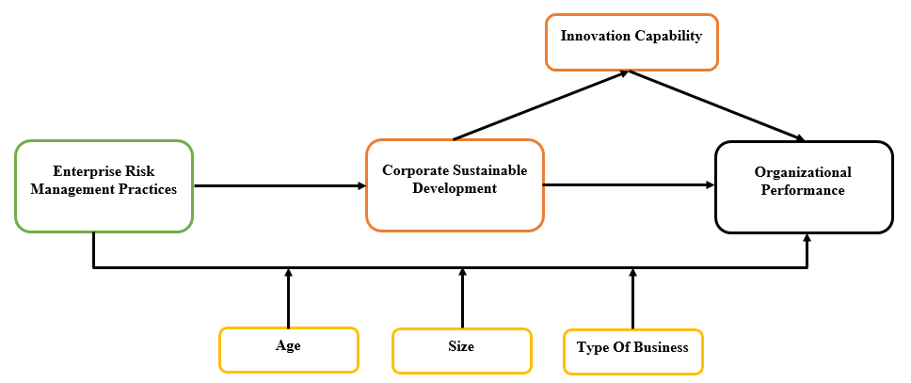

**3. Research Methodology**

This study employs a survey design methodology in exploring the interconnected variables through a semi-structured questionnaire as a data collection instrument. Intending to usea larger sample, the survey design was appropriate as 309 respondents comprised small and medium-scale enterprises in Jordan.

A self-administered questionnaire was developed, pretested, and administered over six weeks. The authors sought ‘content and assured to the respondents of anonymity and confidentiality in their responses. A total of 500 questionnaires were distributed to respondents, out of which 309 questionnaires representing 61.8% were used after screening and cleaning the data. As recommended by previous studies (Rajapathirana& Hui, 2018), a five-point Likert scale from 1 – 5 (strongly disagree – strongly agree) was used to measure constructs in this study. Preliminary coding and cleaning were done to eliminate outliers and other variations in the data. Subsequently, the data were analyzed with the Statistical Package for Social Sciences (SPSS v.23) and SmartPLS 3.0.

**3.2. Measurement of Variables**

An indicative scale was used in measuring variables for this study. A five-point Likert scale was used, ranging from 1 – strongly disagree to 5 – strongly agree. A detailed questionnaire is provided in Appendix A

**Corporate sustainable development**

**Enterprise risk management practices**denote thefirm’s capacity and strategy in managing risks. Six itemsthat are validated in earlier studies with satisfactory composite reliability were used to measure this variable (Munther et al., 2021; Rehman and Anwar, 2019). The variable has reliabilitymore significant than 70%.

**Innovation capacity**

Innovation capacity is the’ 'firm's ability to utilize resources and abilities to create innovative results. It includes utilizing organizational processes and products an organization can use to create innovative results. Innovation capacity denotes the right application of technologies to develop new products and services that meet customer needs and expectations (Rajapathirana& Hui, 2018)

**Organizational performance**

A subjective measure of 'firms' performance was used, considering managers' unwillingness to disclose actual performance data due to confidentiality and commercial sensitivity (Mann et al. 2011).Considering the strong correlation between subjective and objective measures (Wall et al., 2004), subjective measures are favorable in this study (Barrett & Richard 2009). In this study, a self-reported measures were collected from business managers and owners through a questionnaire scaled from 1 – strongly disagree to 5 – strongly agree. The reliability of organizational performance more significant than 70%

**3.3. Control Variables**

Conclusion: there are both internal and external factors that affect business performance, regardless of risk management, innovation capability, and sustainable corporate development. Therefore, this study controlled for ' 'firm's age, size, and type of business. Precisely, the age is measured from the inception of business operations. Firm size is measured as the total number of employees. Businesses are exposed to different risks that need to be managed differently to achieve organizational goals.

# **4. Analysis and Results**

**Response Rate**

The response rate obtained from the survey is presented in Table 1.Kotrlik & Higgins ( 2001) opined that an acceptable response rate should be between 5-10 times the number of variables in a survey.However, given that this study has six variables, a sample size of 60 should be suitable for the analysis of the study. Additionally, the PLS technique requires a minimum of only 30 responses (Chin, 1998). Therefore, a total of 309 responses are appropriate for analysis in this study. Furthermore, besides its ability to take care of a small sample size, the PLS-SEM technique's predictive power is enhanced with a higher sample size (Hair et al., 2017). Therefore, the response rate of 70.0% achieved in this study is considered excellent given Sekaran & Bougie ( 2010) suggestion that no less than 30 per cent response rate is acceptable in a survey research.

Table 4. 1: Response Rate of the questionnaire survey

|  |  |  |
| --- | --- | --- |
| Response | Frequency | Percentage (%) |
| No. of questionnaire administered | 500 | 100.0 |
| Returned questionnaires | 385 | 77 |
| Returned and usable questionnaires | 309 | 61.8 |
| Returned and unusable questionnaires | 76 | 15.2 |
| Questionnaires not returned | 115 | 23 |
| Valid response rate |  | 61.8 |

**Data Screening**

Hair et al. (2007) andTabachnick and Fidell (2013) suggested that in order to prevent misrepresentation of the results of multivariate statistical techniques, screening of the data collected by the researcher is required to detect data errors and probable violations of key assumptions of the technique employed for data analysis. However, the purpose of data screening is to specifically check data errors and detect problems relating to violation of assumptions that are to be resolved prior to the primary analysis of data that have been collected for any research purposes (Fidell et al. 2013).

Therefore, it was essential to conduct data screening while employing a partial least square structural equation model (PLS-SEM) (Pallant, 2010; Tabachnick & Fidell, 2013). Following the statement above, the researcher carried out data screening of questionnaires survey for accuracy of data input, missing data, identification of outliers, and statistical assumptions for multivariate analysis of constructs in this study (Fidell et al. 2013).

**Data Input Accuracy**

A total of 309 duly answered questionnaires were carefully coded and entered into the SPSS version 23 to achieve a high level of accuracy; each item that serves as a question was coded in line with the initials of its variable and according to its position as listed under the various unobserved latent constructs. For example, 5 items measuring Enterprise risk management were coded as ERM1, ERM2, ERM3, ERM4,ERM5 and the same process were applied to other independent variables, moderating variable and dependent variable.No value was out of range for each item when compared against the respectively assigned codes for an item on 'respondents' profile. Hence, every item related to the constructs were found to be within the 5 Point-Likert scales used in the questionnaire of this study.

**Missing Data Analysis**

Missing data occur from the failure of the respondent to provide an answer to either one or some questions/items in the questionnaire. This is where a sampled element fails to respond to one or more questions, thereby becoming necessary to resolve prior to the data analysis process (Brick, & Kalton, 1996). Arguably, missing data turns out to be a problem to be resolved when it becomes impossible to recover the actual missing value (Scheffer, 2002). Dealing with missing data.

The cases with a lower percentage of missing data among the remaining 309cases were treated using mean value replacement method based on the recommendation ofHair et al. (2017), which states that any case of missing data with less than 5% can be treated as such.

**Assessment of Outliers**

An outlier is a data point that is significantly different from the remaining data, (Gupta et al. 2013) Outliers have been recognized as observations with distant values compared to other observations (Byrne , 2016). However, outliers can negatively affect the result of the research estimates, causing the mean estimate to be biased and inflating the standard deviation (Finch, 2017).. Outliers in data analysis could distort and lead to unreliable results (Sarstedt & Mooi 2014).Among various methods of detecting outliers, classifying data points based on an observed distance, Mahalanobis distance (D2) was employed in this study ( Fidell et al. 2013 and Hair et al. 2017). However, based on the 28 observed Items, the threshold of chi-square estimates with p< 0.001 and df=28 is 56.894. Therefore, no cases were found of outlierssinceall items Mahalanobis distance values not exceeded the threshold value of 56.894obtained from the chi-square table.

**Multicollinearity Test**

The correlation between the latent independent variables of the study is essential as it indicates the level at which a variable can be explained by other variables in the analysis.. However, multicollinearity occurs when there is high correlation between an unobserved latent independent construct and others ( Hair et al, 2017 ). The value equal to and greater than 90% (r ≥ 0.9) means that there is multicollinearity among the independent variables (Pallant, 2010).

However, a correlation matrix was examined to identify any occurrence of high correlation, that is, multicollinearity among the independent latent variables of this study ( Peng & Lai 2012).

As shown in table 2, multicollinearity exists because the correlation between all the unobserved latent independent constructs falls below the threshold of r = 0.9.

Table2: Inter-Constructs Correlations for Multicollinearity Test

|  |  |  |  |  |  |  |  |
| --- | --- | --- | --- | --- | --- | --- | --- |
| **Correlations Coeficient** | | | | | | | |
|  | | ERM | IC | OP | SD | ED | END |
| ERM | Pearson Correlation | 1 | .212** | .435** | .080 | .403** | -.004 |
| IC | Pearson Correlation | .212** | 1 | .261** | .226** | .325** | -.009 |
| OP | Pearson Correlation | .435** | .261** | 1 | .138* | .400** | .051 |
| SD | Pearson Correlation | .080 | .226** | .138* | 1 | .157** | .185** |
| ED | Pearson Correlation | .403** | .325** | .400** | .157** | 1 | -.112* |
| END | Pearson Correlation | -.004 | -.009 | .051 | .185** | -.112* | 1 |
| **. Correlation is significant at the 0.01 level (2-tailed). | | | | | | | |
| *. Correlation is significant at the 0.05 level (2-tailed). | | | | | | | |

**Respondents Profile**

This section describes the features of the respondents who participated in the survey. Their profiles were described based on Business Organization type, Educational Qualifications, Age of the Organization, and number of Employees, as depicted in Table 3.

Table 3: Questionnaires 'Respondents' Profile

|  |  |  |
| --- | --- | --- |
| **Respondent Description** | **Frequency** | **Percentage %** |
| **Business Organization type**  Insurance  Banking  Financial institutions  Real estate | 105  84  95  25 | 34  27.2  30.7  8.1 |
| **Educational Qualification**  FA and less  BA/B.Sc/B.com  MA/MBA and Above | 124  167  18 | 40.0  54.0  06.0 |
| **Age of Organization**  10 years and less  11-20 Years  21 and Above | 23  60  226 | 7.4  19.4  73.1 |
| **Number of Employees**  20-50  51-100  101-150  151-250 | 41  79  87  102 | 13.3  25.6  28.2  33.0 |

**Descriptive Analysis of Constructs**

The general statistical description of the constructs used in this study is examined by using descriptive analysis. Descriptive tests are used to determine the level of interest and respondents' views for each measurement or variable. Statistical values of means and standard deviation were calculated for both the independent, mediating, and dependent constructs and are based on the 5-point Likert scale of the items that measure the constructs of the study. The results of these statistical values as shown in Table 4, were used to determine the respondents' views on the level of low (M = 1.00 – 2.25), medium (M = 2.26 – 3.75), and high (M = 3.76 and above) (Healey, 2005).

Table 4: Descriptive Analysis of Constructs

|  |  |  |  |  |
| --- | --- | --- | --- | --- |
| LATENT CONSTRUCTS | N | Mean | Std. Deviation | Level |
| Enterprise Risk Management | 309 | 3.7328 | 1.029 | Medium |
| Innovation capability | 309 | 3.350 | 0.911 | Medium |
| Environmental development | 309 | 3.07 | 1.221 | Medium |
| Social development | 309 | 3.10 | 1.090 | Medium |
| Economic development | 309 | 3.35 | 1.048 | Medium |
| organizational performance | 309 | 3.590 | 1.118 | Medium |

**Evaluation of PLS-SEM Results**

This research paper employs Smart PLS 3.0 for hypotheses testing. There are two steps of performing Structural Equation Modeling (SEM). First, the measurement model is assessed. Lastly, the structural model is run using bootstrapping to evaluate the significance of the path coefficient of the hypothetical relationships presented in the conceptual framework.

## **MEASUREMENT MODEL**

The reliability and validity of the construct were examined first. Table 1 shows the loadings which satisfy the benchmark of > 0.07.

**Table 1: Construct measurement summary**

|  |  |  |  |  |  |  |
| --- | --- | --- | --- | --- | --- | --- |
|  | **ED** | **END** | **ERM** | **IC** | **OP** | **SD** |
| **ED1** | **0.910** |  |  |  |  |  |
| **ED2** | **0.917** |  |  |  |  |  |
| **ED3** | **0.920** |  |  |  |  |  |
| **END1** |  | **0.977** |  |  |  |  |
| **END2** |  | **0.979** |  |  |  |  |
| **END3** |  | **0.972** |  |  |  |  |
| **IC1** |  |  |  | **0.940** |  |  |
| **IC2** |  |  |  | **0.956** |  |  |
| **IC3** |  |  |  | **0.963** |  |  |
| **IC4** |  |  |  | **0.965** |  |  |
| **IC5** |  |  |  | **0.962** |  |  |
| **IC6** |  |  |  | **0.951** |  |  |
| **IC7** |  |  |  | **0.955** |  |  |
| **IC8** |  |  |  | **0.966** |  |  |
| **OP1** |  |  |  |  | **0.928** |  |
| **OP4** |  |  |  |  | **0.907** |  |
| **Op2** |  |  |  |  | **0.900** |  |
| **Op3** |  |  |  |  | **0.834** |  |
| **Op5** |  |  |  |  | **0.926** |  |
| **Op6** |  |  |  |  | **0.910** |  |
| **REM1** |  |  | **0.955** |  |  |  |
| **REM2** |  |  | **0.934** |  |  |  |
| **REM3** |  |  | **0.929** |  |  |  |
| **REM4** |  |  | **0.955** |  |  |  |
| **REM5** |  |  | **0.936** |  |  |  |
| **SD1** |  |  |  |  |  | **0.939** |
| **SD2** |  |  |  |  |  | **0.919** |
| **SD3** |  |  |  |  |  | **0.958** |

**Figure 1: Initial Model (Measurement Model)**

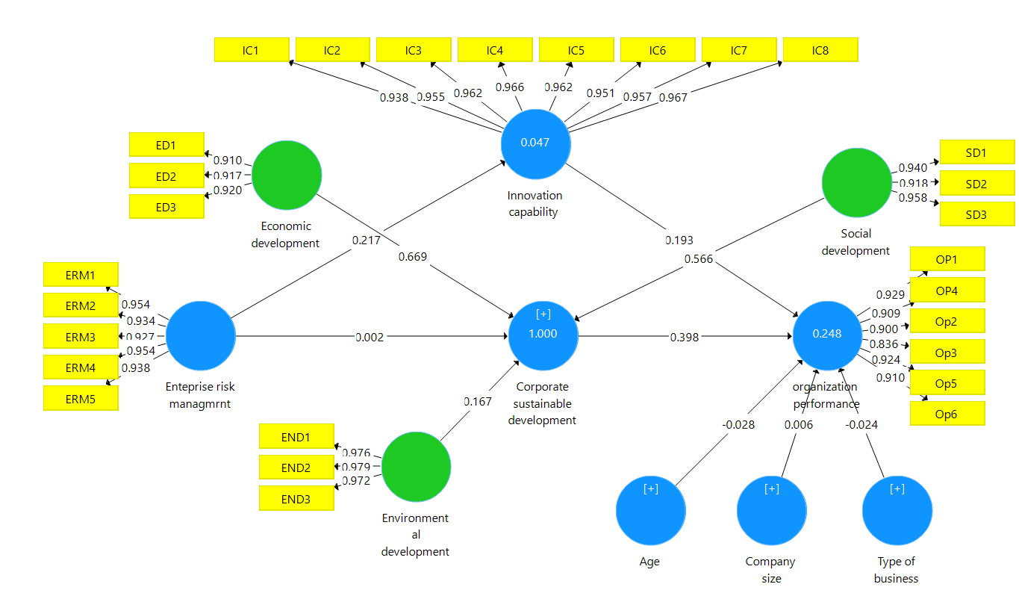

**Table 2: Cronbach's Alpha, CR and AVE**

|  |  |  |  |
| --- | --- | --- | --- |
|  | **Cronbach's Alpha** | **Composite Reliability** | **Average Variance Extracted (AVE)** |
| **ED** | **0.904** | **0.940** | **0.838** |
| **END** | **0.975** | **0.984** | **0.953** |
| **ERM** | **0.968** | **0.975** | **0.887** |
| **IC** | **0.987** | **0.989** | **0.916** |
| **OP** | **0.954** | **0.963** | **0.813** |
| **SD** | **0.933** | **0.957** | **0.881** |

The average variance extracted (AVE) was also examined to ensure the convergent validity of all values was found to be above the threshold value of 0.5. Moreover, the composite reliability (CR) was also examined, and all values were founded to be greater than 0.7.

**Table 3: Discriminant Validity**

|  |  |  |  |  |  |  |
| --- | --- | --- | --- | --- | --- | --- |
|  | **ED** | **END** | **ERM** | **IC** | **OP** | **SD** |
| **ED** |  |  |  |  |  |  |
| **END** | **0.045** |  |  |  |  |  |
| **ERM** | **0.432** | **0.020** |  |  |  |  |
| **IC** | **0.336** | **0.026** | **0.215** |  |  |  |
| **OP** | **0.544** | **0.071** | **0.452** | **0.322** |  |  |
| **SD** | **0.265** | **0.124** | **0.098** | **0.221** | **0.197** |  |

The discriminant validity for the model is checked using the HTMT ratio. This ratio should be less than the benchmark value of 0.85. By looking at the table, all values met the threshold, and the discriminant validity of the model is assured.

## **STRUCTURAL MODEL**

To check the hypotheses of the model bootstrapping was performed. The direct and indirect effects were tested to support the direct and mediated hypotheses.

**Table 4: Path Model (Bootstrapping Results)**

|  |  |  |  |  |
| --- | --- | --- | --- | --- |
|  | **Beat** | **SE** | **T Statistics** | **P Values** |
| **CSD -> OP** | 0.305 | 0.042 | 7.307 | **0.000** |
| **ERM -> CSD** | 0.002 | 0.001 | 2.743 | **0.006** |
| **ERM -> IC** | 0.217 | 0.055 | 3.944 | **0.000** |
| **ERM -> OP** | 0.350 | 0.050 | 7.058 | **0.000** |
| **IC -> OP** | 0.152 | 0.061 | 2.501 | **0.013** |
| **ERM -> CSD -> OP** | 0.172 | 0.025 | 6.926 | 0.000 |
| **ERM -> IC -> OP** | 0.033 | 0.016 | 2.010 | 0.045 |

**Figure 2: The Structural Estimates**

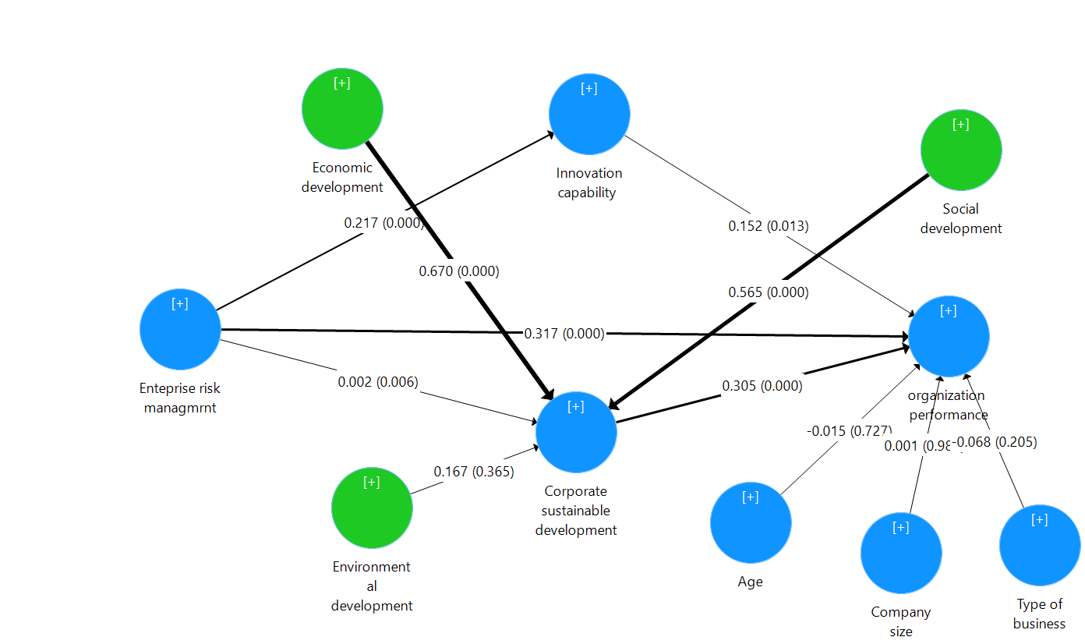

The moderating effect was also tested using the bootstrapping technique. The result is presented in table 5 below:

**Table 5: Results of Hypotheses Testing (Moderation)**

|  |  |  |  |  |
| --- | --- | --- | --- | --- |
|  | **Beta** | **SE** | **T Statistics** | **P Values** |
| **AGE*ERM -> OP** | **0.033** | **0.040** | **0.830** | **0.407** |
| **SIZE*ERM -> OP** | **-0.051** | **0.050** | **1.027** | **0.305** |
| **TYPE*ERM -> OP** | **-0.135** | **0.048** | **2.800** | **0.005** |

**Figure 3: Structural Model of Moderating Path**

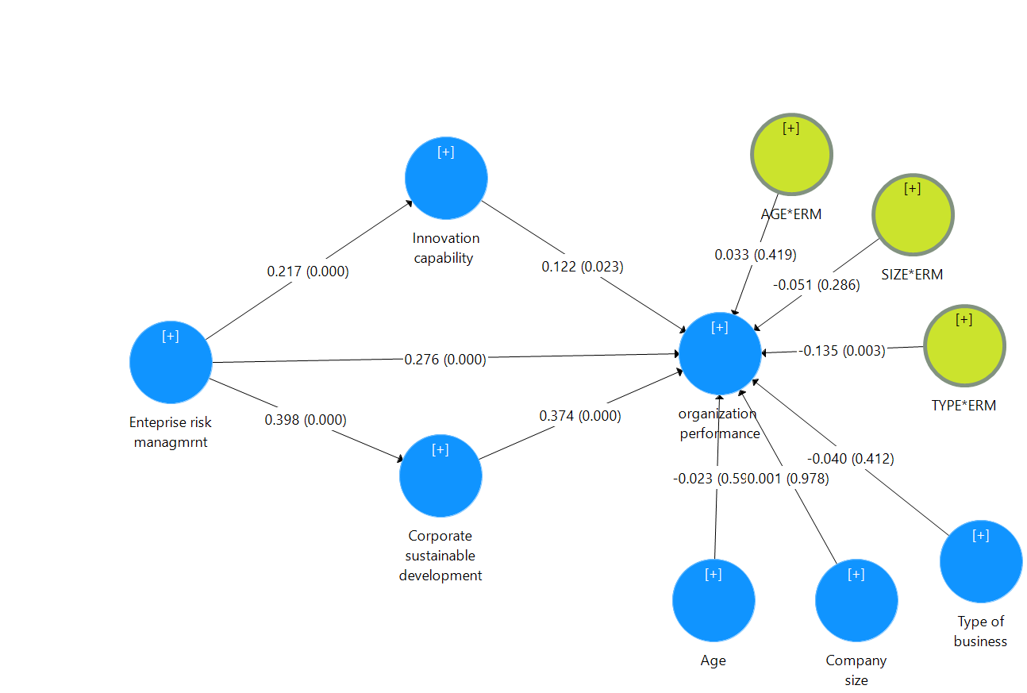

**5. Discussion and Results**

Focusing on one of the emerging countries (i.e., Jordan), this study examined the role of ERM practices on organizational performance using CSD as a mediator. Furthermore, it also examined the role of CSD on organizational performance by using IC as a mediator. We provided empirical evidence in this respect in Jordan.

Our findings in table 4 show that ERM practices significantly influenceorganizational performance, which supported H1 of this study. This is consistent with Yang et al. (2018); Florio and Leoni (2017), who focused on SMEs. This result strongly supportsZou & Hassan ( 2017) who argued that the performance of SMEs ispositivelyassociatedwith ERM practicesin emerging markets. The findings of this research add another empirical evidence in the emerging market to the literature. It finds that CSD is positively associated with ERM practices in Jordanian market, which supports H2 of this study. This means that small and medium-scale Jordanian enterprises are more likely to have a higher level of CSD, when they employ more ERM practices.

Additionally, we found that CSD significantly influences organizational performance. This study found that CSD significantly mediates the relationship between ERM and firm performance. It reveals that ERM influences firm performance slightly more than CSD.

Our results also revealed that CSD has a significant influence on IC. Thus, H5 of the study is positively supported.

It can be seen from table 4 that H6 is significantly supported. Specifically, it shows that IC has a significant influence on organizational performance.

Moreover, it also found that ICsignificantly mediates the relationship between CSD and firm performance, which supported H7 of our study.Italsoreveals that ERM influences firm performance significantly more than IC.

Finally, 'additional analyses(i.e., table 5) show that the type of business significantly moderates the relationship between ERM and the firm's performance. However, the age and size of the company do not moderate the relationship between ERM and the firm's performance.

**6. Conclusions**

This study examines the relationship between innovation capabilities and sustainable corporate development.It also examines the mediating effect of sustainable corporate development on the relationship between ERM and organizational performance. Furthermore, this research sheds light on the mediating role of innovation capability on the relationship between sustainable corporate development and organizational performance. Data were collected from 309 small and medium scale enterprises in Jordan.The results indicate that ERM practices, CSD, and ICsignificantly influence organizational performance. In addition, CSD is positively associated with ERM and IC. This study shows thatCSDsignificantly mediates the relationship between ERM and organizationalperformance. It also found that ICsignificantly mediates the relationship between CSD and organizational performance. This study advisesJordaniancompaniesto hugely increase CSD and innovation capability for their importance in improving the firm's performance.It alsosuggests that businessesimplement formal ERM practices as theyare well suited for gaining CSD and superior performance in dynamic markets. Implications have been discussed above in detail.

**References**

Abbas, J., & Sağsan, M. (2019). Impact of knowledge management practices on green innovation and corporate sustainable development: A structural analysis. Journal of cleaner production, 229, 611-620.

Acharyya, M. (2009). The influence of enterprise risk management on insurers'stock market performance: An event analysis. International Journal of Business and Management Invention, 44(3), 121-136.

Al-Nimer, M., Abbadi, S. S., Al-Omush, A., & Ahmad, H. (2021). Risk Management Practices and Firm Performance with a Mediating Role of Business Model Innovation. Observations from Jordan. Journal of Risk and Financial Management, 14(3), 113.

Altanashat, M., Al Dubai, M., & Alhety, S. (2019). The impact of enterprise risk management on

institutional performance in Jordanian public shareholding companies. Journal of Business and

Retail Management Research, 13(3).

Arvanitis, S., & Hollenstein, H. (2002). The impact of spillovers and knowledge heterogeneity on firm performance: evidence from Swiss manufacturing. In Innovation and firm performance (pp. 225-252). Palgrave Macmillan, London.

Baldwin, J. R., & Johnson, J. (1996). Business strategies in more-and less-innovative firms in

Canada. Research policy, 25(5), 785-804.

Barney, J. (1991). Firm resources and sustained competitive advantage. Journal of

management, 17(1), 99-120.

Barrett, K., & Richard, G. (2009, October). The management challenge of bad data. Governing. Retrieved from http:// [www.governing.com/columns/smart-mgmt/The-Manageme nt-Challenge-of.htm](http://www.governing.com/columns/smart-mgmt/The-Manageme%20nt-Challenge-of.htm)

Baxter, R., Bedard, J. C., Hoitash, R., & Yezegel, A. (2013). Enterprise risk management program

quality: Determinants, value relevance, and the financial crisis. Contemporary Accounting

Research, 30(4), 1264-1295.

Beasley, M., Pagach, D., & Warr, R. (2008). Information conveyed in hiring announcements of senior executives overseeing enterprise-wide risk management processes. Journal of Accounting, Auditing & Finance, 23(3), 311-332.

Behnam, S., Cagliano, R., & Grijalvo, M. (2018). How should firms reconcile their open

innovation capabilities for incorporating external actors in innovations aimed at sustainable

development?. Journal of Cleaner Production, 170, 950-965.

Brick, J. M., & Kalton, G. (1996). Handling missing data in survey research. Statistical methods in medical research, 5(3), 215-238.

Byrne, B. M. (2016). Adaptation of assessment scales in cross-national research: Issues, guidelines, and caveats. International Perspectives in Psychology, 5(1), 51-65.

Cainelli, G., Evangelista, R., & Savona, M. (2004). The impact of innovation on economic

performance in services. The service industries journal, 24(1), 116-130.

Camisón, C., & Villar-López, A. (2014). Organizational innovation as an enabler of technological

innovation capabilities and firm performance. Journal of business research, 67(1), 2891-2902.

Chairani, C., &Siregar, S. V. (2021). The effect of enterprise risk management on financial

performance and firm value: the role of environmental, social and governance

performance. Meditari Accountancy Research.

Chaveerug, A., & Ussahawanitchakit, P. (2008). Learning orientation, innovation capability, and

organizational performance in Thai audit firms: Moderating effects of organization climate and

uncertainty environment. Review of Business Research, 8(2), 92-102.

Cheng, C. F., Lai, M. K., & Wu, W. Y. (2010). Exploring the impact of innovation strategy on R&D employees'job satisfaction: A mathematical model and empirical research. Technovation, 30(7-8), 459-470.

Chin, W. W. (1998). The partial least squares approach to structural equation modeling. Modern methods for business research, 295(2), 295-336.

Deakin, E. (2001). Sustainable development and sustainable transportation: strategies for

economic prosperity, environmental quality, and equity.

Drennan, L. T. (2004). Ethics, governance and risk management: Lessons from mirror group newspapers and barings bank. Journal of business ethics, 52(3), 257-266.

Drobyazko, S., Okulich-Kazarin, V., Rogovyi, A., Goltvenko, O., &Marova, S. (2019). Factors of

influence on the sustainable development in the strategy management of corporations. Academy of Strategic Management Journal, 18, 1-5.

Fidell, S., Tabachnick, B., Mestre, V., & Fidell, L. (2013). Aircraft noise-induced awakenings are more reasonably predicted from relative than from absolute sound exposure levels. The Journal of the Acoustical Society of America, 134(5), 3645-3653.

Finch, H. (2017). Multilevel modeling in the presence of outliers: A comparison of robust estimation methods. Psicologica: International Journal of Methodology and Experimental Psychology, 38(1), 57-92.

Florio, C., & Leoni, G. (2017). Enterprise risk management and firm performance: The Italian

case. The British Accounting Review, 49(1), 56-74.

Gupta, A. K., & Gupta, N. (2020). Effect of corporate environmental sustainability on dimensions

of firm performance–Towards sustainable development: Evidence from India. Journal of cleaner

production, 253, 119948.

Gupta, M., Gao, J., Aggarwal, C. C., & Han, J. (2013). Outlier detection for temporal data: A survey. IEEE Transactions on Knowledge and data Engineering, 26(9), 2250-2267.

Hair, J. F., Hult, G. T. M., Ringle, C. M., & Sarstedt, M. (2017). A primer on partial least squares structural equation modeling (PLS-SEM) (2nd ed.). Thousand Oaks, CA: Sage

Hair, Jr., J. F., Money, A. H., Samouel, P. & Page, M. (2007). Research methods for business. Chichester: John Willey & Sons Ltd.

Hanaysha, J. R., Al-Shaikh, M. E., Joghee, S., &Alzoubi, H. M. (2021). Impact of innovation

capabilities on business sustainability in small and medium enterprises. FIIB Business Review,

23197145211042232.

Hult, G. T. M., Hurley, R. F., & Knight, G. A. (2004). Innovativeness: Its antecedents and impact

on business performance. Industrial marketing management, 33(5), 429-438.

Jaruzelski, B., and Dehoff, K. (2009). "Profits Down." Spending Steady: The Global

Innovation 1000.

Kotrlik, J. W. K. J. W., & Higgins, C. C. H. C. C. (2001). Organizational research: Determining appropriate sample size in survey research appropriate sample size in survey research. Information technology, learning, and performance journal, 19(1), 43.

Krysiak, F. C. (2009). Risk management as a tool for sustainability. Journal of business

ethics, 85(3), 483-492.

Laforet, S. (2011). A framework of organisational innovation and outcomes in

SMEs. International Journal of Entrepreneurial Behavior & Research.

Lăzăroiu, G., Ionescu, L., Andronie, M., &Dijmărescu, I. (2020). Sustainability Management and

Performance in the Urban Corporate Economy: A Systematic Literature

Review. Sustainability, 12(18), 7705.

LeBlanc Brendan CPA, C. I. A., & Kislevitz, J. (2016). Integrating sustainability into enterprise

risk management. The CPA Journal, 86(6), 12.

Lichtenthaler, U., &Muethel, M. (2012). Retracted: The impact of family involvement on dynamic

innovation capabilities: Evidence from German manufacturing firms. Entrepreneurship Theory

and Practice, 36(6), 1235-1253.

Lu, J., Ren, L., Zhang, C., Rong, D., Ahmed, R. R., &Streimikis, J. (2020). Modified Carroll's pyramid of corporate social responsibility to enhance organizational performance of SMEs

industry. Journal of Cleaner Production, 271, 122456.

Mann, R., Adebanjo, D., & Tickle, M. (2011). Deployment of business excellence in Asia: an exploratory study. International journal of Quality & reliability Management.

Markowitz, H. (1952). The utility of wealth. Journal of political Economy, 60(2), 151-158.

Mikalef, P., Boura, M., Lekakos, G., &Krogstie, J. (2020). The role of information governance in

big data analytics driven innovation. Information & Management, 57(7), 103361.

Mills, R. J., Young, C. A., Pallant, J. F., & Tennant, A. (2010). Development of a patient reported outcome scale for fatigue in multiple sclerosis: The Neurological Fatigue Index (NFI-MS). Health and quality of life outcomes, 8(1), 1-10.

Pekkola, S., Saunila, M., Ukko, J., Sillanpää, V., Parjanen, S., Mäkimattila, M., ... & Rantala, T.

(2013). Framework for Measuring Innovation Capability. In Participatory Innovation

Conference (pp. 241-248). Lappeenranta University of Technology.

Peng, D. X., & Lai, F. (2012). Using partial least squares in operations management research: A practical guideline and summary of past research. Journal of operations management, 30(6), 467-480.

Rajapathirana, R. J., & Hui, Y. (2018). Relationship between innovation capability, innovation

type, and firm performance. Journal of Innovation & Knowledge, 3(1), 44-55.

Ramanathan, R., Ramanathan, U., & Bentley, Y. (2018). The debate on flexibility of

environmental regulations, innovation capabilities and financial performance–A novel use of

DEA. Omega, 75, 131-138.

Rasid, S. Z. A., Isa, C. R., & Ismail, W. K. W. (2014). Management accounting systems, enterprise

risk management and organizational performance in financial institutions. Asian Review of

Accounting.

Rehman, A. U., & Anwar, M. (2019). Mediating role of enterprise risk management practices between business strategy and SME performance. Small Enterprise Research, 26(2), 207-227.

Rosenbusch, N., Brinckmann, J., & Bausch, A. (2011). Is innovation always beneficial? A meta-

analysis of the relationship between innovation and performance in SMEs. Journal of business

Venturing, 26(4), 441-457.

Sarstedt, M., & Mooi, E. (2014). A concise guide to market research. The Process, Data, and, 12.

Saunila, M., & Ukko, J. (2013). Facilitating innovation capability through performance measurement: A study of Finnish SMEs. Management Research Review.

Scheffer, J. (2002). Dealing with missing data.

Schulte, J., & Hallstedt, S. I. (2018). Company risk management in light of the sustainability

transition. Sustainability, 10(11), 4137.

Sekaran, U., & Bougie, R. (2010). Research for Business–A Skill Building Approach. John-Wiley and Sons, New York, NY, 4, 401-415.

Shad, M. K., Lai, F. W., Fatt, C. L., Klemeš, J. J., & Bokhari, A. (2019). Integrating sustainability

reporting into enterprise risk management and its relationship with business performance: A

conceptual framework. Journal of Cleaner production, 208, 415-425.

Shang, H., Chen, R., & Li, Z. (2020). Dynamic sustainability capabilities and corporate

sustainability performance: The mediating effect of resource management

capabilities. Sustainable Development, 28(4), 595-612.

Silva, M.J.M., Simões, J., Moreira, J., and Sousa, G. (2012), "Investment and Expenditure on Innovation Activities and Innovative Capability: Empirical Evidence from Portuguese Services Firms and KIBS", International Business Research, Vol. 5, No. 2, pp. 114–122.

Slater, S. F., Olson, E. M., & Hult, G. T. M. (2006). The moderating influence of strategic

orientation on the strategy formation capability–performance relationship. Strategic Management

Journal, 27(12), 1221-1231.

Soliman, A., & Adam, A. (2017). Enterprise Risk Management and firm performance: an

integrated model for the banking sector. Banks and Bank Systems.

Tien, N. H., Anh, D. B. H., & Ngoc, N. M. (2020). Corporate financial performance due to

sustainable development in Vietnam. Corporate Social Responsibility and Environmental

Management, 27(2), 694-705.

Van Kleef, J. A., & Roome, N. J. (2007). Developing capabilities and competence for sustainable

business management as innovation: a research agenda. Journal of cleaner production, 15(1), 38-

51.

Varadarajan, R. (2017). Innovating for sustainability: a framework for sustainable innovations and

a model of sustainable innovations orientation. Journal of the Academy of Marketing

Science, 45(1), 14-36.

Wall, T. D., Michie, J., Patterson, M., Wood, S. J., Sheehan, M., Clegg, C. W., & West, M. (2004). On the validity of subjective measures of company performance. Personnel psychology, 57(1), 95-118.

Yang, C. C., Marlow, P. B., & Lu, C. S. (2009). Assessing resources, logistics service capabilities,

innovation capabilities and the performance of container shipping services in

Taiwan. International Journal of Production Economics, 122(1), 4-20.

Yang, S., Ishtiaq, M., & Anwar, M. (2018). Enterprise risk management practices and firm

performance, the mediating role of competitive advantage and the moderating role of financial

literacy. Journal of Risk and Financial Management, 11(3), 35.

Zou, X., & Hassan, C. H. (2017). Enterprise risk management in China: the impacts on organisational performance. International Journal of Economic Policy in Emerging Economies, 10(3), 226-239.