**Development model of one-foot Hop and Horizontal jump in preschool children and teaching Suggestion**

**Zhen Li 1**

*College of Sports Science, Beijing Sport University, Beijing, China, 2019210160@bsu.edu.cn*

**Xing Zhao 2**

*College of Sports Science, Beijing Sport University, Beijing, China, zhaoxing@bsu.edu.cn*

**Sha Qu 3**

*College of Sports Science, Beijing Sport University, Beijing, China, qusha@bsu.edu.cn*

**Dongmei Luo 4**

*College of Sports Science, Beijing Sport University, Beijing, China, dmluo02@sina.com*

**Abstract**

*Research purpose: This paper aims to provide empirical evidence for preschool children's movement education by analyzing the characteristics of single-foot jump and standing long jump. Research methods: Firstly, TGMD-3 gross muscle motion measurement scale was used to conduct video recording and then scale score on the single foot jump and standing long jump movements of preschool children. The final measured data were input into Microsoft Excel and coded, and the data were analyzed and compared according to percentage. The Results: showed that children in the low age group could not master the one-foot jump, but the high age group did not master the four-foot assist movement. Poor coordination between limbs and body in standing long jump. Conclusion: The most important point to be paid attention to is the coordination training of limbs in displacement in the teaching of single-foot jump and standing long jump for preschool children.*

**Keywords**

preschool children jump on one foot standing long jump movement teaching

**1. Introduction**

Gross Motor Skills (GMS), also known as basic Motor skills, refer to movement, object control, and stabilization skills(Logan, Ross, Chee, Stodden, & Robinson, 2018).

Preschool (3 ~ 6 years old) is a critical period for the development of gross motor skills and plays an important role in the development of children's motor patterns(Hardy, King, Farrell, Macniven, & Howlett, 2010; Stodden et al., 2008) . Multiple studies have shown that pre-school children's gross motor skill proficiency is positively correlated with healthy body weight, higher physical activity levels, and improved cognitive outcomes(Castetbon & Andreyeva, 2012; Diamond, 2015; Lubans, Morgan, Cliff, Barnett, & Okely, 2010; Morano, Colella, & Caroli, 2011; Tonge, Jones, & Okely, 2016) . Recent studies on children's motor education show that targeted motor education will have a positive impact on the motor development of preschool children(YARIMKAYA & ULUCAN, 2014). Therefore, it is particularly important to monitor the gross motor level in early childhood and understand the specific situation of gross motor development of children.

At present, there are a variety of tools used to monitor The Gross Motor movements of preschoolers at home and abroad, among which The Gross Motor Development Test (TGMD-3) has high reliability and validity. The test mainly consists of 6 movements in The movement test and 7 movements in The object control test, totaling 13 movements. Each item in the scale is tested twice and scored according to three to five scoring criteria, with a "1" score for meeting one criterion.

The testing tool applies to children aged 3-10 years(Magistro et al., 2020), but it is found through the test that not all displacement movements have rapid development in stages 3-6. Therefore, rapid and sensitive movements are selected in this stage, and detailed classification is made, and targeted suggestions are put forward for teaching.

**2. Research purpose and significance**

To provide evidence for motor education, this paper encodes the standard score of movement of displacement skills of preschoolers, such as single foot jump and standing long jump.

**3. Research design**

**3.1 Test method**

370 randomly selected children aged 3 to 6 years old were tested for motor development using the TGMD-3 Gross motor Development Scale, including displacement skills of hopping on one foot and standing long jump motor skills. During the test, each child has two formal test opportunities. To ensure the accuracy of the test, the testers of the test have received strict training, in the training, there are special action demonstration personnel and action grading personnel show.

**3.2 Mathematical statistics**

Input the measured data with Microsoft Excel to establish a database. Encode the final score of children's standards for each action with the function F (x) =CONCAT, and then use the percentage statistical method to conduct statistical analysis of the coded data.

**4. Results and analysis**

The purpose of this study is to understand the development characteristics of the gross motor pattern of preschool children in China in more detail and to provide theoretical and empirical evidence for motor education intervention.

In this paper, the TGMD-3 Gross Motor Development Test scale was used to test and record children. Through video analysis, scores were given according to the motor standards, and the final score was regarded as the motor code. As shown in Table 1 and Table 2, the action code of single-foot jump 0202 indicates that children have not mastered the first item, which is the non-supporting leg swing forward to achieve the power effect, and the third item, which is the two arms bend and swing forward to generate force action. The 1200 action code of standing long jump indicates that children only get 1 point when they bend their knees and stretch their arms back in the first preparatory action, which needs to be consolidated and strengthened. In the last two, children take off and land at the same time with both feet, but they cannot grasp the arm pressure when they land, so more teaching guidance is needed.

**Table 1** *Coding examples of single-foot jump and standing long jump action modes*

|  |  |  |  |  |  |
| --- | --- | --- | --- | --- | --- |
| **Gross Motor** | **PERFORMANCE CRITERIA** | | | |  |
| Hop | Non-hopping leg swings forward in pendular fashion to produce force | Foot of non-hopping leg remains behind hopping leg (does not cross in front of) | Arms flex and swing forward to produce force | Hops four consecutive times on the preferred foot before stopping | Gross Motor Coding |
| Test One score | 0 | 1 | 0 | 1 | 0202 |
| Test Two Score | 0 | 1 | 0 | 1 |
| Final score | 0 | 2 | 0 | 2 |

**Table 2** *Coding example of standing long jump action mode*

|  |  |  |  |  |  |
| --- | --- | --- | --- | --- | --- |
| **Gross Motor** | **PERFORMANCE CRITERIA** | | | |  |
| Horizontal Jump | Prior to takeoff , both knees are flexed and arms are extended behind the back | Arms extend forcefully forward and upward , reaching above the head | Both feet come off the floor together and land together | Both arms are forced downward during landing | Gross Motor Coding |
| Test One score | 0 | 1 | 0 | 0 | 1200 |
| Test Two Score | 1 | 1 | 0 | 0 |
| Final score | 1 | 2 | 0 | 0 |

Judging and analyzing children's displacement and object-controlled movements following this motion coding method, it is easier to analyze the development characteristics of children's movements at all ages and provide a strong basis for movement teaching (see Figure 1-6).

**4.1 Preschoolers' one-foot beat was analyzed for coding**

There are four scoring criteria :(1) the unsupported leg swings forward to achieve assist; (2) the non-supporting leg is bent behind the body; (3) two arms curved, swing forward to produce force; (4) The dominant leg jumps 4 times in a row. See Figure 1 to Figure 3 for the distribution of movement patterns in children of all ages.

Among 3 to 4 years old children, 0000, 0001, 0002, and 0202 action modes account for the largest proportion. 0001, 0002, and 0202 indicate that most children do not use non-supporting legs to achieve the help effect. Most of the supporting legs are bent in front of the body, and the two arms are not bent or swing forward to achieve the help effect. In addition, only a small number of girls reached the standard of 2222, indicating that most children in this age group could not master the one-legged movement and the development of this movement was lagging.

For children aged 4 to 5, 0000, 0001, 0002, 0200, 0202, 2222 accounted for the largest percentage of action codes. The proportion of 0202 is the highest, indicating that most people in this age group have not mastered the first and third movement standards, while 0002 and 0002 show that the circumference energy of non-supported legs is bent behind the body. Compared with the lower age group, the number of 0000 decreased more, and the proportion of 2222 increased, indicating that with the increase of age, the beat of one foot has a relatively obvious improvement.

Among 5 to 6 years old children, 0002, 0102, 0202, 2002, 2202, 2222 accounted for a large percentage. Compared with 4 ~ 5 years old age group, the proportion of 0202 is still the highest, the first and third movement is still not well mastered, 0002, 0102, 2002 has a small increase, 2202 has a large increase, indicating that the first and second movement has relatively obvious progress. With the increase of age, the proportion of the 2222 movement code increases slightly. It can be seen that although monopole has developed with the increase of age, most children have not fully mastered this movement. In the future, targeted training should be carried out on the coordination between the supporting leg and the non-supporting leg as well as between the arms, to better master this movement.

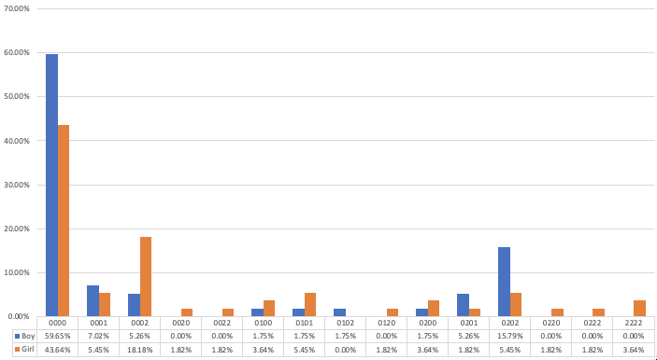

**Figure 1:** *Action coding distribution of "hopping on one foot" in 3 - to 4-year-old children*

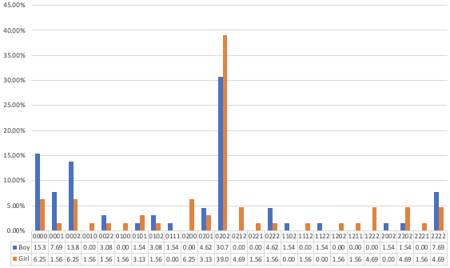

**Figure 2:** *Action coding distribution of "hopping on one foot" in 4-5-year-old children*

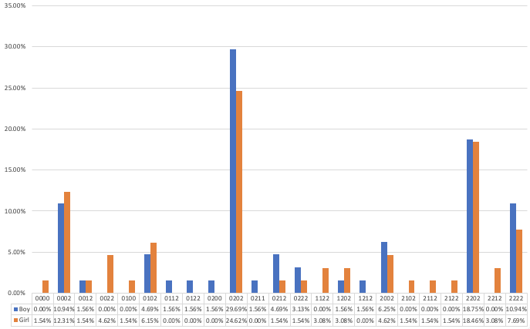

**Figure 3:** *Action coding distribution of "hopping on one foot" in 5 - to 6-year-old children*

**4.2 Analysis of standing long jump action coding of preschool children**

There are four scoring criteria for standing long jump :(1) bend your knees and extend your arms back while preparing; (2) the arms are fully extended forward and above; (3) Both feet take off and land at the same time; (4) Press your arms down when your feet land. Figure 4 - Figure 6 shows the distribution of standing long jump action patterns in different age groups.

As can be seen from the figure below, there are more modes of standing long jump than those mentioned above, which indicates that this movement is more difficult for preschool children to learn.

In the group of 3 to 4 years old, the most movement modes are 0000, 0020, 1020, 2020, 2022, and 0020 accounts for the highest proportion, indicating that this age group failed to master the first, second, and fourth movement standards, while the third movement with both feet jumping and landing at the same time is better. But there are still a large number of children in the standing long jump, the third item is 0 or 1, it can be seen that children still need more practice to master the standing long jump.

4 ~ 5 years old age group, the same as the low age group, one of the highest is 0020, and 0000 percentage significantly reduced, and the action mode is richer, such as 0011, 0111, said the standing long jump as we age, get a degree of development, but to prepare knees have failed to grasp, the other three criteria need to practice more, To achieve consolidation.

Set of 5 ~ 6 years old, is still the highest of 0020 accounted, but compared with the previous two age groups, 2020, 2022, 2222 groups of children increased significantly, as we age, standing long jump ability has been a certain degree of development, but two arms upward with both feet to the ground at full stretch arms down action need to be in the future teaching, focus on education practice.

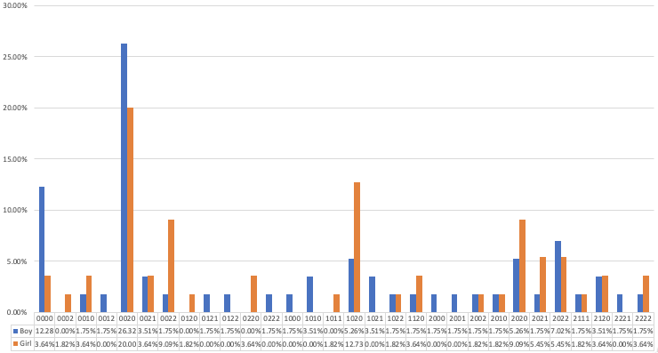

**Figure 4:** *Action coding distribution of "standing long jump" in 3 - to 4-year-old children*

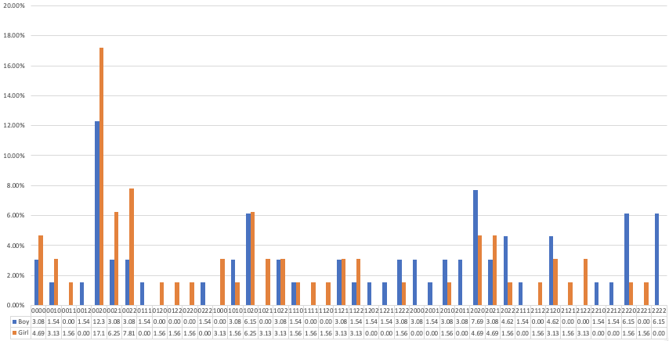

**Figure 5:** *Action coding distribution of "standing long jump" in children aged 4-5 years*

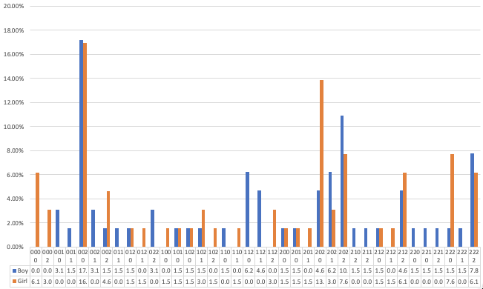

**Figure 6:** *Action coding distribution of "standing long jump" in children aged 5-6 years*

**5. Conclusion**

From the analysis results view, jump and standing long jump on one foot larger age children's action pattern diversity, this shows that the two movements as we age, the overall development model presents the distribution of diversity, but from the hop in 3 ~ 4 years old age group accounted for up to 0000, 4 ~ 5 years of age and 5 ~ 6 years old age group accounted for most of 0202 as you can see, 3 ~ 4 years old to 4 ~ 5 years old should have step-by-step guidance teaching, and 4 ~ 5 years old to 5 ~ 6 years old movement development has obvious stagnation phenomenon, should focus on guiding the unsupported legs and arms of the training.

In standing long jump, 0020 plays a leading role in children of the three ages. With the growth of age, the development of this movement shows a slow-growth trend, but the growth rate is not obvious. We should gradually guide children to carry out the teaching of coordination and cooperation of limbs.

In general, the most important point in the education of one-foot jump and standing long jump for preschool children lies in the coordination and coordination training of limbs in displacement.

**REFERENCES**

Castetbon, K., & Andreyeva, T. (2012). Obesity and motor skills among 4 to 6-year-old children in the united states: nationally-representative surveys. *Bmc Pediatrics, 12*, 9. doi:10.1186/1471-2431-12-28

Diamond, A. (2015). Effects of physical exercise on executive functions: going beyond simply moving to moving with thought. *Annals of sports medicine and research, 2*(1), 1011.

Hardy, L. L., King, L., Farrell, L., Macniven, R., & Howlett, S. (2010). Fundamental movement skills among Australian preschool children. *Journal of Science and Medicine in Sport, 13*(5), 503-508. doi:10.1016/j.jsams.2009.05.010

Logan, S. W., Ross, S. M., Chee, K., Stodden, D. F., & Robinson, L. E. (2018). Fundamental motor skills: A systematic review of terminology. *Journal of Sports Sciences, 36*(7), 781-796. doi:10.1080/02640414.2017.1340660

Lubans, D. R., Morgan, P. J., Cliff, D. P., Barnett, L. M., & Okely, A. D. (2010). Fundamental movement skills in children and adolescents. *Sports Medicine, 40*(12), 1019-1035.

Magistro, D., Piumatti, G., Carlevaro, F., Sherar, L. B., Esliger, D. W., Bardaglio, G., . . . Musella, G. (2020). Psychometric proprieties of the Test of Gross Motor Development-Third Edition in a large sample of Italian children. *Journal of Science and Medicine in Sport, 23*(9), 860-865. doi:10.1016/j.jsams.2020.02.014

Morano, M., Colella, D., & Caroli, M. (2011). Gross motor skill performance in a sample of overweight and non-overweight preschool children. *International journal of pediatric obesity: IJPO: an official journal of the International Association for the Study of Obesity, 6 Suppl 2*(S2), 42-46.

Stodden, D. F., Goodway, J. D., Langendorfer, S. J., Roberton, M. A., Rudisill, M. E., & Garcia, C. (2008). A Developmental Perspective on the Role of Motor Skill Competence in Physical Activity: An Emergent Relationship: Quest: Vol 60, No 2. *Quest*.

Tonge, K. L., Jones, R. A., & Okely, A. D. (2016). Correlates of children's objectively measured physical activity and sedentary behavior in early childhood education and care services: A systematic review. *Preventive Medicine*, 129-139.

YARIMKAYA, E., & ULUCAN, D. D. H. (2014). The effect of movement education program on the motor development of children. *International Journal of New Trends in Arts, Sports & Science Education (IJTASE) ISSN: 2146-9466, 4*(1).