Author Name et al.
Vol. m, No.n, pp. a-b (to be filled by editorial desk)
Date of Publication: (to be filled by editorial desk)
DOI: (to be filled by editorial desk)
This paper can be cited as: (to be filled by editorial desk)
This work is licensed under the Creative Commons Attribution-NonCommercial 4.0 International License. To view a copy of this license, visit http://creativecommons.org/licenses/by-nc/4.0/ or send a letter to Creative Commons, PO Box 1866, Mountain View, CA 94042, USA.

Design and Implementation of an Arabic Braille self-learning website

Abdulmalik Al-Salman
Computer Science Department, King Saud University, Riyadh, Saudi Arabia, salman@ksu.edu.sa

Amani Al-Salman
Special Education Department, King Saud University, Riyadh, Saudi Arabia, a.salman@ksu.edu.sa

Suheer Al-Hadhrami
Computer Science Department, King Saud University, Riyadh, Saudi Arabia, 437204437@student.ksu.edu.sa

Abstract
Blind and visually impaired people have long used assistive technologies, such as braille, to aid them in their day-to-day lives. Given the importance of communication for these individuals, the ability to self-learn braille through a specifically designed educational system is crucial for unlocking the ability to communicate while saving time and money. This paper focuses on the "learn-by-my-hand" system used to teach braille in an Arabic context through an e-dashboard on a self-guided website. The system, which also aids sighted people, is based on content from the Saudi education ministry, allowing users to use braille to complete school courses. It is thought to be the first system of its kind designed to be deployed in schools.
Keywords
Arabic Braille, Assistive technology, Braille, self-learning.

- Introduction
Since its development by Louis Braille in 1824, braille has been a critical tool in enabling blind and visually impaired people to read and write. The system, which works through raised dots representing different characters, was first designed in French but has since been expanded to capture languages across the globe. Each braille cell contains six dots organized, as shown in Figure 1.
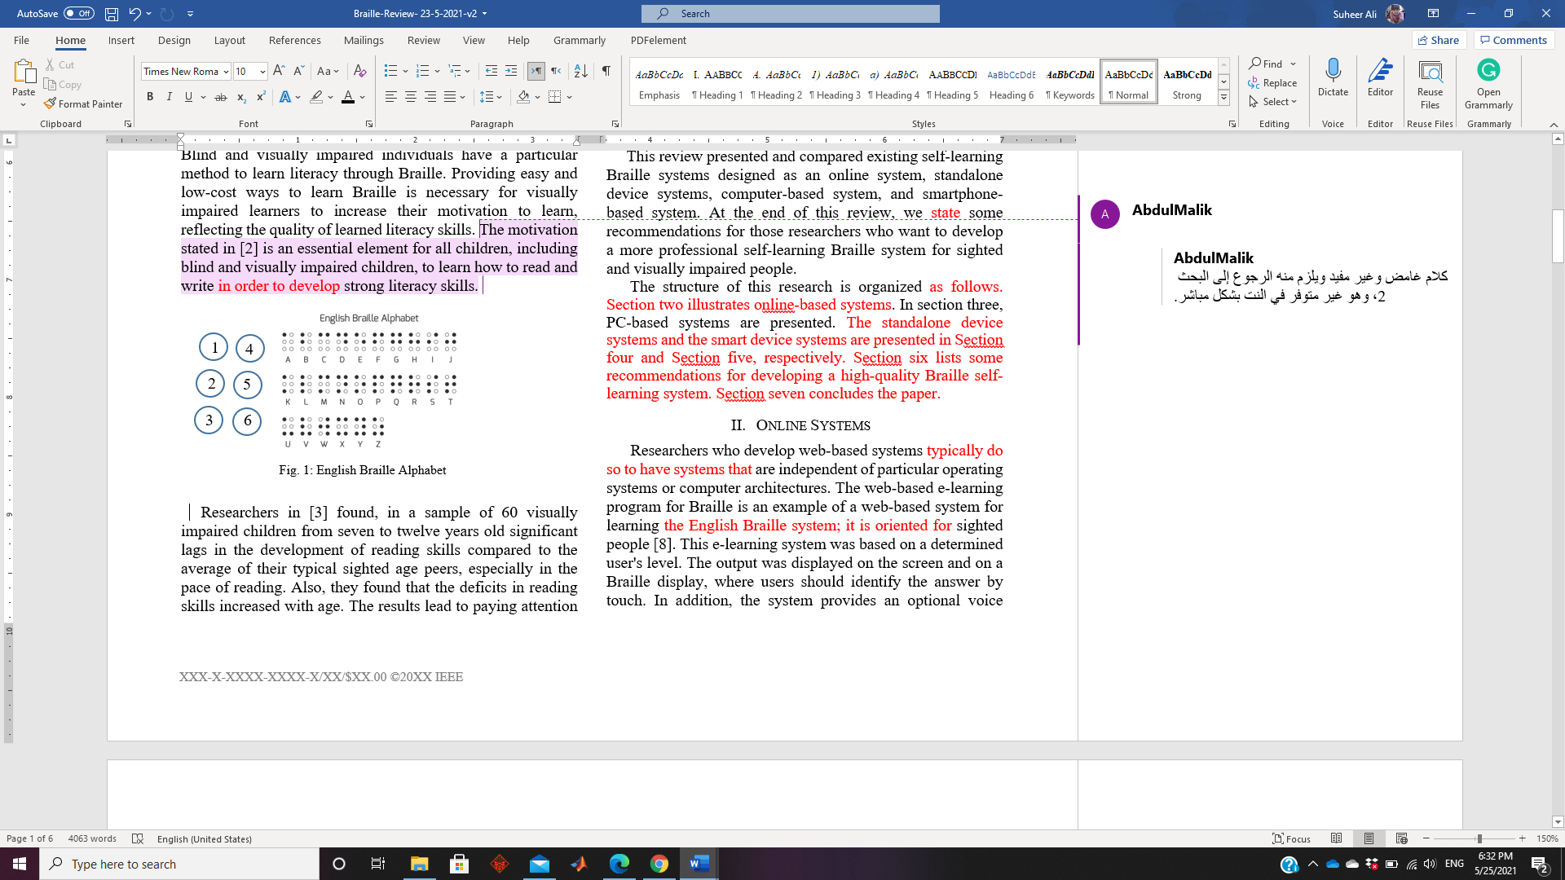§
Figure 1: Braille Cell
Approximately 285 million people worldwide are blind or visually impaired. Based on figures by the International Council for Education of People with Visual Impairment (ICEVI), around 90% are in financial poverty. Furthermore, more than half of visually impaired children are not currently engaged in formal education.
Blind and visually impaired individuals rely on assistive technology to aid them in their day-to-day lives and to help them learn braille, which is essential for allowing them to learn and communicate. However, despite this, many such individuals fail to learn braille because they struggle to find appropriate resources to assist them and the time involved.
While many online self-learning systems exist to help sighted people learn how to read and write, equivalent platforms for blind and visually impaired individuals are fewer in number. This is particularly true in non-English languages, as well as in developing countries (Tang, 2013).
While such systems are welcome, evidence suggests these platforms have clear limitations. According to Kim (Kim, 2018), complexities and inefficiencies related to feature usability, as well as failures to overcome system errors, account for 71% of the problems users face in using assistive technologies. Furthermore, many self-guided platforms designed to teach braille are expensive, impractical, and ineffective.
Several systems for self-learning braille are available. These include computer-free programs utilizing standalone devices that provide verbal feedback, as well as apps that can be used either online or via a smartphone. However, very few of these systems support multiple languages. After assessing various systems aimed at individuals who are blind, visually impaired, or sighted, the researchers found clear divergences in terms of ease of use and enjoyment levels. Even though some programs do offer learning in multiple languages, systems that support either Arabic or English, or both, were evaluated in the research. Platforms in English outnumbered those in Arabic.
Research uncovered that there are currently no online self-guided braille systems in Arabic, nor any apps designed for official school courses. In light of these findings, this paper aims to correct this issue by creating a website that works across multiple platforms to allow users to learn Arabic Braille independently. The system is designed to enable students to learn the first class from the official course of a Saudi Arabian elementary school. The content will therefore be based on the official curriculum provided by the book of the ministry of education. The system's interface is also designed to be suitable for sighted individuals of any age, increasing its applicability. In addition to its educational purposes, the website aims to support both students and their families to learn braille without additional assistance. Furthermore, by enabling self-guided learning, the system will reduce the burden on braille teachers in formal education contexts. The website will be structured through a dashboard design that enables additional courses from the " لغتي my language" book (Textbook, 2021) to be added later. To begin with, however, only the first level in elementary school is included.
The remaining sections of the study are as follows: section two provides a literature review, section three introduces the Learn-by-my-hand system, an analysis of the system is outlined in section four, and finally, a conclusion and discussion regarding future research opportunities are detailed in section five.

- Literature Review
Current self-guided systems for learning braille, including online, smartphone-based, and standalone platforms, have been studied in depth by Alsalman et al. (AlSalman, Al-Hadhrami, & AlSalman, 2022) to improve various programs. Generally, developers of web-based systems aim to produce platforms that can operate across specific computer designs and operating systems. Examples of such English-based programs include eKodBraille (Lee, Mohamed, & Altamimi, 2015) and the e-learning program for braille (Takaoka, Ohta, Sugano, Oda, Maeda, Hanaoka, & Matsuura, 2011). These two systems are both aimed at sighted users.
(AlSaleh & Al-Salman, 2012) created AlWafa, a software program designed to teach braille to individuals who are both sighted and blind. Other systems, like Blind Aid (Khidri, Memon, & Jameel, 2014), offer a low-cost option for self-guided learning by translating inputted documents or words typed on a braille keyboard by verbalizing or displaying the content. Another system, OntoBraille@RID, supports blind people in their efforts to independently learn braille in either English or Chinese (Tang, 2013). This platform offers both practice sections and formal exams.
Standalone self-guided learning platforms include the Spoken Dialogue System (Araki, Shibahara & Mizukami, 2011), Braille Writing Tutor (BWT) device ) Dias, Dias, Belousov, Rahman, Sanghvi, Fanaswala, & Menon, 2009), E-Braille (Wagh, Prajapati, Shinde, Salunke, Chaskar, Telavane, & Yadav, 2012), a one-cell braille tutor (Aizawa & Watanabe, 2014), and Braille Tutor (Joshi & Samasgikar, 2016). With the exception of BWT, with teaches Indian, all of these platforms help users to learn English.
Braille Instructor (Al-Watban, & Al-Salman, 2019), learn braille with Nouf (Montasser, 2020), BrailleEasy (Qatar Computing Research Institute, 2015) ( Šepić, Ghanem, & Vogel, 2015), and touch Braille (R. & A., 2017), are all examples of smartphone apps designed for IOS-based devices. The first three of these systems teach braille in Arabic, while the latter two teach English. Braille Instructor is explicitly aimed at blind and visually impaired individuals. BrailleEasy supports both sighted and visually impaired people, while learning Braille with Nouf and Touch braille are oriented exclusively to sighted people.
Aprende Braille (Mario Ugedo, 2020), Learn Braille: Beginner guide (USEFUL APPS,‏ 2018), Learn Braille (Mario Ugedo, 2020), Braille helper (Kumar, 2021), and. Braille Tutors (Brailliac, 2018) are all examples of Anrdoid-based systems designed in English for sighted individuals, although Braille helper also supports visually impaired people. In addition to English, Braille tutor and Aprende Braille also support Swedish and Spanish, respectively.
Applications that support both Android and IOS devices include Braille Academy (Learn and train, 2020), Taptilo+ (smart, 2020), and Taptilo U (smart, 2018). Several previous studies have sought to design a braille cell that can be implemented in self-guided learning systems for braille (Jawasreh, Ashaari, & Dahnil, 2020)( Wagh, Prajapati, Shinde, Salunke, Chaskar, Telavane & Yadav, 2016)( Avhad, Jadhav, Arbune & Khainar, 2016)( Wicaksono & Kurniawan, 2019)(Kavalgeri, Chakraborthy, Naz & Chaitanya, 2019)( EM, Nithin & BASKARAN, 2021)(Abirami, Dharsana, Ragav & Chaitanya, 2018). Rather than developing learning resources, each of these studies targeted electronic cells. Consequently, only digital numbers and letters were programmed.

- Learn-by-my-hand System design and implementation
While several self-learning braille apps lack the sophistication to support educational standards, there is a lack of research into these systems' educational impact. The current platforms' simplicity means they fail to take into account teacher-student communication, focusing instead on limited processes designed to teach numbers, letters, and basic sentence construction. This study seeks to add this additional link, allowing both teachers and students to engage in learning by setting and completing examinations. The system will also allow students to go back over previous concepts independently. At the same time, parents of blind children will be able to gain insight into the areas in which their children are strongest and weakest. Based on existing research, this will be the first example of such a system for teaching braille in Arabic.
Three forms of control are described on the Learn-by-my-Hand system online page. The first of these is ministry administrator control, which involves the administrator in question overseeing school courses and staff on a national level. The second type of control is school administrator control, through which the administrator in question oversees students and teachers. The final type, teacher control, allows teachers to guide their students and the lessons and exercises they study, as well as to monitor their progress. Students comprise both school pupils and external students who seek to engage in education without formally enrolling. This distinction is important because, unlike normal pupils, students who aren't registered cannot go back over previous lessons as their results are not recorded in the learning database. All school courses are offered in braille on the platform, enabling blind and visually impaired students to engage in the educational process fully. The hierarchy of user control regarding the system is outlined in Figure 2.
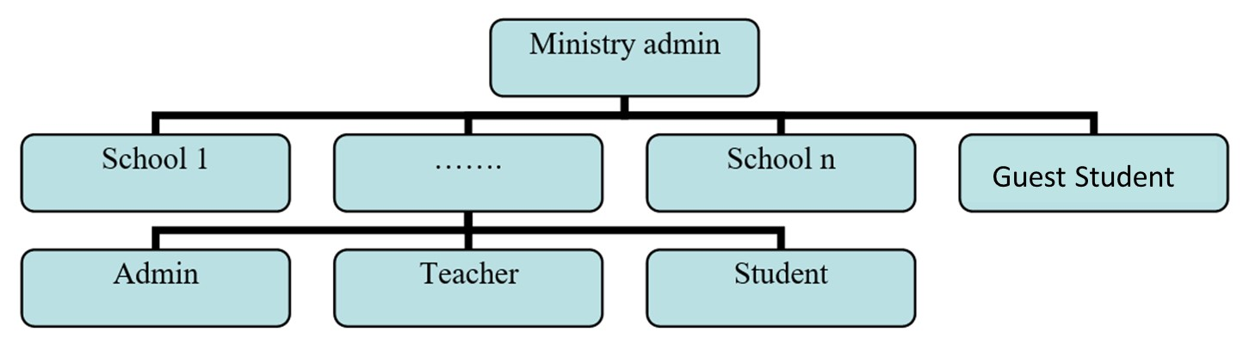
Figure 2: The system users.
  - The system Content
Supporting blind and visually impaired children to engage in level 1 of Saudi Arabian elementary school without outside support is the main goal of the proposed system. The platform uses "لغتي my language's" [26] official teaching materials. This comprises three units: braille recognition; the alphabet, words, sentences, and diacritics; and more advanced lessons based on previous learning. The first unit is designed around a book and Perkins brailler but also allows students to seek support from Orbit Reader [20], ElBraille [14], smart Beetle, and other braille typing devices to improve the system's practicality. Examples of braille typing devices are displayed in Figure 3. The proposed system follows the official book's processes in terms of structure and content.
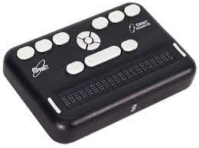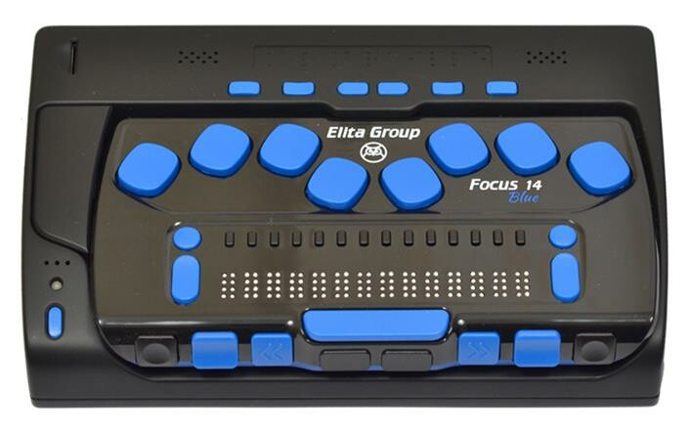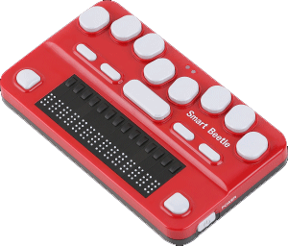
ElBraille 14 Orbit Reader 20 Smart Beetle
Figure 3: Braille Typing Devices.
Slight alterations have been made to the lesson plans to increase their suitability regarding devices used to type in braille. In addition, four extra units were included to increase the learn-by-my-hand approach's functionality. These were designed around Saudi Arabia's officially certified Arabic braille teaching book [34], "كتاب نظام برايل العربي المطور Improved Arabic braille system book." Punctuation in Arabic braille is outlined in unit four. Mathematical symbols and numbers are taught in unit five. Unit six focuses on abbreviations, while unit seven aims to improve students' ability to sense braille through numerous exercises. Teachers also have the freedom to introduce additional content or exams to aid the learning process, while parents can contact the school through the system if required. A map of the student website is shown in Figure 4, highlighting the use of multiple units with their respective lessons and subject matters. The seven units comprise over 50 lessons covering 300 subjects, with at least 550 individual exercises.

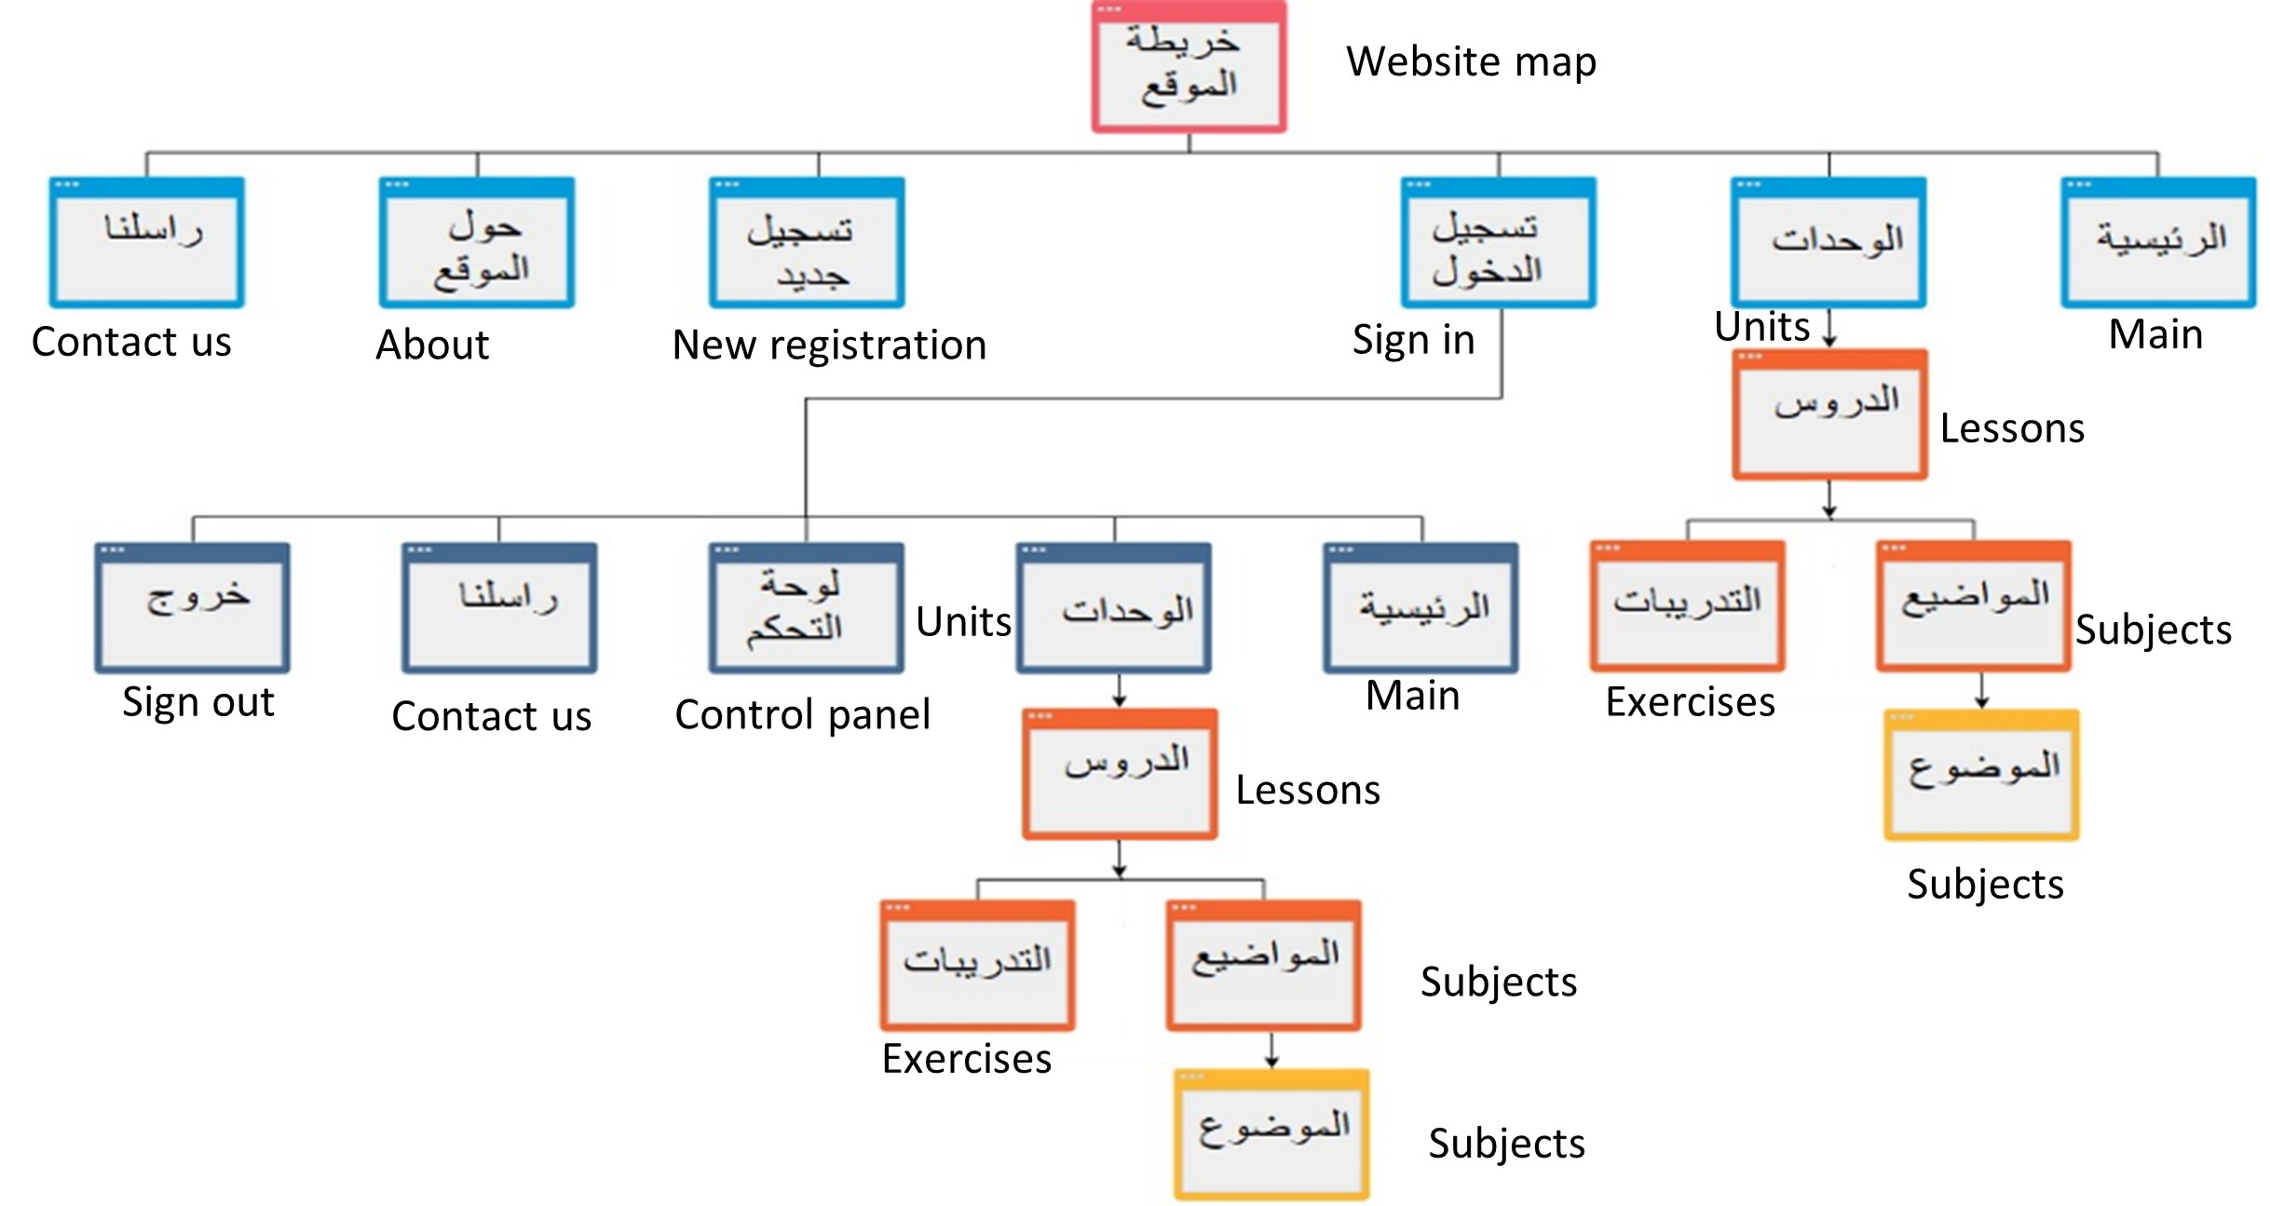
Figure 4: Student Website Map
  - Interface
While the platform is designed for anyone to use, the system needs to be simple enough for blind and visually impaired individuals to navigate the content successfully. This means limiting the number of images and including voiceover technology to verbalize the written content. A survey of 18 blind or visually impaired individuals, as well as their teachers and relatives, was deployed to ascertain the necessary design features. Developers of existing systems and individuals who are engaged with braille learning systems also participated in this process. Of the respondents, 83.3% were fluent in braille reading and writing. The rest had varying proficiency levels, but not to the same standard as their peers. Various questions concerning how to successfully design an online platform interface were included in the survey, with the following suggestions made:
- The platform should support screen reading
- Files need to be presented in Word format for screen-reader access
- No adverts should be featured
- Descriptions need to be provided for all menus, buttons, and images
- Ease and simplicity should be prioritized
- The system should enable blind individuals to process all the content without requiring external support

Each of these recommendations factored into the design of the resulting online platform.
Figure 6: the ministry administrator interface
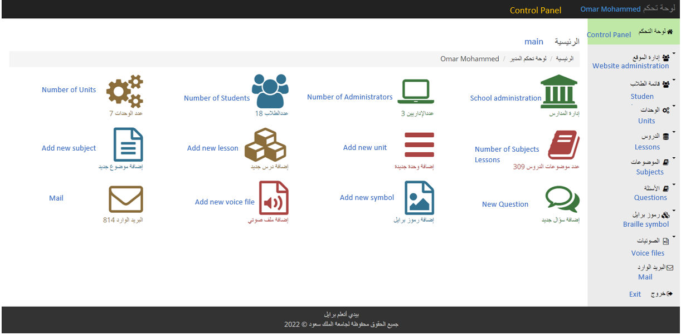
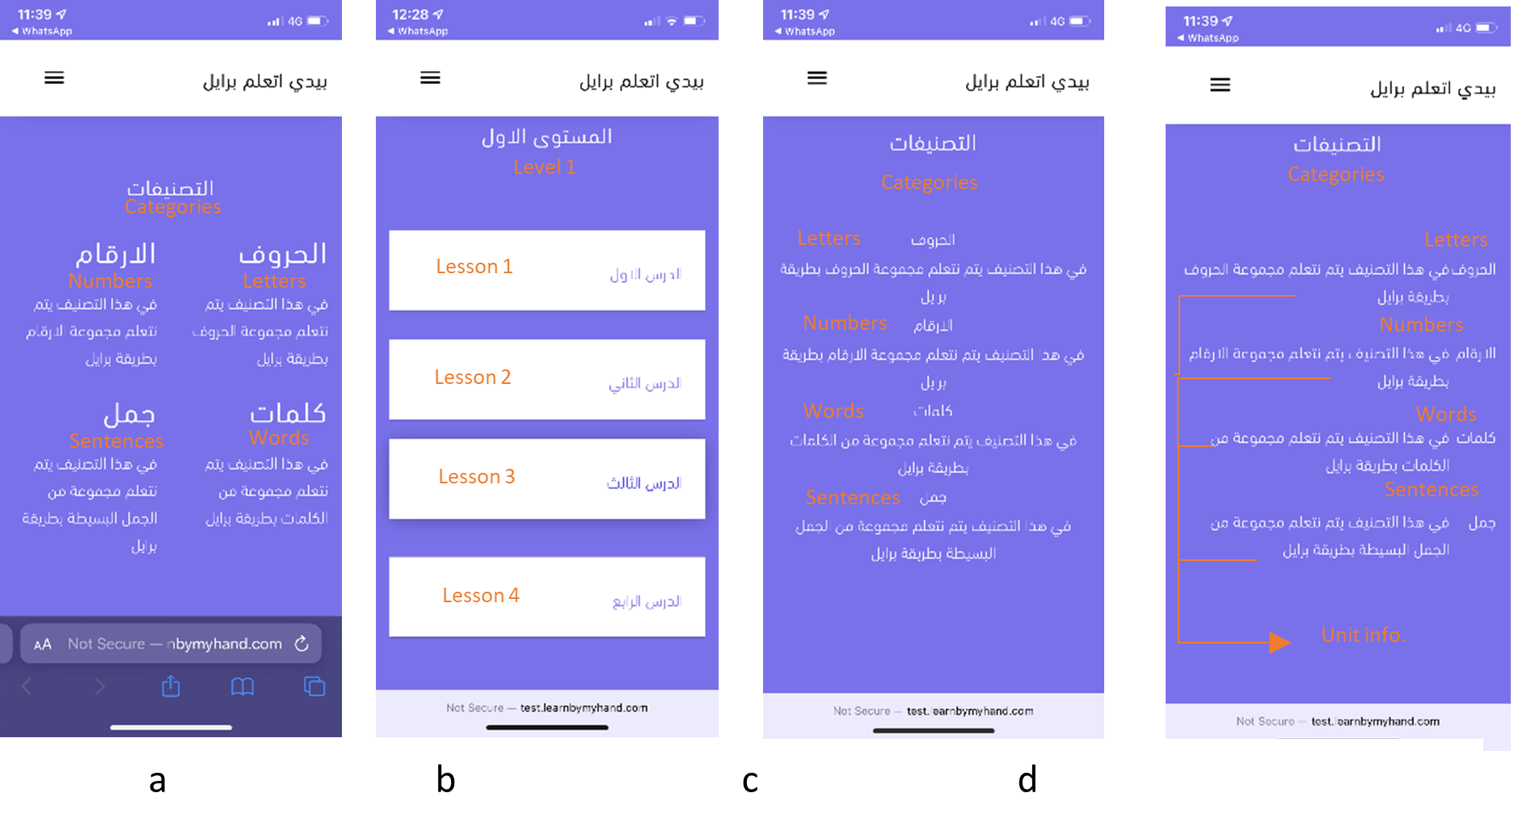
Multiple interfaces were designed, each taking the above factors into account. Six braille teachers were then blind tested to determine which was the most successful option, with each design rated according to how the content was presented. The four main screen interfaces are displayed in Figure 5(a-d). Option b was preferred by all of the participants as the best option, which was therefore chosen. The ministry administrator, school administrator, teacher, student, computer-based, and student smartphone-based interfaces are shown in Figures 6-10. It should be noted that the administrator's interface was not designed for use by visually impaired individuals.
Figure 5: main Screen models.
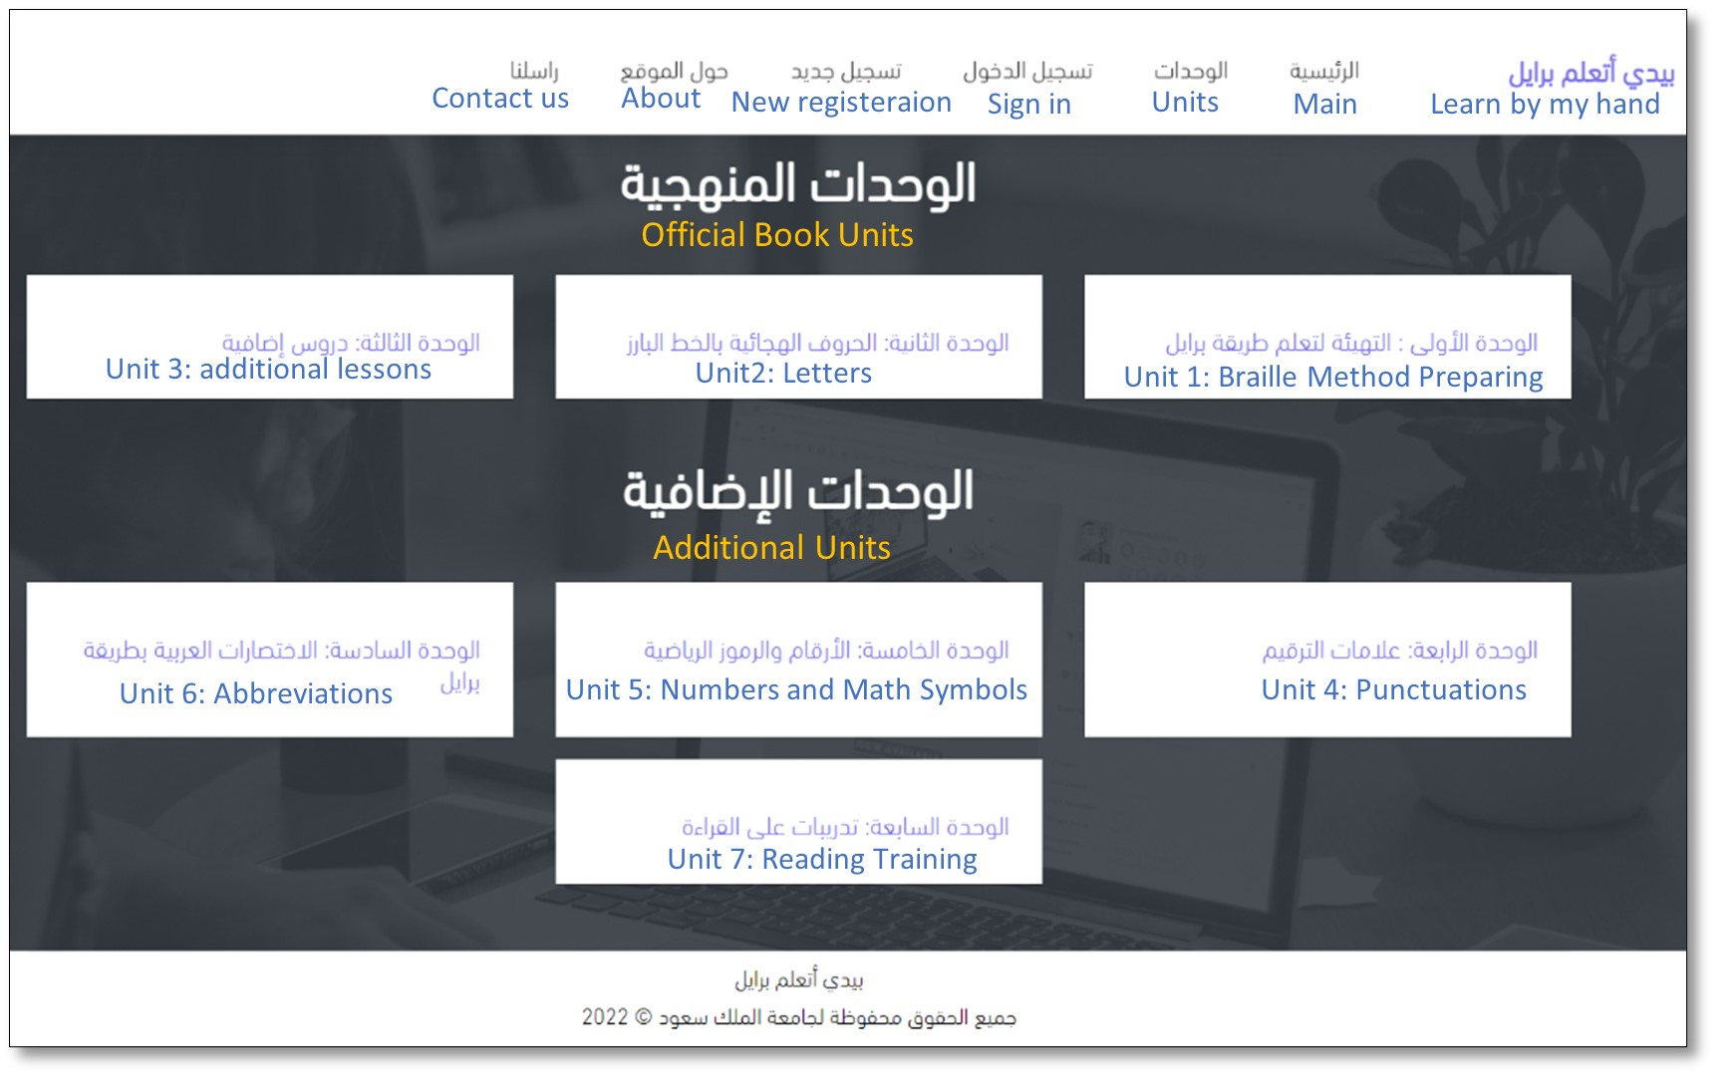
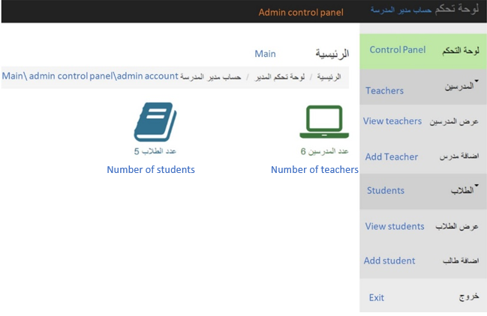
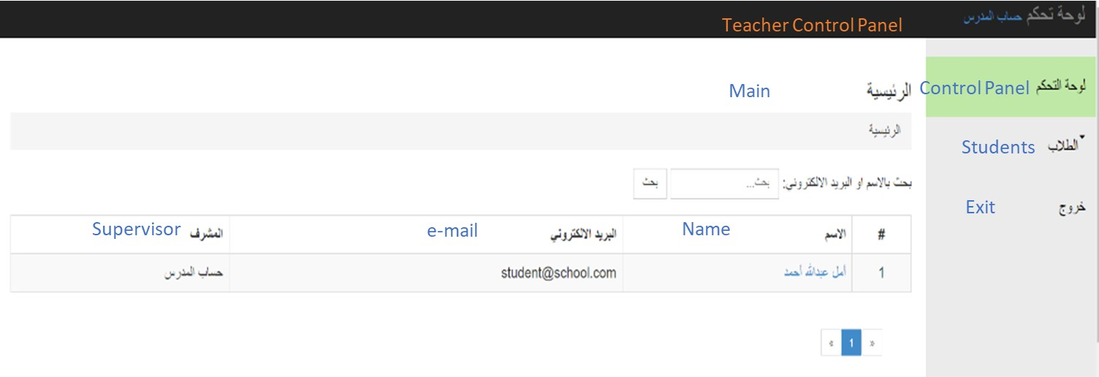
Figure 9: Student computer-based Learn-by-my-hand system.
Figure 7: School Administrator Control Panel
Figure 8: Teacher Page.

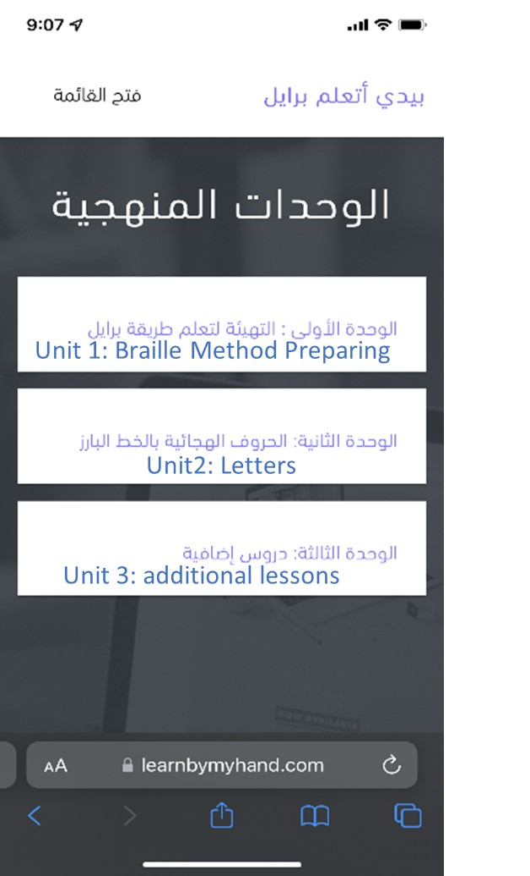
Figure 10: Smartphone-based learn-by-my-hand system interface.

The system allows students with varying levels of sight to access the content successfully. For blind people, the option of using a screen reader allows them to have all the content verbalized. Smartphones, computer screens, keyboards, and braille typing devices can all be used to record inputs and outputs. At the same time, sighted individuals can provide their answers without requiring additional equipment. It should be noted, however, that this approach may be disadvantageous if they attempt to learn braille in real-world environments that necessitate using figure touch techniques. Not relying on a smartphone or keyboard is a key benefit of using a braille typing device, which will help to improve a student's reading ability. بيدي أتعلم برايل (KSU, 2020) provides access to the student page.
- Conclusion
In conclusion, the learn-by-my-hand platform provides a means to self-learn braille in Arabic without additional support or guidance. Through the use of a survey involving 18 people who are either blind or visually impaired themselves or who play an active role in supporting such individuals, a dashboard-based system was designed that enables blind and visually impaired students to access and complete all level 1 school lessons. Based on these findings, future research should seek the responses of the elementary school children for whom the platform was designed to assess its success. For further insight into the platform's ease of use and navigability, such research should also compare the responses of sighted and visually impaired individuals across different age groups.

Acknowledgement
This project was funded by the National Plan for Science, Technology and Innovation (MAARIFAH), King Abdulaziz City for Science and Technology, Kingdom of Saudi Arabia, Award Number (5-18-03-001-0004).
References
Abirami, N., Dharsana, K. S., Ragav, R. A., & Chaitanya, K. J. (2018). Braille Learning System for Blind People. International Journal of Innovative Science and Research Technology, 3(2), 864-867.
Aizawa, F., & Watanabe, T. (2014, October). A braille writing training device with voice feedback. In Proceedings of the 16th international ACM SIGACCESS conference on Computers & accessibility (pp. 243-244).
AlSaleh , W., & Al-Salman, A. (2012). A computer software for teaching sighted people the Braille system. International Conference on ICT in Serving Individuals With Disabilities and Learning Difficulties, Kuwait.
Al-Watban, A., & Al-Salman, A. (2019, May). An Arabic Self-Learning Braille Application for Visually Impaired People. In 2019 2nd International Conference on Computer Applications & Information Security (ICCAIS) (pp. 1-5). IEEE.
Amani AlSalman, Suheer Al-Hadhrami, and Abdulmalik AlSalman."A Review Study on Self-Learning Braille Systems." The 21st International Conference on e-Learning, e-Business, Enterprise Information Systems, & e-Government (EEE), Las Vegas, Nevada, USA, July 25-28, 2022.
Araki, M., Shibahara, K., & Mizukami, Y. (2011, July). Spoken dialogue system for learning Braille. In 2011 IEEE 35th Annual Computer Software and Applications Conference (pp. 152-156). IEEE.
Avhad, A., Jadhav, R., Arbune, A., & Khainar, K. (2016). E-BRAILLE-A SELF LEARNING BRAILLE DEVICE. International Journal of Infinite Innovations in Technology, 4 (3), pp 1-12.
Brailliac (2018, January 7). Brailliac: Braille Tutor. Brailliac: Braille Tutor. Retrieved January 27, 2023, from https://play.google.com/store/apps/details?id=com.lukeneedham.brailletutor&hl=ar&gl=US
Dias, M. B., Dias, M. F., Belousov, S., Rahman, M. K., Sanghvi, S., Fanaswala, I., ... & Menon, S. R. (2009, April). An automated braille writing tutor with multilingual exercises and educational games. In 2009 International Conference on Information and Communication Technologies and Development (ICTD) (pp. 478-478). IEEE.
EM, A. S., Nithin, P., & BASKARAN, M. (2021). Self-Learning Braille Application for Visually Impaired People. Ilkogretim Online, 20(1), 5109-5114.
Jawasreh, Z. H. M., Ashaari, N. S., & Dahnil, D. P. (2020). The acceptance of braille self-learning device. International Journal on Advanced Science, Engineering and Information Technology.
Joshi, A., & Samasgikar, A. (2016). Braille Tutor: A Gift for the Blind. In Advances in Signal Processing and Intelligent Recognition Systems: Proceedings of Second International Symposium on Signal Processing and Intelligent Recognition Systems (SIRS-2015) December 16-19, 2015, Trivandrum, India (pp. 237-244). Springer International Publishing.
Kavalgeri, S. A., Chakraborthy, R. V., Naz, S. F., & Chaitanya, K. J. (2019). International Journal of Research in Engineering, Science and Management. International Journal of Infinite Innovations in Technology, 2(2), 131-135.
Kella Mohan Sandeep Kumar (2021, March 29). Blind Helper. Blind Helper. Retrieved January 27, 2023, from https://play.google.com/store/apps/details?id=com.sanson.blindHelper&hl=ar&gl=US
Khidri, S. A., Memon, S. H., & Jameel, A. (2014). Blind aid: A self-learning braille system for visually impaired. Journal of Engineering Research and General Science, vol. 2, June-July 2014, pp. 641-647.
Kim, H. N. (2018). User experience of mainstream and assistive technologies for people with visual impairments. Technology and Disability, 30(3), 127-133.
King Saud University (n.d.). Learn-By-My-Hand. Learn-By-My-Hand. Retrieved January 27, 2023, from https://learnbymyhand.com/
Learn and train touch reading Xiang Dong (n.d.). Braille Academy: Play & Learn. Braille Academy: Play & Learn. last updated Oct. 2020, Retrieved January 27, 2023, from https://apps.apple.com/us/app/braille-academy-play-learn/id1561530189
Lee, L. W., Mohamed, A. R., & Altamimi, A. A. (2015). Design, development, and evaluation of an automated e-learning tutorial system to instruct pre-service special educators in the Malay braille code. The Asia-Pacific Education Researcher, 24, 481-494.
Mario Ugedo (2020, November 11). Aprende Braille. Retrieved January 27, 2023, from https://play.google.com/store/apps/details?id=com.comoelagua.android.braille&hl=es_419&gl=US
Mario Ugedo (2020, November 11). LEARN BRAILLE. Retrieved January 27, 2023, from https://play.google.com/store/apps/details?id=com.comoelagua.android.braille&hl=es_419&gl=US
Montasser, M. (n.d.). Learn Braille with Nouf, Apple store. مع نوف Braille تعلم. Retrieved January 27, 2023, from https://apps.apple.com/us/app/%D9%85%D8%B9-%D9%86%D9%88%D9%81-braill-%D8%AA%D8%B9%D9%84%D9%85/id1508153898
Qatar Computing Research Institute (2020, February 27). BrailleEasy. BrailleEasy. Retrieved January 27, 2023, from https://apps.apple.com/qa/app/brailleeasy/id1124391970
Qatar Computing Research Institute (n.d.). BrailleEasy. Retrieved January 27, 2023, from https://apps.apple.com/qa/app/brailleeasy/id1124391970
R. &. A. (n.d.). Touch Braille, Apple Store. Touch Braille. Retrieved January 27, 2023, from https://apps.apple.com/us/app/touch-braille/id1199928789
Šepić, B., Ghanem, A., & Vogel, S. (2015). BrailleEasy: one-handed braille keyboard for smartphones. In Assistive Technology (pp. 1030-1035). IOS Press.
Smart braille education OHFA Tech, Inc. (n.d.). Taptilo U. Last updated Oct. 6, 2018. Retrieved January 27, 2023, from https://apps.apple.com/us/app/taptilo-u/id1520169375
Smart braille education OHFA Tech, Inc. (n.d.). Taptilo+. Last updated Nov. 2020.Retrieved January 27, 2023, from https://apps.apple.com/us/app/taptilo/id1434384498
Takaoka, Y., Ohta, M., Sugano, A., Oda, T., Maeda, E., Hanaoka, S., & Matsuura, M. (2011). e-Learning Program with Voice Assistance for a Tactile Braille. International Journal of Educational and Pedagogical Sciences, 5(10), 1273-1276.
Tang, J. (2013). Using ontology and RFID to develop a new Chinese Braille learning platform for blind students. Expert Systems with Applications, 40(8), 2817-2827.
Textbook, E. S. (2021). My Language لغتي, Level 1, elementary school textbook. Ministry of Education.
USEFUL APPS‏ (2018, June 10). Learn Braille. A Beginners Gui. Learn Braille. A Beginners Gui. Retrieved January 27, 2023, from https://play.google.com/store/apps/details?id=com.tresors86.learnbrailleabeginnersguide&hl=ar&gl=US
Wagh, P., Prajapati, U., Shinde, M., Salunke, P., Chaskar, V., Telavane, S., & Yadav, V. (2012). EBraille-a self-learning Braille device. Twenty-Second National Conference on Communication (NCC), 1-6.
Wagh, P., Prajapati, U., Shinde, M., Salunke, P., Chaskar, V., Telavane, S., & Yadav, V. (2016, March). E-Braille-a self-learning Braille device. In 2016 Twenty Second National Conference on Communication (NCC) (pp. 1-6). IEEE.
Wicaksono, M. F., & Kurniawan, R. H. I. (2019, November). Development of Independent Learning System Arabic Letters For Blind People. In IOP Conference Series: Materials Science and Engineering (Vol. 662, No. 2, p. 022110). IOP Publishing.

