**Lome TOGO**

**TITLE : THE**

**SOCIAL INCLUSION**

**OF STREET CHILDREN**

**IN AFRICA: west Africa cote d ivoire,Togo**

**Dr DODJI ERIC MATHEY**

**International Researcher /President**

**Co authors:**

**Save the life Africa**

**71 rue des Filao cite tokoin Lome Togo**

**They need a place to belong**…

**TABLE OF CONTENTS**

* 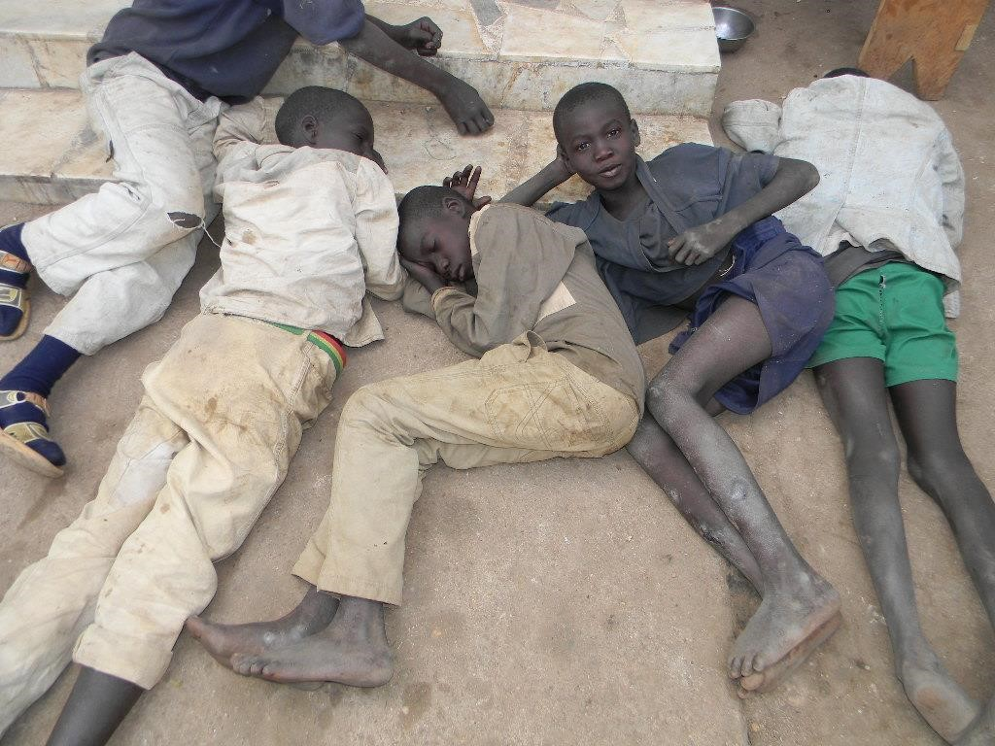**Introduction**
* **Statistics**
* **Reasons and Causes**
* **Objectif and Target**
* **Solutions and actions**

**INTRODUCTION**

The scourge called 'street children‘ brings to the mind the images of children vending, sweeping, cleaning shoes, selling all sort of things, collecting garbage, but in ragged cloths.

Roadways are what they have as bedrooms.

Some of them are involved in:

* drug peddling,
* pick pocketing,
* prostitution,
* begging alms

Others are children doing nothing but just loitering here and there in the streets.

According to the recent data, approximately 100 million children live on the streets of urban areas spread all over the world. They can be observed both in developed and developing countries, In practice, every city in the world has some street children, including the biggest and richest cities of the industrialized world according to UNICEF.

**STATISTICS**

Research made by the Journal of Adolescent Health showed Children reported leaving home when they were between 6 and 16 years of age and having lived on the streets for a period of days to, more frequently, years . On-the-street children tended to be younger than of-the-street children. These data suggest that on-the-street children may grow to be of-the-street youth.

However, data to support this is absent.

Boys were the most visible group on the street in low-and middle-income countries, constituting

50% to 100% of study samples reviewed. Where reported, of-the-street boys were often significantly older than of-the-street girls. Boys had generally spent more years on the street than girls, whereas girls tended to have more contact with family. Girls may also be more amenable than boys to sleep in institutions, be living with relatives, be recruited into sex work, or be in “sugar daddy” relationships with older men, all of which may render them less visible.

**STATISTICS**

**Classification of Policy Approaches evident towards Street Children**

**1. Correctional, reactive or repression-oriented model**

Deviants - threats or potential threats to public order whose deficient characteristics

differentiate them from other children assumed to be ‘normal’, inviting a repressive response to individual children

**2. Rehabilitative or protection-oriented model**

Victims - in which the deficient conditions of street life are emphasized, those whose basic rights to food, shelter, education and health are continuously violated, inviting a more protective approach towards the children in these situations

**3. Human-rights based model**

Citizens whose rights have been violated - A group of people who are discriminated against and whose access to rights as citizens and as children are denied or unsecured by society. Medical based policies have also been proposed all geared to the social inclusion of these street children. But little to nothing has been done in all these areas especially in poor and middle-class countries.

**REASONS FOR ACTION**

Street children are among the most physically visible and vulnerable of all children, living and working on the roads and public squares of cities. Yet, paradoxically, they are also among the most 'invisible‘. They are deprived of vital services such as education and health-care, and protection.

They find themselves on the street for various reasons.

* Poverty
* Lost of one or both of their parents
* Accusation of witchcraft so they are rejected by their families
* Parents’ abusive behaviour, alcoholism, and joblessness

**REASONS FOR ACTION**

Structural factors that may be affecting these street children's health are:

* 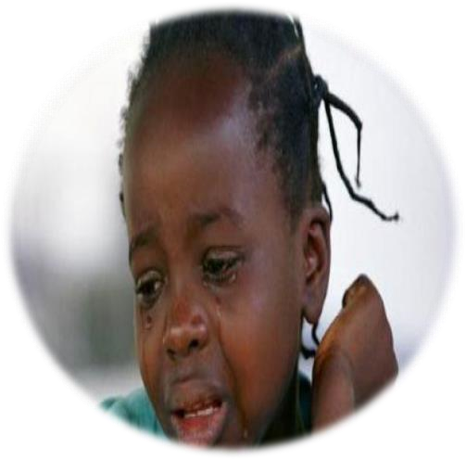Nutrition and Growth deficiency.
* Sexual and reproductive health
* Infectious diseases
* Unintentional injuries
* Substance use and abuse
* Health care

**TARGET**

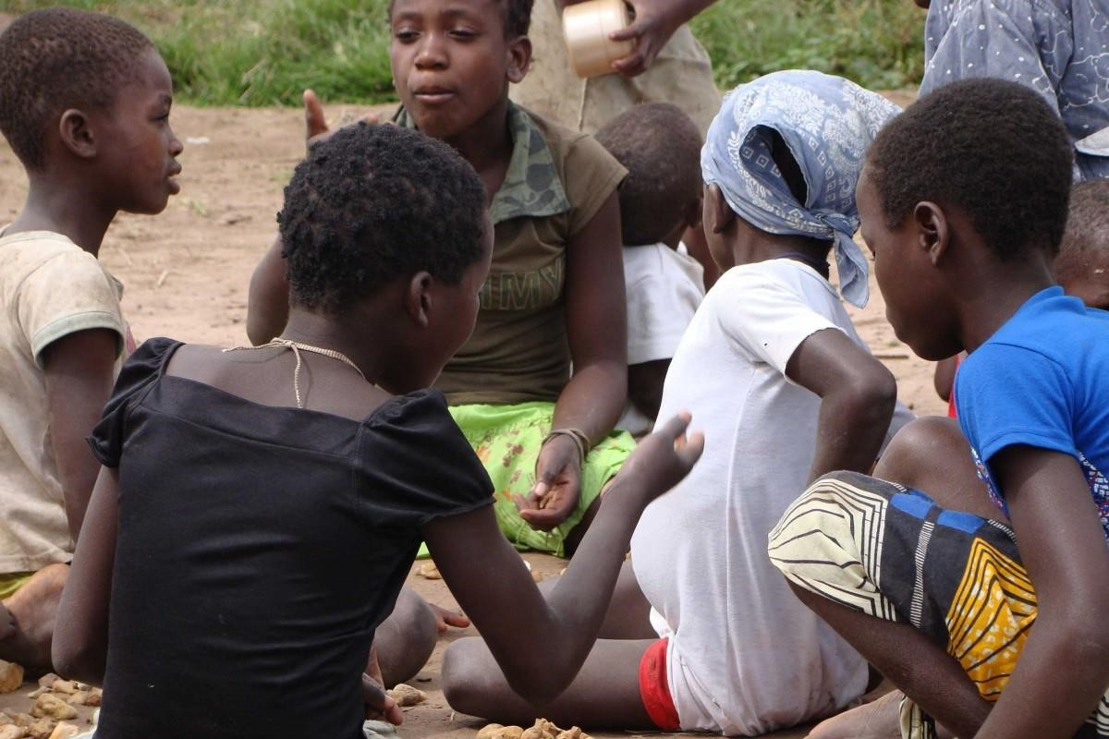There are 3 categories of street children:

1. **Children at risk-** Poor working children, living at home but earning money on the streets for their families. They live on the street with their families and often work on the street. There may be children from migrated families, or temporarily migrated and are likely to go back to their homes.
2. 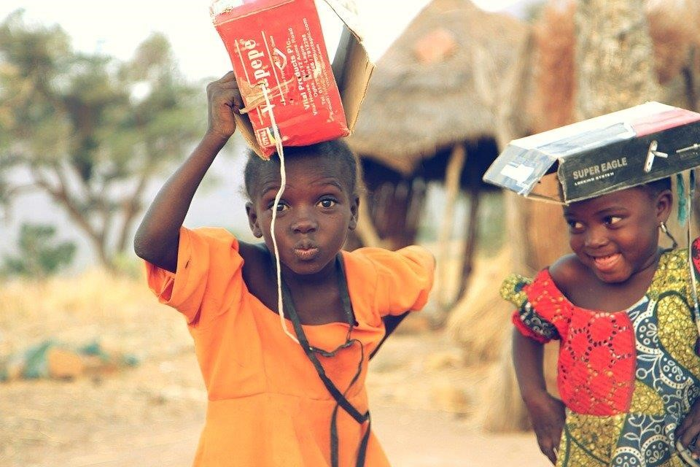**Children on the street** - Children who spend a lot of their time on the street but have some family support and live at home on regular basis. They live on the street by themselves alone otherwise in groups and have remote access or contact with their families in the villages. Some children travel to the cities for the day or periods of time to work and then return to their villages

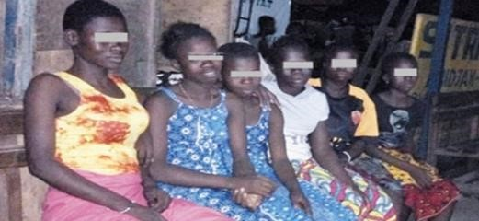**3.Children of the street** - They live and work on street and have no family support or contact. They have no links with families such as orphans, refugees and runaways.

Children of the second and third category are the most helpless as they are easy sufferers of abuse, misuse, maltreatment and exploitation. They are pushed into theft, prostitution gambling etc. for economic survival.

Therefore we want to focus our actions on the second and third category of Children.

The social inclusion of the streetchildren impliesa series of actions that aims to make the street children feel accepted in the society. There's a big problem on hands and actions should start now. There must be deliberate Programs to reintegrate street children into their communities. **These programs need to be developed such that they are appropriate to local settings and recognize the universal human rights of children.**

➢ The provision of safe shelter must be a primary intervention to improve the health of the street children. Based on findings, interventions such as increased access to education for streetbased children, the regulation of access to inhalants, and the enforcement of laws protecting all children from physical and sexual abuse(as codified in the United Nations Convention of the Rights of the Child), must be implemented because they are tools to reduce the problem at hand.

Street children’ resilience and need for independence to survive under particularly harsh circumstances should be recognized. However, it is also imperative to recognize the fiduciary responsibility and shared interest of communities at the local and global level to support these children in becoming productive and healthy adults.

The program ITF stands for IDENTIFICATION,TRAINING and FOLLOW-UP. ➢ IDENTIFICATION

Campaigns of identification of the street children will be organized at strategic places.

Various activities will be organized to entertain them. They also will be given the opportunity to share their stories and talk about what they want to do in life. Health check-up will be done and food will be shared. Then the children will potentially be oriented to NGOs and organisations that can host them. Families that are willing can contribuate by hosting the youngest children for some time.

* TRAINING

During their stay in the various places, training programs will be organised to teach the older children jobs

(Hairdressing,painting,Tailoring,pedicuremanicure…). The youngest will attend special classes so that they can go back to school or just receive the least of education.

They will all be oriented to activities they are talented in. (Football,dancing,singing….)

* FOLLOW-UP

The children will be checked weekly then monthly to make sure the reintegration is effective.

The purpose of this stage is to complete the work started during the stage of identification and also to make the children feel the care and the love. Their emotional state will highly be impacted by this.

**THE END**

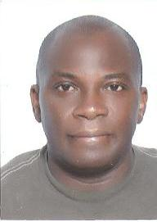

MATHEY-APOSSAN

DODJI ERIC

matheyeric@yahoo.fr / savethelife@hotmail.com

20 years of expertise in Development Project - Consultant - Trainer

Zones & Group programs at risk.

20 years of Professional Experience

TRAINING - DIPLOMAS – CERTIFICATES2010-2020n: Initiator of the Messengers of HOPE Project Migrants and sexual behavior in Switzerland (Autonome schule Zurich Balkans / Program Coordinator Africa DDR Reintegration and Culture of peace of groups at risk Post crisis West

MIGRANTS & REFUGEES and Intern Displaced Populations after civil war and Crisis in West Center of Côte d Ivoire 2000-2012.

DDR PROGRAM DISARMAMENT DEMOBILIZATION & REINTEGRATION of more than 15000 young populations2001-2018

August 2018: Chaired Session of ISPCAN Orphans and Violence Against Children and Children hitted by war and as Minors Soldiers employed in Farms as minors

1986 - 1989: Masters in Educational Sciences - University of Lomé Togo

2000/2003: EU / PRECOD Civil Society Decentralization Project Program to strengthen Decentralized Cooperation Togo Local Expert

2010 DEA Doctorate Humanitarian Law / PSF / AFRICA

2000/2001: Medical College of Wisconsin / us National Institute of Mental health

GAIN Project / Global Institue of Mental Health

1986 - 1987: Masters in English Ghana Institute of Languages ​​Accra

1986 - 1987: Deug II English Spanish - University of Lomé Togo

June 1986: Baccalaureate series AS Letters Philosophies-Languages

CERTIFICATES & ATTESTATION• Certificate of HIV / AIDS Animator city of Colombus State Ohio USA (2007-2010)

• CATF Colombus AIDS Task Force

• Field Agent Certificate - American Red Cross State Ohio USA (2009)

• USAID Affiliate Partner Certificate - SFPS / AIDS Prevention Project - Family Planning (1997-2002)

• Trainer Certificate / AIDS Prevention CRIPS (1996-1998)

• Children's rights, Human rights - Gender violence and disadvantaged children - Areas & Groups at risk - WAO Africa (1989-2008) DEA

• International Solidarity, Sustainable Development and Elton John AIDS Foundation.

• Training of trainers - English, Spanish, Russian, Swiss Aid against AIDS.

• Multicultural experience of more than 25 countries recognized in the world

Publication & research recognized Worldwide - European Union American Research Centers, Switzerland, United Kingdom - American Red Cross

STUDIES / RESEARCH / PUBLICATIONS

Researchs & Abstracts selected by ISPCAN 2018 PRAGUES

1 / ABSTARCT ISP2018-0784 NEW STRATEGIES TO PROTECT CHILD SOLDIER REINTEGRATION AFTER CRISIS CIVIL WAR 1999-2004 in Wwest Cote divoire

2 / CHAIRED SESSION ISPCAN XXII International Congress on Child Abuse and Neglect September 2018 Pragues ,,, VIOLENCE in CHILDHOOD ,,,

. Environmental Health 2018 in Warsow Poland Communication selected ,,

Impact of HIV Positive Migrants in Europe Borders

❖ HIV / AIDS prevention in Africa. Best Original Program selected by the International Scientific Medical Committee College of Wisconsin (Milwaukee-US).

GAIN Project sponsored by US Government NIMH (National Institute of Mental Health) published in Community Health journal, US vol # 4 August 2004-Author DODJI ERIC MATHEY Executive Director Save the Life.

❖ “HIV & AIDS Social care for women in Urban Areas of Togo, West Africa”

IHCM Department of Management –University of St Andrews. Author DODJI MATHEY Excutive Director Save the Live. April 2002

❖ “HIV / AIDS” Reinforcement in Africa Government New Policy-Mole 2984

13th World AIDS Conference-Durban 2000. Author DODJI ERIC MATHEY “Young Taxi Moto Drivers as Peer Educators HIV / AIDS” Alstraet 1354C. 12th World AIDS Conference-Geneva 1998

❖ Initiator of the “Messengers of Hope” Program with more than 10,000 young motorcycle taxi drivers in Togo with a relay strategy and AIDS prevention and free anonymous testing refer more than 100,000 of their customers since 1997 to the present day.

PROFESSIONAL EXPERIENCE ➢ President-Designer NGO SAUVONS LA VIE / SAVE THE LIFE AFRICA Program (1992-Present).

➢ Prevention program, HIV / AIDS care, Impacts on groups at risk & multicultural.

➢ Design of leaflets adapted to socio-cultural & ethnic realities

Immigrants:

▪ Case Togo - Benin - Ivory Coast

➢ Spanish NGO Psicologos Sin Fronteras Valencia - PSF Cultural of Peace: Psychosocial support to risk areas around the world.

➢ Africa Coordinator: Psychosocial support for victims of the post-election crisis in Côte d'Ivoire (2011: present)

➢ European Union (1999-2003)

Decentralized Civil Society Cooperation in Togo-Benin-Brecod-National Consultant

➢ USAID Togo

IST-Wake up Africa project (1996-2000)

➢ WAO Africa

Coordination-Domestic Violence-Children's Rights

➢ Save the Life Africa

➢ Arcat SIDA Paris (1996)

➢ CRIPS Paris (1997)

➢ University of Saarbrucken (1995)

OTHER KNOWLEDGE

English: read, spoken, written (Excellent)

Spanish: read, spoken, written (Excellent)

Russian read, spoken, written (Fair)

HOBBIES: Africa Project Coordinator REAL MADRID Campus Experience www.soccercampsmadrid.com

Youth camp organizations (for 20 years)

Football, Law Tennis, Table tennis

Others: USA Driver's License (2008)

Driving License Togo, Ivory Coast (1992)

American Red Cross Ohio-Colombus volunteer (2009)

COMPUTING: Word, Excel

Internet