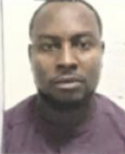

No. 6, Suleiman Fakai Street

Police Estate Dakwa

Abuja

7th April, 2021

Consular Section,

Turkish Embassy,

Plot 333 Mission Street,

Off Diplomatic Drive,

Central Business District

Abuja.

Dear sir/ma,

**LETTER OF CONSENT**

I **Mr. OKUM CHARLES MATTHEW** with passport number: A07712298 the Biological father and my Wife Mrs.OKUM JENNY CHARLES do hereby give my consent to my wife to travel with my daughters to **North Cyprus** for Studies.

Their details are ass follows:

1. **OKOGHENU AIKHOMON MARIA ---- A09289878**
2. **OKOGHENU GRACE EBOSETALE MMESOMACHUKWU – A11386033**

I hereby give my consent to my wife to with my daughter. They will abide by the rule and regulation of above mentioned school and country, he will return to Nigeria after his studies and I will be responsible for all their financial obligation and up keeps.

Thanks for your Co-operation.

__________________________

**OKOGHENU EHIMEN REUBEN GODWIN**