Abstract— The aim of this article is to study the relationship between small and medium enterprises (SME)and loan interest rates in Mongolia. It is essential to deeply consider the development of SME in recent years.
RELATIONSHIP BETWEEN SMALL MEDIUM ENTERPRISES AND INTEREST RATE IN MONGOLIA
ZANABAZAR ENKHBOLD
Institute of Education and Economic Research
Ioeer.mng@gmail.com

INTRODUCTION
Small and medium enterprises (SME) maintain revenue, assets and number of employment below a certain threshold. SMEs play a major role in the economy, particularly developing countries and count as vital contributors to creating a job and economic growth. For instance, 40% of the economy, 7 out of 10 jobs constituted from SME. [Word bank, n.d.]
First and foremost, the definition of SME will be valid for this chapter. As regulated in Mongolian law an enterprise with an annual turnover of less than 1.5 billion tugriks and with less than 200 employees is a SME. Also it is varied by following sectors:
❖ In the industrial sector, if an enterprise has less than 20 employees and the annual turnover is below 250 million tugriks, it is classified as an SME
❖ In service, if an enterprise has less than 50 employees and the annual turnover is below 1 billion tugriks, it is classified as an SME. (D, 2019)
To improve the economic situation obviously there is a need for enhancement of SME development. A Number of examples show incredible economic growth through enhancing SME sustainability. To mention the South Korean example, since the 1960s the government constantly boosted SME and consequently 99% of business entities, 90% of total employees are working in SME. [Bank of Mongolia, 2011, 23]
In order to hold business stable, finding the source of their funding will be the main issue for SME. Basically SME are less likely to get a loan from a bank; instead, they rely on their own assets or loan from friends and family. It usually depends on how many years the business has been held and how big they are. However, according to the bank of Mongolia (BOM) research, 76% of SME loans are from the bank. [Bank of Mongolia, 2018, 26]. It is a seemingly

high number to compare other countries' situation; however, since Mongolian financial sectors are dominated by banks it is common phenomena.
Hence, loaning rate and loan repayment could be vital factors for SMEs future sustainable development. Specially countries like Mongolia which have low growth in derivatives may focus on the SME market.

1.1 Problem Statement

As mentioned above, interest rates could have a highly impact on how SMEs continue their operation. This paper will research what indicators impact sustainability and which are the highest effect on SMEs.

1.2 Literature Review

Many researchers point out SMEs in developing or developed countries both had a need for a consistent financing source in order to maintain a sustainable revenue threshold. As developed countries had a variety of opportunities to diversify their finances. But for developing countries, banks usually extending credit to SME, could affect firms' stable operation. Although banks had interest in extending credit to SME, there are still certain issues about collateral, banks risk and the absence of governmental regulation to boost SMEs development.

However, there is an option to provide financial sources in some developing countries. To exemplify, Indian entrepreneurs in East Africa, Lebanese firms in West Africa and European enterprises in South Africa form networks whose members lend each other indispensable financing with an informal contract enforcement system. This system will decrease asymmetric information and weak formal contract systems. [Biggs & Shah, 2006, #]
An appropriate programme or project to support SME could be one of the gates for development. Recent worldwide attitude for SMEs development is not just to assist with the funding but the soft infrastructures such as telecommunication, water and electricity bills are necessary. But some banks specially named as big sized banks in Mongolia initiate a number of non-financial services to SME. For instances:
● Sponsorships to annual gatherings, conferences, and trade fairs organized by various sectors that help industry representatives in networking
● Initiating training, information sharing and networking events for some selected industries
● Providing business advisory services
● Organizing financial literacy training, also in rural areas. [International Finance Corporation, 2014, #]
As a traditional way to lend from banks, certain common difficulties that could be encountered. [Quartey et al., 2017, #] use Word Bank’s Enterprise Data set to examine factors that impact on SMEs in Africa cross countries. As a consequence, inadequate collateral, risk, and lack of information of SMEs credit history became barriers to access to financial resources. Nonetheless study by [la Torre et al., 2010, #] finds that i). Banks had interest to extend credit to SME and increase its earnings ii). can assist SME multiple ways not just credit iii). serve SMEs through technology, risk rating and training. [Shihadeha et al., 2019, #] research illustrates that enhancing credit to SME would decrease the value of non-performing loans in banking operations in Palestine. According to [Tran, 2021, #)] research indicates in order to obtain a SMEs loan from a bank, company owners had to have a business or personal asset that could be used as collateral.
Furthermore, other reasons SMEs couldn’t access from banks are i) SMEs are not preparing appropriate financial statements ii) not maintaining proper licensing which could decrease estimated collateral. [Akterujjaman, 2010, #]

Data
2.1 Data

This study will be used in the bank's annual report during the 2016-2020 quarters for 9 banks in Mongolia and contains 180 unbalanced observations. (Economic Policy and Competitiveness Research center, 2020) mentioned that there are 3 types of banks varied by their assets.
Big sized | >5 trillion MNT | - Trade and development bank  - Khaan bank  - Golomt bank
Middle sized | 1-5 trillion MNT | - Khas bank  - State bank
Small sized | <1 trillion MNT | - Chinggis Khan bank  - Capitron bank  - National Investment bank  - Arig bank  - Bogd bank  - Credit bank  - Trans bank
Table 1: Type of bank

Due to the lack of a data basement, 9 banks quarterly statements were found for analysis which are: 1 TDB, 2 Khas, 3 Chinggis, 4 Golomt, 5 State, 6 Capitron, 7 Bogd, 8 Trans, 9 Credit. Thus this data includes three nine sections and time series become panel data

2.1 The variables

In order to examine the relationship between interest rate and SME, I chose dependent and independent variables as mentioned below. As for internal variables, I chose interest rate, banks’ total non-performing loan which defaulted more than 180 days, banks’ asset and capital. To clarify external variables, growth of domestic products will be an exemplified cause.

Dependent variable | Independent variables
- credit extended to SME | - interest rate  - non-performing loan  - asset  - capital  - gdp
Table 2: Dependent and Independent variables

1. credit extended to SME: Total loan extended to small and medium enterprises
2. interest rate: Loan rate which extended to small and medium enterprises
3. non-performing loan: Default loans for 180 days or more
4. asset: Total bank asset
5. capital: Total bank capital
6. gdp: Quarterly increments

2.3 Empirical model

To turn dependent and independent variables into econometric equation:

𝐶𝑆𝑀𝐸𝑖𝑡 = 𝐼𝑁𝑇𝑖𝑡 + 𝑁𝑃𝐿𝑖𝑡 + 𝐺𝐷𝑃𝑖𝑡 + 𝐴𝑆𝑆𝑖𝑡 + 𝐶𝐴𝑃𝑖𝑡 + 𝐸

Methodology
In this chapter, I am going to do empirical analysis which represents the relationship between interest rate and small and medium enterprises. As I predicted and mentioned at the problem statement section, growth of interest rate could impact small and medium enterprises ability to borrow from banks. I used the Eviews program to estimate equations and other analysis.

Descriptive analysis and correlation matrix

Before we start all the analysis, I turned total loans extended to small and medium enterprises (csm), gdp, non-performing loan (npl), total asset(ass), total capital (cap) to logarithm to be exact and precise for all consequences. Appendix 1 represents descriptive statistics for this study, including fundamental performance such as mean, median, standard deviations and the others.
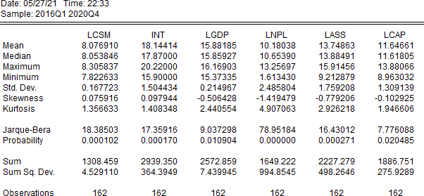
Figure 1: Descriptive analysis

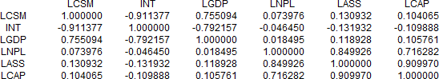
Figure 2: Correlation matrix

LCSM (logarithm credit extended to small and medium enterprises) positively strongly 0.75 correlated to LGDP (logarithm gdp) which could tell us supporting SMEs operation could increase gdp’s growth. As we can see, the interest rate(INT) is strongly negative -0.91 related to LCSM. From this we could conclude growth of interest rate will decrease SMEs' ability to loan from banks.
Meanwhile asset(LASS) and LCSM weakly positively 0.13 related which present banks capacity of asset affect slightly to CSMs credit rating. In addition, correlation between capital and lcsm had weak positive correlation 0.10 which is almost the same as asset. Generally banks capital and asset have strong relationship also correlation matrix could prove that it indeed positively correlated.
Furthermore, I will use assets for the estimation.

Granger causality

The Granger (1969) approach to the question of whether x causes y is to see how much of the current y can be explained by past values of y and then see whether adding lagged values of x can improve the explanation. (Eviews, n.d.)
Thus since we had panel data, Granger Causality test will assist us to get better results for time series analysis.

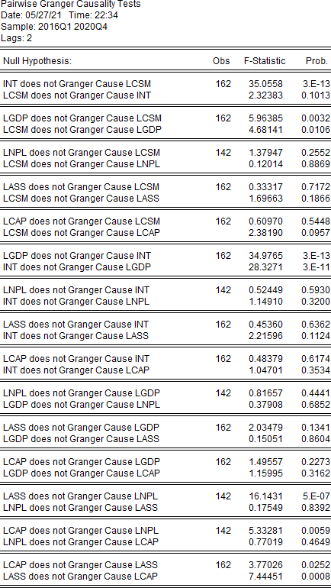
Figure 3: Granger causality

Through review Granger causality tests LGDP and INT, LGDP and LCSM probability below

0.05. It rejects a hypothesis which does not have Granger cause. Further, above variables' past value impact on each other's future value which represents lag value should be included in our estimation

Panel data regression

First and foremost, we have to follow fundamental regulations of regression which describe correct models.
Criterion to select model:

1. T-stat is higher
2. Prob is lower
3. R square is higher but not equal to one
4. F-stat is higher
5. Standard deviation lower model has to be chosen.

Since it has nine cross sections, twenty quarter and unbalanced 180 observations, using panel least square methodology will be the most appropriate way for estimation. However, due to the lack of incomplete data, it turned out to be 153 observations which were automatically computed by Eviews.

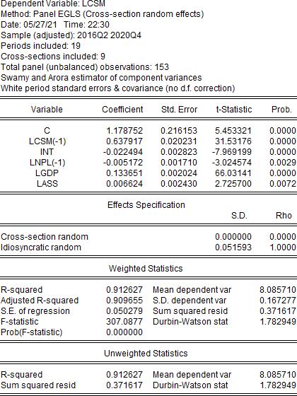
Figure 4: Panel data regression

Random effect model as known as the error components model which is alternative to the fixed effect model described. Since a fixed effect model cannot completely explain estimation and also the fixed effect model was statistically insignificant , I chose a random effect model.
The White period (cross-section cluster) method assumes that the errors for a cross-section are heteroskedastic and serially correlated. The estimator is designed to accommodate arbitrary heteroscedasticity and within cross-section serial correlation. (Eviews, n.d.) In order to calculate coefficient standard errors within a robust method, white-periods will adjust heteroscedasticity.

𝐿𝐶𝑆𝑀 = 1.17 + 0.63 ∗ 𝐿𝐶 (−1) − 0.022 ∗ 𝐼𝑁𝑇 − 0.005 ∗ 𝐿𝑁𝑃𝐿 (−1) + 0.13 ∗ 𝐿𝐺𝐷𝑃 + 0.006 ∗ 𝐿𝐴𝑆𝑆 + [𝐶𝑋 = 𝑅]

All independent variables’ probability below 0.05 mean statistically significance. Further p- value is small enough to reject H0 which interest rate has no significant influence on extended loan to SME. To analyze other countries' cases, one of the powerful factors increasing GDP was small and medium enterprises' constant operation and their impact on the economy. Similarly, this concept works on estimation too. Rising one unit GDP will bring 13% growth for LCSM. If interest rates increase one unit, SMEs' ability to borrow from banks will decrease by 2.2%. Amount of loan and assets are inseparable for the banks. Thus assets increased by one unit, LCSM is expected to increase 0.6%.
Adjusted R square is 0.909 which means independent variables can explain 90.9% of the dependent variables. Durbin Watson stat equal to 1.78 which lay between green gaps. From this, this estimation does not have an autocorrelation issue.
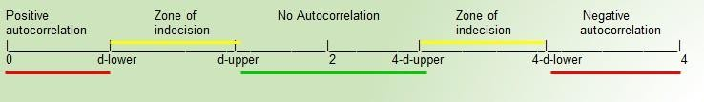
Figure 5: Auto regression gap

Conclusion
The study by the Bank of Mongolia (central bank) determined that the two of the biggest challenges which SMEs are facing nowadays are funding and capabilities of human resources. Even though we have widely discussed the development of SME since the 1990s, expectations could not meet reality nowadays.
If the funding is a problem, a solution will be to extend a discounted loan to SME. Therefore, panel data regression describes decreasing interest rate increase loans extended to SME by 2.2%.
Besides, GDP was strongly negatively correlated with interest rate. Meanwhile GDPs growth is expected to increase loans extended to SME by 13%. These three factors are inseparable chains for the economy. Although a reasonable interest rate will be important for the business environment, it is hard to immediately decrease rates. In other words, it's a long term problem to decrease interest rates step by step.
To sum up, the result of empirical analysis met my prediction that interest rates could impact SMEs ability to loan from banks. GDP and credit extended to SME are strongly positively correlated. Thereby, there is an opportunity to evaluate interest rates indirectly affecting GDP. Since SMEs are regarded as the backbone of the economy, solving issues which SME encounter will be the biggest push for future development.

REFERENCES

- Akterujjaman, S. “Problems and Prospects of SMEs Loan Management: A Study on Mercantile Bank Limited, Khulna Branch” Journal of Business and Technology (Dhaka), pp. 5(2), 38-52, December, 2010.
- Bank of Mongolia, “ЖИЖИГ ДУНД ҮЙЛДВЭРЛЭЛИЙН ХӨГЖИЛ, САНХҮҮЖИЛТИЙН БАЙДАЛ” Vol. 94, 2011.
- Bank of Mongolia, “ЖИЖИГ ДУНД ҮЙЛДВЭРЛЭЛИЙН ХӨГЖИЛ, САНХҮҮЖИЛТИЙН БАЙДАЛ” pp. 70, 2018.
- Biggs, T., & Shah, M. K., “Journal of Banking & Finance African SMES, networks, and manufacturing performance, vol.30 2006.
- Brooks, C., “Introductory Econometrics for Finance.” Cambridge University Press. 2008
- D, J. “SMES ARE THE REFLECTION OF THE DEVELOPMENT. JARGALDEFACTO.”,2019, https://jargaldefacto.com/article/smes-are-the-reflection-of-the-development
- Economic Policy and Competitiveness Research center. (2020, 7 10). Banks competitiveness overview 2020. Economic Policy and Competitiveness Research center.
- la Torre, A., Martínez Pería, M. S., & L. Schmukler, S.” Bank involvement with SMEs: Beyond relationship lending.” September, 2010.
- Quartey, P., Turkson, E., Y. Abor, J., & Iddrisu, A. M. Financing the growth of SMEs in Africa: “What are the constraints to SME financing within ECOWAS?” Review of Development Finance, 7(1), pp. 18-28, June, 2017.
- Shihadeha, F., Naradda Gamage, S. K., & Hannoon, “A The causal relationship between SME sustainability and banks risk” Economic Research-Ekonomska Istraživanja, 32(1), pp. 2743-2760, September, 2019.
- Tran, A. H. “The impact of bank credit accessibility of small and medium enterprises in Ho Chi Minh city, Vietnam”
International Journal of Multidisciplinary Research and Development, 8(1), 25-30, 2021

 

