<https://teraevents.org/conference/dubai-ictel-19-20-feb-2022~about>

**PERSPECTIVES OF TEACHING ENGLISH OFFLINE AND ONLINE IN HIGHER SCHOOLS**

**M. Zh. Tussupbekova, Zh. I. Aristambekova, K.K. Kulanova**

*L.N. Gumilyov Eurasian National University, Astana, Kazakhstan*

*Tusupbekova_mzh@mail.ru*

**Abstract**

*This paper presents the perspectives of offline and online learning during the period of the world pandemic situation. It is not a secret that all Kazakhstani educational establishments have switched from traditional to blended learning. Blended learning is a combination of offline and online teaching. Blended learning can be delivered by online courses, classroom instruction, group projects, video conferences, assignments etc.*

**Keywords**

**Introduction**

COVID – 19 faced all the world community with new ways of teaching and working. Humanity was transferred to the distance learning: education, meetings, seminars, conferences. This situation presents opportunities not only to study, but understand the positive and negative sides of living. The Ministry of education and science of the Republic of Kazakhstan updated testing services, teacher training, information systems in all educational institutions. The main task of the Ministry and institutions was to learn teachers and pupils (students) to provide with educational materials, send assignments, evaluate and give feedback. In his speech, the Minister of education and science of Kazakhstan A. Aimaganbetov noted, that distance learning supposes the using of several methods and tools simultaneously (). During the quarantine, the Ministry provided a free access to Kazakhstani electronic platforms as Bilimland (domestic IT company), Kundelik (e-diary), Daryn (educational system), iMektep (interactive educational platform).

Higher schools of Kazakhstan were ready to transfer to online learning. Since 2000 universities have started to employ own learning management systems (LMS) with various distance learning technologies. LMS handles all aspects of the learning process. L.N. Gumilyov Eurasian national university (ENU) works on online learning platforms as MOODLE, Google classroom, Platonus with well-known video tools MS Teams, ZOOM, Webex, Google Meet. Automatic information system Platonus in ENU is the main tool for teachers and students. With the help of Platonus, teachers and students monitor the whole education process, collect and present all necessary data, track progress, assess individual and organizational learning goals, supply course materials and instructions to write scientific thesis.

Online learning opened up new perspectives in all levels (elementary, secondary, higher) education. Learning platforms offer various approaches to combine information using limitless resources.

**Literature review**

<file:///C:/Users/Fujitsu/Downloads/Janet_Macdonald_Blended_Learning_and_Online_TutoBook4You.pdf>

Graham notes that blended learning is referred to the teaching-learning activity that takes place in a face-to-face interactional e-learning setting [1]. Lim defines blended learning as a learning process that integrates two or more diverse learning strategies, methods and techniques in order to maximize the learning effect and learning environment [2]. Mantyla defines blended learning as the combination of lectures and multimedia that can create a whole new learning experience for the students [3].’ Thus, blended learning can combine both the advantages of offline and online education. Singh characterizes the concept of blended learning in the integration of learning space, self-directed learning and cooperative learning; learning patterns and learning content [4]. Eventually, the goal of blended learning is to first provide students with various learning methods that correspond to their learning styles, and secondly to expand their learning opportunities by delivering the learning content through different methods.

In this research, blended learning is considered to provide students with a meaningful learning environment for elevating English language proficiency, and to maximize both the advantages of online and offline classes. As for online, students are able to access the course materials on the website at any time, and whenever they need; that is, “self-paced learning” is made possible [5]. However, in offline classes, collaborative learning can help students interact with their classmates for more language practice.

According to previous research on the blended learning model carried out by Kim and Choi, among face-to-face classes, online classes and blended classes [6]. Blended classes showed the highest student achievement and higher satisfaction and participation when compared to online and face-to-face class groups. Moreover, Shin implemented a university course using e-learning, blended learning and traditional classes [7].

Integration of online classes with offline classes in blended learning will help provide the 21st century students with various learning methods based on their needs, and enable them to approach knowledge through diverse media while reducing time and space constraints. Thus, blended learning is actively developed and utilized in L.N. Gumilyov Eurasian National University education.

Blended learning at offline universities provided a solution to supplement the offline or e-learning environments. The integration of the two classroom settings was devised for the teachers’ convenience and for its low cost and high effectiveness. However, it also reduced the learning opportunities for learners’ in terms of face-to-face interaction [8]. However, blended learning at offline universities can make up for the loss of learning opportunities through online learning by using web-based discussion classes.

Teaching and learning English utilizing blended learning has many advantages. It supports strong multimedia tools; provides diverse interaction opportunities; allows for contact with English cultures; makes graded classes possible; encourages self-directed learning [9].

In other words, learning English provides students with diverse learning activities and materials according to their linguistic level, self-directed learning is an essential learning experience as learners choose the activities appropriate for their level and are able to control their learning pace. In this context, the web-based learning environment which provides an individualized language learning setting suitable for each learner’s situation is extremely important and if face-to-face interaction which allows for real communication is integrated here, an ideal model of self-directed learning would be created. The type of blended learning where individualized learning is conducted online and interaction is experienced through offline classrooms is rapidly expanding as the new form of English education.

Blended learning is mostly used in examination-oriented courses such as TOEFL or IELTS. Cho points out the factors influencing the effects of blended learning such as content factors, teaching strategies, and teacher factors should be closely scrutinized and a systematic classroom strategy for blended learning should be established [10].

Patrick and Powell state “online learning has the potential to transform teaching and learning by redesigning traditional classroom instructional approaches, personalizing instruction and enhancing the quality of learning experiences” [11]. Online teaching and learning offer not only education quality improvement but also a solution to the problems faced by traditional teaching and learning. Online teaching and learning also provide facilities for both students and institutions which traditional teaching and learning. Xu explains “from the student perspective, the convenience of online learning is particularly valuable to adults with multiple responsibilities and highly scheduled lives; thus, online learning can be a boon to workforce development, helping adults to return to school and complete additional education that otherwise could not fit into their daily routines [12]. From an institutional perspective, online modalities allow colleges to offer additional courses or course sections to their students, increasing student access to (and presumably progression through) required courses”. Furthermore, Means explain “online learning has become popular because of its potential for providing more flexible access to content and instruction at any time, from any place [13]. Ni states “student grade distribution does not present significant differences between online and face-to-face classes in this study” [14].

Applying online teaching and learning to answer the challenges of the times without eliminating the need for face-to-face classes might become the solution which bridges two conflicting groups regarding to the application of online teaching and learning. It, however, needs proof through a number of studies.

The academic 2019-2020 year in L.N. Gumilyov Eurasian National University started with offline learning and finished with online learning because of the world pandemic situation. Since the middle of March 2020, students of ENU have shifted online education. Teachers and professors scrambled to set up remote learning options for more than 20 000 students. This situation speeded up fast changes in educational system. Teachers faced challenges with moving the materials online, choosing digital platforms to deliver course materials to all students, making notes and distributing video lectures, and focusing in-person time to interact with students. Shifting online education shows the positive changed attitude of teachers and students towards learning. In this period, online education is a supplement to offline education. In fact, 58% students have faced with online educational platforms before pandemic participating in courses, seminars, online tests etc. (Picture 1).

Picture 1 – The percentage of students using online educational platforms

Moreover, students know many programs to use in learning and teaching. There are various educational technologies, but each of them has their own functions. The analysis shows the most useful technologies in teaching and learning are Power Point and Google Forms (Picture 2).

Picture 2 – The most useful technologies in English teaching and learning

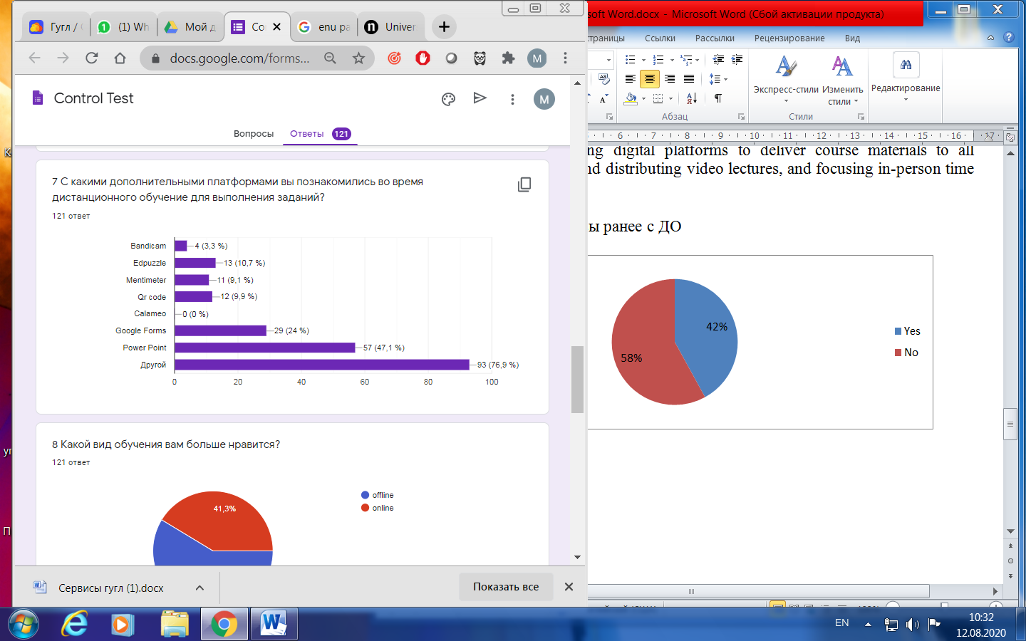

Power Point is usually used to introduce with the new lecture or lesson, make presentations, prepare projects etc. Presentations of the new topic with pictures, graphs and multimedia keep the class interesting and students attentive [15]. The result of an informal survey of students and teachers about the usefulness of Power point in English classes shows that presentations increase the ease of understanding of the topic presented.

Another educational instrument which is often used by teachers is Google forms. Google Forms are used to gather data, receive feedback to students and teachers, test students, evaluate students’ works, and see the results of teaching and learning. In other words, Google forms can be used in various ways to increase classroom environment benefits. Google forms allow assigning a survey before starting learning English in order to know about students’ previous experiences, their level of knowledge, interests, preferable learning styles, and identify misconceptions. Moreover, tests and quizzes in Google forms are graded automatically and students can view their answers (Picture 3).

Picture 3 – Tests and students’ results in Google forms

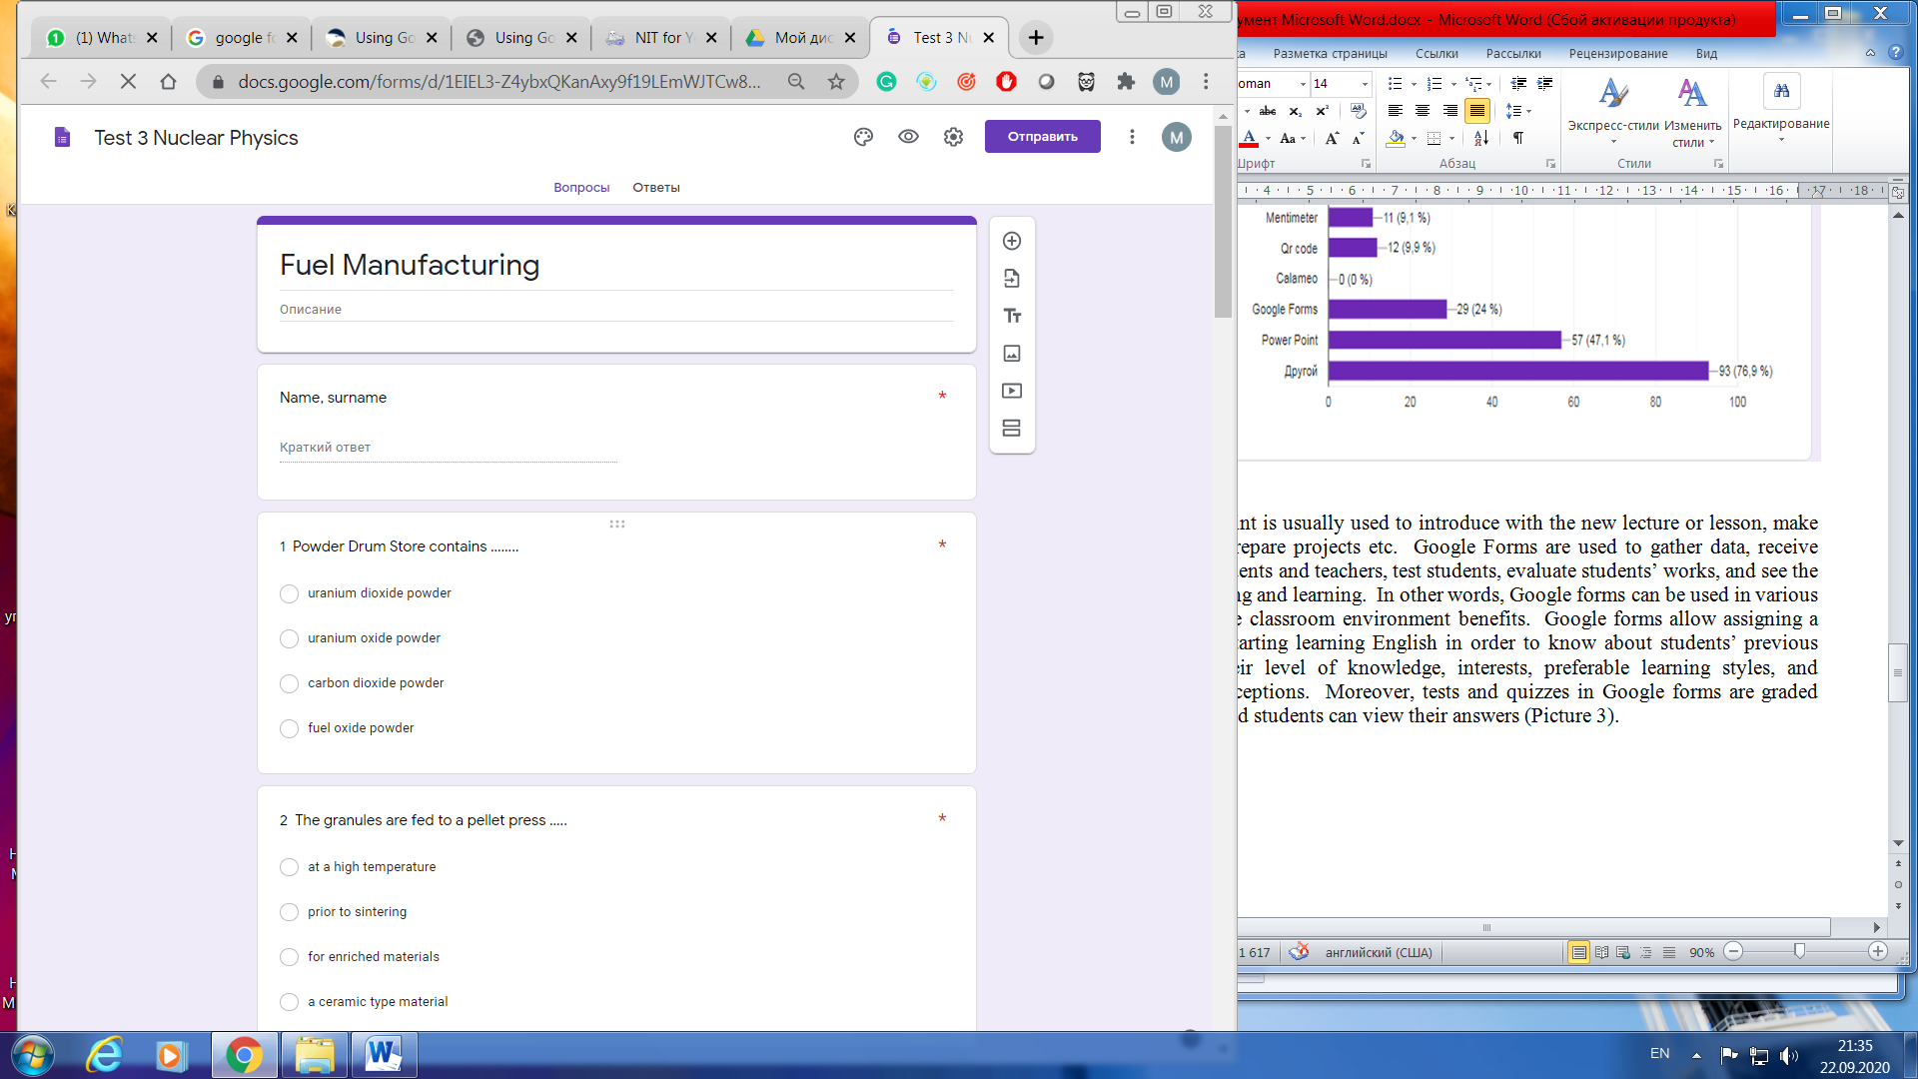 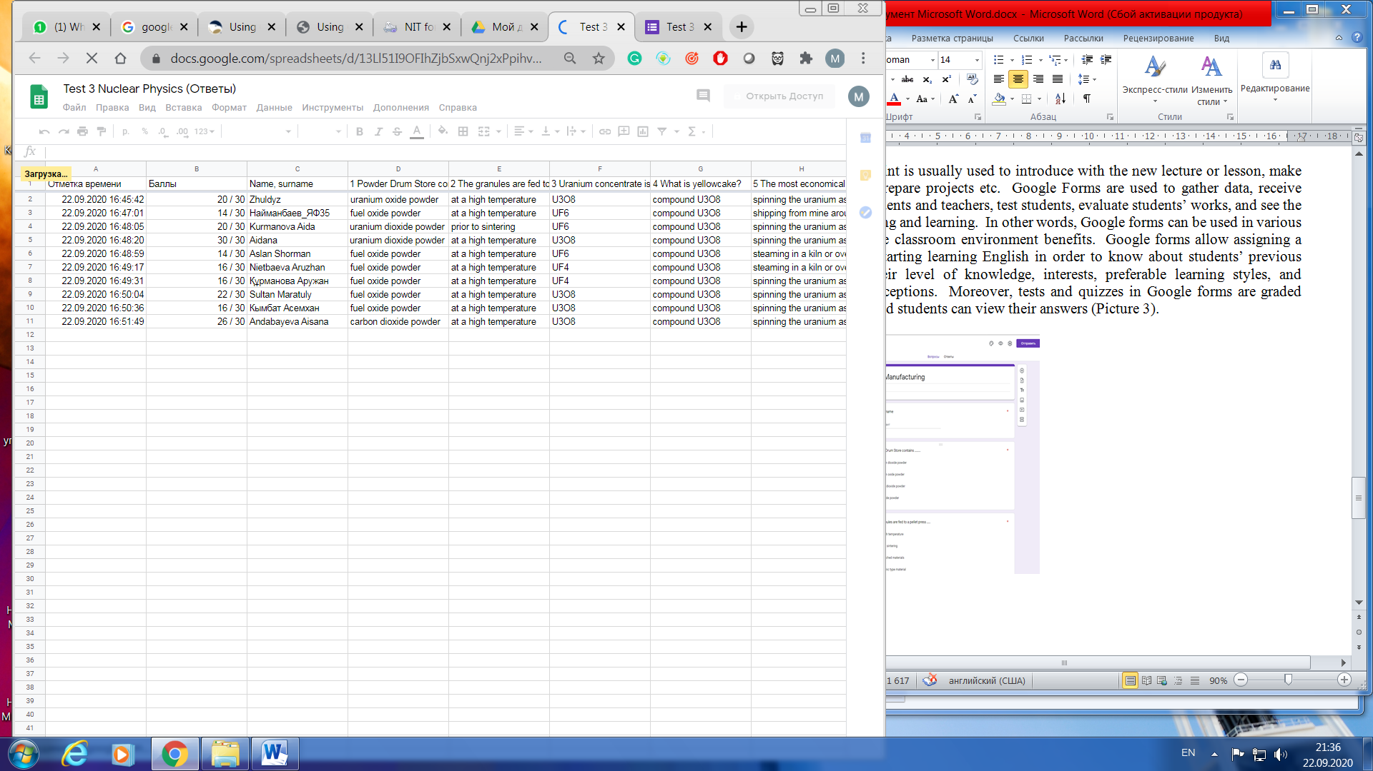

The considered educational instruments and technologies can be used in online and offline learning. Our experience indicates that online learning is more flexible than offline. Teachers support students via mail and online chat system (what’s app, telegram, face time etc.).

Thus, blended learning means not only mixing of online and offline education activities, but educational platforms and instruments. During the pandemic, blended learning is increasingly introduced in educational system throughout the world. The right strategies of blended learning depend on teaching activities. Our practice determines the right strategies of blended learning which provide the exact amount of balance of online and offline English teaching:

1. to have an opportunity to use multiple types of innovative technologies (free teaching resources, online discussion groups, teacher-led debates, home-grown educational materials etc.);
2. to incorporate technologies for reinforcement the students’ knowledge (preparing own video, pass online questionnaire or interview, interactive games);
3. to introduce with new ideas and techniques (flipping the classroom, differentiated work with students, independent students’ work);
4. to keep and follow traditional methods simultaneously (lecture, seminars, classroom discussion);
5. to vary assessments and make special evaluation cards with schedules (measuring students’ comprehension, digital quizzes, paper-based assessment, writing essays, end-course assignments, presentations, self-assessment and peer*assessed assignments);
6. to mix group of students to do various additional assignments (group projects, online collaboration);
7. to prepare digital curriculum (teaching materials, digital lessons, hands-on activities, guided notes, formative and summative assessments).

**References**

1 Graham C. R. Emerging practice and research in blended learning //Handbook of distance education. – 2013. – Т. 3. – С. 333-350.

2 Lim D. H., Morris M. L. Learner and instructional factors influencing learning outcomes within a blended learning environment //Journal of Educational Technology & Society. – 2009. – Т. 12. – №. 4. – С. 282-293.

3 Mantyla K. Blending e-learning. – American Society for Training and Development, 2001. – 160 c.

4 Singh H. Building effective blended learning programs //Educational Technology-Saddle Brook Then Englewood Cliffs NJ-. – 2003. – Т. 43. – №. 6. – С. 51-54.

5 Akkoyunlu B., Soylu M. Y. A study of student's perceptions in a blended learning environment based on different learning styles //Journal of Educational Technology & Society. – 2008. – Т. 11. – №. 1. – С. 183-193.

6 Kim D. M., Choi C. Developing future leaders at Hyundai Motor Company through blended learning //Industrial and Commercial Training. – 2004. – C. 286-290.

7 Shin S. B., Han H. J. Strategy and Effect on Interdisciplinary Project-based Learning based Blended Learning //The Journal of Korean Association of Computer Education. – 2006. – Т. 9. – №. 4. – С. 25-34.

8 Baek S. A study on the possibility of applying blended learning to design education //Journal of Korean Society of Design Science. – 2003. – Т. 16. – №. 4. – С. 443-452.

9 Tham K. O., Tham C. K. Blended learning-A focus study on Asia //International Journal of Computer Science Issues (IJCSI). – 2011. – Т. 8. – №. 2. – С. 136.

10 Cho I. H. The blended learning strategies and ROL. – 2003. – C. 470-476.

11 Patrick S., Powell A. A Summary of Research on the Effectiveness of K-12 Online Learning //International Association for K-12 Online Learning. – 2009. – C.12.

12 Xu D., Jaggars S. S. The impact of online learning on students’ course outcomes: Evidence from a large community and technical college system //Economics of Education Review. – 2013. – Т. 37. – С. 46-57.

13 Means B. et al. Online learning: A meta-analysis and review of online learning studies //Washington, DC: US Department of Education. – 2010. – 94 c.

14 Ni A. Y. Comparing the effectiveness of classroom and online learning: Teaching research methods //Journal of Public Affairs Education. – 2013. – Т. 19. – №. 2. – С. 199-215.

15 Jones A. M. The use and abuse of PowerPoint in Teaching and Learning in the Life Sciences: A Personal Overview //Bioscience Education. – 2003. – Т. 2. – №. 1. – С. 1-13.