**THEORIES SUPPORTING BLENDED LEARNING: CRITICA ANALYSIS**

Dr. Muttu Vemula

Assistant Professor

Department of Education

Mizoram University

Aizawl-796004

**Abstract**

Blended learning is one of the innovations of educational technology used in teaching-learning process in all the corners of the globe. The impact or success of the blended learning is dependent on many factors ranging from learners’ characteristics to organisational factors. The effectiveness of blended learning can be enhanced by taken into consideration all the factors and strategies can be used to reduce the negative impacting factors and empowering the positive impacting factors.

**Keywords:** Blended learning, Effectiveness of Blended learning, Factors impacting Blended learning.

**What is Blended Learning?**

Blended Learning is combining multiple learning components and learning events to create a meaningful learning.

In other words, blended learning is a term applied to the practice of providing instruction and learning experiences through some combination of both face-to-face and technology-mediated learning.

Blended learning is the use of traditional classroom teaching methods together with the use of online learning for the same students studying the same content in the same course. It is a “thoughtful fusion of face-to-face and online learning experiences**” (Garrison & Vaughan, 2008).** During the technology-mediated components of these learning experiences, students are not required to be physically together in one place but may be connected digitally through online communities. For example, one blended learning course could involve students attending a class taught by a teacher in a traditional classroom setting while also completing online components of the course independently, outside of the classroom, on an online learning platform.

**Components of Blended Learning**

**Let’s review what** choices we have under each ***synchronous*** and ***asynchronous*** format.

**Synchronous Physical/Face-to-Face Components (not limited to)**

* Face-to-face Tutoring
* Coaching or Mentoring Sessions
* Classroom
* Workshops
* Conferences
* Meetings
* Labs

**Synchronous Electronic Components (not limited to)**

* Internet conferencing
* Audio Conferencing (i.e., phone conferencing)
* Live Video via satellite or Videoconferencing
* Virtual Online Classroom
* Instant Messaging

**Asynchronous Components** (not limited to)

* On-line self-paced Learning Content (Web pages)
* E-mail, Discussion Forums
* EPSS (Electronic Support Systems) & Job Aids
* Web/Computer-Based instruction
* Books
* Articles
* CD-ROM
* Audio (disc/tape)
* Video (disc/tape)
* White papers
* Archived Live Events

**Advantages and Disadvantages of Blended Learning Components**

**Advantages of classroom**

* Motivation
* Responsiveness
* Experiences
* Team Building

**Disadvantages of Classroom**

* Instructor
* Scheduling
* Audience
* Travel
* Physical
* Learn anytime, anywhere
* Time savings
* Cost Efficient
* Learner control

**Disadvantages of Self-Paced on-line**

* Bandwidth
* Interaction
* Development
* Cost
* Drop-Outs

**Advantages of CD-ROM**

* More Engaging
* No Internet Connection

**Disadvantages of CD-ROM**

* Content
* Peer-to-Peer
* Development

**Advantages of Videoconferencing**

* Savings
* Participation
* Visual

**Disadvantages of Videoconferencing**

* Quality
* Technical Support

**Dimensions of the Blend?**

**A blended learning program may combine one or more of the following dimensions**

**1.** Blending Offline and Online Learning

2. Blending Self-Paced and Live, Collaborative Learning

3. Blending Structured and Unstructured Learning

4. Blending Custom Content with Off-the-Shelf Content

5. Blending Learning, Practice, and Performance Support

A Framework for Creating the Right Blend

The Framework serves as guide and tool that enables designers to ask the right questions and organize their thinking processes when planning a blended learning program.

**The Octagonal Framework**

The framework has eight dimensions: institutional, pedagogical technological, interface design, evaluation, management resource support, and ethical.

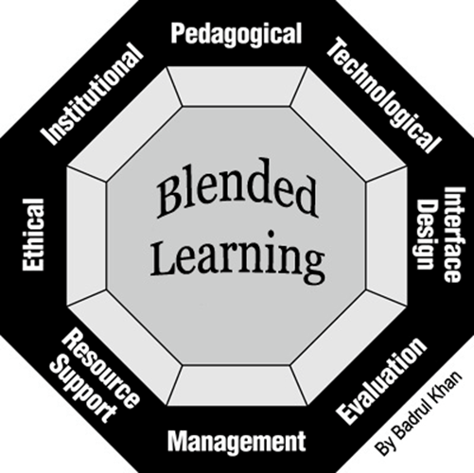

**Institutional**

* Administrative affairs
* Academic affairs
* Student services

**Pedagogical**

* Goal Analysis
* Audience Analysis
* Content Analysis
* Medium Analysis
* Design approach
* Methods and Strategies

**Technological**

* Infrastructure Planning
* Hardware
* Software

**Interface Design**

* Page and Site Design
* Content Design
* Navigation
* Accessibility
* Usability Testing

**Evaluation**

* Assessment of learners
* Evaluation of the instruction and learning environment.

**Management**

* Maintenance of Learning Environment
* Distribution of Information

**Resource Support**

* Online Support
* Instructional/Counseling Support
* Technical Support
* Career Counseling Services
* Online Resources
* Offline Resources

**ETHICAL**

* Social and Political Influence
* Cultural Diversity
* Bias
* Geographical Diversity
* Learner Diversity
* Digital Divide
* Etiquette
* Legal Issues
* Privacy
* Plagiarism
* Copyright

**THEORIES SUPPORTING BLENDED LEARNING**

As most of us around the world have done the majority of our learning in person and in classrooms, we usually refer to the combination of in-person and online teaching as a special form of learning called “blended.” Someday, however, we expect this form will become the standard, and we will drop the term “blended learning” altogether.

Blended learning “is part of the ongoing convergence of two archetypal learning environments” (Bonk & Graham, 2006, p. 2). However, the influences of the two types of delivery are not equal, and how to blend looks different if you are starting from an in-person school to how it looks if you are coming from a distance education background.

**THE COMPLEX ADAPTIVE BLENDED LEARNING SYSTEM**

Blended Learning System, or CABLS framework. The learner sits at the centre of the model, but all components impact each other. There are six elements in the system, all with their own sub-systems.

.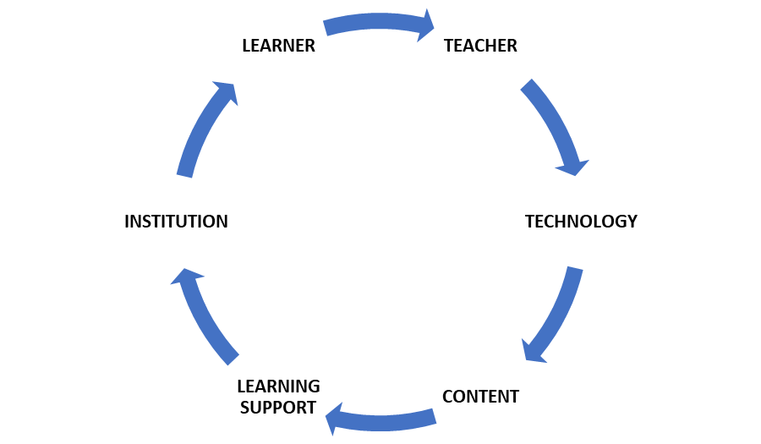

**THE SIX ELEMENTS OF THE CABLS FRAMEWORK**

These six elements are:

1. Learner
2. Teacher
3. Technology
4. The content
5. Learning support
6. Institution

**LEARNERS:** The role of learner’s adapts, or changes as learners engage for the first time or in new ways with the elements in the system. This is key to the support and training of lifelong learners, a characteristic identified as important in 21st-century society. Most important is the well-researched change from passive to active learner.

**TEACHERS:** The “teachers” will be identified by new labels, such as facilitators, mentors, advisors and moderators. The role of teachers is also new in blended environments and will co-evolve with students as both engage with and adapt to each other and the other four elements in the system. The assumption is that teachers engaging in blended learning will adapt to pedagogies appropriate not only for blended learning but for learners preparing to engage productively in 21st-century societies, which are characterised by significant diversity.

**CONTENT:** The dynamic between the learner, the teacher, the technology, the learning support and the institution impacts the choice and use of content. The opportunity for deep learning of content is available via this complex engagement of multiple learning modes influenced by many elements. The interactive, dynamic, media-rich materials available online create opportunities for teachers and learners to add content before, during and even after the course experience. Subject matter is still an important influence on the delivery of learning. Content refers to subject matter and the material elements used to engage learners in the process of mastering that subject.

**PROBLEM BASED LEARNING**

CONTENT

INTARACTIVE LEARNING

**COLLEBORATIVE LEARNING**

**INDIVIDUALIZED LEARNING**

DEEPER LEARNING

**Problem-Based Learning (PBL)** is a teaching method in which complex real-world problems are used as the vehicle to promote student learning of concepts and principles as opposed to direct presentation of facts and concepts. In addition to course content, PBL can promote the development of critical thinking skills, problem-solving abilities, and communication skills. It can also provide opportunities for working in groups, finding and evaluating research materials, and life-long learning (Duch et al, 2001).

PBL can be incorporated into any learning situation. In the strictest definition of PBL, the approach is used over the entire semester as the primary method of teaching. However, broader definitions and uses range from including PBL in lab and design classes, to using it simply to start a single discussion. PBL can also be used to create assessment items. The main thread connecting these various uses is the real-world problem.

Any subject area can be adapted to PBL with a little creativity. While the core problems will vary among disciplines, there are some characteristics of good PBL problems that transcend fields (Duch, Groh, and Allen, 2001):

* If used for a group project, the problem needs a level of complexity to ensure that the students must work together to solve it.
* If used for a multistage project, the initial steps of the problem should be open-ended and engaging to draw students into the problem.
* The problem must motivate students to seek out a deeper understanding of concepts.
* The problem should require students to make reasoned decisions and to defend them.
* The problem should incorporate the content objectives in such a way as to connect it to previous courses/knowledge.
* DEEPER LEARNING

**DEEPER LEARNING: Deeper learning** is the process of **learning** for transfer, **meaning** it allows a student to take what's learned in one situation and apply it to another.

CORE SKILLS: Mastery of rigorous academic content. Development of **critical** thinking and problem-solving **skills**. The ability to work collaboratively. Effective oral and written communication

**Deeper learning experiences allow students to develop these critical competencies:**

* Content Mastery. Students apply new knowledge to real-world situations.
* Effective Communication. ...
* Critical Thinking & Problem Solving. ...
* Collaboration. ...
* Self-directed **learning**. ...
* Academic mindset.

Technology in general terms refers to any equipment or mechanism that extends the human capacity to get things done, the creation and use of technical means, and their interrelation with life. Emerging technologies are tested and then either adapted for new uses or discarded if not of significant value. Technology for learning requires new roles for the learner and teacher and new ways of accessing and working with content. Much research is available on technology for learning in many settings with diverse learner groups, resulting in a large range of outcomes. There is still much testing and research needed to identify the applications, challenges and outcomes of technology for learning. In this theoretical framework, the technology has to be seen as part of the system of blended learning, one that includes all elements working in relation to each other.

**LEARNER SUPPORT**

Helping learners master the content and become competent learners has to be part of their education. Learner support is included in this framework to emphasise the development required to be a competent blended learner and the ongoing support needed when the system includes complexity. Support can involve technology troubleshooting, material access and learning to communicate effectively online, as well as all the other usual support around understanding content and assignments.

In addition, there is a measure of independence attached to online learning that, once mastered, is a lifelong asset. However, it does require the scaffolding of support across diverse learners and over time. For Wang et al. (2015), learner support means “academic support focusing on helping learners to develop effective learning strategies, such as time management and collaborative skills, and technical support aiming to help students improve their knowledge of the technological tools and the fluency with which they use the tools to complete specific learning tasks” (p. 384).

**INSTITUTION** Just as classroom-based learning requires buildings, desks, lighting and other accessories of brick-and-mortar institutions, blended learning requires technological infrastructure and digital janitors. Institutional support is a necessary if not sufficient condition for successful blended learning.

**Seven Blended Learning Structures in Education**

Now that you have a view on the theory underlying blended learning, we can discuss more concrete applications of types of instruction.

Many factors must be considered when choosing how to blend in-person and online teaching and learning activities. In some cases, most interactions between students and the teacher, as well as the direct delivery of instruction, take place in person in the classroom, while materials and possibly some additional activities are delivered online. In other cases, most of the class activities occur online, with infrequent meetings in person to solve problems and support community building.

In some blended arrangements, students may choose which activities to complete online and which to complete in a classroom. Ideally, blends are personalised so individual students have the blend that best fits their age, life circumstances and learning needs. These are called à la carte models. Students choose what to take fully online, what to take fully in person and, when the design is available, blended courses where they choose when to go to in-person classes and when to watch videos, download readings and complete assignments online.

This kind of personalisation is not always available. Most important is ensuring that students are able to function well as learners with any delivery method, single-mode or blended, even if it is not their preference or the best situation for them. Teachers are valuable coaches for helping students manage in any learning situation; it is up to teachers and learning designers to offer blended activities that best suit the subject, the learners’ needs and the curriculum requirements. Not all unique and interesting blended learning designs are one-size-fits-all model.

Below are seven sample configurations of blended learning activities, offered by O’Connell (2016) for you to consider for your teaching situation. These examples of blended learning are drawn from higher education but can be shaped to fit any teaching and learning situation.

• **Blended face-to-face class:** which is also called “face-to-face driver model,” the blended face-to-face class model is based in the classroom, although a significant amount of classroom time has been replaced by online activities. Seat time is required for this model, while online activities are used to supplement the in-person classes; readings, quizzes or other assessments are done online at home. This model allows students and faculty to share more high-value instructional time because class time is used for higher-order learning activities such as discussions and group projects.

• **Blended online class**: The class is mostly conducted online, but there are some required in-person activities such as lectures or labs. Also, it referred to as the “online driver model,” this class is the inverse of the blended face-to-face class.

• **The flipped classroom**: The flipped classroom model can be seen as a sub-model of the blended face-to-face or blended online class. The flipped classroom reverses the traditional class structure of listening to a lecture in class and completing homework activities at home. Students in flipped classes watch a short lecture video online and come into the classroom to complete activities such as group work, projects or other exercises.

• **The rotation model:** which is online learning model, in this model, students in a course rotate between various modalities, one of There are various sub-models: station rotation, lab rotation and individual rotation. Some of these sub-models are better suited to K–12 education; station rotation, for example, requires students to rotate between stations in the classroom at an instructor’s discretion. Others work well on a college campus; the lab rotation model, for example, requires students in a course to rotate among locations on campus (at least one of which is an online learning lab). In the individual rotation model, a student rotates through learning modalities on a customised schedule.

• **The self-blend model:** Learners using this model are enrolled in a school but take online courses in addition to their traditional face-to-face courses. They are not directed by a faculty member and choose which courses they will take online and which they will take in person.

While many of the blended learning models on this list are at the course level, self-blending is a programme-level model and is familiar to many college students.

• **The blended MOOC**: In 2012, according to Campus Technology, San Jose State University piloted a blended MOOC using MIT’s Circuits and Electronics course, with students taking the MOOC out of class while face-to-face time was used for additional problem solving (LaMartina, 2012). The blended MOOC is a form of flipped classroom using in-person class meetings to supplement a massive open online course. Students access MOOC materials perhaps from another institution or instructor if the course is openly accessible outside of class and then come to a class meeting for discussions or in-class activities.

• **Flexible-mode courses:** In this Flexible-mode courses offer all instruction in multiple modes in person and online and students choose how to take their course. An example of this is San Francisco State University’s hybrid flexible (HyFlex) model, which offers classroom-based and online options for all or most learning activities, allowing students the ability to choose how they will attend classes: online or in person (Beatly, 2016).

**Conclusion:** in the present paper critically revied the concept of Blended Learning is combining multiple learning components and learning events to create a meaningful learning. Components of Blended Learning Blended Learning System, or CABLS framework. The learner sits at the centre of the model, but all components impact each other. There are six elements in the system, all with their own sub-systems. Seven Blended Learning Structures in Education in the theory underlying blended learning and its discussed more concrete applications of types of instruction.

References:

* Bailey, J., Martin, N., Schneider, C., Vander Ark, T., Duty, L., Ellis, S., ... & Terman, A. (2013). Blended learning implementation guide  2.0. DIGITAL SHIFT.
* Banerjee, G. (2011). Blended Environments: Learning Effectiveness and Student Satisfaction at a Small College in Transition. Journal of Asynchronous Learning Networks, 15(1), 8-19.
* Bonk, C. J., Kim, K. J., & Zeng, T. (2006). Future directions of blended learning in higher education and workplace learning settings. Handbook of blended learning: Global perspectives, local designs, 550-567.
* Boyle, T., Bradley, C., Chalk, P., Jones, R., & Pickard, P. (2003). Using blended learning to improve student success rates in learning to program.Journal of educational Media, 28(2-3), 165-178.
* Caraivan, L. (2011). BLENDED LEARNING: FROM CONCEPT TO IMPLEMENTATION. *Euromentor Journal*, *2*(4), 1.
* Chatterjee, A., & Kothari, P. (2014, October). Bridging achievement gaps amongst school students through a technology-based blended learning model. In *Frontiers in Education Conference (FIE), 2014 IEEE* (pp. 1-8). IEEE.
* Dalsgaard, C. (2006). Social software: E-learning beyond learning management systems. European Journal of Open, Distance and E-Learning, 9(2).
* Driscoll, M. (2002). Blended learning: Let’s get beyond the hype. E-learning,1(4), 1-4.
* Eryilmaz, M. (2015). The effectiveness of blended learning environments. Contemporary Issues in Education Research (Online), 8(4), 251. Retrieved from <http://search.proquest.com/docview/1722651929?accountid=7113>
* Flexible learning spaces in schools. (n.d.). Retrieved February 02, 2016, from <http://www.education.govt.nz/school/property/state-schools/design-standards/flexible-learning-spaces/>
* Graham, C. R. (2006). Blended learning systems. CJ Bonk & CR Graham, The handbook of blended learning: Global perspectives, local designs. Pfeiffer.
* Graham, C. R., Woodfield, W., & Harrison, J. B. (2013). A framework for institutional adoption and implementation of blended learning in higher education. *The internet and higher education*, *18*, 4-14.
* Garrison, D. R., & Kanuka, H. (2004). Blended learning: Uncovering its transformative potential in higher education. *The internet and higher education*, *7*(2), 95-105.
* Horn, M. B., & Staker, H. (2011). The rise of K-12 blended learning. *Innosight institute*.
* Moss, B., & Fink, L. (2014). Blended Learning Resources for Middle Grade Teachers. *Voices from the Middle*, *22*(2), 10.
* O'Byrne, W. I., & Pytash, K. E. (2015). Hybrid and Blended Learning. *Journal of Adolescent & Adult Literacy*, *59*(2), 137-140.
* Onguko, B., Jepchumba, L., & Gaceri, P. (2013). “For us it was a learning experience” Design, development and implementation of blended learning.*European Journal of Training and Development*, *37*(7), 615-634.
* Osguthorpe, R. T., & Graham, C. R. (2003). Blended Learning Environments: Definitions and Directions. *Quarterly Review of Distance Education*, *4*(3), 227-33.
* Picciano, A. G., & Seaman, J. (2009). K-12 Online Learning: A 2008 Follow-Up of the Survey of US School District Administrators. Sloan Consortium. PO Box 1238, Newburyport, MA 01950.
* Poon, J. (2013). Blended learning: An institutional approach for enhancing students' learning experiences. Journal of online learning and teaching, 9(2), 271.
* Singh, H. (2003). Building effective blended learning programs. EDUCATIONAL TECHNOLOGY-SADDLE BROOK THEN ENGLEWOOD CLIFFS NJ-, 43(6), 51-54.
* Toshalis, E., & Nakkula, M. J. (2012). Motivation, engagement, and student voice. Education Digest, 78(1), 29-35.
* Uğur, B., Akkoyunlu, B., & Kurbanoğlu, S. (2011). Students’ opinions on blended learning and its implementation in terms of their learning styles.Education and Information Technologies, 16(1), 5-23.
* VanDerLinden, K. (2014). Blended learning as transformational institutional learning. *New Directions for Higher Education*, *2014*(165), 75-85.
* Yapici, I. U., & Akbayin, H. (2012). High school students’ views on blended learning. *Turkish Online Journal of Distance Education*, *13*(4).
* Ziegler, M., Paulus, T., & Woodside, M. (2006). Creating a climate of engagement in a blended learning environment. *Journal of Interactive Learning Research*, *17*(3), 295.