 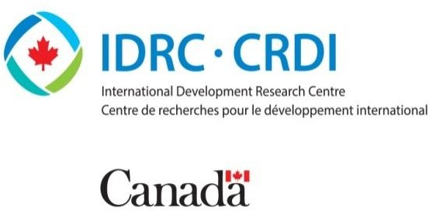

Best Practices in Primary Education for Improving Retention, Reducing Drop Out and Enhancing Learning Outcomes in Extreme poverty and Rural Areas of Ghana

**Associates for Change, 2022**



**1.0 Introduction**

Ghana has subscribed to all international commitments that emphasize access to quality education as a fundamental human right, including goal 4 of the sustainable development goals (SDGs). This has led the government of Ghana to embark on a consistent policy agenda (over the past two to three decades) towards ensuring equal access for all children through Education for All (EFA) initiatives such as Free Compulsory Universal Basic Education (FCUBE), capitation grants, cash transfers, school feeding programme, free school uniforms, scholarships for selected students, progressively free senior high school policy, fully free senior high school policy, among others. Currently, the full cost of publicly provided pre-tertiary education (other than Parent Teacher Association dues) has been transitioned to public budget, with the government absorbing the user fees of primary and secondary education, including cost of textbooks, furniture, and other infrastructure costs, among others.

While these initiatives have contributed to opening school doors to many children who otherwise would not have been able to attend, there are still challenges with enrolling the

remaining 10-20 percent of children from underserved areas and ensuring that they learn. The UNESCO institute of statistics (UIS) reported in 2021 that over 265 thousand eligible primary school age children are out of school in Ghana (UIS, 2021). The data (disaggregated by sex and locality) show that children from poor and rural backgrounds form the highest percentage of excluded children, with nearly half of them being girls. Even more worried some, 15 percent of girls and 17 percent of boys enrolled in primary school are at risk of dropping out (Multiple Indicator Cluster Survey, 2018).



***“The UNESCO institute of statistics (UIS) reported in 2021 that over 265 thousand eligible primary school age children are out of school in Ghana (UIS, 2021).”.***

Aside the high educational deprivation rates, Ghana also faces the problem of poor learning outcomes and education inefficiency especially at early grade levels (P1 to P3) (Bashir et all.,

2018). For example, recent evidence suggests that about 21.1 percent of sixth graders in Ghana cannot read a word and 43.1 percent cannot arrange numbers in order (Asadi, 2020). There are also spatial differences – wide regional imbalances and rural-urban gaps – in student schooling output. This contributes to low survival rates, limiting the country’s ability to generate the requisite human capital to compete for jobs and investments in an increasingly globalized world.

Civic actors and government actors in the education innovation space have designed several interventions to address the learning outcome gap, inefficiency challenges (e.g., trained teachers) and high dropout rates. One of these innovations is the Complementary Basic Education (CBE) programme or what is termed internationally as Accelerated Education Programs (AEPs). AEPs are typically designed to fill critical gaps in the delivery of essential educational services, especially in deprived rural and extreme poverty zones that are challenged by a confluence of demand and supply bottlenecks. They are flexible, age-appropriate programs that deliver education to underserved groups in an accelerated period — specifically, for out-of-school, over-age children and youth who have been excluded from education or had their education interrupted due to crisis and/or conflict. These programs have helped transition millions of out-of-school children (OOSC) in hard-to-reach communities back into the regular system. Notwithstanding, high numbers of school age children continue to be out-of- school. In fact, an estimated 885,490 primary and secondary age children are still out of school in Ghana (UIS, 2021), with the Northern, Greater Accra, and Ashanti regions having the highest concentration of OOSC.

The high OOS numbers are largely driven by rural-urban migration, long distance to schools, poverty, socio-cultural factors such as early

marriages, and high opportunity cost of enrolling children in school. Poverty and/or conflict have deprived millions of older children and youth of basic education, particularly in rural SSA (UNESCO Monitoring report, 2018). Other factors such as displacement, living in a child-headed household, being an ex-child soldier (such as cooks, porters, and sex slaves) or being disabled compounds many of the losses suffered by those deprived of an education.

***“AEPs are typically designed to fill critical gaps in the delivery of essential educational services, especially in deprived rural and extreme poverty zones that are challenged by a confluence of demand and supply bottleneck children (OOSC) in rural areas of Ghana.”***

In addition to the underlying structural factors, COVID-19 crisis is identified as a potential driving force of OOS rates. The pandemic has led to a huge disruption in education delivery resulting in loss of progress for most underprivileged students thereby, widening educational inequality. Given the imminent threats posed by the COVID-19 shock amid the seeming failure of home-grown policies to bridge wide rural-urban gaps in primary education, it is imperative to examine best practices in early grade learning for adaptability in Ghana. This forms the subject matter of the issue brief. We conduct a desk-based review of relevant studies and evaluation reports to enable us draw insights from best practices for improving educational outcomes in early grade in Ghana.

*Figure 1: Global Number of Out-of-School Children, Adolescents and Youth, 2000-2017*

*Source: UNESCO Institute for Statistics Database*

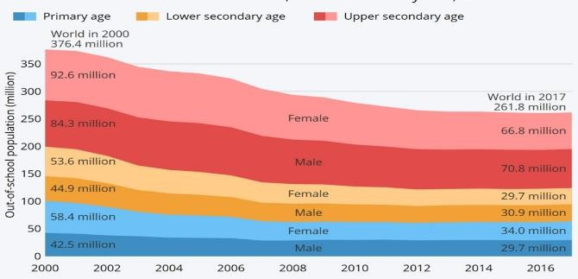

# 2.0 Review Methodology

Under the IDRC out of School Study on Education Innovations in West Africa, the team conducted a desk-based review of evaluation reports and papers that focus on primary education, with a view to drawing lessons from best practices for improving educational outcomes in early grade in Ghana. After conducting a structured search of relevant reports and papers using established academic databases (Web of Science, Google scholar, and others), we reviewed the titles, abstracts, and full text of the relevant reports to enable us extract information on thematic areas such as reducing out-of-school risk-factors through home-grown education innovation, responsiveness of these innovations to the needs of excluded children and, best practices within the context of student level interventions in or outside the regular primary school system. The insights from these discussions enabled us to draw lessons to guide the design of context-sensitive educational interventions.

# Addressing Educational Exclusion and Dropout Risk Factors through Accelerated Education Programmes

Evidence shows that rural populations in Ghana suffer the worst form of out-of-school rates, mostly due to poor economic and social conditions of rural households along with high opportunity cost of educating a child and low (perceived) value of education. Economic factors that limit access to education for rural children include family’s inability to sustain its basic needs and support children in school, large family sizes amid high levels of food insecurity, need for children to fulfil competing family and work commitments, among others. Shah et al. (undated) have shown that economic poverty is a significant driver of low enrolment and retention rates as well as high dropout risks among children from rural families. Most families in poor, rural populations live under below the national poverty line. Such families are extremely poor and mostly depend on the labour of their children to bring necessary income, especially when fathers have irregular sources of income. Some socio-cultural and religious practices that hinder children’s participation in formal education include family inheritance process, early marriage practices, and the notion that the girl child is the ‘bona fide property’ of the husband and his family. The practices of early marriage and fosterage, which are widespread across the regions of the north, restrict the full participation of children in basic education, especially girls. Surprisingly, preference towards boys’ education remains a significant driver of out-of-school rates among girls from rural and poor backgrounds (Ghana Living Standard Survey, 2012). In the case of boys, heavy responsibilities such as the need to fend for themselves and their siblings, reduce their survival rate in school. In addition to the socio-

cultural barriers, supply side factors such as lack of access to schools, long distance to schools or lack of trained teachers and requisite school resources present a significant economic burden to these households, and contribute to pushing learners out of school, particularly as they grow older.

Civic actors (School for Life, Afrikids, Pronet, Action Aid, and others) have taken steps to address out-of-school rates in deprived areas of Ghana through AEPs, as these programs are perceived to provide some of the best alternatives for underserved children. The experiences show that these models have a huge potential in raising learning in deprived communities. Thus, the Ministry of Education (MoE) adopted the CBE programme, which is a government-led AEP, to provide a fully “free” educational pathway and reduce the burden to vulnerable care givers (such as grandparents, female-headed households, and widows) of the cost of education (Hayford et al., 2017).

The evidence over the years suggests that the CBE programme has opened school doors to many students previously underserved, most of whom subsequently transitioned into the formal school system and even progressed to higher levels. Hayford et al. (2018), for example, showed that in contexts where economic deprivation denies children the right to education, CBE provides necessary teaching and learning resources to help such children learn under flexible arrangements. This affords such children the opportunity to participate in education and still support their parents, either on the farm or other economic activities. Thus, many poor boys and girls have had access to basic literacy and numeracy training through the CBE programme, subsequently transitioning into the regular system (see Figure 2 below).

Despite the gains, Shah et al. (undated) have observed that even with clear legislation, in the form of Complementary Basic Education Policy,

to address out-of-school situation in Ghana, formal school enrolment and retention rates remain low among underprivileged children (including children from poor economic backgrounds, street working children, children exposed to drug misuse, and those with disabilities). Some children who enroll in the CBE programme fail to graduate. Others drop out after transitioning into the formal system. This raises questions about conceptualization – whether the CBE, in its current design, is appropriate for children in areas previously underserved. Besides, questions relating to whether this approach is a cost-effective option for addressing out-of-school rates remain relevant. Therefore, further action is required in terms of adapting the current model to meet the needs of children in extreme poverty zones while ensuring that resources are applied productively.

*Figure 2: Mean Reading Comprehension Scores for Low and High Performing CBE Students*

*Source: Crown Agents CBE Management, Final Impact Evaluation (2018)*

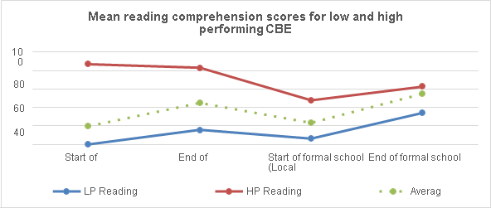

# Best Practices for improving participation, retention, and learning outcomes

This section discusses interventions that have proven to be effective in improving school participation, retention, and transition, as well

as promoting quality of education delivery at the primary level.

## Improving Learning Outcomes – Ghana Partnership for Education: Learning

USAID/Ghana designed and implemented an Early Grade Reading (EGR) Program in 2017- 2019 to support mother tongue phonics-based instruction through a structured pedagogy model. The program was implemented in over 7000 schools across all the previous 10 regions of Ghana, with instructional materials translated into 11 local dialects. In total, more than 700,000 students were enrolled, and 51,000 teachers and supervisors were engaged in the program.

An impact evaluation was conducted in 2019 after two years of implementation, which revealed that the EGR program substantially and significantly improved pupil-reading skills in both Ghanaian languages of instruction and English, as measured by the Early Grade Reading Assessment (EGRA). Benchmarking the Learning program’s effect sizes against peer programs, the study found that the USAID/Ghana program’s impacts were larger than those of other comparable peer programs elsewhere. The results further show that the program’s component most associated with higher learning outcomes for children is the scripted lesson plans (Ghana EGR Program Impact Evaluation Report, 2019).

*Figure 3: Benching Ghana's EGR program Effect Size Relative to other interventions at Midline*

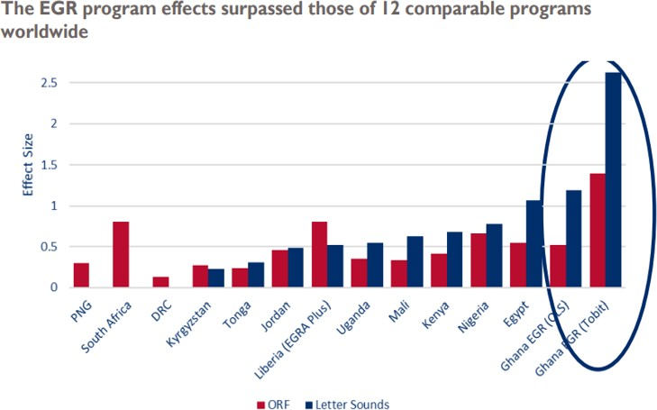

*Source: Ghana EGR Program Impact Evaluation (2019)*

Comparing the midline to baseline further shows that on average, between 21-26% of children moved up to a higher English reading skill level based on the Annual Status Education Report (ASER). While this shows a significant improvement, reading achievement in English remains low, especially among children from remote areas. In fact, performances of 60-66% of the children remained low at the same basic reading skill level on ASER in English.

*Figure 4: Endline Level on the Ghanaian National Reading Scale, P1 and P2 Pupils, By Treatment Status and Language*

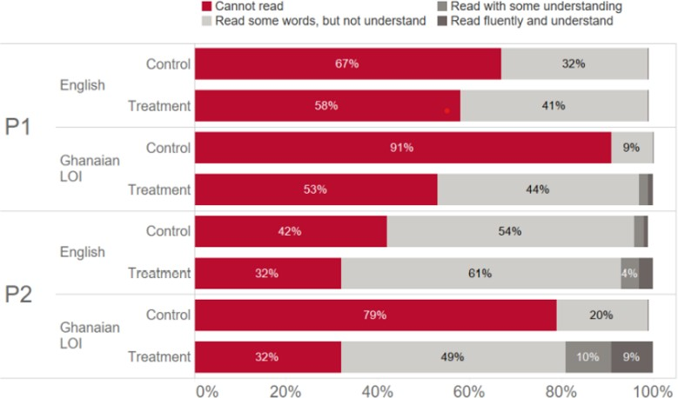

*Source: Ghana EGR Program and Impact Evaluation (2015)*

Overall, the impressive results of the EGR program show that a local language approach to early grade instruction is possible in Ghana’s diverse linguistic environment, as it will serve as a pedagogically sound practice for further language learning, including English.

## Expanding Coverage for Out-of-School Children (OOSC)

The government of Ghana, as part of efforts to address the high OOSC rates, scaled up the CBE Programme in the early 2010s with support from FCDO and USAID. This was meant to prepare OOSC for entry into the formal system by helping them to acquire foundational literacy and numeracy skills. The programme has recorded high success rates since its implementation, as over 90% of the 533,521 learners enrolled transitioned into the formal education system. These achievements have been possible because the programme design and implementation were based on solid collaborations with the private sector, Non- Governmental Organizations (NGOs), Civil Society Organizations (CSOs), Faith Based Organizations (FBOs), Development Partners (DPs), Staff/Labour Unions, among others.

Besides, the designers of the programme recognized the fact that learners learn at their own pace, which is why facilitators are trained to be able to spot individual differences so that they can support struggling students to learn (DFID, 2018). Foundational mother tongue was also used as medium of instruction. This was aimed at matching the language of the CBE class with the mother tongue of learners, with the expectation that it would help boost their confidence and improve their performance.

Evidence from the CBE pedagogy evaluation by DFID in 2018 confirmed that mother-tongue instruction is key to unlocking learning potential and that, the use of appropriate teaching learning resources (TLRs) helps to concretize learning and make it more relevant. Indeed, the use of the local language creates an

atmosphere where the facilitator and students communicate freely (DFID, 2018). Further, a functional literacy curriculum is used under the CBE, which makes it much easier to link the content of lessons to the local context.

Question-and-answer, demonstration, learner centred approaches, and directed instruction are also key elements of the CBE instructional approach. This generally creates a friendly classroom environment thereby, encouraging high pupil participation rates. It is also worthy of note that facilitators utilize a variety of learning and teaching resources outside of the classroom, showing that the CBE can easily be adapted to suit the local context.

*Figure 5: A typical AEP class*

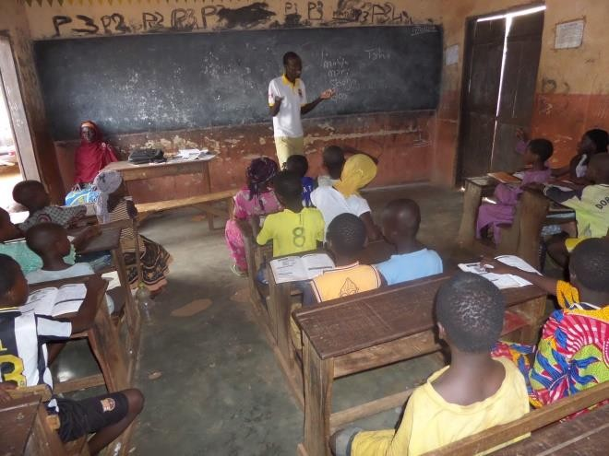

Akyeampong et al. (2018) observed that families of the CBE graduates were often enthusiastic to support their children’s transition because of their appreciation of the benefits of educating a child in terms of economic empowerment, community development, and social mobility. Again, their recognition of the transformational changes in their children, such as seeing them read fluently, made them proud. In most cases, these experiences led to a shift in existing negative attitudes about girl child education. Moreover, parents were delighted with their children’s ability to become actively involved in valued social activities such as reading the bible in their local language. This suggests that the CBE

pedagogical approaches would be more effective if they were enhanced to make them more responsive to the cultural, social, and linguistic characteristics of the targeted group of learners.

The experience with the CBE programme suggests that it provides an opportunity for OOSC to develop a positive self-identity, which gives them the confidence they need to transition to and progress in the regular system. However, the gains in terms of increased levels of parental and family involvement appear to wane after the CBE learners transition into the formal system, as some parents start to feel anxious about their inability to afford the cost of formal schooling (school uniforms, stationery, and other related expenses). Other parents have had to deal with the opportunity cost of keeping their wards in school. Yet, irregular attendance by CBE learners and their low commitment to learning, especially among children from single parent, female-headed households, were serious issues that challenged the effective implementation of CBE (Akyeampong et al., 2018).

*Figure 6: A section of beneficiaries of the CBE Programme*

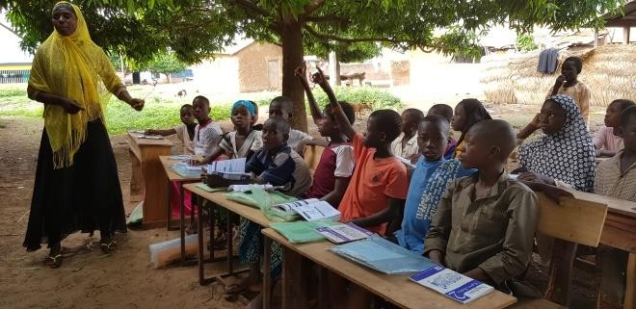

The implication is that, to achieve the desired impact of CBE, the programme should be adapted to make it more responsive to the socio-economic context of learners.

# 5.0 Enhancing Teacher Accountability

An important intervention towards enhancing teacher accountability is the Link Community Development (LCD) program, which was first rolled out in the Upper East region in 1999 and

later in the Ashanti region in 2007/08. The overall aim of the programme was to improve the quality of teaching and learning in underprivileged schools in Ghana through organizing training workshops to enhance teacher capacity. This would help disadvantaged pupils attain learning outcomes that are comparable to the national average, bridging the rural-urban gap in educational attainment. The LCD programme was an improvement upon the Link Community School Programme (LSP), an approach to developing head teacher competencies and strengthening School Management Committees (SMCs) through periodic training workshops on financial and project management. Other components of the programme included efforts to encourage community ownership of schools through fundraising activities and school incentive grants. The programme has been scaled to cover up to 71 Link schools across three program districts in the Upper East Region.

The LCD relies on three main strategies, including putting mechanisms in place to link selected Ghanaian Primary schools with interested schools in the UK. This involved activities such as providing head teachers and SMCs training in project and financial management, offering small school incentive, and facilitating cross-cultural exchange through letters and sometimes visits by teachers to the UK and vice versa. The second key strategy of LCD is the inside-out approach which involved building on the capacities of schools and enhancing existing systems and structures of the District Education Office (DEO) to deliver quality education services to their communities.

*Figure 7: A typical AEP class*

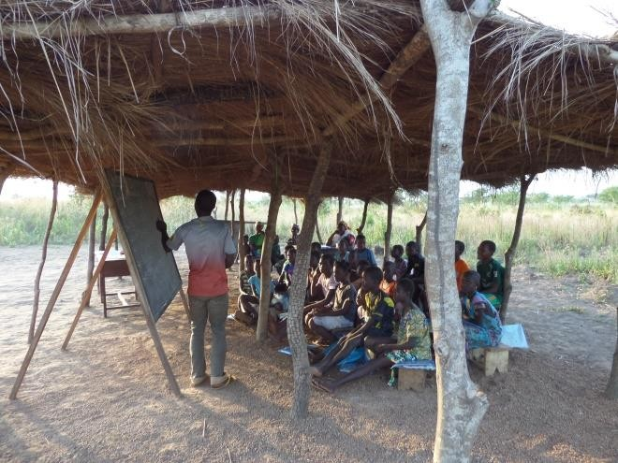

The final strategy of LCD is the School Performance Review (SPR) process which has been operated in the Upper East Region since 2005/06 and more recently in the Ashanti Region (BAK District). The SPR strategy involves several dimensions including assisting the DEOs to collect data to enhance their understanding of school and child performance. In addition, the DEOs are assisted to set up a systematic process of generating feedback, which is useful in informing decisions about quality improvement. Again, the LCD provides opportunities to engage with and learn from government partners regarding the methods that could be most effective in supporting the improvement of quality teaching and learning. These led to the revival of the Performance Monitoring Test (PMT) and SPAM process, which were piloted in the then Bolga district in 2004/2005.

An evaluation of the LCD revealed that the School Performance Report (SPR) process is more effective in districts where there are strong educational leadership and management capacities at the DEO level. This may have been driven by the prescription to include accountability structures in the SPR in response to the demands generated from the information and processes stimulated by the performance monitoring testing and the school performance appraisal meetings held between teachers and community members about their children’s performance.

The LSP strategy, through its capacity building workshops for head teachers and Parent Teacher Association (PTA) along with the structures put in place to encourage project and financial management at the school level, enhanced the performance of PTAs and SMCs within LCD communities. It was found that many of these head teachers continued good practices of school management when transferred to other non-LCD schools. The training of head teachers and SMC chair helped to forge closer ties and increased their understanding of their roles and how to improve child, teacher, and school performance in their communities.

*Figure 8: A section of AEP students*

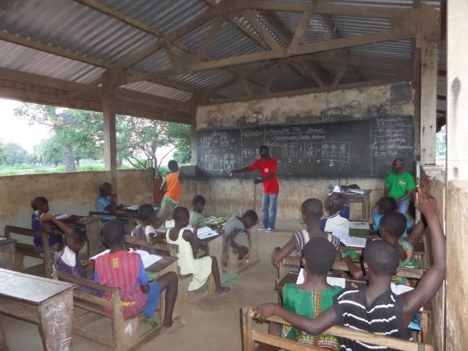

The ripple effects of the LCD strategies were felt across the non-LCD domains and across schools in other non-intervention districts. For instance, most head teachers who had been trained under the program reported that they were now more confident and better able to complete the current government School Performance Improvement Plan (SPIP) process in helping their schools to access the capitation grants. Circuit Supervisors confirmed that the heads of Link schools were more often able to plan for their SPIPs and involved teachers and community members in the process of developing their school SPIPs as compared to non-LCD schools. Another difference was the fundraising approach which had gained momentum in many of the LCD and non-LCD

schools across the district. Communities were finding innovative ways to fundraise and support their schools particularly in areas where school feeding programs were being phased out and the government was unable to deploy professionally trained teachers (e.g., Kassena- Nankana).

The evaluation report also showed that there was increased enrolment and retention in schools that were studied across the LCD intervention districts but with some decline in the recent years due to the pull out of major food incentive and feeding programs. Additionally, the Link School Program was successful in motivating teachers and ensuring that there was some cross-cultural learning taking place in the school. The program also built the capacities of the head teacher to improve their project and financial management skills through training and application of their knowledge to the Link grants and special grants. The most significant outcome of the LSP program was the increased participation and investment of parents and community members in the LCD schools through fundraising and awareness creation activities. This coupled with the SPR processes brought the school communities closer to the school and attracted key members of the community including the SMC and PTA members to regularly monitor the school and take more ownership in school management.

From the report, there was evidence that the SPR process would be sustained in the districts which had recognised the value of performance monitoring data to enhance accountability and performance systems from the bottom up through the demand by parents for better quality education. For instance, District Directors of Education in Talensi-Nabdam and Bawku West used terminal examinations as a means of tracking progress among children at the primary level. LCD support had enhanced their understanding and recognition of the power of using performance testing to hold

their teachers, and Circuit Supervisors accountable for school performance.

There was also evidence that the SPR process could be financed by the District Education Offices with minimal support by LCD if factored into their budgets and work plan. Approximate costs of the SPR on a per school basis suggests that the project costs for 50 schools within a district averaged GHS10,0000 in 2007, which covered all aspects of SPR including the data collection and SPAM phase of the process. Sustainability of the LSP strategy was also evident by the growing ability of SMCs and PTAs to fundraise and use their capitation grant for improving school performance. With the introduction of the capitation grant, some schools were using the Link grant and the SPIP grant for the same purposes.

The report further showed that the LCD work was very effective in complementing and enhancing accountability systems and in helping to improve school quality and performance in DEOs, where leadership is in place to hold Circuit Supervisors accountable. Within the Talensi-Nabdam district (TND) where strong measures had been taken to ensure performance and accountability of district officers and teachers, the LCD approach was instrumental in improving quality and ensuring higher levels of performance among children.

Again, the evaluation report indicated that more strategies and inputs are needed to build accountability beyond DEOs to hold top education management accountable in non- performing districts.

In terms of the enrolment and retention effects of LCD, the study found that LCD helped improve enrolment and retention particularly in Link schools where inputs and strategies for improving quality complemented the SPR approach of strengthening accountability mechanisms. This may have been the case because schools had become agents of community development, encouraging parents

to be involved in the process through providing schools with support packages ranging from teaching learning resources (TLRs) to small grants. This made a huge difference in terms of helping schools to meet their immediate needs and thereby, creating a conducive enrolment to attract high enrolment and retention rates. The LCD support also strengthened SMC/PTA management and ownership through a combination of interventions including training, sensitization, and fundraising.

Moreover, children schooling output was gradually improving in LCD and non-LCD schools where strong leadership and accountability structures for CS performance had been put in place (e.g., TND). Educational quality improvement was evident in schools where the SPR was in full force and well implemented, though further commitment is required to fully embed it in the planning processes of government and DEOs to maximize its impact. For instance, in future, LCD should ensure that circuit supervisors facilitate the production of circuit development plans which are used to develop the District Implementation Plan (DIP). Care must be taken to make sure that the DIP is not replaced with the Annual District Education Operational Plans (ADEOP) as the planning report for SPR, since this may not reflect the needs at the community/school level and the findings of the SPIPs and SIPs in each school.

The bottom-up approach under the LCD could be utilized to enhance the planning processes that are currently in place at the district and national levels including the DESP and ADEOP. In fact, the bottom-up planning based on the SPR, SPAM process can help districts develop their own DIP which can inform the ADEOP in future.

# 6.0 Improving Trained Teacher Supply and Retention in Extremely Rural, Deprived Areas (UTDBE Evidence)

The Voluntary Service Overseas (VSO) Ghana has over five years now supported the Tackling

Education Needs Inclusively (TENI) programme, which was focused on improving the quality of basic education in the country. The programme was targeted at addressing the persistent challenge with inadequate supply of trained teachers in deprived areas of Ghana, especially across the three northern regions. The strategy was to deploy volunteer and pupil teachers to fill the teacher gap in these areas and thus, motivate increased pupil enrolment, retention, transition, and school attendance. In 2015, Associates for Change assessed the value- addition of volunteer teachers in the education sector to inform policy and practice regarding the scale of additional training and capacity building required to fully address the challenge. The study also explored the motivational forces shaping the commitment of Ghanaian teachers to serve in deprived rural areas and their value addition, with emphasis on

* + - Volunteer teacher influence on the delivery of quality education
    - The influence of an enabling environment for supporting teachers at school level and pre/post training
    - The influence of head teachers’ mentorship
    - The influence of Colleges of Education and post-teacher education in-service training on the background and life trajectory of the teacher.

The endline findings of the Untrained Teacher Diploma Programme (UTDBE Impact Evaluation, 2016) revealed that the Upper West, Northern, Upper East, and Western Regions, often had fewer trained teachers with several classrooms deprived of trained teachers. The study estimated that an increase of 52 per cent in the current trained teacher population will be required to close the trained teacher gap across the nine study districts in the Upper West, Northern and Western Regions. Responding to

interview items, some district directors of education indicated that most of the trained teachers posted to their districts refuse to report, owing to the deprivation status of the communities where they are to reside and teach. This resulted in heavy reliance on untrained teachers across all levels, with kindergarten registering the highest rate of untrained teachers (68.1 per cent). Primary and Junior High School levels recorded 51.4% and 28.6% untrained teacher rates, respectively. Even with the introduction of the UTDBE programme, the number of untrained teachers continued to increase by about 7.3% between 2011 and 2014.

Notwithstanding, the evidence show that a higher proportion of UTDBE trainees are willing to stay in rural, deprived areas due to community affiliation and the desire to serve their communities. This is not the case with DBE teachers, who mostly refuse posting to underserved communities. In some cases, the few that accept posting to these areas are not motivated to stay because of restricted supply or absence of basic social amenities such as potable water. This challenge cuts across the divide though it is more prevalent among DBE teachers. Associates for Change, in an endline evaluation of the UTDBE programme in 2016, found that UTDBE trainee retention after completion is largely driven by factors such as school/community relations, personal reasons, and general efforts made towards retaining them including incentive packages. The study further shows that community affiliation (e.g., whether the UTDBE trainee is from the community) is an important determinant of teacher retention particularly in deprived communities. Moreover, some UTDBE teachers are motivated to stay when they find themselves in communities where parents, chiefs as well as the SMC/PTA support them in terms of promoting their wellbeing.

Regarding value for money, the input and output data suggest that the UTDBE programme

delivers more cost-effective outcomes compared to the Diploma in Basic Education (DBE) model. This is beside the fact that a major cost component of the DBE model i.e., conventional teacher trainee allowance (about 63% of the total cost) had been removed from the total cost of formal teacher education in 2015 due to government policy. In fact, training a teacher under the conventional DBE model (excluding teacher trainee allowance) cost the government 60% more than the cost of training a teacher using the UTDBE mode. In terms of absolute cost, the total cost of training one UTDBE trainee over a four-year period is GH¢13,048 (US$3,441) compared to GH¢17,787 (US$4,691) in the case of the DBE model. Of the total costs, the UTDBE trainee bore GH¢6,552 (US$1,728), about 50.2% of the overall cost, while the Ghana Partnership for Education Grant (GPEG) absorbed GH¢6,496 (US$1,713), representing approximately 49.8% of the cost over the four-year training period. A DBE trainee on the other hand bore GH¢7,389 (US$1951), which is equivalent to 42% of the total cost, while the Government of Ghana (GoG) absorbed GH¢10,398 (US$2,742) i.e., about 58% of the cost.

The evidence shows that the ability to adapt the UTDBE model to meet context-specific needs could help bridge the trained teacher gap in deprived areas of Ghana.

# 0 Girls Education Programmes

Over the years a number of Girls Education Programmes have been implemented by INGOs and civic actors and across several countries. Notable among these interventions is the Sahel Women’s Empowerment and Demographic Dividend Project (SWEDD). The project was implemented in a number of countries including Benin, Burkina Faso, Cote d’Ivoire, Mali, Mauritania, Niger and Chad with over 150,000 women beneficiaries. The project seeks to strengthen girls’ education. The intervention provides women and girls across West Africa

vocational training to help them earn more. The project also strengthens girls’ education, increases access to reproductive health services, and engages whole communities on issues including child marriage, human rights and gender equality.

*Figure 9: An out of school child baby-sitting her younger sibling*

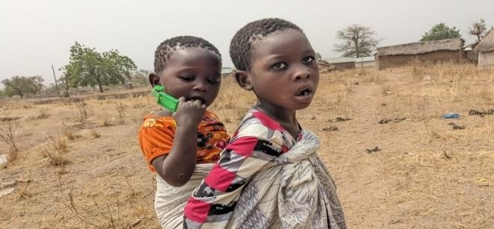

The World bank has invested over $680 million to support the first and second phase of SWEDD (UNFPA, 2020). In Ghana the Strategic Approaches to Girls Education (STAGE) Project is a notable example of a girls focused education program in Ghana. This AEP model has been implemented in Ghana using the Complementary Basic Education model to empower girls and ensuring gender equality in access to education.

Girls Education interventions have helped state agencies to provide the necessary environment for girls’ learning in terms of training in gender issues in education for pre-service and in- service teachers, establishing girls’ education units, divisions and/or focal persons, and equity quotas.

*Figure 10: A section of Out of school children in Northern Ghana*

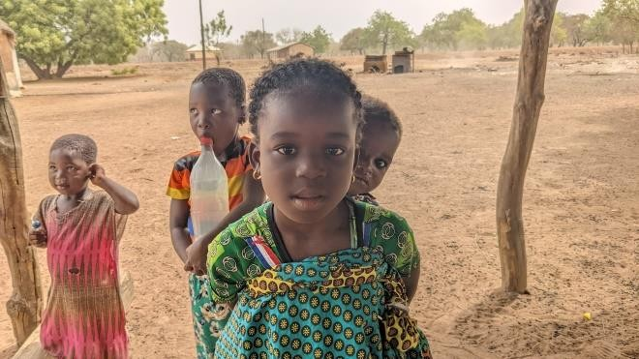

The innovations have increased awareness on gender inequalities in education and this has further enabled parents, communities and governments to support girls’ education.

Furthermore, Girls Education Programmes have led to increased investments in the education of girls by NGOs and governments as part of efforts to address gender inequalities in education

Another impact of Girls Education Interventions is the Creation of safe spaces for girls to learn and share together without fear. Through programmes such as STEM clinics for girls and Girls’ Clubs, girls are empowered and are taught how to develop strategies for assertiveness. (Nation et al, 2019) The influx of Girls Education interventions have helped in setting up of support mechanisms such as mentorship programmes, girls’ camps with girls’ desk officers sustaining these initiatives.

Girls Education is faced with a number of barriers including strong socio-cultural forces, poverty and lack of safeguarding

Many girls are out of school due to poverty and their retention is dependent on continued support. In the case where there is little or no financial support at all, the students will be unable to meet basic physiological needs such as sanitary towels, school uniforms and food and would have no option that to drop out. Under such circumstances, adolescence/teens girl AEP graduates may transition from safe spaces into at-risk situations.

In addition, violence at home, in the community and at schools affects girls physically and emotionally leading to a threat in gender equality and girls education. Girls are likely to drop out of school when there are no proper safeguarding measures in schools and communities.

There is therefore the need for Girls Education interventions to focus on addressing the barriers by providing financial support and

proper safe guarding in communities where they exist.

# Conclusions and Recommendations

## Conclusions:

The evidence shows that there are several best practices, within the context of student- and teacher-level interventions, that the government can adopt to address the out of school children situation leading to enhanced levels of participation, retention, and learning outcomes. The Ghana EGR program, a USAID- supported intervention, caused a significant improvement in reading fluency and reading comprehension in English and the Ghanaian Language among the 7000 grade 1 and 2 learners that were targeted across the then 10 regions of Ghana. The endline evaluation report shows that the Ghana’s EGR program compares favourably with any other peer program elsewhere in terms of size effect.

The Complementary Basic Education program, a government-led AEP, has been beneficial in addressing the OOSC situation in Ghana. Evaluations have shown that the use of foundational mother tongue as medium of instruction leads to high achievement among CBE learners. In some cases, CBE transitioners achieve higher learning outcomes than their peers in the formal educational system.

Further, assessment of the UTDBE program suggests that a higher proportion of UTDBE trainees compared to DBE teachers are willing to stay in rural, deprived areas due to community affiliation and the desire to serve their communities.

The Link Community Development (LCD) program and its components are effective in ensuring performance and achieving accountability among teachers and district officers, leading to improved quality and performance of learners. Insights from the SPR

strategy results from the testing provided a guide for teachers, circuit supervisors and district officers to respond to the existing gaps in the delivery of quality education. The inside- out approach which focused on building capacities of Head Teachers and SMCs/PTAs contributed created conditions to foster a better relationship between the teachers and parents towards enhancing the performance of learners.

The Untrained Teacher Development for Professional Teachers (UTDBE) programme was introduced to upgrade the teaching skills of teachers, to increase the number of teachers and to phase out pupil teachers and replace them with trained teachers in the Ghanaian educations system. Overall studies have shown that the UTDBE programme is more cost effective relative to the traditional DBE model of training and could be adopted as a means of tackling teacher gaps in rural and hard to reach areas in Ghana.

## Key Recommendations:

* + - Scale up the UTDBE programme to cover “community-based” teachers who have demonstrated at least 2 years of volunteer service to the system and willing to stay for 8 years (4 years while government supports 50% payment for UTTDBE and 4 years afterwards as GES teachers)
    - Scale up the EGR Learning programme for all primary schools in Ghana in order to ensure that the basic levels of reading are attained by P3. In addition, the Ministry of education (MoE) should invest to provide requisite teaching and learning resources, including textbooks books. Regular in-service training must also be provided for teachers along with the rigorous monitoring systems to ensure efficiency in programme implementation
    - Allocate at least 1% of basic education budget to the Complementary Basic Education Authority, as part of contributing to the

realization of Ghana’s Education Strategic Plan (2018 to 2030) through partnering the NGO sector. This will make it possible to scale the Complementary Basic Education programme to cover 500,000 more children in extreme poverty zones

* + - * The MoE should collaborate with the Ministry of Food and Agriculture and other key development pratners to ensure that LEAP is fully tied to girls’ entrance at primary and JHS
      * Efforts should also be made to create a legal regime that will support the full enforcement and implementation of laws meant to protect children, particularly girls at primary and JHS levels against early marriage and child elopement, but also child trafficking. Again, the social protection regime should be enhanced to check socio-cultural and child labour practices that force children out of school. This may include refocusing the GES/MOE gender and protection policies at schools.

# References

Akyeampong, K., Carter, E., Higgins, S., Rose, P., Sabates, R. (2018). Understanding Complementary Basic Education in Ghana: Investigation of the experiences and achievements of children after transitioning into public schools. Report for DFID Ghana Office. REAL Centre, University of Cambridge. https://doi.org/10.5281/zenodo.2582955

Asadi, G. (2020). Parents' investments in the quality of education: the case of Ghana. Education Economics, 28(6), 621-646.

Associates for Change (2021) Ghana Literature Review on Accelerated Education and Girls Empowerment Models. Associates for Change commissioned research by IDRC/GPE

Associates for Change (2016). Final Impact Assessment of the Untrained Teacher Diploma Programme (UTDBE), Ministry of Education/GPE.

Associates for Change (2009). LCD Education Programme Evaluation "Strengthening the Chain of Accountability to Improve Quality and Performance in Ghanaian Primary Schools: Impact Evaluation of the Link Community Development,)"

Bashir, S., Lockheed, M., Ninan, E., and Tan, J. P. (2018). Facing forward: Schooling for learning in Africa. World Bank Publications.

Casely-Hayford, L., Ghartey, A. B., and Justice Agyei-Quartey (2017). Parental and Learner Choice in Basic Education across Ghana’s Three Northern Regions Ghana. Fifth Annual CBE Research Study

Ghana Early Grade Reading Program Impact Evaluation (2019). 2019 Endline Report. USAID Partnership for Education: Evaluating Systems

Ghana Statistical Service (2018). Ghana Multiple Indicator Cluster Survey. Survey Findings Report for 2017/2018

Ghana Statistical Service (2012). Ghana Living Standard Survey Round Six (GLSS 6), Survey Findings Report for 2012/2013

Nation, J. M., Harlow, D., Arya, D. J., & Longtin,

M. (2019). Being and Becoming Scientists: Design-Based STEM Programming for Girls. Afterschool Matters, 29, 36-44.

UNESCO Institute of Statistics (2021). Data on Out-of-School Children: Available at <http://data.uis.unesco.org/>

UNFPA welcomes the World Bank's approval of an additional $376 million to advance women's and girls' empowerment in Africa. UNFPA WCARO. (2020, June 4). Retrieved March 29,

2022, from

https://wcaro.unfpa.org/en/news/unfpa- welcomes-world-banks-approval-additional- 376-million-advance-womens-and-girls- empowerment