COMPUTER AIDED INSTRUCTION IN BARTENDING AND BAR SET-UP: AN ENHANCEMENT STRATEGY FOR STUDENTS’ ACADEMIC PERFORMANCE.

Antatico, Kenneth Roy A.1, Buenavides, Elmer C.
June 2022

ABSTRACT
Excellent instruction requires access to high-quality instructional materials. One method for providing effective instruction is to use Computer Aided Instructional Materials, which provide one-on-one interaction to students and provide them the freedom to learn at their own pace. This study is conducted to address the compelling need for quality education that can improve students’ learning in a more indulgent and convenient manner. It is supplemental material in the subject Bartending and Set Up to have a meaningful teaching-learning engagements for both faculty and students of Glan Institute of Technology.
Based on the validation provided by the panel of assessors, this study used experimental and evaluative descriptive research designs to determine the quality of Computer Aided Instruction. There were 64 student participants who were chosen randomly.
The data was examined with descriptive and inferential methods such as the mean, standard deviation, and t-test.
Based on the findings, the academic performance of the students has greatly improved in the experimental group with the intervention of Computer Aided Instruction in comparison to the control group with the traditional method. Finally, it was deduced from the finding that computer aided instruction is an effective tool in developing and improving students' academic performance. This study will also serve as an avenue in developing effective materials to elevate the level of instruction.

Keywords: computer-aided, bartending, bar set-up

- INTRODUCTION

The introduction of technology has altered many aspects of the teaching and learning process. Using technology, many strategies and approaches were developed to make the teaching process easier and maximize student learning. The usage of technology, on the other hand, has an impact on the ways in which student learn. Teachers are increasingly relying on computers to aid classroom education.
The claims of Mercado et al. (2019) posit that computers and other parts of Information and Communications Technology (ICT) have changed the way people live, work, play, and learn. Technologies are designed to aid all elements of life, including academics, and can allow students to study and practice using tools on a global scale, allowing them to draw concrete connections with activities outside of the classroom.
In many aspects of life, technological growth has been unavoidable. There is no exception for education. Everyone working to improve our teaching and learning processes in order to meet the needs and demands of the 21st century learning.
The potential benefits of the Computer Aided Instruction (CAI) in modern world cannot be ignored because proven findings that on the instructional usefulness of computers, particularly in affluent countries, cannot be disregarded. The Integration of ICT in the teaching learning process has been adopted through the use of computers and other technological gadgets for curriculum content delivery Ayuba and Timayi (2018). Unlike traditional classroom, when students are grouped together regardless of their difference or class can be used individually or in a group setting. (Laleye (2019).
The use of ICT in teaching is a relevant and functional way of providing education to learners in order to assist them developing the required capacity for the world to work (Kosoko-Oyedeko & Tella, 2010).
Furthermore, the use of multimedia in education has altered people's learning processes significantly. Computer technology has the potential to improve student performance and the quality of teaching education programs at all levels. To fulfill the goals and demands of 21st-century education, everyone is working to improve our teaching and learning processes.
Consequently, Geist and King (2008) as cited by Chin (2014) asserted that many students are negatively impacted by those traditional methods. Despite this, some teachers are still hesitant to adopt and implement new teaching methods because they have spent so much effort perfecting a system that has worked well for them over the years.
Similarly, in Glan Institute of Technology, teaching Food and Service Management has been a challenge because it usually takes place inside the laboratories and other facilities, and equipment are provided for learning activities including cooking and drinking activities. Integrating computer aided instruction with the researcher made module to the subject Bartending and Bar Set-Up will be of great help to facilitate a holistic approach to students by helping them improve skill performance, attitudes, habits that will ultimately upshot in the highest potential level of skills and abilities. It enables students to understand and experience a range of food preparation and bar activities that allows them to cope with stress, improve professional inputs in a more indulging and convenient way it can be used to facilitate effective instruction that brings out a more meaningful learning.
The fundamental goal of this research is to create a computer-assisted learning system to Bachelor of Technical-Vocational Teacher Education (BTVTEd) students and instructors, it will be used as supplement strategy to improvement academic achievement in the subject Bartending and Set Up. This research presents image visualization and demonstrates a high level of professional ability. The researcher hopes that this endeavor gives meaning solution to difficulties in technical laboratories that may pave the way toward better technical knowledge and skills.

- METHODOLOGY

The study sets with the minimum hardware specifications and software requirements needed to run the system. Agile methodology provides several opportunities to analyze a project's direction through its development life cycle. Agile methods are undertaken into chunks of different phases in planning, requirements analysis, design coding, unit testing, and review if all are functioning and run successfully.
The sets of related activities are as follows for Sprint 1 is enable and provide security level for every user. Sprint 2 is to manage the information of the teacher and student. Sprint 3 is to manage activities task type as Pretest, Posttest, Quiz, Assignment, Laboratory Activity and Examination. Sprint 4 is to manage question type and Sprint 5 is to provide and print gradebook.
In comparing the produced Computer Aided Instruction (CAI) to the current traditional approach, it used the pretest and posttest. The results were calculated statistically by calculating the mean gain of the two groups and using a paired samples t-test to evaluate significant differences at the 0.05 percent level.
The experimental and evaluative descriptive research designs were used in this mixed methods study. For the experimental group, the tool Computer Aided-Instruction (CAI) was developed, whereas the control group did traditional instruction.
The Two Group Control Group Experimental Design was used to examine the functionality, effectiveness, and acceptability of the system under development by analyzing the pretest and posttest scores of the control and experimental groups.
The evaluative descriptive research approach was used to ascertain the participants' perceptions of the generated modules for the said technology. The Computer Aided Instruction (CAI) and module are subjected to an expert validation to gauge the system face and content validity based on the functionality, effectiveness, and acceptability. The Computer Aided Instruction in Bartending and Bar Set Up was then compiled which was validated and evaluated by the pool of experts. The researcher provided a web-based computer aided instruction with the domain name www.cai-git.com and validation tool to the IT experts and Faculty for the evaluation and validation.
To find out the performance of the participants, it administered pretest and posttest using the test questionnaires from the Computer Aided Instruction and module in Bartending and Bar Set Up. Pretest gathered baseline data on what students know before being exposed to instructional materials, and a posttest to assess students' achievement after learning the content of the materials.
A web based of Computer Aided Instruction in Bartending and Bar Set Up was given to the experimental group that was utilized for the completion of following topics: Module -1 Beverage Service Industry, Module -2 Bar Organization, Module-3 Bar Parts and Equipment Lay out, Module-4 Beverage, Module-5 Basic of Coffee of the School Year 2021-2022.
On the other hand, the data from control group were gathered through traditional approach wherein topics, concepts and competencies were the same as those given to the experimental group. It employs a self-learning printed module which consists of varied activities and exercises and students could learn in their own pace without interaction with the instructor.
There were three (3) types of participants in this study namely: 1) five (5) Faculty Members, 2) five (5) IT Practitioners, and sixty four (64) third year students from BTVTED major in FSM of Glan Institute of Technology who were randomly selected. Thirty two (32) of them were assigned to the control group and the other thirty two (32) were assigned to the experimental group. All these students were enrolled in the second semester SY. 2021-2022.
This study used random sampling, also known as a sample picked at random, which is intended to provide an unbiased representation of the entire population when choosing the experimental and control group participants who used the Computer Aided Instruction the researcher considered the participants on their internet connectivity, available educational gadgets such smart phones, laptops and tablets, computer skills, financial resources, learning environment and convenience.
The study employed two (2) sets of research tools. The survey questionnaire and the pretest and posttest. The Survey Questionnaire intended to evaluate the system in terms of its functionality, effectiveness and acceptability was adapted from Ibrahim, Leng, Yusoff, Sammy, Masrom, & Rizman (2017).
The CAI system was utilized to determine the student’s performance using the Pretest and Posttest.
Average rating computation was used to determine the academic performance of the participants. Percentage was utilized to determine the participant’s writing academic performance both before and after the test. The Five Point Likert Scale was adapted by the researcher from the study of Kimani (2015) as cited by Jalagat & Al-Habsi (2017).

- RESULTS AND DISCUSSION
The study is focused on determining whether the application software is suitable for Bartending and Bar Set Up in increasing the academic performance of the Bachelor of Technical Vocational Teacher Education major in Food and Service Management 3A and 3B students compared to the lecture method or traditional approach in teaching. The effects of the teaching method used were determined through the scores of the students in the pre-test and the experimental group used the Computer Aided Instruction (CAI) to Bartending and Bar Set Up and the control group used the traditional method or lecture method.

Table 1. Pretest Scores of the Student Participants in the Control and Experimental Group.
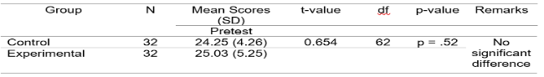

Table 1 shows the independent t-test result for the Pretest of Control and Experimental Groups. This implies that pretest scores from both control and experimental groups are homogenous. This further implies that spread on pretest scores in control group and experimental groups are the same and that students from each of the two groups have the same level of understanding and performance on the subject matter. Moreover, independent t-test was used to determine how students perform before the start of the intervention.
Table 2. Pretest and Posttest Mean Scores of the Student Participants in the Control and Experimental Group.
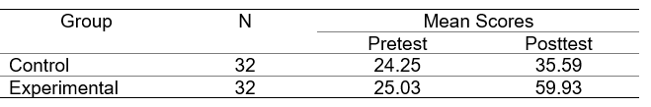

Table 2 provides the data on the pretest and posttest mean scores of the student participants in the Control and Experimental groups who have the same number of participants. The results implies that students from the experimental group scored higher in the posttest than the students from control group, subsequently, this indicates that after the intervention imposed by the instructor, results from posttest shows remarkable increased in the mean scores of the student participants in the experimental group who used Computer Aided Instruction.
This substantiate the study of Olagunju (2013) that CAI is a very effective instructional technique in the teaching and learning process because it provides an interaction between an individual learner and the computer just as it happens in tutorial system between the teacher and the individual learner and is able to display instructional materials to each student.

Table 3. Difference on Pretest and Posttest Mean Scores of the Control and (Traditional Approach)
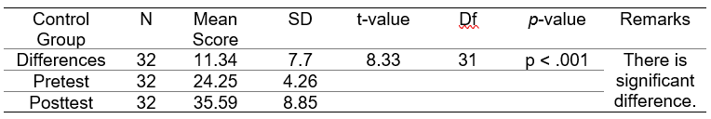

Table 3 provides the result of the paired t-test on the pretest and posttest mean scores of the control groups who utilized the traditional approach. Dependent paired t-test was conducted to determine significant difference on the performance of students under control group. Data shows highly significant difference between pretest and posttest performance of respondents. This implies that students from this group perform better during the posttest as compared with the pretest. It can also be concluded that students have learned from the traditional approach made as the mode of delivery of the lesson.
It substantiates the claims of Ambayon (2020) that traditional instruction is more operative in the teaching-learning method as equated to traditional teaching approaches because in traditional approach, the students learn in their own stride. It is unrestricted self-learning panache in which instantaneous reinforcement, a comment is provided to practice exercise, which stimulates the students and builds curiosity in them. Hence, this kind of learning modality increases the student-centered approach in learning.
Although, based on the table, experimental group did improve in their performance, it was not expressively higher compared to the experimental groups who used the computer aided instruction. As validated by the claims of Alvarez (2021) that the issues encountered with the modular distance learning approach were communication failures such as instructions or confusion of students on the modules, limited teacher guidance, students' disrespectful approach to teachers, complaints about not understanding the module, and all of which resulted in student misbehavior and failure to pass worksheet on time.

Table 4. Difference in the Pretest and Posttest Mean Scores of the Experimental Group (CAI)
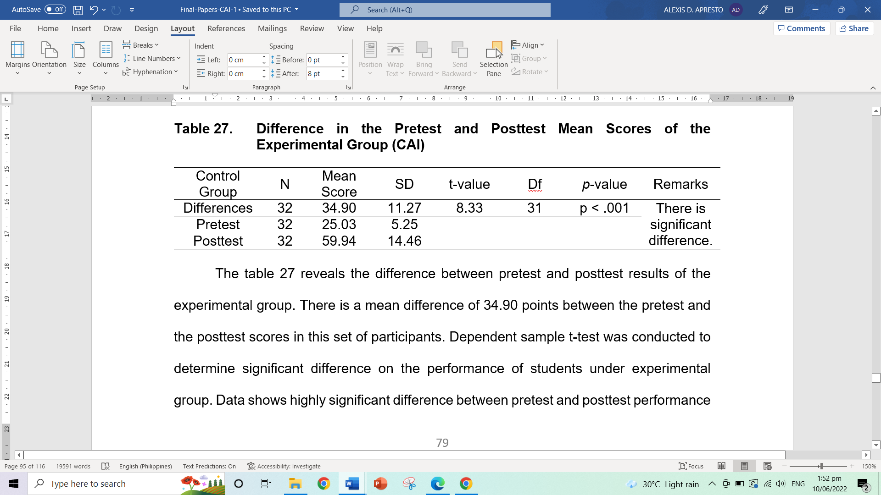
The table 4 reveals the difference between pretest and posttest results of the experimental group. There is a mean difference of 34.90 points between the pretest and the posttest scores in this set of participants. Dependent sample t-test was conducted to determine significant difference on the performance of students under experimental group. Data shows highly significant difference between pretest and posttest performance of the respondents (t (31) = 8.33, p< .001). This implies that students from this group perform better during the posttest as compared with the pretest. It can also be concluded that students have learned and performed better from the CAI approach as the mode of delivery of the lesson.
This confirms the study conducted by Suson (2020), that the effect of computer aided instruction (CAI) on students' achievement in multiplicative skills will be statistically improved. Further, CAI is more effective than standard teaching methods in teaching wherein the students' and teachers' interests will be elevated and statistically contributed to the students' overall learning. Hence, it is evident that there are struggles associated with the use of modular distance learning
It also affirms with the study of Psycharis & Kallia (2017) that it is hard to deny that student motivation to learn is one of the factors that influences learning effectiveness. Because the medium generated was interactive, the CAI model was able to enhance students' interest for learning compared to modular and traditional instructions. These findings are consistent with other studies that show that interactive learning media improve self-efficacy, and that they are practical to because they are able to assist students in learning as a direct and inverse proportional subject, and see student value preferences. It cannot be denied that student enthusiasm. One of the aspects that influences the efficacy of learning is motivation. Because the medium generated was interactive, the CAI model was able to enhance students' interest for learning.

Table 5. Pretest and Posttest Mean Gain Scores in the Control and Experimental Groups
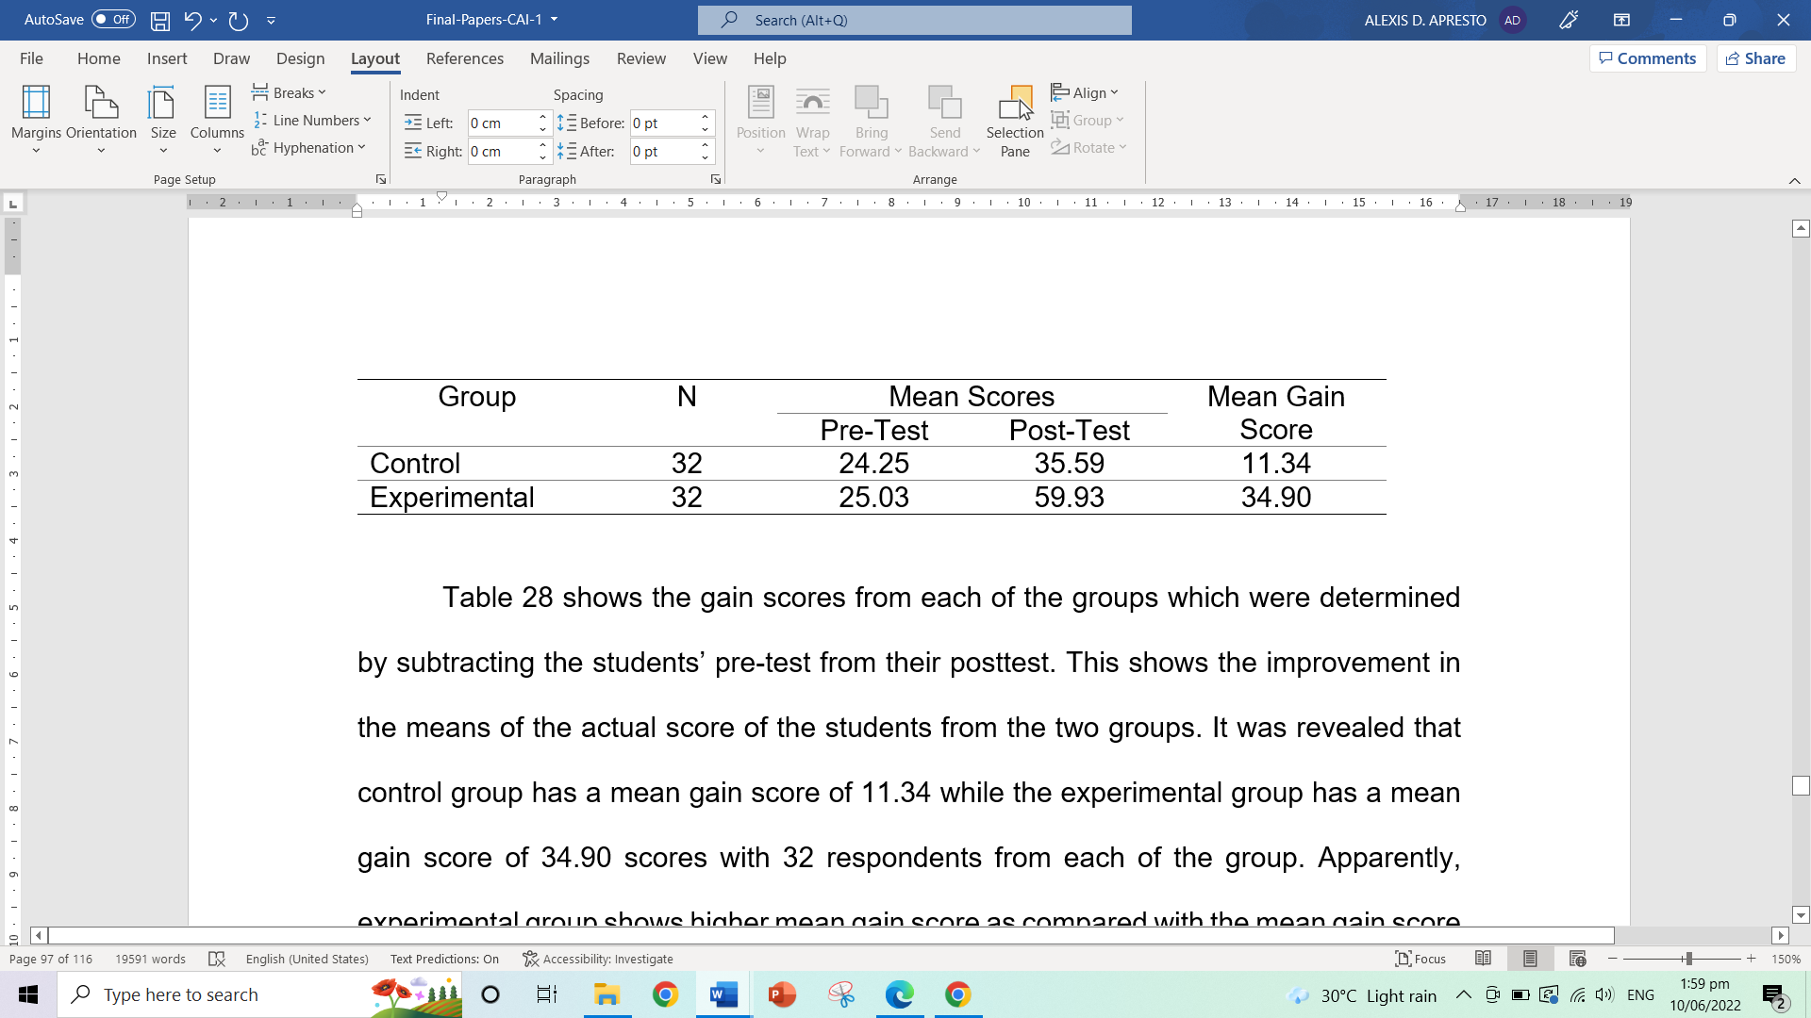
Table 5 shows the gain scores from each of the groups which were determined by subtracting the students’ pre-test from their posttest. This shows the improvement in the means of the actual score of the students from the two groups. It was revealed that control group has a mean gain score of 11.34 while the experimental group has a mean gain score of 34.90 scores with 32 respondents from each of the group. Apparently, experimental group shows higher mean gain score as compared with the mean gain score from the control group.
This sustains the claims of Chen (2017) that computer-aided instruction, was proven the effectiveness on the promotion of students’ academic achievement. Computer-aided instruction was a practicable teaching method as it could promote students’ academic achievement and enhance the learning interests and attitude. Moreover, computer aided instruction could reduce students’ time for learning. More so, the study of Fan and Ma (2018) revealed that computer aided instruction utilized the characteristics of computers (texts, pictures, and images) and was the teaching software learning system constructed by adjusting task complexity and learning speed according to learners’ individual differences.
Table 6. Difference in the Pretest and Posttest Mean Gain Scores of the Control and Experimental Groups


Table 6 reveals the difference between the gain scores of the control group and experimental group. There is a mean difference of 18.14 points. Independent sample t-test was conducted to determine significant difference on the gain scores of students between experimental group and control group. Data shows highly significant difference between the mean gain scores of the two compared groups with (t (62) = 9.76, p < 0.001). This implies that even though students improved from either of the groups, students from the experimental groups significantly perform better. This further implies that the intervention made in the experimental group (the use of CAI as mode of delivery of the lesson) can improve students’ performance better as compared to the intervention made in the control group (the use of modular approach).
This implies that even though students improved from either of the groups, students from the experimental groups significantly perform better. This further implies that the intervention made in the experimental group (the use of CAI as mode of delivery of the lesson) can improve students’ performance better as compared to the intervention made in the control group (the use of modular approach). Further, it is worthy to note that the performance of the experimental group has achieved a significant increase using the Computer Aided Instruction than those in the control group who were exposed to teaching using modular approach.
As shown in Table 3 and Table 4, it can be concluded that the first null hypothesis of no significant difference between the pretest of both control group and experimental group is accepted. On the other hand the data shows that there is significant difference between on the post test scores of students from control and experimental group. It implies that students’ scores improve in the posttest from both groups.
As shown in Table 6, it can be concluded that the second null hypothesis of no significant difference between the gain scores of students from control group and experimental group is rejected. This implies that gain score from experimental group is significantly different from the control group. It can be further concluded that experimental groups with CAI as mode of delivery of the lesson perform better as compared to the control group with modular approach as mode of delivery of the lesson.
It validates the Teng & Ca (2021) that computer-assisted instruction is advantageous in the implementation of physical education programs, particularly in the teaching of academic concepts and principles. This study had certain limitations that should be mentioned. First, the quality of the multimedia program determined the efficiency of computer-assisted instruction, whereas the effectiveness of traditional teaching was determined by the effectiveness of the physical education teacher. Second, the number of participants in the study should be increased.
Table 7. IT Practitioners’ Assessment of Computer Aided Instruction in terms of Functionality, Effectiveness and Acceptability
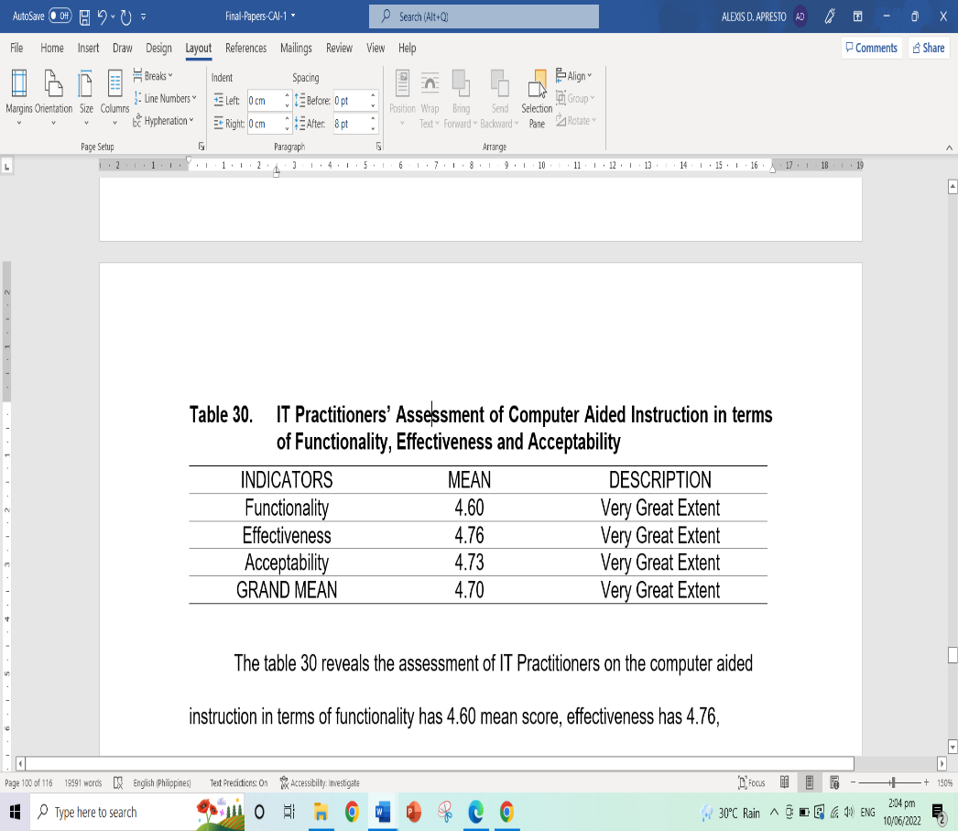

The table 7 reveals the assessment of IT Practitioners on the computer aided instruction in terms of functionality has 4.60 mean score, effectiveness has 4.76, acceptability 4.70 with the overall grand Mean of 4.70 or at Very Great Extent. It implies that CAI generally developed at 81% and above quality standard. Indicate implications such as those related to technology, students’ learning, and instructions suited to curricular needs of the learners.
Moreover, it substantiate the claims of Kaur (2018) that Computer Assisted Instructional Packages can be created by the joint efforts of the computer experts and the subject expert. The teacher plays more roles in facilitating instruction to the learner. The concept of motion instructional package can be used both in the classroom and even in instances where the students are withdrawn from the teacher in time and space.

Table 8. Faculty Participants’ Assessment of Computer Aided Instruction in terms of Functionality, Effectiveness and Acceptability



The table 8 shows the faculty participant’s assessment on the computer aided instructions in terms of functionality it has a mean of 4.76, effectiveness has 4.80, acceptability 4.67 with the grand mean of 4.74 or at Very Great Extent respectively. It implies that CAI generally developed at 81% and above quality standard. Indicate implications such as those related to technology, students’ learning, and instructions appropriate to the curricular needs of the learners.
It supports the claims of Wahyuni (2016) that educators should have access to digital applications that can help them improve the effectiveness of their teaching and learning. Computers are a type of technology that can be employed in the learning process. Some instructional methodologies are computer-assisted and may be accessed via a computer. CAI-based learning has recently been established, and it has aided teachers and students in their learning. In the future, the computer will be able to assist tens of thousands of students simultaneously. CAI is a computer-assisted instructional strategy that involves students actively and provides feedback.

Table 9. Students’ Assessment of Computer Aided Instruction in terms of Functionality, Effectiveness and Acceptability
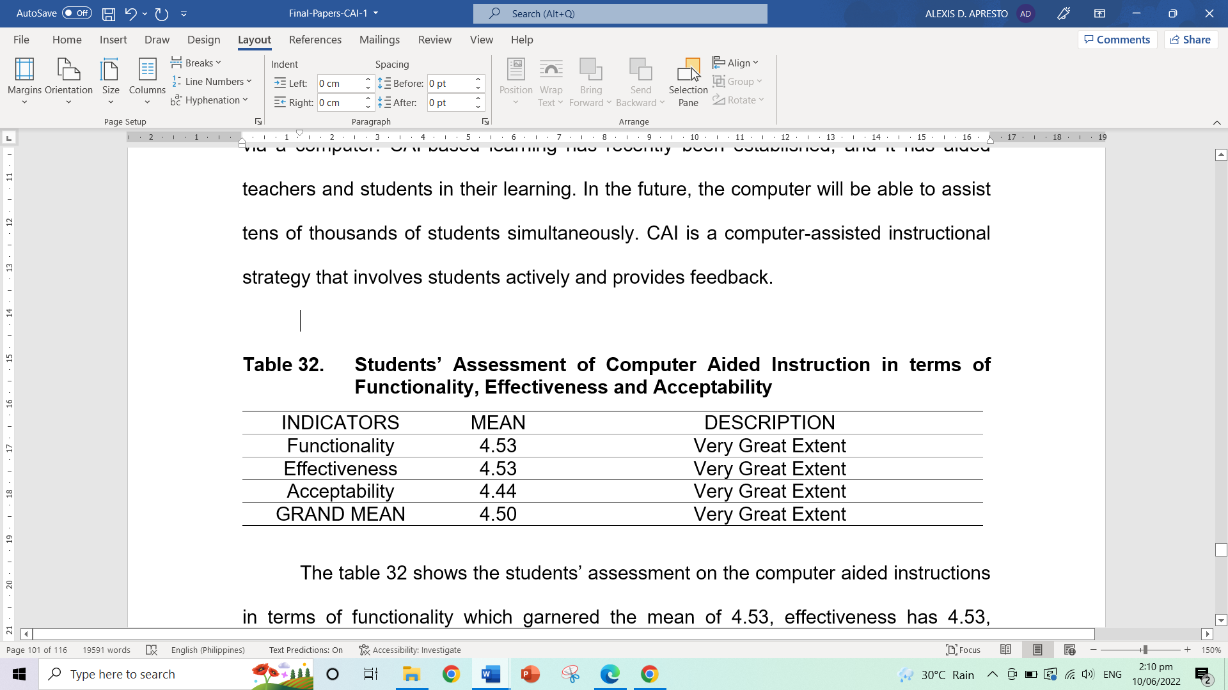
The table 9 shows the students’ assessment on the computer aided instructions in terms of functionality which garnered the mean of 4.53, effectiveness has 4.53, acceptability 4.44 with the grand mean of 4.59 or at Very Great Extent respectively.
It implies that CAI generally developed at 81% and above quality standard. Indicate implications such as those related to technology, students’ learning, and instructions appropriate to the curricular needs of the learners.
This withstand the claims of Xie (2020) that the academic conditions of different schools in different regions are different, and the differences in students’ cognitive levels are also obvious. Therefore, designing corresponding autonomous learning materials in a targeted manner, with the help of these materials in conjunction with the corresponding autonomous learning mode, can help students improve their academic performance.

REFERENCES
Adams, C. (2019). TPACK model: The ideal modern classroom. In R. Power (Ed.), Technology and the curriculum: Summer 2019. Lethbridge, AB, Canada: Power Learning Solutions.
Guthrie, J. T., & Klauda, S. L. (2015). Engagement and motivational processes in reading. In P. Afflerbach (Ed.), Handbook of individual differences in reading (pp. 41–53). New York, NY: Routledge
Herbert, N. (2017). Impact of student engagement on first year ICT performance. In 2017 International Conference on Computational Science and Computational Intelligence (CSCII; pp. 1085-1090). Los Vegas, Nevada.
Keane, R. V. (2018). The effects of computer-assisted instruction for students with learning disabilities in a self-contained social studies setting (Unpublished doctoral dissertation). Rowan University, Glassboro, NJ.
Kunkel, A. (2015). The effects of computer-assisted instruction in reading analysis (Unpublished doctoral dissertation). University of Minnesota, Minneapolis, MN.
Abarro, V. (2016). Development and Validation of a Computer Aided Instructional Material in Selected Topics in Elementary Algebra. International Journal of Scientific and Research Publications, 6 (6), 81-80.
Ahiatrogah, P. & Bervell B. (2015). Effect of Computer Assisted Instruction on the Achievement of Basic School Students in Pre-Technical Skills. Academic Journal of Interdisciplinary Studies. 2 (1), 84-85.
Ali, G. Haolader, F. A., & Muhammad, K. (2015). The role of ICT to make teaching- learning effective in higher institutions of learning in Uganda. International Journal of Innovative Research in Science, Engineering and Technology, 2(8), 61-73.
Alvarez, M. Y. (2021). Issues And Concerns Of Teachers In Mindanao State University- Sulu Towards Modular Distance Learning Approach: An Analysis. Indonesian Community Empowerment Journal, 1(2), 51-69. https://doi.org/10.37275/icejournal.v1i2.12.
Ambayon, E. (2020). Modular-based approach and student’s achievement in literature. International Journal of Education and Literary Studies, 8(3). https://doi.org/10.7575/aiac.ijels.v.8n.3p.32.
Bonsu N.O, Bervell B., Kpodo E., Arkorful V., Edumadze J K E., (2020). Computer- Assisted Instruction in the Teaching and Learning of History: A Systematic Review in Africa, 586.
Comi, S. L., Argentin, G., Gui, M., Origo, F., & Pagani, L. (2017). Is it the way they use it? Teachers, ICT, and student achievement. Economics of Education Review, 56, 24–39.
Chen, C., Chen C., & Shieh, C.J., (2017). A Study on Correlations between Computer- Aided Instructions Integrated Environmental Education and Students’ Learning Outcome and Environmental Literacy. EURASIA Journal of Mathematics, Science and Technology Education, 16(6). https://www.ejmste.com/download/a-study-on-correlations-between-computer-aidedinstructions-integrated-environmental-education-and-8229.pdf.
Ibrahim R, Leng N S, Yusoff R C M, Samy G N, Masrom S, Rizman Z I. E-learning acceptance based on technology acceptance model (tam). J. Fundam. Appl. Sci., 2017, 9(4S), 871-889.
Falck, O., Mang, C., & Woessmann, L. (2018). Virtually no effect? Different uses of classroom computers and their effect on student achievement. Oxford Bulletin of Economics and Statistics, 80(1), 1–38.
Fan, N., & Ma, Y. (2018). The Role of Written Corrective Feedback in Second Language Writing Practice. Theory and Practice in Language Studies, 8(12), 1629- 1635. https://doi.org/10.17507/tpls.0812.08.
Hou, Y.-J. (2019).Thinking and educational technology in EFL classrooms: Effects on students’ reading comprehension and engagement. International Journal of Literacies, 26(2), 19.
Hussain, R. (2017). Effects of Information and Communication Technology (ICT) on Students’ Academic Achievement and Retention in Chemistry at Secondary Level. Journal of Education and Educational Development. 4 (1), 73-93
Koledafe, O., Ogunlade, & O., Olafare, O., (2018). Design and Validation of Computer Assisted Instructional Package to Teach the Concept of Motion in Secondary School Physics. Journal of Curriculum and Instruction 11(1), 81 – 90.
Lai, R. (2016). The Effect of Computer-Assisted Instruction for Elementary School Students in Food Safety and Sanitation Knowledge. MATEC Web of Conferences. 62(3), 4-5.
Li, D., & Wang, J. (2014). Relationship between computer-based reading activities and reading achievements among Hong Kong and US students: A comparative study using PIRLS 2011 Data. Frontiers of Education in China, 9(4), 552–576.
Olagunju, A. M. (2013). Trajecting Teacher Education through Computer aided instruction for national development. Journal of Modern Education Review, 3(12), 932-941.
Pagani, L., Argentin, G., Gui, M., & Stanca, L. (2016). The impact of digital skills on educational outcomes: Evidence from performance tests. Educational Studies, 42(2), 137–162.
Rahmawati, D., Hidayanto, E., Anwar, R. B. (2017). Process of Mathematical Representation Translation from Verbal into Graphic. International Electronic Journal of Mathematics Education, 12(3), 367-381.
Rosali, LJD (2020). Effect of Computer-Assisted Instruction (CAI) on the Academic Achievement in Secondary Physics. International Journal, 7(5): 15-10.
Safdar, A., Yousuf, M. I., Parveen, Q., & Behlol, M. G. (2017). Effectiveness of Information and Communication Technology (ICT) in teaching mathematics at secondary level. International Journal of Academic Research, 3(5), 67-72.
Suson, R. and Ermac, E. (2020). Computer Aided Instruction to Teach concepts in Education. International Journal on Emerging Technologies, 11(3): 47–52.
Umbara, U. et al (2020). Increase Representation in Mathematics Classes: Effects of Computer Assisted Instruction Development with Hippo Animator. International Electronic Journal of Mathematics Education. 15(2)10-14.
Williams, M., Linn, M. C., Ammon, P., & Gearhart, M. (2017). Learning to teach inquiry science in a technology-based environment: A case study. Journal of Science Education and Technology, 13(2), 189–206.
Xia, Y. (2016).Aspnet: aspect extraction by bootstrapping generalization and propagation using an aspect network,” Cognitive Computation, 7 (2) 241–253.

Xie, Z. (2020) Effectiveness of autonomous learning materials for students during the COVID-19 pandemic: A case study of the Daxie Second Elementary School in Ningbo, Zhejiang, China. Sci Insigt Edu Front 2020; 6(1):613-624.
CITATIONS
Posit that computers and other parts of Information and Communications Technology (ICT) have changed the way people live, work, play, and learn. Technologies are designed to aid all elements of life, including academics, and can allow students to study and practice using tools on a global scale, allowing them to draw concrete connections with activities outside of the classroom. (Mercado et al. 2019).
The Integration of ICT in the teaching learning process has been adopted through the use of computers and other technological gadgets for curriculum content delivery Ayuba and Timayi (2018).
Unlike traditional classroom, when students are grouped together regardless of their difference or class can be used individually or in a group setting (Laleye (2019).
The use of ICT in teaching is a relevant and functional way of providing education to learners in order to assist them developing the required capacity for the world to work (Kosoko-Oyedeko & Tella, 2010).

Many students are negatively impacted by those traditional methods. Despite this, some teachers are still hesitant to adopt and implement new teaching methods because they have spent so much effort perfecting a system that has worked well for them over the years (Geist and King 2008) as cited by Chin (2014).

The survey questionnaire and the pretest and posttest. The Survey Questionnaire intended to evaluate the system in terms of its functionality, effectiveness and acceptability was adapted from Ibrahim, Leng, Yusoff, Sammy, Masrom, & Rizman (2017).

The Five Point Likert Scale was adapted by the researcher from the study of Kimani (2015) as cited by Jalagat & Al-Habsi (2017).

The CAI is a very effective instructional technique in the teaching and learning process because it provides an interaction between an individual learner and the computer just as it happens in tutorial system between the teacher and the individual learner and is able to display instructional materials to each student (Olagunju (2013).

The traditional instruction is more operative in the teaching-learning method as equated to traditional teaching approaches because in traditional approach, the students learn in their own stride. It is unrestricted self-learning panache in which instantaneous reinforcement, a comment is provided to practice exercise, which stimulates the students and builds curiosity in them. Hence, this kind of learning modality increases the student-centered approach in learning (Ambayon (2020).

The issues encountered with the modular distance learning approach were communication failures such as instructions or confusion of students on the modules, limited teacher guidance, students' disrespectful approach to teachers, complaints about not understanding the module, and all of which resulted in student misbehavior and failure to pass worksheet on time (Alvarez (2021).

The effect of computer aided instruction (CAI) on students' achievement in multiplicative skills will be statistically improved (Suson (2020).

It is hard to deny that student motivation to learn is one of the factors that influences learning effectiveness (Psycharis & Kallia (2017).

The computer-aided instruction was proven the effectiveness on the promotion of students’ academic achievement. Computer-aided instruction was a practicable teaching method as it could promote students’ academic achievement and enhance the learning interests and attitude (Chen (2017).
The computer aided instruction utilized the characteristics of computers (texts, pictures, and images) and was the teaching software learning system constructed by adjusting task complexity and learning speed according to learners’ individual differences (Fan and Ma (2018).
The teacher plays more roles in facilitating instruction to the learner. The concept of motion instructional package can be used both in the classroom and even in instances where the students are withdrawn from the teacher in time and space (Kaur (2018).

The computer-assisted instruction is advantageous in the implementation of physical education programs, particularly in the teaching of academic concepts and principles. This study had certain limitations that should be mentioned. First, the quality of the multimedia program determined the efficiency of computer-assisted instruction, whereas the effectiveness of traditional teaching was determined by the effectiveness of the physical education teacher. Second, the number of participants in the study should be increased. (Teng & Ca (2021).
The academic conditions of different schools in different regions are different, and the differences in students’ cognitive levels are also obvious. Therefore, designing corresponding autonomous learning materials in a targeted manner, with the help of these materials in conjunction with the corresponding autonomous learning mode, can help students improve their academic performance (Xie (2020).

KR.A. Antatico, is with the Glan Institute of Technology, Glan, Sarangani Province, 9517, Philippines (kennethantatico@gmail.com)
E.C. Buenavides, is with the Graduate School, Sultan Kudarat State University, EJC. Montilla, Tacurong City, 9800, Philippines (elmerbuenavides@sksu.edu.ph)

