**USE OF COMPUTER SIMULATION IN THE LEARNING PROCESS**

Consideration of issues related, on the one hand, with computer modeling and, on the other hand, with physical phenomena and processes, is the main one in the preparation of students in specialized physics and mathematics classes, since it combines the basics of computational mathematics, physics and computer science. The use of computers is associated with the solution of a number of problems in the development of physical education. Automated training systems can be used as an addition and explanation of the lecture material, for the current control of knowledge in practical classes when modeling specific tasks, as well as for conducting virtual laboratory works in case of insufficient laboratory facilities at the training site or remote mode of operation. Systems created with the use of computer technology belong to a specific type of technical teaching aids and are designed to make the teacher's work more efficient.

Mathematical difficulties arising in solving physical problems are easily overcome by computer mathematics systems. The most convenient programming language in this respect is Python. This system has the most comfortable interface for physics students and sufficient mathematical capabilities.

Mathematical difficulties arising in solving physical problems are easily overcome by computer mathematics systems. The most convenient programming language in this respect is Python. Python has several powerful and popular libraries that are designed for working with big data: analysis, visualization, trend forecasting. For example, the open source SciPy library includes modules for math, engineering, and scientific computing. Matplotlib is one of the most popular data visualization libraries. The PANDAS library is used to analyze information. This language is convenient in that it is very simple and suitable for beginners, has the most comfortable interface for students of physics and sufficient mathematical capabilities.

At this qualitatively new level of the learning process, it becomes possible to acquire and develop trainees' skills in manipulating ready-made mathematical models of objects, compiling complex systems and devices, i.e. design work, as well as the modernization of models, their generalization for new conditions, i.e. conducting research work.

So, we can say that computer simulation, in comparison with a laboratory experiment, makes it possible to:

1. to receive visual dynamic illustrations of physical experiments and phenomena, to reproduce their subtle details, which often elude the observation of real phenomena and experiments;

2. to visualize not a real natural phenomenon, but its simplified model, which is not achievable in a real physical experiment; in this case, it is possible to gradually include in the consideration additional factors that gradually complicate the model and bring it closer to a real physical phenomenon, change the time scale of events;

3. Simulate situations that are not realized in physical experiments.

At the same time, we note that computer modeling cannot completely replace a full-scale experiment, but is its most important addition.

The simplest physical processes, such as rectilinear uniform and uniformly accelerated motion, motion of a body thrown at an angle to the horizon, rotation around a circle, etc. it is very convenient to simulate using the Python programming language. Python is a popular high-level programming language that is designed to create applications of various types: web applications, games, desktop programs, and working with databases.

The main features of the Python programming language:

1. Scripting language. The program code is defined in the form of scripts.

2. Support for a wide variety of programming paradigms, including object-oriented and functional paradigms.

3. Interpretation of programs. To work with scripts, you need an interpreter that runs and executes the script.

Python offers several options for GUI development. Of all the GUI methods, tkinter is the most commonly used method. This is the standard Python interface for the Tk GUI toolkit that ships with Python.

Also in python there are many libraries for visualization: matplotlib, seaborn, ported from R ggplot and others. Among them, there are those that allow you to build interactive graphics, for example, bokeh, pygal and plotly.

As an example, we will give a program that simulates the movement of a body thrown vertically up (down) in Python by plotting the dependence of the coordinate on time.

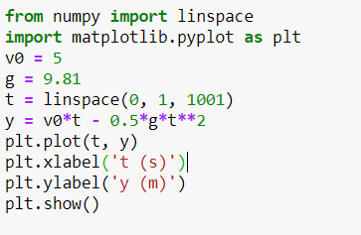

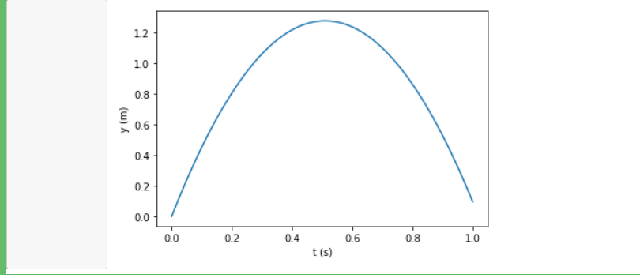

At the beginning of our program, we included the NumPy library. NumPy is an open-source Python module that provides general math and numeric operations in the form of pre-compiled, fast functions. They provide functionality that can be compared to that of MatLab. We only use a few functions in this program: linspace, plot, xlabel, and ylabel. The pyplot function is used to add plot elements (lines, images, text, etc.) to the current axes in our shape.

The given example demonstrates the convenience and ease of use of the Python language for modeling physical processes for educational purposes.