Adoption of Online Learning amongst Undergraduate Students of Public Universities in Kenya amid Corona Virus Pandemic. A Case of University of Nairobi-Kenya.

Dr. Ouru John Nyaegah
Lecturer & Coordinator School of Open and Distance Learning University of Nairobi,
- O. Box 30197-00100 Tel:+254-721343108, Nairobi -Kenya. jnyaega@uonbi.ac.ke

Abstract: Acquisition of Education is very crucial in the development of the individual and society and it cuts across different stages of human growth and development with specific and achievable goals. The purpose of this survey was to establish the extent to which Corona Virus Pandemic influenced adoption of Online learning among undergraduate students at Nakuru and Kisii Learning Centers of the University of Nairobi. The study came up with five objectives which focused on learners’ attitudes towards adoption of virtual learning, how they applied online platforms to learn and how they coped up with online challenges. The study used 232 students while Spear-man Coefficient of Correlation Formula was applied to establish research instruments’ reliability. The study established that, despite the university ensuring online learning, students faced poor internet connectivity, and unfavorable study environments. Strategies were urgently needed in order to build a Resilient Education System to enhance learning in the university
Keywords: Pandemic, Cessation of movement, Lockdown, Online Platforms, Resilient Education System.
- Introduction
Education is universally recognized as a basic human right which every child of school going age is entitled to. As observed by Walsh E, (20 July 2009) [1], education is so essential in ones live that when its provision to learners is disrupted, it brings far reaching consequences that are capable of breaking society and many generations to come. The main goal of education at university level is to see to it that it has prepared learners adequately for a live of purpose within any given environment or society by offering them a diversified curriculum that caters for individual differences and one that takes care of their talents, opportunities and also their future responsibilities while inspiring them to have the desire for self-development and achievement of full satisfaction, among others. Corona Virus disease was first discovered mid December 2019 in Wuhan which is one of the cities in China. Since that time, many countries across the world have witnessed thousands of cases of infections that have led to loss of lives and by extension closer of many higher education learning institutions.

The disease’s rapid spreading tendency made WHO to declare the virus a global pandemic on Tuesday 11Th March 2020 and since that time, many governments, the government of Kenya being among them, by using guidelines given by WHO, have come up with common health measures that are meant to control the spread of this highly contagious disease. These measures have included imposing lock-downs in highly affected cities, asking their citizens to observe social distancing, avoidance of having huge social gatherings in places like bars, churches and mosques, postponement of foreign travels, avoidance of face-to-face learning in schools, tertiary institutions and universities, among others. As of 22nd June 2020, positive Corona Virus cases had surpassed 8000 mark while in India for example, as of 18Th June 2020 alone, it had reported 170,384 positive cases, 194,324 recoveries and 12,237 deaths, as observed by MoHFW (2020)[2].
The Kenyan government while working together with other governments globally have come up with stringent mitigation measures that are aimed at controlling the spiral spreading nature of the virus. From March 25Th 2020, the government of Kenya through a presidential directive imposed two phases of nationwide curfews, three lock-downs involving Mombasa and Nairobi Counties and “Stay at home” policy extensions of more than three months. Kenya is not alone in doing this as it can be noted that, in Canada, citizens of that country have been subjected to five lock-downs with the current one being extended to 30Th July 2020 and the government plans to start providing essential services in a planned manner starting 1St August 2020 as observed by Cecco L, (2020)[3]. According to Davis BM, Markel H, Navarro A, Wells E, Monto AS, and Aiello AE (2015)[4], undergraduate education is education that is provided to learners who have successfully completed secondary school education and have joined colleges, university campuses and their subsequent learning centers and for which the learner is typically expected to graduate after being awarded a Bachelors Degree in a congregation organized by his or her respective university. In some countries such us USA, Britain, Kenya, among others; all students who are registered to do programs at higher education institutions, campuses, and also those enrolled in tertiary institutions are mostly referred to as "Campus students". As observed by Giuffrida A, Tondo L, Beaumont P (2020)[5], approximately 600 million university students’ learning has been interrupted globally due to the closer of their learning institutions.
As observed by Abidah A., Hidaayatullaah H.N., Simamora R.M., Fehabutar D., Mutakinati L (2020) [6], during lock-downs, lecturers are instructed to provide learning services through online learning platforms. As was observed, after the presidential directive which effectively witnessed closer of all learning institutions in the country, many universities in Kenya, both public and private experienced confusion and did not know what to do next. Most of them have remained closed to date and students are staying at home without any learning going on at all except at University of Nairobi where students are going on with virtual learning and even others who are enrolled in some campuses like ODeL Campus have in the recent past done their online exams and are currently taking new semester lessons online.
According to Ebijuwa, A.A. (2005) [7], there is need for institutions of higher learning to embrace creative teaching which will ensure learning continues irrespective of any prevailing virus outbreak. In order for students to overcome their mental stresses and anxieties that come about as a result of imposed curfews, and lock-downs. The unprecedented outbreak of COVID-19 as noted by Davies, H. and Tearle, D. (1999) [8], has resulted in digital revolution which is currently witnessed at institutions of higher learning. Universities have been left with no choice but to embrace virtual learning as an alternative measure to face-to-face method of teaching in lecture theaters and are now preparing content which can be delivered to learners by way of offering virtual lessons, video teleconferencing, electronic open books, online examination, and interactions at various virtual virtual learning environments. According to Gonzalez D, Siyanbola, G. and Oladapo, S. (2020) [9], COVID-19 pandemic has brought about a significant positive impact. They observe that the virus has brought about a new era of learning efficiency and performances that have resulted into the adoption of contemporary online learning strategies.
2. Research Objectives.
The survey sought to achieve the following objectives;
- To assess the extent to which online learning was adopted amongst undergraduate students of the university of Nairobi amid Corona Virus Pandemic;
- To assess the extent to which undergraduate students studying at University of Nairobi centers were conversant with the usage of available online platforms;
- To examine the influence of Corona Virus Pandemic on students’ learning status and progression during cessation of movement and lock-downs;
- To assess the influence Corona Virus Pandemic had on learners’ economic, social interactions and on their educational development.
- To explore challenges undergraduate students studying at the centers were facing while using online platforms to attend to their online classes;

- Research Questions;

The survey was out to seek answers to the following questions;
- To what extent has Corona Virus Pandemic influenced undergraduate students’ adoption of online learning platforms at learning centers?
- To what extent are undergraduate students studying at the centers conversant with the usage of available online platforms?
- How has COVID-19 Pandemic influenced students’ learning status and progression during cessation of movement and lock downs?
- To what extent has COVID-19 Pandemic influenced students’ economic, social Interactions and their educational development?
- What are the challenges students enrolled at University of Nairobi Centers are facing while using online platforms to attend to their online lessons?

4. Research Methodology
4.1 Research Design;
This is an online survey-based study and it thus used a survey design. According to Carlson, B and Firpo, M. (2001)[10], a survey is an instrument which is used to collect data focusing on information on a given phenomenon and is in most cases applied in psychology based researches that collect self reported data from study respondents. The study’s choice of this design was motivated by the fact that the design provides for a suitable instrument for collecting a large amount of data which in this case was a structural questionnaire. The research design was considered the best since it covered both the independent and dependent variables in the study adequately and it made it possible for the researcher to obtain a lot of information in the study area.
4.2 Target Population;
According to Muloye K, (2008)[11], target population in a survey includes a set of units by which the survey’s data is generated in order to be utilized in making inferences which will make the study to arrive at generalized conclusions. This survey targeted 468 undergraduate students enrolled at Nakuru and Kisii Learning Centers of the university of Nairobi as per the official records available at the centers. This targeted population enabled the researcher in this survey to come up with criteria for selection of a sample to be used for the study which he did by looking at all elements in the target population and then drew the sample that he used for this study. The researcher worked on an assumption that the selected participants were going to be available at the time the study was going to start.

  - Research Instruments;
Using a structural questionnaire developed and administered online, the study was conducted between 1St May and 20Th July, 2020 and it involved 232 participants. This number was arrived at through random sampling procedure carried out by the researcher. The study also used an interview schedule to obtain data from the respondents. Both the questionnaire and the questionnaire were then sent to the selected sample through their group WhatSapps, and their email addresses. By using Google Meets and through purposive sampling, the researcher interviewed the administrators of the two centers, the Kisii Center Regional Coordinator and the two Class Representatives from the two centers.
  - Validity of Instruments;
According to Joppe (2000)[12], and Gribalosik & Midaslimack (2011)[13], validity is the study instruments’ ability to accurately measure what it was set to measure, that is, how factual the the information given by respondents is. The researcher improved the instrument’s content validity by using experts to assess the suitability of the questions asked in the questionnaire and who focused on areas of their expertise and made judgement. The study therefore made use of the principal investigator, who is himself an expert in research to validate the instruments.
4.5 Reliability of the Instruments;
Instruments’ Reliability is defined as a method of assessing the accuracy of a research instrument that is to be used in data collection. This assessment is done in order to establish whether the instrument is capable of producing stable and consistent outcomes. Researchers use various techniques to test the reliability of instruments. As observed by Phelan & Wren (2006)[14], the split-half reliability technique was used to test the reliability of the instruments used for this study whereby the researcher randomly placed into two halves all questionnaire items that were seeking similar information. The test was then given to the sampled respondents who were carefully selected from outside the regions which were to be covered by this study and the total score for the two sets was computed in order to get a split-half reliability which made it possible for the researcher to get the correlation between the two ‘split sets’ of the scores. The researcher therefore computed the scores for each half using spear-man coefficient of correlation formula shown below;
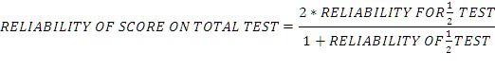 The instruments’ Internal consistency was also determined by grouping questions in the instruments that measure same concept (Gribalosik & Midaslimack, 2011)[13]. The study then used SPSS to calculate the piloted instruments’ internal reliability by use of Cronbach Alpha since the instruments were seeking students’ attitudes towards online learning using Likert Summated Scale. Equivalent-Form method was used by developing two sets of instruments that measure the same variables. The instruments were then administered to the Pilot respondents which were filled and collected immediately they were completed. The two instruments were correlated to calculate consistency using Spear-man correlation formula.
- Data Collection Procedure;
Data for this study was collected by the researcher himself who undertook the exercise by administering the structured questionnaire and interview schedule to all the respondents in the two centers. This resulted into generation of primary data which was needed for the study to progress well. The use of key informant interview guided questionnaire administration. Participants’ full consent was sought in a Google Meeting with all undergraduate students from the two centers held on 25Th April 2020 before their participation in the online survey. A total of 232 students and their center administrators provided complete information regarding the survey.
- Data Analysis Procedure;
The researcher in this survey analyzed data using both descriptive and inferential statistics. This was done in order to make the researcher get to know how respondents were distributed across the two study areas. The use of descriptive statistics resulted into the researcher being able to calculate measures of central tendencies such as the means, standard deviation, frequencies, percentages, correlation coefficient and participants’ responses on educational decisions and problems related to their studying methods during COVID-19 outbreak.
- Study Findings and Discussions The study first undertook the analysis of the participants’ personal profiles and the results were as shown in Table 1below;

Table 1: Participants’ Ages, Gender and Marital Status;
Participant | Age | N | % | Gender | N | % | Marital Status | N | %
Students | 20-24 | 56 | 24.13 | Males | 116 | 50 | Single | 113 | 48.71
 | 25-29 | 55 | 23.71 | Females | 116 | 50 | Married | 73 | 31.46
 | 30-34 | 53 | 22.84 |  |  |  | Single Parents | 46 | 19.83
 | 35-39 | 37 | 15.95
 | 40-44 | 33 | 14.22
TOTAL |  | 232 |  |  | 232 | 100 |  | 232 | 100
The study findings in Table 1 indicate that students aged between 20 to 24 years were 56 in number which constituted 24.13% of the total number of participants while 23.71% of the respondents who were 55 in number were aged between 25 and 29. Those aged between 30 and 34 were 53 in total and they constituted 22.84% while those aged between 35 and 39 were 37 in number and they formed 15.95%. Only 33 participants who formed 14.22% were aged between 40 and 44 years. Findings of the study thus indicate that, out of the total number of participants (232), almost two-thirds of them fell between the ages of 20 and 29 years with a median age being 30 years. The study had an equal number of male and female respondents who participated in the survey. The Regional Coordinator and Administrator of Kisii Center were all males while the Administrator of Nakuru center was a female and therefore they were among the 232 participants of the study. The study also sought to establish the marital status of all the study participants as this would help the researcher establish whether the students who participated in the study had ability to make independent decisions on their academic progress and the results were as shown in figure 1 below;

Figure 1: Participants Marital Status;
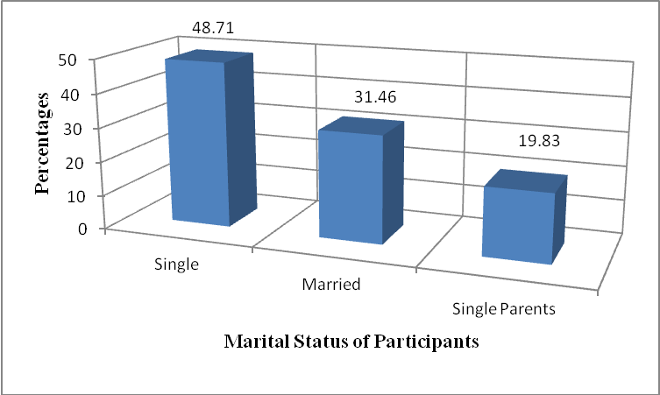
From the information presented in figure 1, it can be established that out of the 232 participants, 113 of them who formed 48.71% were single, 73 of them forming 31.46% were married while 19.83% who were 46 in number were single parents. From the analysis therefore, this meant that, those who were single were therefore depending on their parents and guardians and thus were not in a position to make independent decisions on issues concerning their studies while those who were married also relied on their family members for support and would therefore not make independent decisions. The study established that single mothers and fathers were more focused and determined to continue with their studies and graduate despite challenges brought about by COVID-19 pandemic’s effects.
The study also sought to establish the financial status of the participants and their families. This was important as it helped the research in establishing whether the participants were capable of meeting the costs of buying laptops, having internet connectivity in their houses and buying internet bundles which were necessary components in virtual learning. Besides, the study also sought to establish those who were employed and were earning a monthly salary and the results were as shown in Table 2 and Figure 2 below;

Table 2: Participants and their Families Financial Status;

Students | Monthly Income | N | % | Parents Category | Monthly Income | N | %
Employed | 1000 - 4999 | 22 | 9.48 | Employed | 1000 - 4999 | 21 | 9.05
 | 5000 - 9999 | 19 | 8.17 |  | 5000 - 9999 | 18 | 7.76
 | 10000 - 14999 | 17 | 7.33 |  | 10000 - 14999 | 13 | 5.60
 | Over 15000 | 10 | 4.31 |  | Over 15000 | 13 | 5.60
Unemployed |  | 61 | 26.29 | Unemployed |  | 109 | 46.98
Self-Employed |  | 103 | 44.39 | Self-Employed |  | 58 | 25
TOTAL |  | 232 | 100 |  |  | 232 | 100
29.31
From the results given in Table 2, the study established that 68 undergraduate students who formed 29.31% and who participated in the study were employed, 61 of them constituting 26.29% were unemployed while 44.39% of them who were 103 in total were self-employed. The study indicated that those employed were earning varying monthly salaries. Those earning between Kshs: 1000 and 4999 were numbering 22 and they formed 9.48% of the total number of the participants while those who earned between Kshs: 5000 and 9999 were 19 in number and they constituted 8.17% of the total number of the respondents. Students who were working and earning between Kshs: 10,000 and 14999 were 17 in number and they formed 7.33% while 4.31% of them and who were 10 in number were earning over Kshs: 15000. This therefore meant that, students who were employed and earning a monthly salary constituted 29.31% and were 68 which is a smaller number compared to a total of 164 of them who formed 70.69% who were not earning a monthly salary. The study therefore established that, those who were earning a monthly salary responded to virtual learning faster compared to those who were not.
The study also sought to establish the financial status of the parents and guardians of the students purposely to ascertain whether students used for this survey were getting support from them and the results were as shown in Figure 2 below;

Figure 2: Parents and Guardians of Students’ Income;
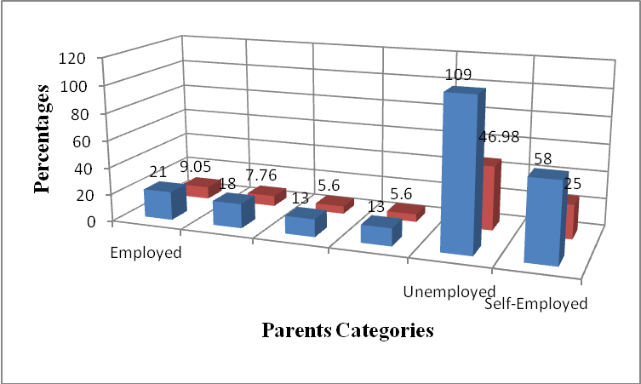
From Figure 2, the study established that 21 parents who formed 9.05% were employed and earning a monthly salary of between Kshs: 1000 and 4,999 while 18 of them who formed 7.76% were earning a monthly salary of between Kshs: 5000 and 9,999 as opposed to 13 of them who were earning between 10,000 and 14,999 and who constituted 5.6% of the total number used for the study. Only 13 parents who also formed 5.6% were earning more than Kshs:15000 per month. The study further established that, those parents who were working and earning a monthly salary fairly supported undergraduate students in meeting virtual learning requirements at the two centers. The study also established that 109 parents who formed 46.98% were unemployed while 58 of them who constituted 25% of the number used for this study were self employed. Students of such parents faced numerous challenges during COVID-19 pandemic as they could not manage to continue with their online studies due to unfavorable learning environments at their homes.When students were asked to indicate how prepared they were in embracing virtual learning while in their homes, the results of the information they gave is as shown in the table 3 below:

Table 3: Students who were using both Smart Mobile Phones and Laptops
SN | Students with Smart Phones | N | % | Students with Laptops | N | % | Those Without any of the two. | N | %
1 | Females | 102 | 43.97 | Females | 48 | 20.69 | Females | 11 | 4.74
2 | Males | 98 | 42.24 | Males | 34 | 14.66 | Males | 21 | 9.05
 | TOTAL | 232 | 86.21 |  | 82 | 35.34 |  | 32 | 13.79
The results of the study in table 3 shows that female students who were 102 and who formed 43.97% were having smart phones for use in online learning as opposed to their male counterparts who were 98 of them and who constituted 42.24% of the total number. A total of 48 female students had laptops and they formed 20.69% as opposed to their male counterparts who formed 14.66% and were 34 in number. The study further showed that 11 female and 21 male students who formed 4.74% and 9.05% respectively neither had a smart phone nor a laptop. This category of students therefore was feeling that virtual learning was an extra burden on their studies. The results shows that female students who were enrolled in the two centers were more equipped in handling online learning when compared with the males during the cessation of movement and lockdown. When respondents were asked to indicate their attitudes towards adoption of virtual learning while in their homes, their responses were as shown in table 4 given below;
Table 4: Respondents Attitudes and Reactions towards Adoption of Virtual Learning;
SN | Attitudinal Statement | N | % | Students’ Reaction | N | %
1 | I don’t know what Virtual Learning Means | 109 | 46.98 | I opposed it for fearing that it was a complicated way of learning. | 89 | 38.36
2 | Virtual Learning is not possible since I am not a computer expert | 34 | 14.66 | I anxiously waited to be told how it was going to work. | 78 | 33.62
3 | Method is not suitable for doing my end of semester exam. | 45 | 19.40 | I felt it was a method only used to teach those working in offices hence less intellectual. | 35 | 15.09
4 | Not suitable to replace face-to-face Teaching in Lecture halls. | 44 | 18.96 | I was negative to it since I felt it was going to lead to increased fees payment. | 30 | 12.93
 | TOTAL | 232 | 100 | TOTAL | 232 | 100
From the responses given in table 4, students who numbered 109 forming 46.98% at first did not know what Virtual Learning was and were therefore not able to understand how they were going to learn without attending normal lectures at their centers. Some of the students who formed 14.66% and who were 34 in number felt this type of learning was not going to be possible while 45 of them who formed 19.40% believed that there was no way they could get lessons virtually and do exams online. The presidential directive which effectively led to the closer of all learning institutions came at a time when most undergraduate students were ending their semesters and do end of semester exams. This category of students therefore felt doing exams from home online was not going to be possible since supervision and invigilation of those exams by lecturers were not going to be possible. Students numbering 44 and who formed 18.96%had a belief that virtual learning was not a suitable method that could replace face-to-face method of learning. It is important to note here therefore that, from the results given in the table, all students in the two centers had negative attitudes towards the coming in of virtual learning which has now become the new normal in all departments in the University of Nairobi.
Figure 3: Students Responses to how they reacted to adoption of Virtual Learning;
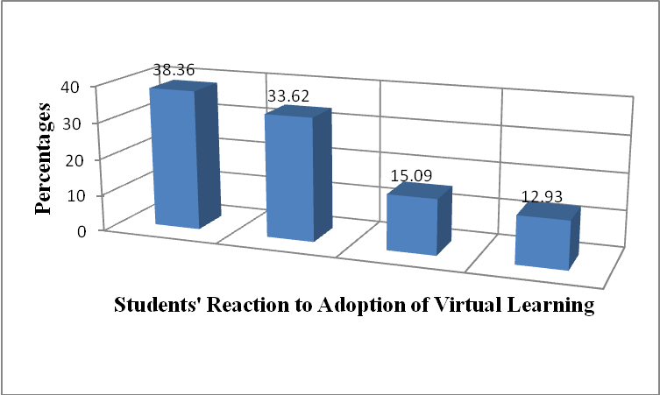
The decision by the university management to have all learning programs continue being offered by the university online caught all undergraduate students at the centers by surprise therefore making them react differently as indicated in figure 3. Participants numbering 89 and who constituted 38.36% opposed online learning for fear of the unknown it was going to come with. They feared it because they felt it was a complicated way of learning which they were not conversant with. Participants of the study who were 78 in total and who therefore formed 33.62% anxiously waited to be told by center coordinators and university management how they were going to learn using this method of learning. This group of students was willing to continue with their studies but they did not know how it was going to be done. It was clear that every student was willing to continue with his or her studies and do end of semester exams as planned early.By the time this survey was being undertaken, it was clear that, COVID-19 pandemic had influenced their learning status and academic progress significantly as can be deduced from their responses presented in the table below;
Table 5: Students’ Responses on Influence of COVID-19 on their Learning Status
SN | COVID-19 & its Influence on my Learning Status | N | % | Suggestions on how to make  It more effective | N | %
1 | Assurance of continuity in learning hence no loss of time. | 105 | 45.26 | Provide us with Sim-Cards and Bundles of a Widespread Network i.e Safaricom. | 78 | 33.62
2 | Has made learning Possible wherever one is. | 58 | 25 | Reduce Fees for us since we are learning from homes using our phones & Laptops. | 88 | 37.93
3 | Has minimized my travels from home to my Center to get face-to-face lessons | 46 | 19.83 | Train all students on effective ways of using online Platforms | 43 | 18.54
4 | Has made Book-Based Online Examination Possible Since I can do my exams while at home. | 23 | 9.91 | Universities to ensure availability of Wifi Network across the country | 23 | 9.91
 | TOTAL | 232 | 100 |  | 232 | 100
The table indicates that majority of the respondents numbering 105 and who formed 45.26% confirmed that COVID-19 pandemic had led to the introduction of online learning which assured them of their continued learning hence no time was wasted as a result of the virus’ effects. Besides, 58 respondents who formed 25% confirmed that they were getting lectures from wherever they were without necessarily going to their centers. This, according to them, had made them cut down costs on travels to the centers to attend to the lessons. This was expressed by 46 respondents who formed 19.83% of the total number of the respondents used for this study. COVID-19 pandemic’s effects led to the introduction of Open Book exams which was never known to be existing before as indicated by 23 students who formed 9.91% . These respondents therefore, despite its many negative effects, expressed happiness that the virus had opened up their eyes thus changing their mode of studying significantly.
The survey also sought to get respondents’ suggestions on what in their opinion was to be done by the university management in order for virtual learning as a method of teaching be more effective and their responses were as presented in the figure given below;
Figure 4: Students Responses on how Virtual Learning can be Improved.
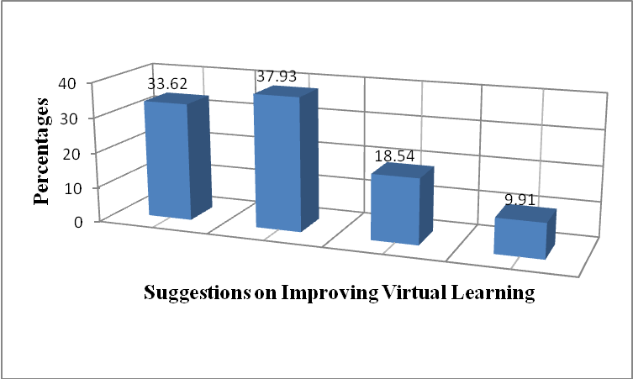
From the responses in Figure 4, respondents numbering 78 of them who formed 33.62% were of the opinion that they be provided with Sim-Cards and Data Bundles of a widespread network most preferably that of Safaricom . While majority of the students embraced virtual learning, they were of the view that the Telecom Sim-Cards loaded with data bundles which they were given by the university were not serving them well as expected since its network was not available in most parts of the country. They therefore suggested that an agreement be reached with Safaricom so that they can use its network. The study also established that, 88 respondents who formed 37.93% were of the opinion that fees be reduced since students were now learning from their home thus not using most university resources at the centers and the university in general. This if done was going to make learning more affordable. Some respondents numbering 43 and who formed 18.54% suggested that all students be trained adequately on how they can effectively use the available university owned platforms to better their learning. Respondents forming 9.91% and who were 23 in total suggested that, the university talks to county and central governments so as to make network available in all regions students were coming from. This was seen to be a major hindrance to the success of virtual learning in the university.
When asked to identify and explain challenges they were facing while using and attending to Virtual Learning lessons and how they possibly could be solved, their responses were as shown in the table given below;

Table 6: Challenges Students faced when attending to Virtual Lessons and their suggested solutions;
SN | Challenge Type | N | % | Suggested Solutions | N | %
1 | Lack of Reliable Network | 89 | 38.37 | Government to ensure Network availability | 87 | 37.5
2 | Lack of Suitable Tools | 38 | 16.38 | University to provide laptops to students | 44 | 18.96
3 | Lack of Technological Skills | 43 | 18.53 | All students to be trained adequately | 58 | 25
4 | Poor Learning Environments | 33 | 14.22 | Government to ensure affordable housing | 05 | 2.16
5 | Unreliable Power supply | 29 | 12.5 | Government to ensure reliable power supply | 38 | 16.38
 | TOTAL | 232 | 100 | TOTAL | 232 | 100

The study as can be observed in table 6 experienced a number of challenges as they were trying to attend to online classes using available online platforms. Majority of the students who participated in this study numbering 89 of them and who formed 38.37% indicated that they face network related challenges. Most of those who gave this as a challenge said that there was not Telecom network in the regions where they were living. This made them miss lessons and also Google meetings organized by their coordinators and administrators. Besides, 38 respondents forming 16.38% indicated that they lacked the essential tools like Android Smart Phones and Laptops which they were advised to ensure they had for use while 43 forming 18.53% cited lack of technical skills as a major challenge they faced. Respondents numbering 33 and who formed 14.22% showed that there was lack of enabling learning environments in their homes at that time while 29 of them constituting 12.5% cited unreliable Power supply as their main problem in their regions. It is important to note here therefore that, in as much as they were willing to embrace online learning in order to continue with learning, taking lessons while at home was a major challenge. However, despite this challenges, they were happy that the university had come up with a method which was a better option that ensured no time was lost in the course of their studies.
The study sought suggestions from respondents as to how the challenges they identified would be countered and given in figure 6 below are the suggestions they gave;
Figure 5: Students Suggestions on how Challenges they face would be solved;
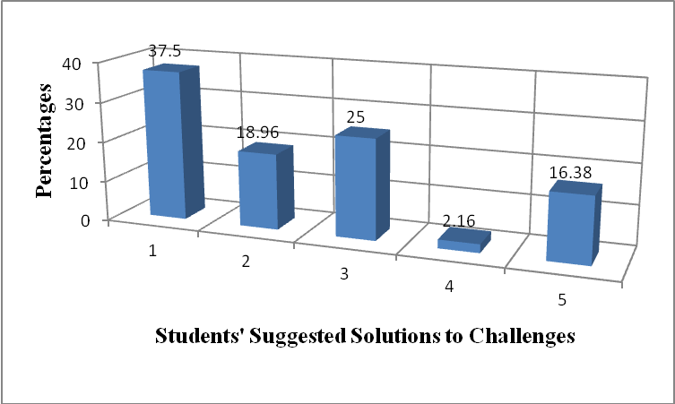
As indicated in figure 6, respondents numbering 87 and who formed 37.5% of the total number used for this study suggested that our central government, through request from universities, to consider having all regions in all the 47 counties covered with reliable network while 58 respondents who constituted 25% suggested that all undergraduate students be adequately trained on how they can access and use available online platforms. This was found to be essential because some students were accessing online lessons using trial and error methods while some would not access the lessons at all. The study established that the issue of having laptops for use was a big challenge most students as pointed out by 44 respondents who formed 18.96% of the total population used for this study. Besides, 38 of them forming 16.38% suggested that the government should consider ensuring availability of power supply across all regions in the country. Power blackouts that interrupted online lessons especially during rainy sessions were cited as one of the major obstacles to a successful usage of online lessons. While this still remains a challenge, 5 students who formed 2.16% cited poor housing in regions where they were living was a challenge and suggested that the government ensures that citizen are provided with affordable houses as enshrined in its big four (4) agendas rolled out in 2018.
Participants of this study were also asked to explain how COVID-19 pandemic had influenced their socioeconomic interactions and their educational development. Besides, they were also asked to indicate measures they had employed in order to cope up with new social behavior and their responses were as presented in the table given below;

Table 7: Responses on Behaviors that were influenced by Corona Virus and coping Strategies;
SN | Type of Behaviour Influenced | N | % | Coping Strategies Employed | N | %
1 | Social Distancing | 56 | 24.14 | Avoidance of Crowded Places | 53 | 22.84
2 | Use of Masks all the time | 57 | 24.57 | Purchasing of recommended Masks | 50 | 21.56
3 | Freedom of Movement | 48 | 20.69 | Adoption of Stay at Home Policy | 42 | 18.10
4 | Freedom of Worship | 33 | 14.22 | Adoption of Online Church Services | 41 | 17.67
5 | Face-to-face Teaching | 38 | 16.38 | Adoption of Virtual Learning | 46 | 19.83
 | TOTAL | 232 | 100 | TOTAL | 232 | 100

According to the results shown in table 7, COVID-19 changed students’ behaviors in many ways. Respondents who formed 24.14% and who were 56 in number indicated that the pandemic effects had brought about social distancing behavior which is a behavior that was never practiced before corona struck the country. The habit of people exchanging greetings by hugging one another and generally interacting very closely had changed and as observed, they were now greeting one another using signs while keeping the 1.5 meters rule given by Ministry of health officials. Besides, 57 respondents who formed 24.57% indicated that the pandemic had brought about wearing of masks all the time as a measure of controlling close infections of the disease while 48 of them who formed 20.69% indicated that it had brought about restricted free movement of people from one place to another.
The results in the table also indicate that 33 respondents who formed 14.22% indicated that the disease had led to closer of worship in churches and mosques numbered while respondents numbering 38 and who constituted 16.38% indicated that the virus brought an end to face-to-face method of teaching in universities. It is important to note that, the fast spreading disease led to closer of many businesses therefore ruining our country’s economy. As observed by responses given by participants of this study, many peoples, including their parents lost their jobs while the stay at home policy resulted in unprecedented family squabbles and breakages.
The study sought responses from participants on how they managed to cope with the strict social conditions that were brought about by the virus and the coping strategies they came up with are as presented in figure 7 below;
Figure 6: Students’ Responses on Coping Strategies they Came up with;
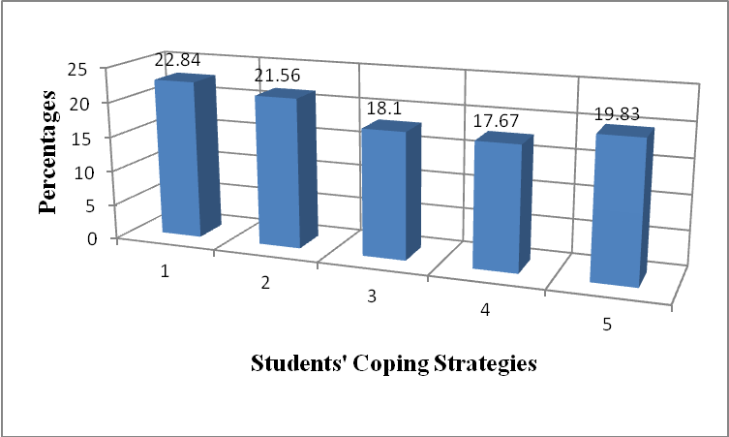
The results in figure 7 show that 53 respondents who formed 22.84% had no option but to avoid crowded places as they were seen as places one could easily contract the disease while 50 respondents who formed 21.56% were to ensure they put on masks as directed by ministry of health officials. These are strategies that were in the past never regarded as important health measures that could help control the spread of a contagious disease by citizens. It is a behavior that was only seen in medical practitioners and especially when performing surgery procedures in hospitals. The study also observed that 18% of the respondents who were 42 in number indicated that they employed the ‘Stay at Home’ strategy as a way of preventing oneself from contracting the virus while 41 forming 17.67% avoided going to places of worship and had to receive church services online. Respondents studying behavior was not spared either as they had to change from taking classes at the centers physically to taking them online. The and many other strategies made lives of respondents and the lives of many Kenyans across the country change significantly.
Conclusion
From the study findings, the study observed that many undergraduate students got to know about the existence of the disease in January 2020 when World Health Organization pronounced it as a global pandemic. Of 232 respondents, 98 of them forming 42.2% had received information on the existence and devastation of the virus in the month of January this year while a half of them constituting 57.8% of the total number used for this study learned of the same through social media, which was an indication that all respondents who participated in this study very much aware of the effects of the disease.

On students’ Learning status and academic progress during Corona period, respondents were asked several questions that were aimed at establishing methods of learning which were adopted to ensure continuity of their education, content in the syllabus which had been covered, time spent for studying and whether they had separate study rooms at their homes. From the responses given, the study established that 88 students who formed 37.9% continued with their studies by reading textbooks and digital materials while 71 of them (30.6%) relied on the notes they had been given by their lecturers. Respondents who were 27 (11.6%) in number reported that over 50% of the content contained in the syllabus had been covered by lecturers at the time COVID-19 had been covered while some of them forming 66.8% confirmed that they on several occasions missed online lessons due to lack of knowledge on how they were to access them, due to poor network coverage in places where they were staying, lack of network bundles, power blackouts and also due to lack of required tools like Laptops and smart phones. Respondents forming 54.3% in their response to the same indicated that they spent most of their time doing other household tasks at their homes rather than studying as opposed to the number of hours they were devoting for studying before Corona Virus disrupted their studies. Out of 232 students, 103 (44.4%) had no separate study rooms.
Concerning information obtained on Online Classes, the study established that, out of 185 students who attended virtual learning, a very small number (26) constituting only14.1% of them attended to their online classes daily, while 54% of them attended to such classes less than three times a week. Majority of the students who formed (85.8%) used their smart phones to attend to virtual learning while 14.2% of the students used their laptops or desktop computers. Although 85.8% of students used their android mobile phones for e-learning, 5.3% of them borrowed those gadgets from family members while 0.9% of the students took their online lesson using phones they borrowed from their family members and neighbors.
Use of digital platforms to ensure learning continued in the University of Nairobi by lecturers as opposed to no learning in other universities during this time, ensured continuity in teaching and learning to all undergraduate students in those critical situations. The study noted that 13.4% of the respondents indicated that their center lecturers contacted them through their mobile phones and WhatSapp groups and asked them to enroll for digital learning classes. It is therefore important to note, as reported by respondents of the study, students forming 73.7% indicated that they never participated in the online learning at all prior to the outbreak.
On Platforms undergraduate students used for virtual classes, sharing of reference materials and how they were evaluated, the study established that, most of them used Zoom App, Google Meet/Hangouts, Google Classroom, WhatSapp, You Tube live, some used Skype, The study showed that majority of the respondents who formed 34.2% used the Zoom app to attend to their online lessons, followed by Google classroom which registered a student representation of 33.4% and YouTube live which registered a student representation of 14.7%). The study revealed that some students studied by sharing reference materials rather than attending online lessons simply because they did not have a reliable internet connectivity in their homes.
In regard to the impact of COVD-19 on their socioeconomic spheres of lives, data provided by respondents was analyzed and the results indicated that, out of 232, 181 students who constituted 78.02% indicated in their responses that their economic statuses were greatly affected negatively by the pandemic while the rest reported that they experienced low family incomes during that time and by extension COVID-19 generally had a negative impact on their education. Besides, 176 (75.9%) of the students thought that COVID-19 pandemic was going to make them drop out of university education. Concerning study related problems during cession of movement and lock downs, the study observed that most students went through stress, were greatly depressed while others forming 42.0% of the participant population experienced anxiety. Some students who constituted 32.4% faced problems which were associated with unreliable and poor network connectivity, followed by the absence of a favorable environment while studying from their home, an expression given by students who constituted 12.6% of the participants of this survey.

Study Recommendations
As observed in the findings of this survey, COVID-19 pandemic has impacted on the education sector negatively. When the study carried out an assessment on students’ academic progress at that time, it was realized that, although a substantial proportion of them were using digital platforms to learn, many of them were facing huge challenges related to the effective use of the available online methods of learning. The study therefore came up with recommendations which, if they are implemented by the government, policymakers, and institutional authorities can go a long way to enable institutions of higher learning continue with their learning programs in future uninterrupted in case a similar outbreak is experienced. The study recommends that universities management come up with a uniform academic plan that will be applied strictly to all students learning in those institutions and ensure they put in place a proper Education Continuity Plan (ECP) which will ensure a continuous learning process during an outbreak of any pandemic.
Secondly, the study recommends that universities should ensure they have in place infrastructural facilities that conforms to the Ministry of Health’s set health standards. The government should provide funds which will be used to improve university education system and to provide capacity training sessions to stakeholders of all higher education institutions. Intervention measures should be initiated through a targeted approach which would bring about creation of suitable and affordable housing facilities to be used for studying among students hailing from vulnerable regions of the country and which meets all sanitation standards set by the Ministry of Health as a mitigation measure that will ensure the safety and health security of all learners during an outbreak of similar characteristics as COVID-19 pandemic..

Acknowledgement.
The study recognizes significantly contributions made by my colleagues in the university working at the regional centers whose suggestions, participation and coordination skills led to the successful completion of this study.

References:
[1] Walsh E, (20 July 2009). "Closing schools won't stop pandemics: study". Reuters. Retrieved 17 March 2020.
[2] MoHFW (2020) “Closer of Public and Private Institutions as a Measure to Containing COVID-19”, Government Printer, 23rd March 2020.
[3] Cecco L (2020-03-16). "'Stay home': Justin Trudeau closes Canada's borders over coronavirus". The Guardian. ISSN 0261-3077. Retrieved 2020-03-16.
[4] Davis BM, Markel H, Navarro A, Wells E, Monto AS, and Aiello AE (2015). "The effect of reactive school closure on community influenza-like illness counts in the state of Michigan during the 2009 H1N1 pandemic". Clinical Infectious Diseases. 60 (12): (p. 90-7). doi:10.1093/cid/civ182. PMID 25896795.
[5] Giuffrida A, Tondo L, and Beaumont P (2020). "Italy orders closure of all schools and universities due to coronavirus". The Guardian. ISSN 0261-3077. Retrieved 2020-03-15.
[6] Abidah A., Hidaayatullaah H.N., Simamora R.M., Fehabutar D., Mutakinati L (2020). The Impact of Covid-19 to Indonesian Education and its Relation to the Philosophy of “MerdekaBelajar” SiPoSE: Studies in Philosophy of Science and Education. (P.38–49).
[7] Ebijuwa, A.A. (2005). Information and Communication Technology in university; Computer Networks as Social Networks and Annual Review of Sociology, (p. 213–238).
[8] Davies, H. and Tearle, D. (1999). Internet Insights: How Academics are using the Internet. Computers in Libraries 15 (2), (p.32-36).
[9] Gonzalez D, et, al (2020). Internet Development and Connectivity in Nigeria Schools. Program: Electronic Library and Information Systems, 39 (3), (p.257-268).
[10] Carlson, B and Firpo, M. (2001). Can the Internet in tertiary education in Africa contribute to social and economic development? International Journal of Education and Development using Information and Communication Technology, (IJEDICT), (p. 122-131).
[11] Muloye K, (2008). Tech Savvy Students Stuck in Text-dominated Schools: A Summary of available research on Student Attitudes, Perceptions and Behaviour. Education Evolving (p.68)
[12] Joppe, C. (2000). A Qualitative Study of Teachers’ Opinions on the use of the Internet in P[lanning and Instruction. Using the Internet in Education-Strengths and Weaknesses.
[13] Gribalosik A, and Midaslimack, H (2010). Emerging Respiratory Infections in the 21st Century, An Issue of Infectious Disease Clinics. 24. Elsevier Health Sciences. (p.614).
Phelan and Wren (2006). Assessment of access and use of school library information resources by secondary schools students in Morogoro Municipality, Tanzania. Library Philosophy and Practice.Retrieved April 2, 2015.

Author;
The author is a long serving Lecturer and an Experienced Researcher in the field of Education currently working in the Department of Open Learning Programs, School of Open and Distance Education at College of Education and External Studies - Kikuyu Campus of the University of Nairobi-Kenya.


