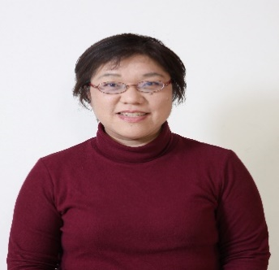 

**Title: Nurses’ Intention to Leave Work and their Family Variables**

Yoshiko Yamaguchi1), Takahiro Inoue1), Hiroko Harada2), Miyako Oike3)

1) Kwassui Women’s University, Faculty of Nursing, Japan

2) Ube Frontier University, Faculty of Nursing, Japan

3) International University of Health and Welfare, School of Nursing at Fukuoka, Japan

**Abstract: (up to 250 Words)**

Shortage of nurses is a serious problem in many countries. Previous research reported that nurses' intention to leave work was related to family variables, such as parenting or work-family interface (e.g., work-family conflict and work-family enrichment). We conducted an empirical research to identify the relationship between nurses’ intention to leave work and their family variables. The following results were derived: (1) parenting was not directly related to nurses’ intention to leave work, (2) nurses in hospitals and nursing homes showed that work-family conflict was directly and positively associated with their intention to leave work, however, there was no significant relation among home healthcare nurses, (3) most nurses perceived that fulfilling a family role has a positive effect on nursing (76.9% hospital nurses and 85.2% home healthcare nurses), (4) hospital nurses’ intention to leave nursing was negatively related to their perception of fulfilling a family role and had a positive effect on nursing. In addition, nursing research was indirectly and negatively associated to nurses’ intention to leave work owing to the perception that fulfilling a family role has a positive effect on nursing, and (5) the intention of hospital nurses’ in their twenties to leave nursing was negatively related to work-family culture, however, there was no significant relation in other age groups. Thus, we concluded that nurses’ family variables had complex effects on their intention to leave work.

**Biography (up to 100 words):**

Yoshiko Yamaguchi has received her Ph. D in Kyushu University, Japan. Currently, she is working as research associate in Home Care Nursing, Faculty of Nursing, Kwassui Women’s University, Japan. She has successfully completed her responsibilities as reviewer for 10 papers from year of 2016 to 2017. She is serving as an editor of International Journal of Nursing & Clinical Practices and Journal of Comprehensive Nursing Research and Care. And she is honorary president of the scholarly association IAPHLSR: International Association for Promotion of Healthcare and Life-Science Research.

**Presenting author details**Yoshiko Yamaguchi  
+81-957-27-3005

Nursing & Healthcare Management  
Oral presentation  
Twitter account:  
Linked In account:

Email: **y-yoshiko@kwassui.ac.jp**