Title: Combining Chalk-Talk with Cognitive Style Power Point-Based Lectures to Increase In-class Student Engagement in Health Profession Education
Fariha Kauser¹, Anshoo Agarwal ², Madiha Younas³
1. Ex -Health Professional Education Student, Dundee University, Scotland
2. Professor, Pathology Department, Faculty of Medicine, Northern Border University, Arar, Saudi Arabia
3. Lecturer, Riphah International University, Islamabad ,Pakistan

Background
It's clear that students benefit from activities that focus their study time and help them draw connections between textual information and lecture content. PowerPoint handouts are well suited for student guidance of this sort.
Many faculty members, however, are reluctant to distribute handouts of PowerPoint presentations prior to class for fear that students will see them as substitutes for lecture and fail to attend the actual session. Others balk at the idea of distributing handouts as students enter the lecture hall, worrying that students won't pay attention during class or that they will fail to develop good note taking skills. Providing verbatim copies of lecture presentations, the standard practice, may well encourage students to fall into these traps, suggesting that everything one needs to know is included in the handout.
When used appropriately, interactive PowerPoint handouts can improve student learning by structuring study time, encouraging critical thinking, preparing students for lecture, and providing opportunities for active learning during the course of the session. By PowerPoint presentations interventions the faculty can help students engage the material actively and efficiently before and during class. By using the handout as a vehicle to ask questions or assign exercises, faculty can promote active participation.

Aim & Objectives:

Incorporating interactive Power point-based lectures as an active learning in Health Profession Education
Material & Methods:
Student perceptions about incorporating interactive Power point-based lectures as an active learning in Health Profession Education was examined by using questions with a 5-point Likert scale. The power point presentations with incomplete details were given to students prior to the day's lecture. Students were asked to work through the power point handouts as they read the textbook in preparation for the lecture, answering all questions and bringing their completed handouts to class. Questions based on the power point presentations were asked from the students in between the lectures.
Example is shown below: a) the topic ‘Cirrhosis’ b) a scenario with learning objectives c) power point handouts showing only outlines d). Power point handouts to be used in the lecture next day.
Interactive Power point handouts with only outlines were sent prior to the day lecture is scheduled.

Case scenario:
A 57-year-old man presented to the emergency room with a history of increasing abdominal girth, and vomiting blood. Family members related that he had consumed alcohol for many years, drinking up to 1 liter of liquor per day. On the day of admission, he vomited some blood, followed by increased confusion. His past medical history was notable for unknown prior abdominal surgical procedures, for which he received blood products. The physical examination showed that he had a protuberant abdomen. And he was jaundiced. Small spider-like tangles of blood vessels were present over the skin of his neck and chest. Palpable breast tissue was present. The cardiac examination was unremarkable. His abdomen was protuberant with shifting dullness, and his spleen was palpable. His liver percussed to a span of 10 cm. A few large blood vessels were noted in the periumbilical area. There was bilateral pedal edema. Neurologically, the patient was oriented only to name. On voluntary dorsiflexion of his hands, a flapping motion was noted.
Learning objectives
- Definition of cirrhosis
- Causes /classification
- Morphological changes
- Clinical presentations
- Complications

Sample of handout for the students sent prior to the lecture:
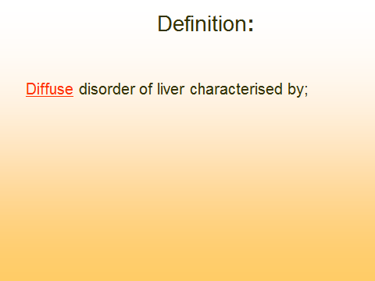
Sample of In-Class PowerPoint Presentation
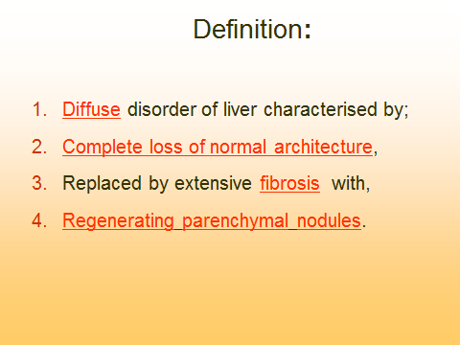

Results:
30% of the students disagreed regarding the handouts sent to them prior to the lecture were useful for identifying key concepts and learning outcomes and to them the handouts have not contributed in their learning much.42% of the students were not satisfied with this type teaching as they felt that mostly they had no time to read the topic from the books and then try to understand the lecture handouts. Instead they felt that handouts may have been more useful if it was possible to send at least one week before the scheduled lecture. Majority of them were motivated to read the book but again because of time constrain they could not complete their reading.65% felt that it had been useful than other teaching methodology like problem based learning as they had some clue as what to study regarding the topic.34% felt that they would like to recommend this type of teaching methodology to other faculty members to make it an adjunct teaching tool, they feel more comfortable with traditional lecture based teaching. 74% agreed that they had an opportunity to discuss and recall essential concepts and think critically while going through the Lecture PowerPoint’s. 79% of the students mentioned that it helped them to integrate information and establish their understanding of various pieces of data. 81% felt that the Lecture PowerPoint’s hand outs offered opportunities for learning by themselves by looking for missing information from the books. To 69% the exercise provided an atmosphere of challenge, and performing .57% felt that the looking for missing information in the lecture Power points handouts from the text books was fun.
Conclusions:
When used appropriately, PowerPoint handouts can improve student learning by structuring study time, encouraging critical thinking, and providing opportunities for active learning during the course of the session. By PowerPoint presentations interventions the faculty can help students engage the material actively and efficiently before and during class.

Key words: Cognitive Style, Interatcive , Power Point-Based Lectures , Increase In-class Student Engagement, Health Profession Education, Active learning sessions

References:
- Cornelius T. L., Owen-DeSchryver J. (2008). Differential effects of full and partial notes on learning outcomes and attendance. Teaching of Psychology, 35, 6–12.
- Stark-Wroblewski K. S., Kreiner D. S., Clause C. B., Edelbaum J., Ziser S. B. (2006). Does the generation effect apply to PowerPoint handouts. Psychology and Education: An Interdisciplinary Journal, 43, 28–38.
- Stark-Wroblewski, K. S., Kreiner, D. S., Clause, C. B., Edelbaum, J., & Ziser, S. B. (2006). Does the generation effect apply to PowerPoint handouts? Psychology and Education: An Interdisciplinary Journal, 43, 28– 38.
- Tufte, E. R. (2003). The cognitive style of PowerPoint R (2nd ed.). Cheshire, CT: Graphics Press.
- Tufte, E. R. (2006). The cognitive style of PowerPoint: Pitching out corrupts within. Cheshire, CT: Graphics Press LLC.
- Gier, V. S., & Kreiner, D. S. (2009). Incorporating active learning with PowerPoint-based lectures using content-based questions. Teaching of Psychology, 36(2), 134–139. https://doi.org/10.1080/00986280902739792
- Brock, S., & Joglekar, Y. (2011). Empowering PowerPoint: Slides and teaching effectiveness. Interdisciplinary Journal of Information, Knowledge and Management, 6, 85-94.
- Cavanagh, M. (2011). Students’ experiences of active engagement through cooperative learning activities. Active Learning in Higher Education, 12(1), 22-33. doi: 10.1177/1469787410387724
- 13. Craig, R. J., & Amernic, J. H. (2006). PowerPoint presentation technology and the dynamics of teaching. Innovative Higher Education, 31(3), 147- 160. doi: 10.1007/s10755-006-9017-5
- 14. Dunn, D. S. (Ed.). (2011). Best practices for technology-enhanced teaching and learning: Connecting to psychology and the social sciences. New York: Oxford University Press.
- 15. Holstead, Jenell. (2015) The Impact of Slide-Construction in PowerPoint: Student Performance and Preferences in an Upper-Level Human Development Course. Scholarship of Teaching and Learning in Psychology, 1(4).
- 16. Inoue-Smith, Yukiko. (2016). College Based Case Studies in Using PPT Effectively. Cogent Education,3. doi:10.1080/2331186X.2015.1127745
- 17. Mehta, Maulin, Sandeep Adwal and Ashutosh Chourishi. (2017) Evaluation of different teaching-learning methods according to students’ preference and perception. International Journal of Basic & Clinical Pharmacology. 6.1
- 18, Fratto, Victoria A. (2011) Enhance student learning with PowerPoint games: using twenty questions to promote active learning in managerial accounting. International Journal of Information and Communication Technology Education. 7(2).
- 19. Swati, Betharia. (2016). Combining Chalk Talk with PowerPoint to Increase In-class Student Engagement. INNOVATIONS in Pharmacy, 7(4)

