

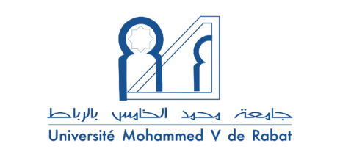

**A Pragmatic Study on the Realization of Apology Strategies Performed by Moroccan EFL University Learners and British Native Speakers**

*Fatima Zahrae KHABAR*

Fatima Zahrae KHABAR is a PhD candidate at ENS, Mohammed V University in Rabat. She holds MA in `Applied Linguistics and ELT from Ibn Zohr University, and BA in TESOL from ENS. In addition to that, she holds some international teaching certificates from Cambridge like the CELTA, TKT, TESOL, and Adv. TESOL certificate for teacher trainers and assessors. As for her professional experience, she has been training teachers abroad in many countries in Asia including Malaysia, Indonesia, and South Korea. She is also the coordinator of EdYOUfest UK in Morocco. Currently, she is working in the training department of a multinational company in Casablanca as a full time Business English Trainer.

**Abstract**

The speech act of apology has received significant attention in interlanguage pragmatics. The present study investigates the realization of apologies by Moroccan EFL undergraduate students from two educational levels: semester one (S1) and semester five (S5). Their production is compared and contrasted against the apologies elicited from British English native speakers. To this end, 40 Moroccan EFL S1 students, 40 Moroccan EFL S5 students, and 40 English native speakers filled a written discourse completion task consisting of eight hypothetical scenarios.  Adopting the mixed-method approach, data was analyzed quantitatively and qualitatively using Blum-Kulka and Olshtain's (1984) taxonomy. The findings revealed some cross-cultural differences between the British and the Moroccan EFL respondents. In addition, the qualitative and statistical analysis showed that S5 students displayed less significant differences with English native speakers compared to S1 students in their use of apology strategies. Nevertheless, the findings indicated that the educational level had a minor influence on the overall EFL learners’ performance. Accordingly, this study suggests that there is a need to increase EFL learners’ pragmatic competence and awareness.

***Key words:*** interlanguage pragmatics, cross-cultural pragmatics, pragmatic competence, pragmatic awareness, socio-pragmatic norms.