A Study on the Blended Teaching of Foreign Language in China from the Perspective of Ecology —— A Visualized Analysis Based on CiteSpace
Song Linlin, Xue Jin
(University of Science and Technology Beijing, Beijing, 100000;
songlinlin999@dingtalk.com; beijingxuejin@aliyun.com)

Abstract
It has been 15 years since the theories in ecology had been introduced to foreign language education in China. Researches from the ecological perspective on blended teaching of foreign language are also thriving as the educational technologies are ever enhanced. In this study, the related CNKI literatures from 2010-2020 were collected, and CiteSpace was employed to carry out the review for the exploration of the research hotspots, trends and limitations in this area. The results show that, 1. in China, the main methods to realize the blended teaching are flipped classroom and MOOC; 2. a majority of the macroscopic researches are conducted to build an ecological mode for college English and higher vocational English while the microscopic researches are for teachers’ and students’ ecological niches; 3. with the advent of “Internet Plus” age, researches in China will march on to the“smart”ecology of blended foreign language education.; 4. though the studies involved in diverse directions, there are limitations in this field due to a late start. In the future, researchers with a better understanding of the theories in both ecology and foreign language education should try not only theoretical studies but also empirical studies that cover all forms of foreign language education in China, so as to promote the generalizability.

Key Words: the perspective of ecology; foreign language education; blended teaching; visualized analysis

- Introduction
As the human society has entered the information age, great changes occur in the production mode, lifestyle and learning style. The development of education in China has been characterized by universal education, quality education, individualized education and lifelong education. Technology brings both positive and negative influence to education, foreign language education can never be excluded. The artificial intelligence, digital technology and information technology all shed their light on the traditional foreign language teaching paradigm in China, and now these technologies are leaping from mere assistance to a leading position(Chen, 2005, 2009). Taking use of the technology, blended teaching makes it possible for the combination of online and offline activities and as a result enhances the interaction and extra-curricular engagement (Garrison & Vaughan, 2008), which is called “new normal” (Chen & Wang, 2016; Dziuban et al., 2018) in foreign language education in China. From Web 1.0 to Web 3.0, technologies employed in the blended foreign language teaching are getting more and more diverse. The integration of MOOC, micro-course, flipped class and smart class meets the multi-dimensional needs in the teaching process(Hu & Wang, 2019). Nevertheless, this trend also proposes new expectations and problems for us: learners’ self-regulation, teachers’ and learners’ ability in handling technologies, and the teaching technology administration and support from the educational institution are all challenges for blended foreign language teaching(Rasheed, Kamsin, & Abdullah, 2019).

In China, the ecological research on foreign language education can be traced back to 2005. Gu (2005) described the revolutionary influence brought about by the computer technology and the network from a macro perspective, and tried to build up an ecological model based on foreign language education. Following this move, most of the ecological studies on foreign language education concentrate on the college English, ecolinguistics, the integration of information technology and foreign language courses, and the niche study of teachers and students. From an ecological perspective, most of these studies set college English as ground, focusing on the course design, teaching technology and the niches of teachers and students and striving for an individualized teaching style and an autonomous learning style (Chen, 2005).While it can be observed that the combination of ecological theories and foreign languages studies tends to be mechanical with the directions alike; the instructive function from this area is half presented (Ren, 2015); most of the people set the information technology at the assistant position rather than at the leading position in foreign language education; and research questions tend to be scattered since 2014. (Wang & Bao, 2020)

As an independent ecological system with its distinct energy flow, information flow and material flow, foreign language education in China achieves its dynamic balance through the interaction of various ecological factors.Blended foreign language teaching, a micro ecological system of the former, is confronting the continuous intrusion of new ecological factors of educational technology, and therefore the traditional ecological balance is broken. How to integrate traditional factors and new factors to establish a new ecology of blended foreign language teaching in China is of great significance.

Based on the above requirements, this study intends to discuss the status-quo, hotspots and future trend of blended foreign language teaching in China from the ecological perspective in the past decade. This paper collects the literatures related to blended foreign language teaching from the ecological perspective in CNKI in the past decade, and uses the visual analysis software CiteSpace to conduct a multi-dimensional and in-depth analysis thus to provide guidance for the further development of foreign language education in China.

II. Research design
1. Research problems
This study tries to answer the following four questions: (1) What is the current situation of research on the blended foreign language teaching in China from the perspective of ecology? (2) What are the research priorities in this field? (3) What is the future trend of research in this field? (4) What are the research limitations in this field?

- Inclusion Criteria
This study used CNKI to search for the terms “ecology”, “blended teaching”/ “blended learning” / “MOOC” / “SPOC” / “flipped class” and “English” / “foreign language”. All journals in CNKI published between 2010 to 2020 were counted in. A total of 158 literatures were collected. After a manual reading, conference papers, foreign journals and irrelevant articles were screened out, and finally 154 effective papers were located.

- Research tools and operation methods
In this study, CiteSpace (version 5.7.R3), a visual analysis software designed by Professor Chen Chaomei from Drexel University,USA, was used as the data analysis tool. By collecting and analyzing literature information in related fields, visual knowledge maps can be obtained, so that researchers can effectively and accurately grasp the knowledge structure, hot topics and topography of the research field to explore and analyze the cutting-edge knowledge and research trends in this field (Chen, 2016).

The 154 eligible papers were imported into CiteSpace after format transformation, the time slicing was from 2010 to 2020 with the years per slice as 1 year; the term source included “Title”, “Abstract”, “Author Keywords(DE)” and “Keywords Plus(ID)”; the node type was set as “Author”, “Institution” and “Keyword”; selection criteria was set as top 50 most cited literature in each year. The author relationship map, institution relationship map, and keyword co-occurrence map were generated, analyzed and interpreted respectively. While adopting the CiteSpace to conduct visual analysis, all the 154 literatures were read so as to run both quantitative and qualitative research to have a more comprehensive understanding of the core topics discussed in this field and the problems existing in the research.

III. Analysis and discussion of research results
1. A General Description
According to the literature search results of CNKI (Figure 1), in the past 10 years (2010-2020), the research on the blended foreign language teaching from the ecological perspective in China generally presents an upward trend. Before 2013, there was no systematic and integrated research. Based on the integration of previous studies, relevant research literatures appeared for the first time in 2014, and the total number of published papers was only 4. From 2015 to 2018, there was a steady increase in relevant research, with an average of about 20 papers published each year; In 2019, it showed a sharp upward trend and reached the peak of research in this field (41 papers). The number of literatures fell in 2020, but still increased slightly compared with 2018.

Therefore, blended foreign language teaching from the ecological perspective is an emerging research field in China, with a history of less than ten years and limited numbers of literatures. In the context of the deep integration of foreign language education and information technology in China (Chen & Wang, 2016), the interdisciplinary topic of ecological perspective has gradually gained attention and has become a hot topic in the past two years, and will maintain the momentum of sustainable development.
Figure 1. The number of articles published in the past decade

Literature statistics show that the literature carriers of relevant research in China are diversified. In addition to language journals, educational journals and comprehensive academic journals are also important positions for the distribution of such literature. However, only 7 papers were published in the core journals (including the extended edition) in China, accounting for 4.5% of the total number. In descending order of citation frequency, the top 5 academic journals are Technology Enhanced Foreign Language Teaching, Foreign Language Research, Journal of Heilongjiang College of Education, Foreign Language Teaching and Overseas English. 16 researchers published more than 2 papers (Table 1), and the fund support rate was more than 90%.
We can see that although the application of ecological theory to foreign language education research has obtained some attention (Wang & Bao, 2020), and funds are plentiful, but ecological perspective of blended foreign language teaching is still an emerging field in China, leaving huge space for both research depth and breadth; most of the researches are independent and scholars and research institutions have not formed a core group for cooperation. Currently, research teams that are doing persistent research include Prof. Qin team from Dalian University of Foreign Languages, Prof. Ye team from The Second Military Medical University and Prof. Ma from Heilongjiang Institute of Technology. What is worth mentioning is that, since 2004, Prof. Chen team from Shanghai International Studies University, has devoted to the research of foreign language teaching informatization from the aspects of the theory, practice and development. In recent years, the research team gradually introduced ecological theory into the study of foreign language teaching informatization, including niche study of teachers and students, the ecological construction of college English course system and so on. Their efforts offer more possibility in enriching the methods for foreign language education, besides, they build up a solid theoretical foundation for blended foreign language teaching research from the ecological perspective.
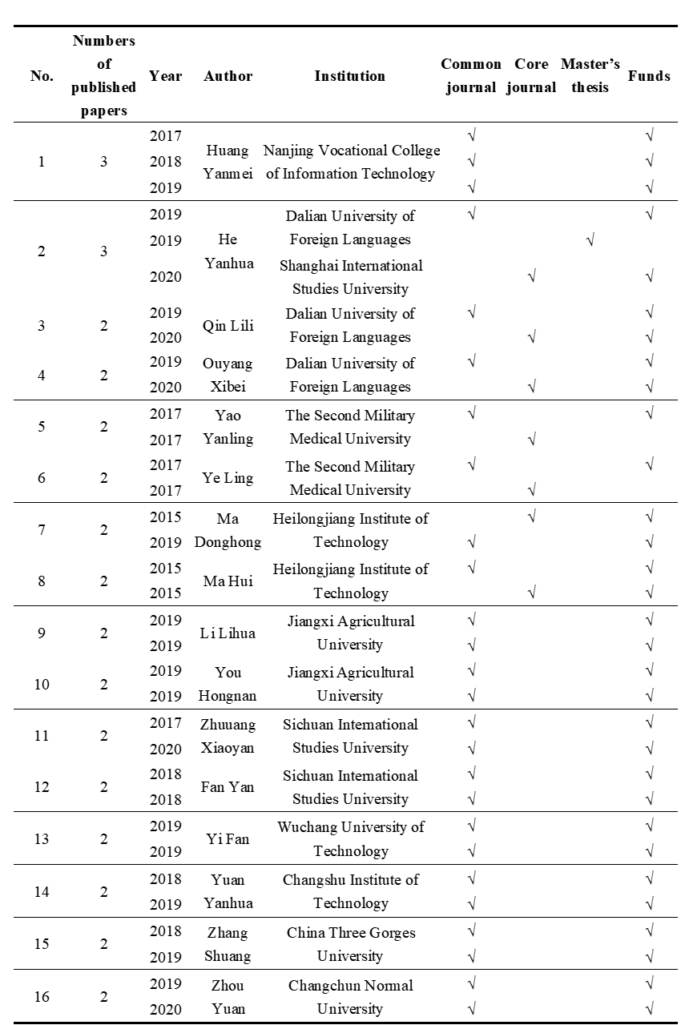
Table 1. Scholars with more than 2 papers published and the related information

- Analysis of research hotspots
Key words are the core summary of one research. When two or more keywords appear in the same literature, it is called keyword co-occurrence. The number of co-occurrences is proportional to the degree of their relationship. Through keyword co-occurrence analysis in CiteSpace, the hotspots, distribution and discipline structure of a research field will be revealed (Chen, 2016). Cluster will be formed by summarizing closely-related keywords, and each cluster can be considered as a relatively independent research field, or as the research frontier of this discipline. This study draws and interprets the related keywords map of blended foreign language teaching from the ecological perspective, and vividly identifies the hot spots and development trends in this field.

The Node Type was set as “Key Words” to generate co-occurrence keyword map using the minimum spanning tree (MST) algorithm. After an integration of nodes with the same concept but different expressions (such as “blended teaching” and “blended teaching mode”, “MOOC” and “MOOCs”, etc.), the total node number is 264 and 345 lines between all the keywords. In the keyword co-occurrence map in Figure. 2, each node represents a keyword. The larger the node, the greater the keyword frequency. The line represents the co-occurrence of keywords in the literature. The thicker the line is, the higher the co-occurrence frequency is. The line color represents the co-occurrence time (year) of keywords. Another essential indicator of keyword co-occurrence is centrality (Freeman, 1979). Nodes that can act as a bridge between two or more nodes have high betweeness and occupy a pivotal position in the research of this field. Nodes with centrality greater than 0.1 are called critical nodes, circled by purple rings. In this study, 21 clusters were identified by clustering algorithm. The clustering results were significantly effective (Q=0.32, S=0.92). The top ten were MOOC, flipped classroom, ecologicalization, ecolinguistics, vocational English, teaching, flight staff, smart education, ecology of education and classroom ecology.

Incorporating high frequency keywords, high centrality words and clustering, we find the research hotspots in this field are as follows:

2. 1. Ecological construction of blended foreign language teaching model
Blended foreign language teaching combines traditional face-to-face courses with online activities and tasks. The online part is realized by various video and audio resources, learning platforms and social software. New technologies can meet students’ requirements for teaching places, teaching methods and communication methods (Kitchenham, 2011). Therefore, contemporary students are increasingly inclined to online communication methods and blended learning environments (Allen, 2011). As a result, the topic of building a new ecology of foreign language teaching arises at the moment. Flipped class, MOOC and micro-course are widely used in China and are the focus of researchers. This kind of nodes appeared early, with steady numbers of papers published each year, involving a wide range of fields, including the ecological construction of English classroom in college English, vocational English, English majors, ESP and the primary and secondary schools. Zheng (2016) regards English flipped class teaching as a micro education ecosystem. It achieves a dynamic balance through the interaction between different ecological subjects and between ecological subjects and the surrounding environment, thus achieving a benign and orderly development. This construction process includes the optimization of classroom layout, the creation of authentic scenes, the trust and cooperation between teachers and students, the emphasis on teaching interaction and the continuous updating and construction of teaching database. In this way, a student-centered and harmonious classroom can be established. Zhang and Guan (2016) believe that educational ecology theories such as the law of the minimum limiting factor, the law of tolerance, and the principle of optimum are vital to the understanding of the college English reformation. To solve the conflict between traditional face-to-face teaching method and autonomous learning trend, and to reconstruct the ecological balance in college English teaching in the new period, the traditional autonomous learning center should be upgraded to a flipped class mode, and its niche should be repositioned under the guidance of an overall, systematic and dynamic educational ecology theory.

With the advent of the “Internet Plus” era, the realization means of blended teaching are more diversified. Ye et al. (2020) perceive that “Internet plus education” makes autonomous learning possible, information is no longer one-way flow, and a variety of mobile terminals break the space and time limitation of foreign language teaching, renewing the traditional teacher-student relationship and expanding the scope of foreign language classroom ecology. Taking the flipped classroom of college English translation course as an example, she established a teaching ecology of “absorption” before class, “internalization” during class and “intensification” after class, and applied smart teaching devices to make the communication between teachers, students and teaching resources more direct, simultaneous and multi-channel. Zhong (2018) proposed that the cultivation of smart talents with correct values and creativity requires a smart education, a smart classroom, and ultimately an open life-long education system with a reformed education ecosystem. Through the establishment of a smart classroom teaching mode of English listening and speaking, and the integration of the face-to-face class and the virtual class, the effective teaching of students’ learning, listening and writing has been realized, and the harmonious state of extracurricular man-machine communication and interpersonal communication in class has been obtained.

2. 2 Teacher and student niche research
In the 1930s, the theory of educational ecology came into being in the west, which was the result of the mutual penetration of pedagogy and ecology. Since 2005, foreign language scholars in China have gradually jointed foreign language education with ecology to study the harmonious and sustainable development of foreign language education. No matter what kind of teaching environment and hardware facilities are available, the harmonious development of foreign language teaching is always inseparable from the interaction between teachers and students. As ecological factors, they have their unique ecological niche in the system and are in a key position. Teachers and students, together with educational administration personnel, information technology and teaching resources, constitute the dominant biological chain of the teaching ecosystem (Zhu, 1997). The research involves not only the ecostate of the ecological niche, but also its ecorole, its realistic influence on the environment. The increase of the ecostate and ecorole is called the expansion of ecological niche, which is the instinctive attribute of the development of ecological subjects (Li & Chen, 2017). Due to the advancement of technology and the continuous evolution of the teaching ecological environment, it appeals to many scholars whether the ecological niche of teachers and students has changed, whether it is constantly expanding, and whether it develops in a coordinated and balanced way with the ever-changing teaching ecology. Ma and Ma (2015) note that far-reaching effects have been brought about to college English ecological system since the emergence of MOOC, which urges teachers to protect and expand their niche to adapt to the changing environment; except for the cultivation of their intellectual ability and information attainment, teachers need to strengthen their collaborative innovation ability and emotional ability, build up a learning community taking in both teachers and students, and gradually establish a sustainable development of ecological system of foreign language teaching and learning. Hu (2019) discusses the refactoring of blended teaching pattern of the follow-up college English course, which is of both the instrumental and humane features. Hu reorients the niche for teachers and students in the light of the sustainable development perspective, systematic perspective and holism in ecological education. Teachers turn into the organizer of teaching activities, while the students into active participants. Harmonious communication and continuous support between them are emphasized, each factor in the system can develop healthily and sustainably, thus the teaching effect will be improved. Hu and Wang (2019) also call for the establishment of a “Faculty Learning Community” under the background of blended teaching to promote the expansion of teachers’ ecological niche and achieve the harmonious development of the relationship among people, education and environment.

2.3 Other studies
Literature analysis shows that the research subjects of blended foreign language teaching focus on college English and higher vocational English. Although the frequency of higher vocational English is not high (8), the centrality is 0.23, ranking the fourth (Table 2). It is highly pivotal. The ecological constructions of higher vocational English, higher vocational English writing, business English translation, ESP and other courses are hot topic as well. On the one hand, it can be seen that higher vocational English is applying diversified technologies in seeking new development in the new era and realizing the importance of dynamic balance in the teaching ecology. On the other hand, it also reflects the current situation that related researches are too scattered and not in-depth enough.
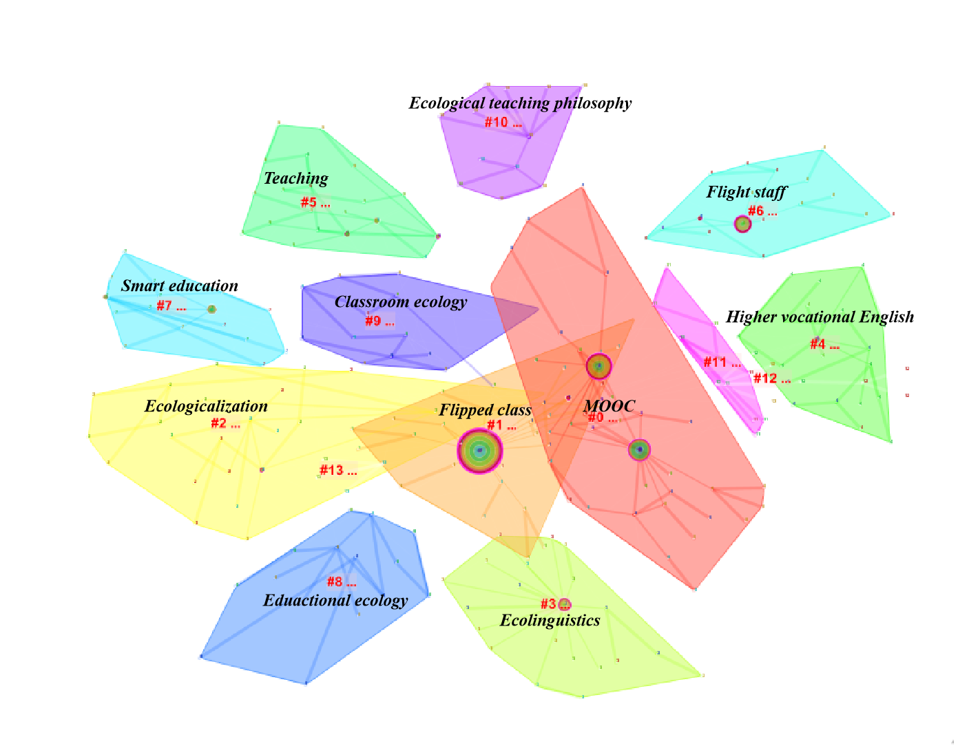
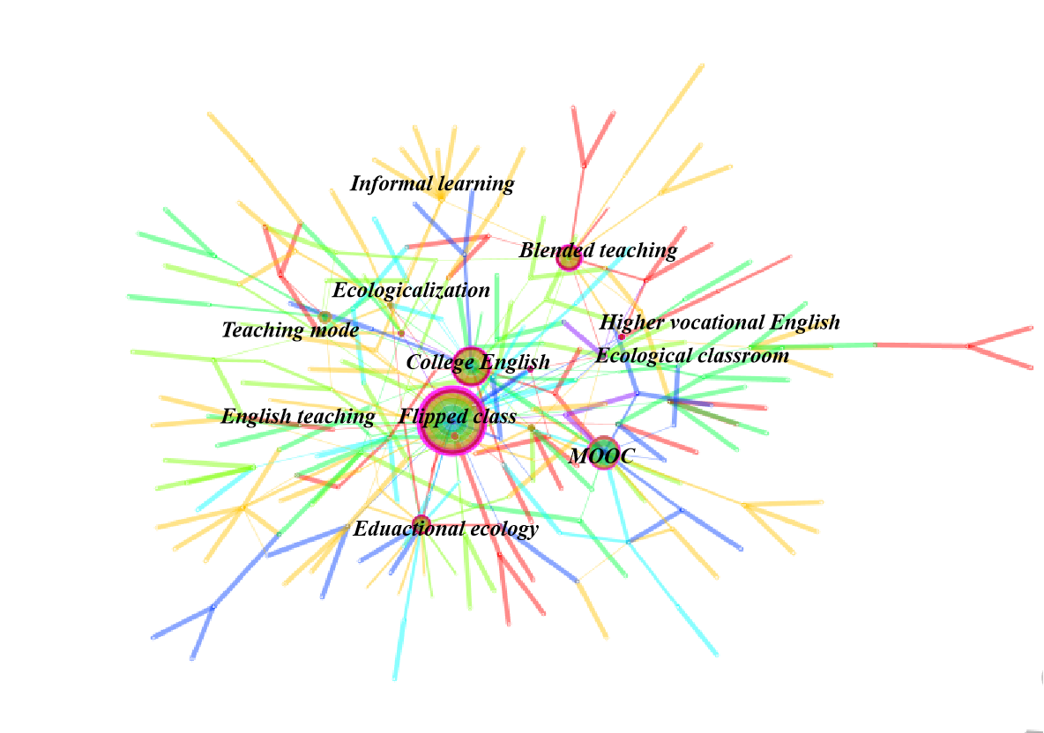

Figure 2. Keywords co-occurrence and clusters

Table 2. Top 10 keywords

3. Research trends
Through computation, CiteSpace can detect burstness, which indicates the abrupt change of a keyword over a period of time. The greater the burstness is, the higher attention the topic is attracting, and the more lively the topic is. This is also an indicator to measure the frontier of a field (Wang & Bao, 2020). A total of 13 burst terms for the development of blended foreign language teaching from the ecological perspective in China were identified (Figure 3). Through observation, we can divide the development of this field in the past ten years into the start-up period, from 2010 to 2013, during which the information technology and foreign language courses are fully integrated (Chen & Wang, 2016), and the combination of ecological perspective and foreign language teaching research is getting attention (Wang & Bao, 2020); from 2014 to 2017, the ecological research period of blended foreign language teaching dominated by informatization ; and from 2018 to 2020, the ecological research period of blended foreign language teaching with “smart” as the frontier .

In 2015, the Chinese State Council issued the “Guidelines for ‘Internet Plus’ Action Plan”, defining “Internet Plus” as: innovation achievements generated by the Internet should merge with every aspect in the economic society so as to propel the technological progress, efficiency promotion and organizational transformation, boost the creativity and productivity of substantial economy and thus introduce a new and comprehensive socio-economic development form based on the Internet infrastructure and innovation elements. Furthermore, in 2019, China Ministry of Education confirmed the term “Internet plus Education” in the “Key Points of Education Informatization 2019”. With the development of technology, the requirement of constructing of an intelligent teaching environment has been upgraded to that of a digital campus/smart campus, and the implementation of innovative development of smart education. The education in China under the background of “Internet Plus” will gradually get smarter. In this context, it is a major issue in foreign language teaching to integrate smart teaching methods into smart teaching environment, conduct intelligent learning and establish an ecological system of foreign language teaching (Chen, 2020). Future foreign language education will continue to integrate massive online and offline digital resources and establish a real-time interactive learning system. Such a smart environment can not only perceive the educational environment and the learning state of learners, adapt to the individual needs, but also provide timely and appropriate evaluation guidance and suggestions (Hwang & Gwo-Jen, 2014). When these smart factors join the ecosystem of foreign language teaching as a strong force, how to define their ecological niche, how to adjust the “ecostate” and “ecorole” of the old and new factors in the system to achieve a new ecological balance, and when the foreign language education in China will usher in an overall reform, will be the problem for scholars to solve.
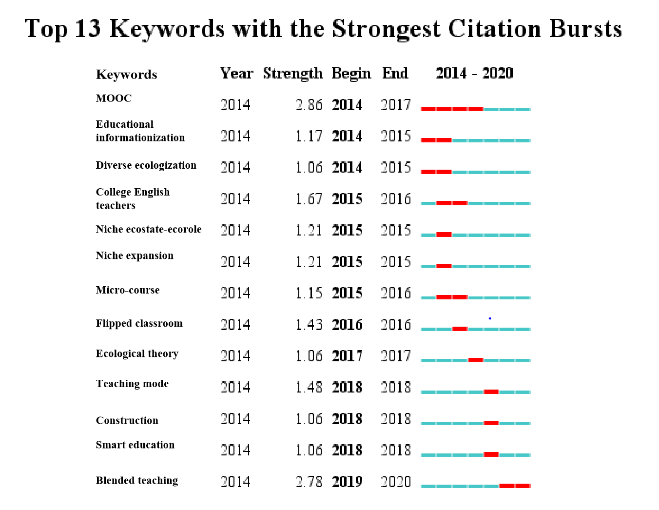
Figure 3. Burst keywords

4.Research Limitations
In this study, CiteSpace was used to analyze and review the research hotspots and development trends of blended foreign language teaching from the ecological perspective in China in the past ten years. Through the interpretation of authors, institutions, co-occurrence of key words and burst words, we find that the combination of ecology and blended foreign language teaching research in China is relatively late, with few literatures, and no core research team has been formed. Most of the preliminary studies focused on the specific forms of blended teaching, such as the ecological construction of flipped class, MOOC and micro-courses. The research subjects were mostly college English and higher vocational English. In the past two years, driven by the continuous development of technology and policies, the research focus has gradually turned to the ecological construction of smart foreign language teaching.

Reviewing the literature, we can easily find that although the research fits with the development of the times and responds to the changing needs of learners, there are still some limitations.

One is the misapplication of the theory. As an inter-discipline, foreign language researchers have a limited knowledge of ecological theory, and some of their studies are just superficial understanding towards the concepts. This requires researchers to analyze and solve problems in foreign language education in the new era on the premise of mastering ecological theory and establishing a correct ecological view. Similarly, as a fresh term, smart education has also been misused by many researchers, who confuse “smart” with flipped classroom, MOOC, micro-courses and other concepts that have merely replaced some new devices. As researchers, only by clarifying complex concepts can we conduct rigorous and accurate research.

The second is the limitation of the research subjects. The existing literatures show that most majority of the research subjects are college English and higher vocational English, while the proportion of English major is small, indicating that the ecological research of blended teaching for English majors in China is still in its infancy. However, the study of higher vocational English shows a wide range of topics but lack of depth, which requires scholars and institutions to carry out exchanges and cooperation, form academic communities in this field, and improve the overall scientific research ability.
In addition, the research in this field is prone to concentrate on model construction, yet empirical research is still lacking, characterized as small scale, short time, single type, few replicated verification, little effect, and lack of meta-study and meta-evaluation (Lv & Zheng, 2016). For instance, in the co-occurrence of keywords, the frequency of “teaching mode” is 8 times, the centrality is 0.14, and the burstness is 1.48; while the frequency of “empirical research” is only 2 times, and other indicators are not significant. The comparison between the two is obvious. Future research should focus on online and offline ecological assessment of blended foreign language teaching model, quantifying the balance point of the ecosystem, and building a more effective ecology of blended foreign language teaching.

IV. Conclusion
In this study, the ecological research literature on blended foreign language teaching in China in the past decade was collected; and CiteSpace, a scientometrics software, was used to conduct a visual analysis of the research in this field to summarize its development status and future trend. For teaching and learning, the blended way is one of the most effective method in that it combines the traditional and innovative way, contributing to the effective learning in the new environment (Cheung et al., 2019). The coexistence of a variety of factors leads to a huge complex ecosystems. Although the present researches concentrate on many directions such as college English, higher vocational English, the ecological construction of flipped class or MOOC, and the niche research of teachers and students, more comprehensive, rigorous and quantitative research are in want to promote the application of ecological theory to education and to maintain the ecological dynamic balance of education system in China.

Due to the short development time of this field, the limited literature database of CNKI and the inevitable subjectivity of manual screening to some extent, this study has some shortcomings. Future research can collect literatures from inclusive resources and select more accurate literature for analysis and comparison, so as to enrich the ecological research in blended foreign language teaching in China.

References
Allen I E J . (2011). Going the distance: online education in the united states, 2011. Sloan Consortium, 18(12), 44.
Chen, C. . (2016). CiteSpace: A Practical Guide for Mapping Scientific Literature.Nova Publishers.
Chen Jianlin. (2005). Computer-assisted teaching or autonomous teaching. Technology Enhanced Foreign Language Teaching (04), 9-12.
Chen Jianlin.(2020). On the application of artificial intelligence technology in foreign language teaching. Journal of Beijing International Studies University (02),14-25.
Chen Jianlin, & Shi Guangxiao. (2009). On IT-based foreign language instruction model—a case study of DDL. Foreign Language Teaching (06), 58-61+83.
Chen Jianlin, & Wang Jing.(2016).On the development of “normal” in IT-based foreign language education. Technology Enhanced Foreign Language Teaching(02),3-9.
Cheung, Simon K. S.; Lee, Lap-Kei; Simonova, Ivana; Kozel, Tomas; Kwok, Lam-For (2019). [Lecture Notes in Computer Science] Blended Learning: Educational Innovation for Personalized Learning Volume 11546 (12th International Conference, ICBL 2019, Hradec Kralove, Czech Republic, July 2–4, 2019, Proceedings) . Springer.
Chong Chongyan.(2018).Design and Application of Teaching Model Based on Smart Classroom—Taking English Listening and Speaking Class Teaching as an Example (Master’s Thesis, Beihua University).
Dziuban, C. , Graham, C. R. , Moskal, P. D. , Norberg, A. , & Sicilia, N. . (2018). Blended learning: the new normal and emerging technologies. International Journal of Educational Technology in Higher Education, 15(1), 3.
Freeman, L. C. . (1979). Centrality in social networks : conceptual clarification. Social Network, 1(3), 215-239.
Garrison, D. R. , & D. Vaughan, N. . (2008). Blended learning in higher education (framework, priciples and guidlines). John Wiley & Sons.
Gu Yueguo. (2005). An ecological model of education with special reference to online education. Technology Enhanced Foreign Language Teaching(04),3-8.
Hu Fangyi, & Wang Hongjun. (2019). From “task chain” to “ecosystem”: the ecological construction of college English teaching. Foreign Language Teaching(02),76-79.
Hu Jing.(2019). Ecological teaching model of college English continuous courses based on blended learning. Journal of Hubei University of Education(06),11-16.
Hwang, & Gwo-Jen. (2014). Definition, framework and research issues of smart learning environments—a context-aware ubiquitous learning perspective. Smart Learning Environments, 1(1), 4.
Kitchenham, A. . (2011). Blended Learning across Disciplines: Models for Implementation. IGI Global.
Li Chen, & Chen Jianlin.(2017).A study on the student’s ecological niche in college English teaching ecosystem. Technology Enhanced Foreign Language Teaching(05),15-22.
Lv Hongbo, & Zheng Jinzhou.(2016). How far away is the educational empirical study?. Journal of Hebei Normal University/Educational Science Edition(01),5-9.
Ma Hui, & Ma Donghong.(2015).A study on the niche ecostate-ecorole of college English faculty in the context of MOOC. Continue Education Research(06),62-64.
Rasheed, R. A. , Kamsin, A. , & Abdullah, N. A. . (2019). Challenges in the online component of blended learning: a systematic review. Computers & Education, 144, 103701.
Ren Li.(2015). A study on college English education from the ecological perspective: retrospect and prospect. College English Teaching and Research(05),62-65.
Wang Wei & Bao Yan.(2020). Characteristics and trends of foreign language teaching in China from the perspective of ecology—a visualized analysis based on CiteSpace. Foreign Languages Research(05),52-59.
Ye Ling, Yao Yandan & Han Ye.(2020).A study on college English faculty development based on flipped classroom. China Medical Education Technology(02),146-149.
Zhang Mulin & Guan Dehua.(2016).A study on the reposition and upgradation of autonomous learning center during college English transformation phase from the perspective of educational ecology. Educational Review(08),134-137.
Zheng Yan.(2016).On the construction of English flipped classroom teaching ecology. Foreign Languages Research(02),124-127.
Zhu Chunquan.(1997).The niche ecostate-ecorole theory and expansion hypothesis. Acta Ecologica Sinica (03),324-332.

