**The process of developing indigenous culture-integrated mathematics remedial teaching modules for elementary school low-achieving indigenous students in Taiwan**

Ting-Ying Lo, Associate Professor

Department of Child Development and Family Studies,

Tzu Chi University, Hualien, Taiwan.

**ABSTRACT**

Mathematics is one of the most difficult subjects for most indigenous students in Taiwan. In view of the international trend of emphasizing the education equity principle concerning the learning of minority students to improve their success in mathematics, this study implemented an activity theory to analyze the difficulties of low-achieving indigenous students in mathematics. Then, it developed an indigenous culture-integrated mathematics remedial teaching module to address the students’ challenges.

Furthermore, this research applied the case study method and invited twelve fourth- and fifth-grade Truku indigenous students with low achievement in mathematics in the tribal Mountain Primary School (pseudonym) and the tutors of the two classes as the study participants. The research tools used for analysis included a teacher-student interview outline, an indigenous culture integration mathematics remedial teaching module, classroom videos, and reflection logs.

Moreover, from the analysis of the activity theory, this study found that the low-achievement indigenous students’ resistance appeared among the tools, rules, and division of labor, which caused them to produce contradictory emotions towards mathematics, such as a lack of self-confidence. The study team developed a mathematical remedial module integrating indigenous culture into the problem-solving tasks. They taught multiple representations with graphs that the low-achieving indigenous students were good at and used peer tutoring strategies to address the challenges.

60% of the indigenous low-achieving students have improved their arithmetic operation ability. This finding implies that the dual-guidance teaching strategy expanded the indigenous students’ ability to use multiple representations to solve problems, improved their confidence to present solutions, and appeared to have a “sense of ability” to contribute to the team.

***Keywords***: Activity theory; Culture-integrated mathematics module; Indigenous students; Mathematics remedial teaching

**1. Introduction**

In recent years, the Taiwan government has actively and continuously implemented educational interventions to offer assistance to the disadvantaged and promote the cultural advantages of the indigenous group. In particular, the government has established indigenous culture experimental schools (Hsu, 2019) and offered mathematics remedial for low-achieving students, which echoes the development trend of world education where multiculturalism is valued.

Teaching research in the fields of ethnic mathematics, culturally responsive teaching or culturally integrated mathematics teaching modules improves the conceptual understanding and problem-solving skills of indigenous students (e.g., Demitra & Sarjoko, 2018).

Based on the above multicultural research results and the world's respect for multiculturalism, the researchers has the following goals:

**1.1 Research objectives**

The principal objectives of the study were as follows.

•To implement an activity theory to analyze the difficulties of low-achieving indigenous students in mathematics.

•To develop an indigenous culture-integrated mathematics remedial teaching module to address their difficulties.

**2. Literature**

Vygotsky (1935; 1978) emphasized the influence of social culture on the development of human cognition. He pointed out that when people participate in social and cultural activities, shared experiences among people-using the basic tools of culture, such as language, symbols, numbers, and words, and through the cooperative relationship between subjects, objects, and tools - act as an intermediary with each other affecting the whole activity. A collaborative dialogue allows people not only to be passive recipients of information but active participants in creating meaning (Qiu, 2006). Based on the intermediary action triangle of subject, tool, and outcome by Vygotsky and Engeström (1987), this study added three elements: rule, community, and division of labor, called “the activity model”, as shown in Figure1. This model explains that the subject uses mediators: tools, rules, and division of labor to interact with the community, generating a perception of the goal and affecting the outcome.

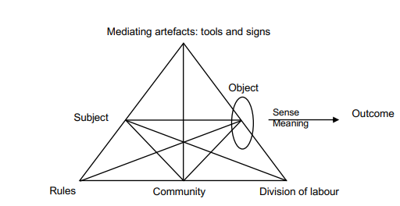

Figure 1: Engeström’s (1987) activity theory model, taken from Daniels (2001).

**3. Research methodology**

**3.1 Participants**

This study applied the case study method and invited 12 low-achieving fourth- and fifth-grade indigenous students in the tribal Mountain Elementary School (pseudonym), comprising eight boys and four girls. The invited students failed to pass the mathematics basic competence test of the Ministry of Education (2019) and needed to strengthen the arithmetic operational skills and basic concepts of fractions proposed by the two math teachers from the classes. Therefore, it was necessary to implement learning assistance and guidance.

The school is located in the tribes where 90% of Truku people live, the clan of the 16 indigenous peoples in Taiwan. Although the young tribal people do not like the older adults communicating in their native language, they often participate in daily traditional cultural inheritance activities. They hold celebrations for marriage, winning awards, and graduations and prepare pork to share with everyone in the tribe. Given the low migration rate, students were resistant to diverse cultural stimulation and learning.

The researchers observed the learning process of low-achieving indigenous students in the classroom. The teacher's teaching has the following characteristics.

• Teacher-centered instruction

• Teachers talked to high-achieving indigenous students more by oral interaction

•The teacher primarily used mathematical representations of numbers and symbols.

•Teachers often used textbook examples to explain new concepts, but some examples deviate from students' life experiences.

**3.2. Research tools**

The research tools include teaching videos, teaching materials, a mathematics module, reflection logs, and outlines of teacher and student interviews. The interview questions for teachers include “What do you think of students with low math scores in the class?”, “Can you give us feedback on the remedial teaching module?”. On the other hand, the interview questions for students include “Who do you think can help you the most in learning mathematics?”, “In today’s class, did you understand the concept where the teacher converted mixed fractions to improper fractions?

**3.3. Data processing and analysis**

This study applied the template analysis style by Chang (2010). In addition, this study adopted the triangulation method, which included multiple data, multiple raters, and multiple analysis methods, to improve the reliability of data analysis. Among them, the raters invited two senior students who completed independent qualitative research to discuss the inconsistencies and obtain a consensus.

**4. Results**

**4.1. Mathematics resistance and learning difficulties of low-achieving students**

The researcher found that the resistance of the low-achieving indigenous subjects lies in “material tools”, such as digital representation, abstract, and a cultural experience; “psychological tools”, such as ambivalence towards mathematics, lack of assistance in solving math problems at home; “division of labor”, such as unequal teacher-student ratios, the indigenous low-achieving students spending extra time even in holidays for math remedial teaching, and the ineffective implementation of peer guidance; “rule”, such as the inconsistencies between school culture and tribal learning culture, parents and students being low achievers in mathematics, students’ ambivalence about learning math. All of the above resulted in little to no motivation and low interest in mathematics and even school learning.

**4.2. The mathematics remedial teaching module**

Based on the learning challenge of the low-achieving indigenous students, the study team developed a mathematics remedial teaching module, “Come! Let’s go hunting”. After discussing with the math teachers of the two classes, the remedial teaching goal was aimed at strengthening the students’ arithmetic operational skills and the basic concepts of fractions. Subsequently, three units were designed with the math concepts relevant to Truku hunting, sharing food, and music culture. For resistance 1, the module taught multiple representation strategies with graphs representations of where students are good at. For resistance 2, the module was based on the peer tutoring model, involving the “dual mentors”, who were college students and high-achieving indigenous students, to cooperate in guiding the low-achieving students to solve problems. For resistance 3, the peer tutoring model stressed that equal rights exist between mentors and mentees. For resistance 4, the module integrated indigenous culture into the mathematics problem-solving task, creating a friendly and “I can contribute to the team” learning atmosphere.

**4.3. Teaching process**

The first unit, “Collaborative Carrying Prey down the Mountain”, illustrated the teaching process. The researcher implemented construction-oriented teaching centered on indigenous student culture experience.

*4.3.1. Introducing the ancient and modern hunter spirit; arousing similar experiences to promote mathematics learning*

*4.3.2. Designing problem-solving tasks in real-life situations and teaching peers to practice multiple representation strategies to solve math problems*

*4.3.3. Providing an opportunity to present problem-solving strategies, allowing the low-achieving indigenous students to gain achievement*

**4.4 Low-achieving indigenous students’ learning effect**

The researchers took the first unit as an example to analyze the learning effects of the module and strategy on the low-achieving indigenous students as follows:

**4.4.1. Arithmetic operation ability**

The study team designed a summative assessment at the end of each unit to check the learning effectiveness of the low-achieving indigenous students. Based on the summative evaluation of Unit 1, the researcher took Task 1 as an example. The task is as follows: Six students want to work together to climb a mountain in seven days, and one needs to eat three kilograms of food a day. How much food do they have for seven days?

As shown in Figure 2, seven indigenous students (58.3%) answered the question correctly. LS56M found a regularity relationship between the “Number of Classmates” and the “Seven-day food quantity”. When a student is added, the number in brackets will be plus three; so when the third student is added, they need to write (3+3+3) × 7 in the table cell. The student wrote down the solution tips carefully: “the relationship was between twenty-one kg each time” (total weight) and “increase 3 kg each time” (number of students). The low-achieving students frequently used multiplication to calculate the result. For instance, they directly wrote 9 × 7 = 63 in the column instead of calculating through continuous addition. This finding shows that the low-achieving students understood multiplication, allowing them to calculate fast and accurately.

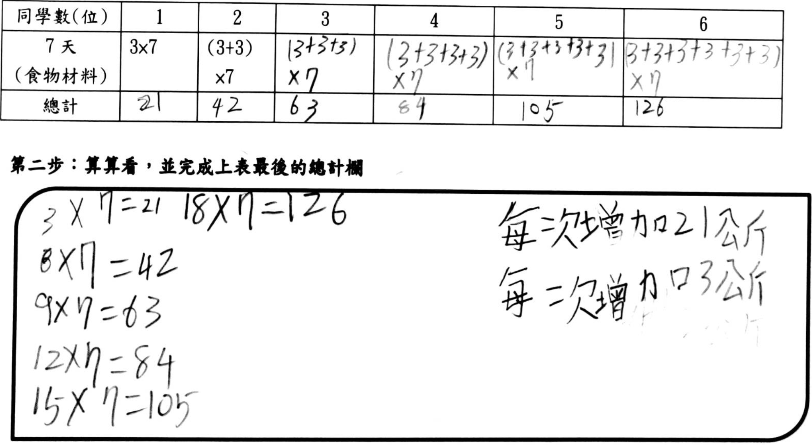

Figure2: LS56M problem-solving process

**4.4.2. The teaching effect of peer tutoring**

The researcher took Task 3 as an example. This task includes the following question: “Please calculate how many times your team will move the heaviest prey down the mountain. How many kilograms will you move every time?”. Further, the researcher took the team that drew eighty-six kilograms of prey as an example. The guidance difficulty encountered by high-achieving indigenous students HS59F used oral language and digital representation alternately to LS52F. However, these two representations were difficult for her to understand. The college students then observed the difficulties, demonstrated the graphic method to understand the meaning of the math problem, and marked the key sentences with a color pen to help describe the problem’s meaning. The double guiding strategy could enable the high-achieving and low-achieving indigenous students to practice more multiple representation strategies.

HS59F revised the guidance after comprehension: “LS52F, this key sentence in this question was very important (demonstrate by pointing the sentences with your finger). You should circle the sentence and read it again. There were six peers in our team. I drew a circle to represent 1 and wrote ten kg in the circle, which means ‘I can carry 10 kg’. You represented the second circle and wrote ten kg because you could carry ten kg. For the first time, six team members could carry sixty kg. Look at my drawing and compare it to the question. Did you understand the meaning of 10×6?”.

Figure3 shows that the total weight of the prey drawn by the team was eighty-six kg. After LS52F understood HS59F’s guidance, she learned to use three representations strategies—diagrams, tables, and word symbols—to solve the problem. The answer to this task was the prey needed to be carried twice; at first, six team members had to carry ten kg, with a remaining twenty-six kg. Thus, two members must carry five kg during the second time, and the other four must carry four kg.

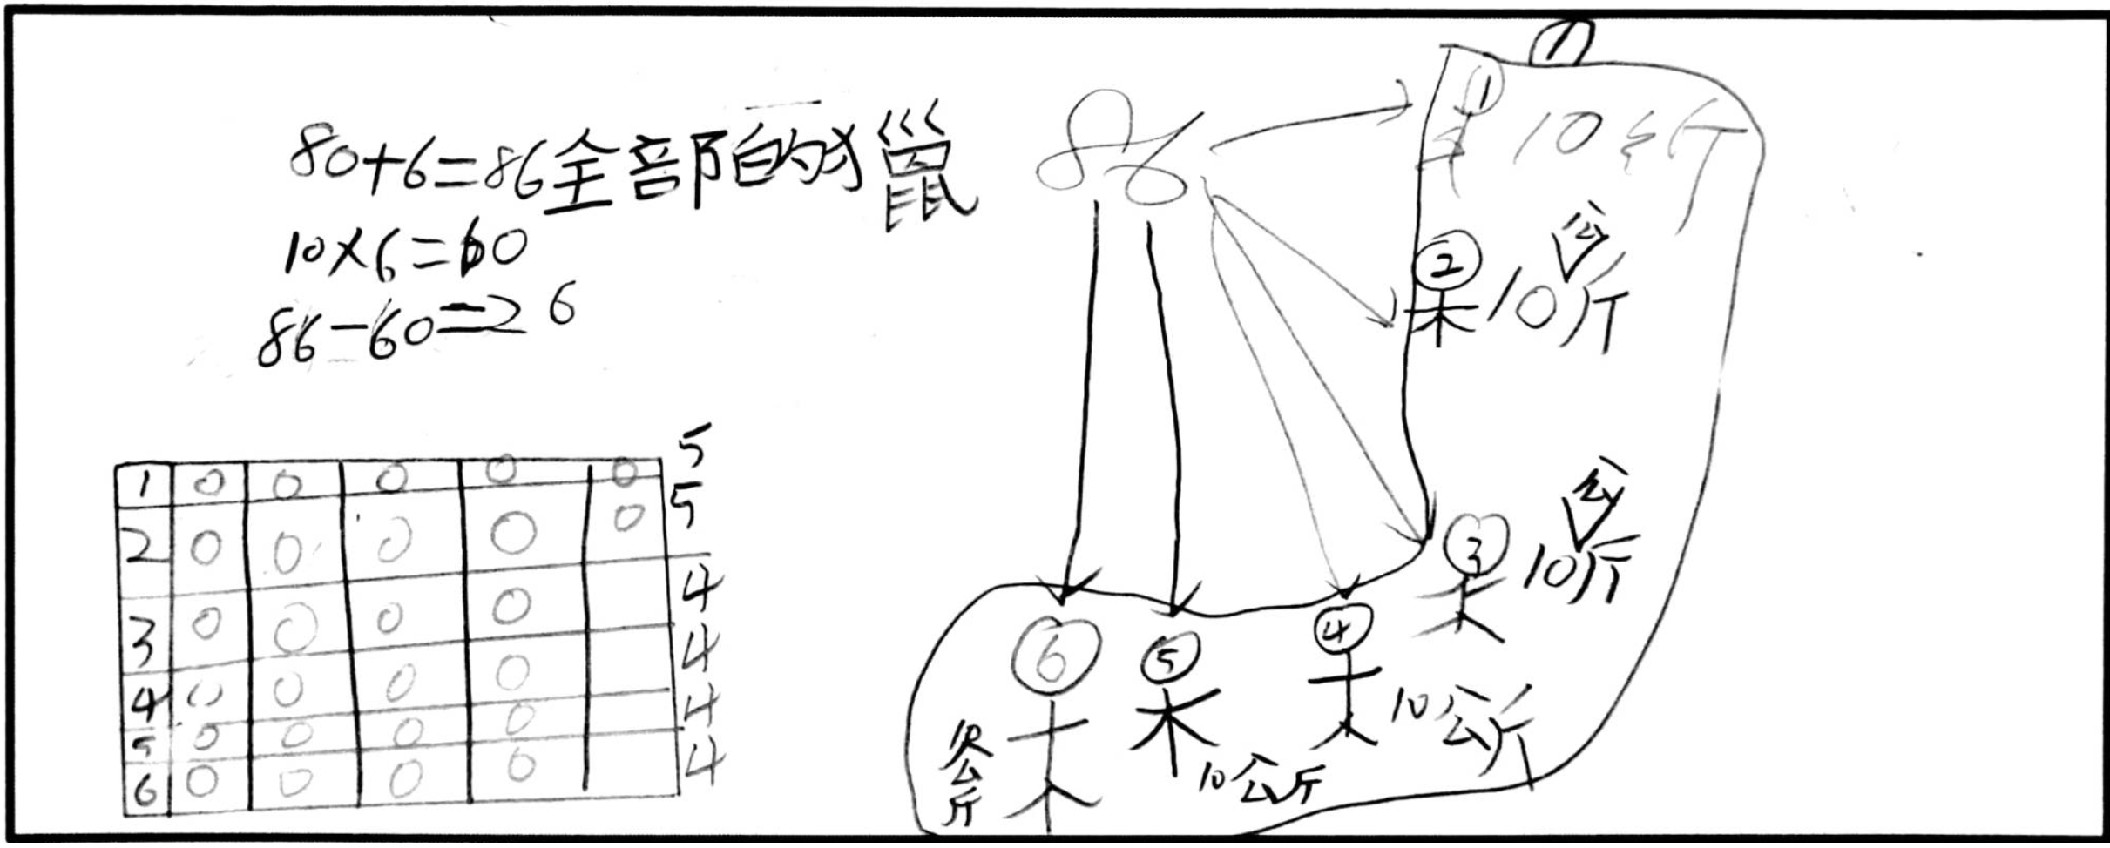

Figure3: LS52F using multiple representation strategies to solve problems

**4.4.3. The learning effect of the oral presentation**

This module is based on the equal rights between the high- and low-achieving students to decide the way of cooperation and division of labor. This equality of rights allowed both to contribute to the team’s scoring and transfer from the higher students who dominated the right to present.

The low-achieving students in math (50%) were not only brave to present on stage, but they also calmly answered the teacher's and peers’ questions. The module allowed them to practice oral presentation among the team, write the problem-solving steps by themselves, practice again by writing on the blackboard, and present more confidently.

**5. Conclusion**

This study analyzed the resistance to and difficulties of low-achieving indigenous students through the activity theory. It further developed a remedial teaching module to address these problems and integrated indigenous culture into mathematical concepts to improve the students’ arithmetic operational ability and basic concepts of fractions.

**REFERENCES**

Chang, F.-F. (2010). The five steps of qualitative data analysis: climbing up a ladder of abstraction. J*ournal of Elementary Education,35,87-120*. doi:10.7036/JEE. 201004.0087

Daniels, H. (2001). *Vygotsky and Pedagogy*. London: Routledge Falmer.

Demitra, D., & Sarjoko, D. (2018). Effects of handep cooperative learning based on indigenous knowledge on mathematical problem solving skill. *International Journal of Instruction, 11*(2), 103-114. doi: 10.12973/iji.2018.1128a.

Engeström, Y. (1987). *Learning by expanding: An activity-theoretical approach to developmental research*. Helsinki, Finland: Orienta-Konsultit Oy.

Qiu, M.-W. (2006). A *study on the application of cognitive development theory in teaching*. Retrieved from https: //mail.nhu.edu.tw/~society/e-j/56/ 56-33.htm.